GSC Meeting - Geneva - 4/10/2018 - Discussion group in the morning

How to better understand local building practices (LBP). Applicability and accountability.
Host: Enrique Sevillano (CRAterre)
- Main reflections during the open conversation:
- Assessment is crucial.
  - It is necessary to do assessment in order to understand habitational cultures.
  - Speaking with people is the first thing. Trust them!
  - It must be done case by case. In very close zones, almost everything changes concerning LBP.
  - Assessment must be done on:
    - Infrastructure to access sites,
    - Housing (technical and cultural),
    - Availability of means, scarcity of materials,
    - What people want, what they can afford?
    - Consider the esthetical part, because a house is also to be beautiful.
  - Assessment must be capacity-focused and not needs-focused.
- Women must be put in the centre of the LBP assessment.
  - Women spend more time in houses and they have very important information about LBC and cultural practices.
  - More women are needed in the technical staff because there is more confidence between women during the assessment, field surveys.
  - It is also crucial to understand the roles of men and women in the construction practices.
- It is necessary to show that LBP work.
  - For that, research is needed. More important to be done by local universities. Universities often lack of practical knowledge, but can pilot tests and provide with students to understand how things work.
  - Show how LBP work when memory is lost (generations lose memory of earthquake resistant practices, because sometimes it takes time to happen again).
- LBP are important to be respected. They may also be improved avoiding top-down solutions.
  - Balance must be conserved between improvement and respect of LBP.
  - When appropriate, improvements must be undertaken only when they are easy to assume by the whole community (technically, financially).
  - LBP must be evolving to adapt to changing environment.
  - Advocacy must be done towards governments to facilitate solutions which are realistic for population (sometimes standards are impossible to follow).
- Different risks must be taken into account:
  - Security of shelter is crucial against raping, robbery, etc.
  - Fire and other risks relied to use of the housing are important to take into account (risk of fire of thatch roofs…).
- Projects must be implemented by multidisciplinary teams during the whole duration (technical, economic, cultural, social skills).

- Recap of key messages:
- Assessment is crucial. Need to take into account not only technical practices, but also cultural practices and social analysis of habitat (how people live/use/maintain their houses). Importance of women.
- Need to respect LBP and not underestimate them. Help them evolve when necessary with reinforcements in weak points, for climate change adaptation… Building practices are in constant evolution.
- Need to advocate for the acceptance of LBP (advocacy to governments and powers and research).

- Who and what to be done:
Cluster (Global + Country level) + PSB WG
Trust the communities
Support to convince donors and agencies that LBP are important and best way forward (advocacy)
Create a comprehensive sample assessment tool for understanding LBP: capacities + linkages with tradition + market accessibility + social perception, etc.
Training of local staff about LBP assessment tool
Field practitioners
Trust the communities
Involve more women in assessments (technical staff + women from communities)
Involve communities in the assessment and also in the design practices
Involve and cooperate with local universities and with the private sector. Trainings on site
Improve communication on LBP by as many ways as possible (radio, one-to-one, etc.)
Mobilise local artisans to capitalise on existing knowledge and skills
Encourage LBP despite the increasing demand for CGI sheets
Design of more secure and safer shelters
Universities (most local) / academics
Trust the communities
Understand linkages with the long term effects of humanitarian shelter
Help accept and improve LBP through research on LBP
Community
Involve more women
Involve local carpenters and craftsmen
Participate in assessment and design
Other actors to be engaged : Governments and public powers, private sector, donors

- Final reflection:
It is never too late to start conversation with communities. Even if it was not done from day 1, it should be done

Annex (pictures)
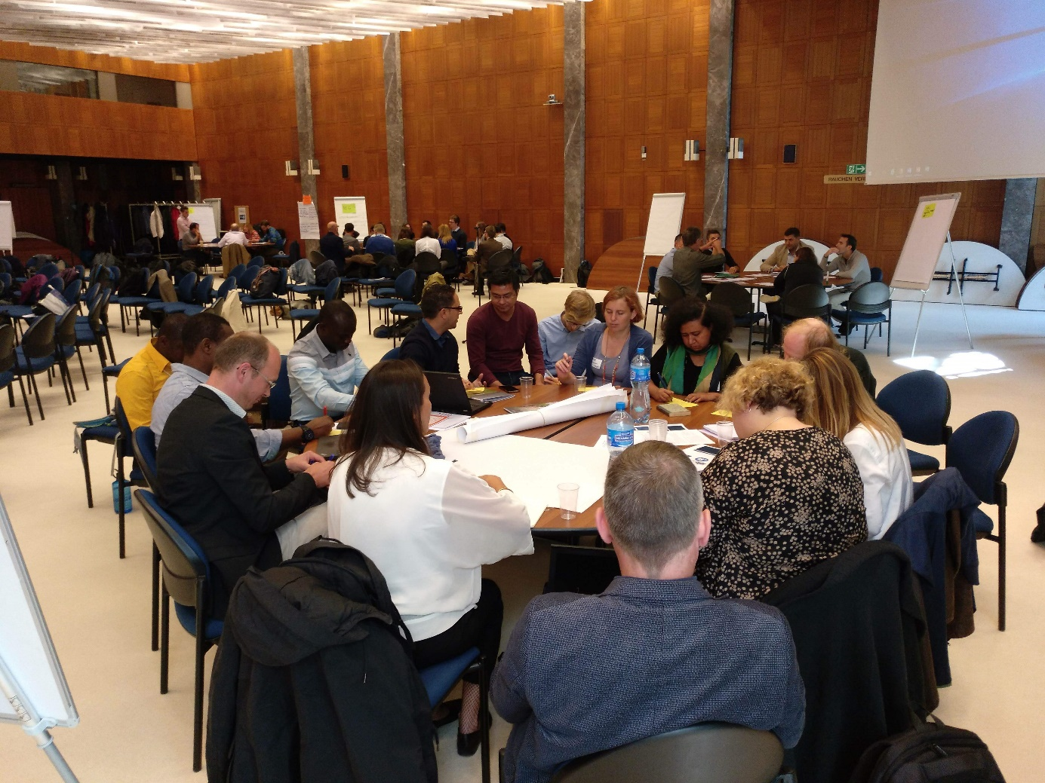
Working session
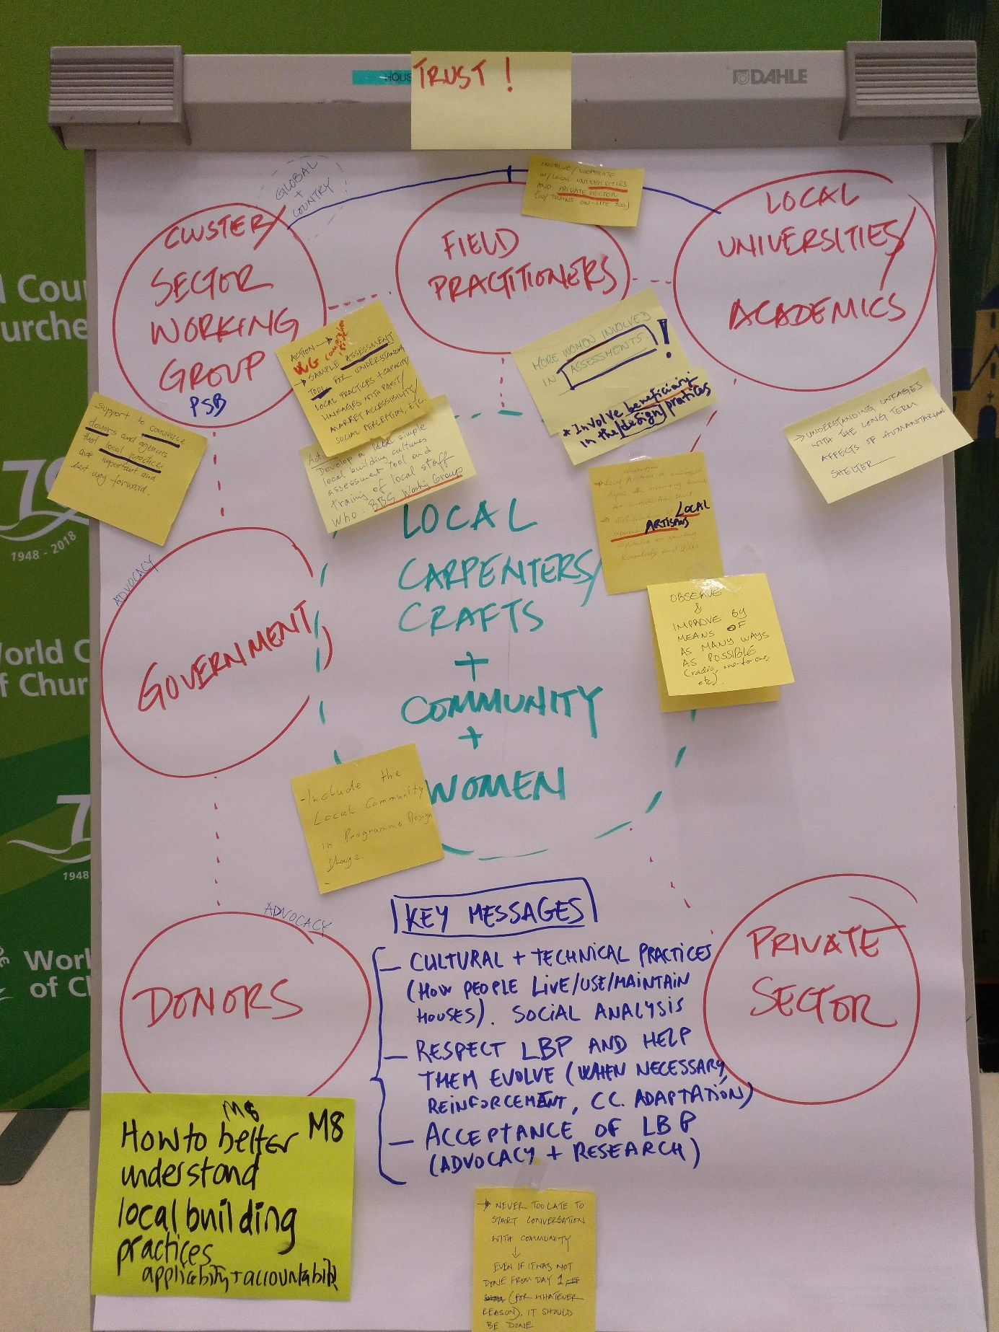
Recap panel
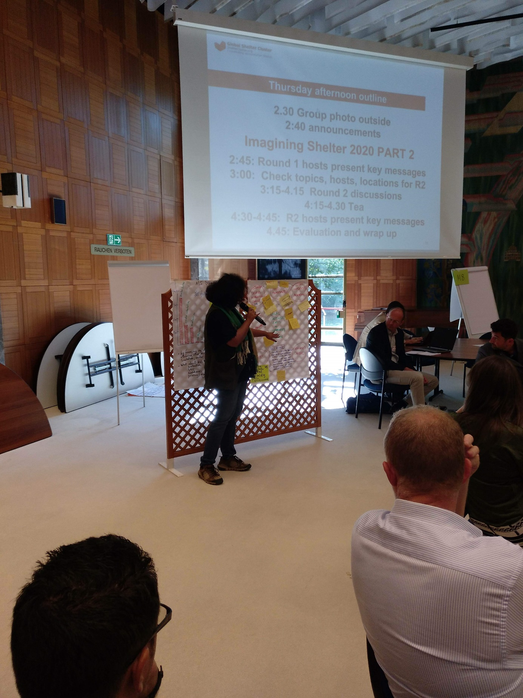
Presentation

