Global Shelter Cluster

Construction Standards Working Group

Break-out Sessions at the GSC Meeting

3rd October 2018

Overview
The first part of the session focused on the presentation of the document and the background of the working group. I have tried to share the document strengths and weaknesses; discuss the work done during the course of the current year on the Construction Good Practice Standards document. Unfortunately, it was not possible sharing hard copies of the document to the participants so we went through the main chapters with a power point presentation. This was followed by a group discussion on the document and on the next steps for the dissemination options (including workshops and events). The feedback collected will also serve as a way forward.

Introduction and Objectives
- Purpose and use of the Standard.
- Overview of the Standard.
- Future direction and goals of the Standard.
During the session, the Construction Standards document was presented highlighting the work done during the course of the year and describing the barriers encountered during the compilation. Particular emphasis was given to the Benchmarks and Target highlighted and where the representatives of the six (6) organizations have shown most interest. The title of the document seemed not to be appropriate because of the terminology Standards that could be misleading or misinterpreted.

Feedback, ideas and next steps
- What solutions exist for the issues that have been brought up?
- What are the next foreseeable steps?
- What concrete steps can be done to help move the Standards forward?
- What changes / additions would help the Standard?

- The Standards should be seen as a contributing element for long-term outcomes, beyond sectoral / different usage interventions. This is different in post natural disasters contexts and in conflict, where the construction sector can be used to advocate private companies and host governments, donors, within international organizations implementations. This can be fostered through other interventions such as quick-impact projects of infrastructure rehabilitation.
Increase the possibility to use the standards in preparedness activities and capacity building (such as country workshops).
The best modality for delivering these capacity building and learning opportunities would be through field trainings (trainer of trainers) and e-learning.
- Linkage with universities and between practice and research.

ACTIONS
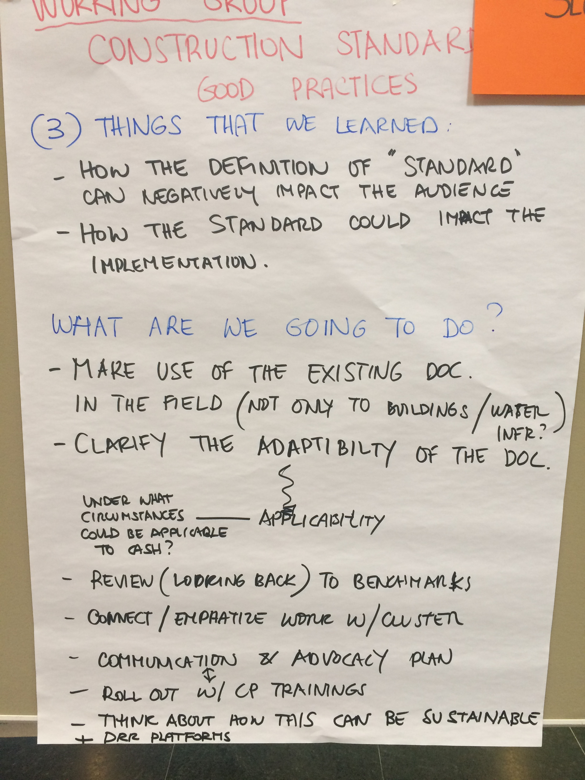
- Contact other Cluster Coordinators and ECHO has provided the contact of the Global WASH Cluster Deputy Coordinator (UNICEF).
- Include concrete examples of the application of the standard on constructions in the field (not only in building constructions but also water infrastructure).
- Change the Title (remove Standards from the title)
- Address the different usage of the document as in Procurement, building back safer, cash modalities, etc.
- Clarify the adaptability and the applicability of the Standards and in which circumstances could be appropriate for cash interventions.
- Capacity: Increase the possibility to use the standards in preparedness activities and capacity building (such as country workshops).
- Advocacy: in the construction sector can be used as an advocacy tool with private companies and host governments, donors, within international organizations and beyond.
- Align the Standards with the Inclusion of Persons with Disability in Shelter and Settlements (working group).
- Attach Checklists that could facilitate the users to apply the recommendations of the document.
- Foster linkages with universities to share the Standards and collect case studies.

