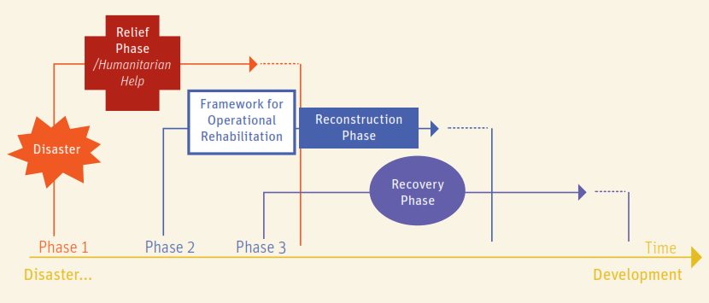
TWG Recovery Beira 03/05/2019

- Update on resettlement plan and policy 10 min (depending on updates) | Action | Responsible
1.1- Update on RRR (Returns Resettlement Relocations)  4W of the current RRR situation is ongoing | Final document on RRR | Rudy
1.2- IEC key messages  Finalized doc on key messages to be diffused within the communities (Banners, leaflets,....)  CRS sent some further visual material that could be included in the key messages (e.g. binding wire good practices, CGI roof installation) | Final IEC key messages to be shared | Pablo
- CASH 5 min
2.1- Brief presentation of Cash WG activities in Beira  Working on vouchers total amount estimation (e.g. Food Security vouchers = 3'740 Mt approx. 62 USD)  CWG could provide support to establish vouches amount for Shelter activities  Daily rate for Volunteers |  | Ricardo
To collect data and need of legal advice on the fixed term contracts for skilled / unskilled workers (ILO) | Contacts for legal advice + ILO + code of labour | Nancy  Lucio
- Case studies 15 min | Action | Responsible
3.1 - COSACA Strategy  Rural (Guara Guara): construction of individual houses for HH (target: 4'200 HHs)  - IPA (Integrated Project Approach) with WASH and education component  - Use of vouchers and organization of market fairs  - Timber for house construction from sustainable sources could be imported from South Africa  - Replanting of trees is foreseen (e.g. planting mangroves and mangroves farming)  - Technical assistance: involvement of local university and Mission Educate  Urban:  - Building resilience at community level (no technical materials or individual shelters)  - Work at larger scale (bairro, area,....), urban planning scale, not at the HH scale  - Info / training / improvement of the existing skills, construction techniques, plans to have longer term impacts on the communities  - Work with the Beira Municipality, REACH, UN-Habitat |  | CARE Team
3.2 - UN-Habitat activities  - Assessments in Beira, Dondo urban areas  - REACH / Un-Habitat methodology (fey informants, FGDs,....)  - Area based Integrated Approach  - Coordination with local Authorities (Municipality of Beira)  - Focus on flood, which is the main concern for local population  - Technical assistance to the Municipality of Beira | To start an Urban WG (?) | Ana
3.2 - IFRC pilot project in Buzi, Beira and Dondo  - Shelter assistance to 2'400 HH using voucher (rural and urban)  - IPA (Integrated Project Approach) with WASH, LLH components  - Training to the workers / community members / HHs will be provided  - Integrated project, including LLH, WASH components  - House cost first draft estimation:  Cement blocks/CGI roof = 1'000 USD  Sticks-adobe / CGI roof= 750 USD | To share BoQ, design, tech specs of the shelters | Betisa  Pablo
- INFO POINT Updates / questions / points of discussion from the Recovery Partners | Action | Responsible
4.1 - TIMBER: we met a company producing timber from protected sources (apparently the only one in Mozambique), based close to Gorongosa.  Timber could be suitable for infrastructures construction  For further info: http://www.levasflor.com/  Nils Von Sydow - nils@levasflor.com |  | Lucio
4.2 - VOCATIONAL TRAININGS: Visited the Young Africa vocational training centre in Beira. YA is also present in Dondo. Over 1'200 trainings/year  For further info: https://youngafrica.org/ya-mozambique  Christian M. SCHAFER - Technical Advisor - christian.schaefer@youngafrica.org |  | Lucio
4.3 - CRA Terre training
Not discussed during the meeting: there is a possibility to have CRA Terre supporting the recovery process with trainings on earth construction techniques.

- Next meeting
Friday 10/05/2019 – 15:00 Airport - Cafeteria ground level

Next week: BoQs, design, tech specs of the houses and other technical documents
Presentation of Samaritan Purse work (to be confirmed)

Please update the table with the (tentative) plan of your organization and share it next meeting:

 | LOCATION | TOTAL TARGET |  | SHELTER | DISTRIBUTION PLAN |  |  |  |  |  |  |  |  | PLAN | REMARKS
 |  | HH | People |  | April | May | June | July | Aug | Sept | Oct | Nov | Dec | PLAN | REMARKS
ALLIANCE2015 | Nhamatanda |  |  |  |  |  |  |  |  |  |  |  |  |  | Shelter support with local materials (to be confirmed)
CHEMO Consortium
CARE / COSACA
CVM/GRC | Sussundenga (Manica) | 1.500 | 7.500 | 1.500 |  |  |  |  |  |  |  |  |  | Aug.2019 | Shelter support with local materials  Hygiene and NFI will be part of the assistace  Construction materials/tools with In-kind assistance given to the short timeframe
CVM/GRC | Manica |  |  |  |  |  |  |  |  |  |  |  |  | July 2020 | Shelter / WASH
IFRC | Buzi / Beira / Dondo | 2.400 | 12.000 | 2.400 |  |  |  |  |  |  |  |  |  |  | Integrated Project Approach including Shelter, LLH, WASH
IOM
MEDAIR
SAMARITAN PURSE
UN-Habitat

Name | Organization | Role | Number | Mail
Ana CUBILLO | UN Habitat | Slum Upgrade Expert |  | ana.cubilloarias@un.org
Renata MENDEZ | CRS | Shelter TA | +258 848820288 | renatamendezf@gmail.com
Carolina BENZONI | AVSI | Education Coord | +258 850245183 | carolina.benzoni@avsi.org
John BIRCHENOUGH | CAFOD | Humanitarian | +44 7920287546 | jbirchenough@cafod.org.uk
Robert CRUICKSHAWK | CAFOD | Humanitarian | +258 842563222 | rcruickshawk@cafod.org.uk
Rudy MAGIRENA | Shelter Cluster | SC Roaming Coordinator |  | moz.coord3@sheltercluster.org
Nancy DORAN | CRS/CARITAS/CHEMO | Shelter TA | +1 2624154362 | nbdoran@gmail.com
Mark LANGHAM | SAMARITAN PURSE | Coord | +258 852107867 | MLangham@samaritan.org
Ricardo LOBO | CASH WG | Coord | +258 873429812 | beiracwg@gmail.com
Simon DEPREZ | CARE | Shelter Advisor |  | simondeprez@hotmail.fr
Betisa EGEA | IFRC | Shelter Coordinator IFRC | +258 871265948 | shelter1.mozambique@ifrc.org
Christophe ARNOLD | CARE | Shelter Advisor | +41 787651627 | arnold.christophe@gmail.com
Guiomar GRANDE | CARE | Shelter Advisor | +258 876235518 | guiomargrande@gmail.com
Holly SCHOFIELD | CARE | Shelter Advisor |  | hschofield@careinternational.org
Lucio COCCONI | Shelter Cluster | Tech Coord | +258 844511893 | moz.tech1@sheltercluster.org

