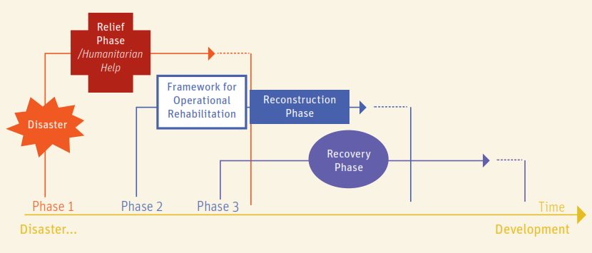
TWG Recovery Beira 17/04/2019

- INGC's resettlement plan and policy 20 min | Action | Responsible
INGC policy on relocation. The objectives of INGC is to resettle over 15'000 HHs in new location (e.g. Buzi area is planning to resettle 14% of the population).  INGC should provide construction materials and tools, CGIs for roofing, workforce.  WASH component (1 latrine per HH) is included in the INGC plan. | Clarify resettlement plans with the INGC | Marla/Lucio
DTM did intention surveys in the accommodation centers. Information will be approved by INGC and shared by DTM Mozambique very soon.
Points to clarify with INGC:  - Criteria for Beneficiaries selection.  - How INGC is selecting new sites? e.g. there will be the definition of no-build zones?  - How long will take the resettlement process?  - Important to better understand the criteria for resettlement, that may have an impact on Shelter Cluster Partners shelter projects (e.g. a Partner may decide to assist the reconstruction in a village located in a no-build area: could this be a problem for INGC?  - How will the SC Partners projects will fit in the INGC plans? | Mapping of no-build zones (if any) and overlapping with SC Partners areas of intervention
- Ongoing reconstruction: updates and samples from the field 20 min | Action | Responsible
The people are already rebuilding their homes, using a wide range of locally available materials, including debris, wooden sticks,.....  The quality of self-reconstruction is in general very low.  The reconstruction is proceeding quite fast, so that many people in 1-2 months will already have newly rebuilt shelters | Partners will share photos and findings from the field | SC Partners
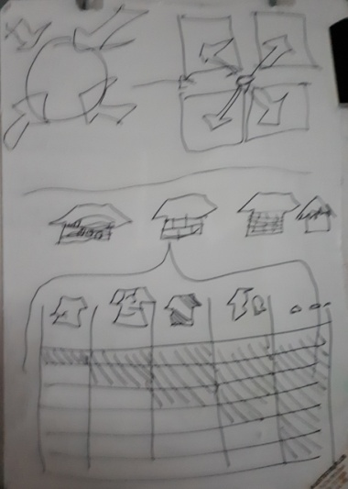  Priority to establish a matrix with list of damages, typologies and proposed interventions.  The matrix will be a key tool to define the intervention strategies and the cost of the proposed actions (e.g. partial reconstruction, complete reconstruction, reparation, upgrading of the existing, support to hosting families....)  SC Partners should provide a basic strategic framework to engage with donors, HQ and stakeholders to decide where to go next.  BoQ and price of the interventions? | Matrix with typologies, damages | SC  SC Partners
- Plans of the Shelter Partners 15 min | Action | Responsible
How will the SC Partners participate and support the reconstruction process?

- IFRC has a target of 2,000 HH and they have some budgets and they are changing all their plans, as people are rebuilding into retrofitting, very little rebuilding. Beira and rural areas + a whole package with HH and WASH (integrated approach). Selection of most vulnerable in most damaged areas in Buzi and Dondo. They have to decide where so they start a participatory approach (maybe blanket selection, as there are not big differences among HH). They may open a dialogue with the communities as they may open modalities: reconstruction, materials, cash for rent, etc.  - COSACA working is exploring alternatives, including interventions in urban areas, maybe using vouchers for materials or reconstruction. Haven’t identified communities yet.  - Emergency architects: concentrating in rebuilding infrastructures (schools,....) used as evacuation centers  - Samaritan Purse: plan shelter intervention in rural areas (south Buzi)  - German Red Cross (not present at the meeting) will support reconstruction with materials, tools with voucher modality in Sussundenga (until August 2019).  - UN habitat: much information from the past 10 years rebuilding in Mozambique. Planning a building back better campaign. | Share survey tools and methodology/ technologies for sharing with OCHA in HR.info | Shelter partners
- Others
TWG IEC (information education and communication) messaging about building back safer meeting will take place Thursday 18/04 @ 5:00. ToRs shared.

WFP is taking the lead on establishing Linha Verde, an inter-agency complaints and feedback mechanism composed of three components: 24/7 call centre and a network of complaints boxes and community-based complaints mechanisms (CBCM). Information gathered during the community engagement will be shared with partners to inform of needs and priorities on the ground to help improve programming. Information shared with users will raise awareness of services and how to provide feedback. WFP will share a briefing pack, which includes requests for information on shelter activities and focal points for feedback referral.

UNDP: shares the planning and summary of the PDNA (post disaster needs assessment) that is being done led by UN Habitat and UNPD.

Asbestos: a consultant on asbestos disposal has been requested by the Municipality of Beira
Please, share your assessments populating this OCHA catalogue:  https://docs.google.com/spreadsheets/d/1uCJYpgs6d681rv0WAbobxYtBEm-XYubyVzrhBT91OHE/edit#gid=0  More shelter assessments can be found in:  - https://www.globaldtm.info/mozambique/  - https://data.humdata.org/search?groups=moz&q=&ext_page_size=25  - https://www.humanitarianresponse.info/en/operations/mozambique/assessments  - https://maps.mapaction.org/event/moz-idai-2019 | Share metadata of your assessments | SC Partners
Next meeting: Wednesday 24/04/2019 – 15:00 Shelter Cluster corner

