Terms of Reference
Fiji National Shelter Cluster

Introduction
The following Terms of Reference (TORs) have been adopted to guide the operations of the Fiji National Shelter Cluster (SC) in providing effective and efficient service to the Government and people of Fiji before, during and after natural disasters. The TOR is intended to be a dynamic tool to inform the operations of the Cluster, with regular updates to ensure ongoing relevance.
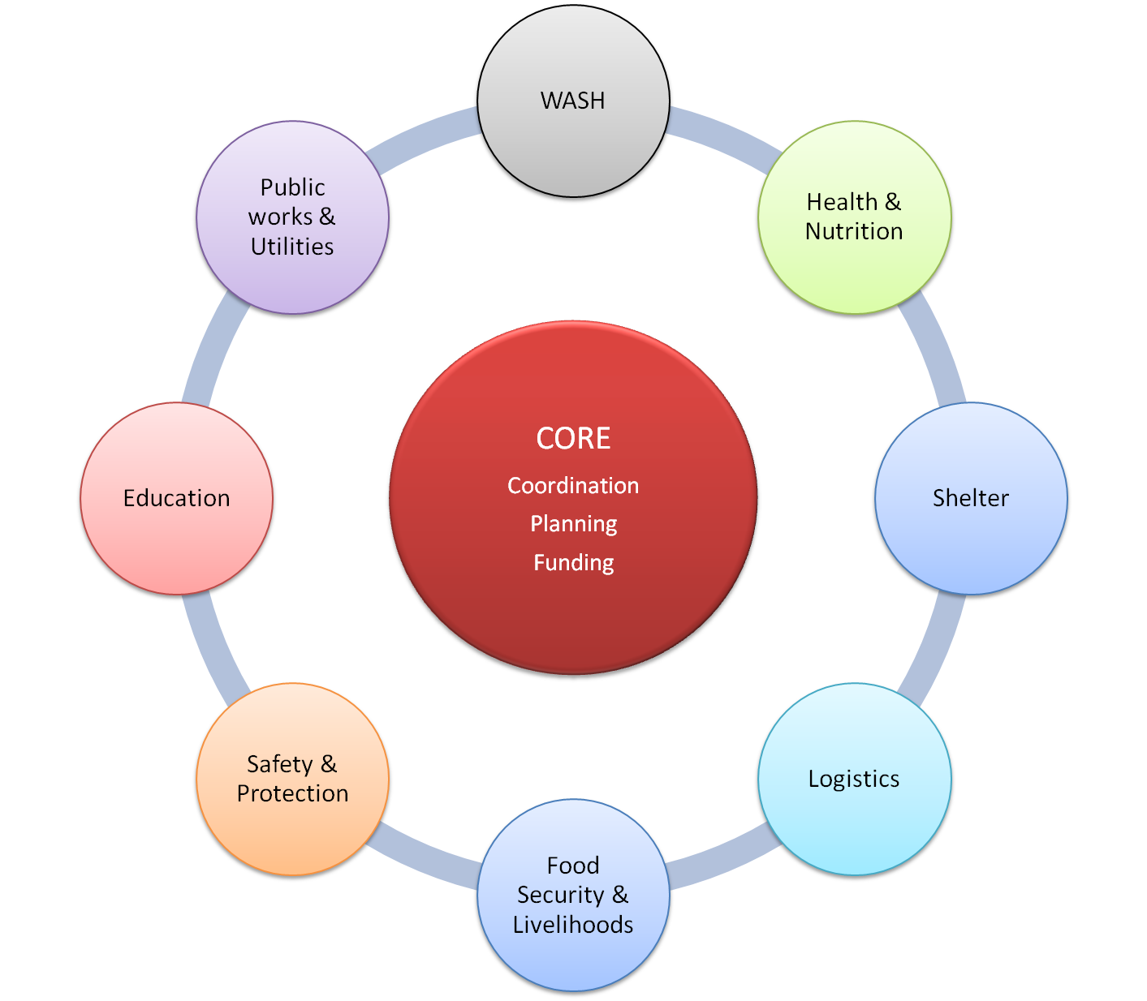
Figure 1: Fiji National Clusters

Background
The Fiji National Clusters were adopted in late December 2012 during the response to TC Evan. There are eight Clusters as follows: WASH (Water, Sanitation & Hygiene), Shelter, Education, Health & Nutrition, Logistics, Safety & Protection, Food Security & Livelihoods, Public Works & Utilities. The Fiji National Disaster Management Office (NDMO) sits at the “core” of the Cluster system as illustrated in Figure 1 to provide overall coordination and to facilitate central planning and funding issues.
The Cluster System is now operational at the National Level. Procedures to implement the System at Divisional and Provincial/District Levels are yet to be developed. However, Figure 2 provides some guidance. Each of the nominated Lead Agencies for the Clusters has a representative at Divisional Level (the Logistics Cluster appears to be the only exception). The proposal is that Lead Agency representatives will be appointed to the Divisional Emergency Operations Centre (DivEOC) team to represent each Cluster. Cluster Lead Agency representation at District/Provincial Level varies widely and Cluster Partnerships will be required at this Level.
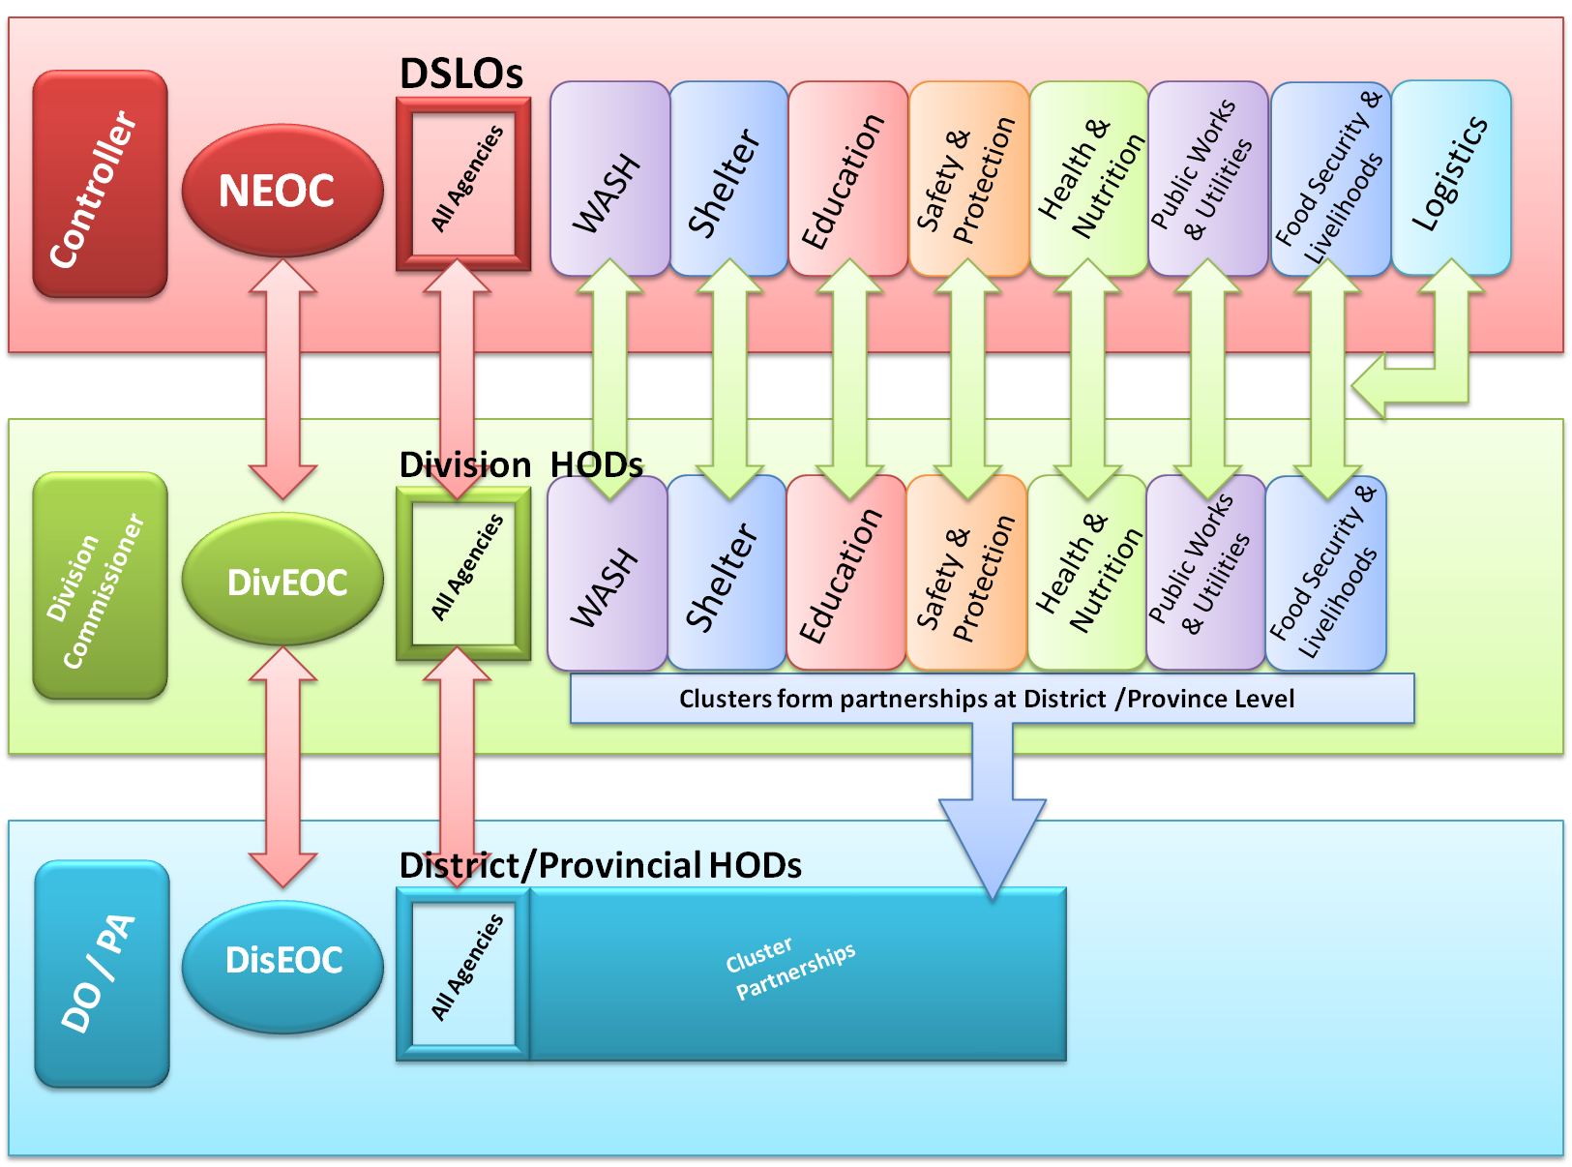
Figure 2: Clusters at Divisional and District Levels

A major advantage of this system will be the resulting multiple lines of communication between the three levels of Government (National, Divisional and District/Provincial) to facilitate improved implementation outcomes.
The Clusters are expected to operate continuously, with ongoing accountability not only for the response to emergencies but also (more importantly) for preparedness and early recovery.

Objective
The objective of the SC is to plan and implement proportionate, appropriate and timely shelter responses in humanitarian crisis situations which will address both the immediate and longer term shelter needs of the vulnerable affected populations while looking at the same time looking at the integration of disaster risk reduction activities. This will be achieved through providing predictable, systematic and country-driven services, and includes the need to:
- Facilitate effective sharing of information amongst agencies and organizations, including local organizations and local government partners involved in shelter response efforts, preparedness and recovery;
- Ensure adequate shelter contingency and preparedness planning and support Cluster members to provide timely response during emergencies;
- Ensure coordination of the emergency shelter programmes and activities amongst the partners engaged in emergency response including non members and local partners;
- Address disruption in the provision of existing government services during emergencies and liaise accordingly with government partners;
- Ensure early recovery planning as well as prevention and risk reduction concerns are addressed and incorporated where possible at all stages of emergency planning and response;
- Liaise and coordinate with other Clusters as required.

Role of the Lead and Co-Lead Agencies and Cluster Partners

Lead Agency
The Lead Agency for the National Shelter Cluster is the Ministry of Local Government, Urban Development, Housing & Environment.
As the Lead Agency the Ministry of Local Government, Urban Development, Housing & Environment is accountable for the performance of the National Shelter Cluster. The Ministry is to ensure that:
- Key Partners are included in the work of the Cluster
- There is appropriate coordination within the Cluster and with the other National Clusters and other national and international agencies
- Any cross-cutting issues are addressed
- There is effective needs assessment and analysis
- Adequate contingency and preparedness planning is carried out
- Appropriate standards are in place together with necessary arrangements for monitoring and reporting
- There is suitable advocacy for the objectives and activities of the Cluster
- Arrangements are in place for any necessary resource mobilisation, and
- Appropriate training and capacity building is carried out to ensure that Cluster activities are well-informed and relevant.

Co-Lead Agency
The Co-Lead Agency for the Shelter Cluster is the International Federation of the RedCross/Red Crescent Societies (IFRC).
The Co-Lead is to provide active support to the Ministry of Local Government, Urban Development, Housing & Environment ((MoLGUDH&E) in fulfilling its role for the Cluster as outlined in Section 4.1 above.

Key Partners
Agencies
Government Lead
Ministry of Local Government, Urban Development, Housing & Environment
Co-Lead
IFRC
Key Partners
Act for Peace (AFP)
Australian Agency for International Development (AusAID)
Community Support Network (CSN)
Fiji Institution of Engineers (FIE)
Fiji Red Cross Society (FRCS)
Good Neighbour International (GNI)
Habitat for Humanity Fiji (HFHF)
I Taukei Affairs
International Federation of Red Cross/Red Crescent Societies (IFRC)
Local Government Units (LGU)
Ministry of Education (MoE)
Ministry of Health (MoH)
Ministry of Labour (MoL)
Ministry of Local Government, Urban Development, Housing & Environment (MOLGUDH&E)
Ministry of Provincial Development and National Disaster Management– (Divisional Offices, NDMO, Rural Housing Unit)
New Zealand Agency for International Development (NZAID)
OCHA
People's Community Network (PCN)
Rotary Fiji, Rotary Lautoka
Salvation Army
Table 1: Lead, Co-Lead and Key Partners

Table 1: Lead, Co-Lead and Key Partners

Key Partners for the Cluster are expected to also support the Lead in facilitating the Cluster objectives and activities and to meet on a regular basis to share information, discuss issues and potential solutions and set priority activities of the Cluster. The Cluster may appoint a Strategic Advisory Group (SAG) composed of selected members to address core issues and make recommendations to the Cluster.
Technical Working Groups (TWiGs) may be appointed from amongst the Cluster membership to provide guidance on technical matters as required and then disbanded.
Currently identified Key Partners for the Cluster are listed in Table 1.

Activities
The National SC carries out the following activities in order to achieve its objectives. The Cluster:
- Formalises existing coordination mechanisms among humanitarian actors, and local and national authorities.
- Strengthens partnerships between UN Agencies, the Red Cross Movement, international organisations, national and international NGOs, donor partners and national authorities.
- Provides a platform for exchanging information and making decisions to improve strategic coordination and prioritisation.
- Collects, analyses and disseminates information within the Cluster, across other Clusters and to stakeholders.
- Provides operational advice, best practices and troubleshooting assistance to Cluster Key Partners and other stakeholders.
- Represents the Shelter Cluster in other Cluster meetings and high-level events and provides relevant input and support.
- Advocates for, identifies and mobilises resources (ie financial, HR, assets) for services provided by the Cluster or other Key Partners.
- Ensures adequate preparedness through capacity building and contingency planning.
- Defines priorities, work plan, specific terms of reference, duration and exit strategies.
- Monitors and evaluates its performance against the work plan / identified benchmarks.

Cluster Priority
Priorities for the Shelter Cluster fall into 5 identified categories:
- Assessment of emergency shelter needs
- Supply, distribution and restocking of emergency shelter NFIs
- Provision of assistance with repairs and replacement dwellings to both the formal and informal sectors
- Provision of ‘Build Back Safer’ training and messaging with all interventions
- Investigation of appropriate preparedness activities

Elaborate on the above priorities under the headings below if appropriate

Assessment of emergency shelter needs

Supply, distribution and restocking of emergency shelter NFIs

Provision of assistance with repairs and replacement dwellings

Provision of ‘Build Back Safer’ training and messaging

Investigation of appropriate preparedness activities

Key Documents
- Fiji TC Evan Shelter Cluster Strategic Operational Framework Technical Guidelines
- Fiji TC Evan Technical Standards and Guidance
- Fiji TC Evan Shelter Cluster Work Plan
- Fiji TC Evan Shelter Cluster Contact List
- Contingency Plan to be developed?
- SOPs to be developed?

