Shelter partners have requested that the HSWG undertake a gap analysis to identify remaining shelter needs for the Yolanda response, based on available data. The aim of this analysis is to support agencies to identify locations with remaining shelter gaps, and in the absence of reliable quantitative measures of remaining needs, to support the prioritisation of these areas. The following analysis provides a way to identify and prioritise these gaps, and is structured at the municipality level, covering municipalities within the government’s priority 50km corridor (171 municipalities). Municipalities in which reported damaged were less than 500 houses in total, have also been excluded from the analysis.
NOTE: HOW TO USE THIS DOCUMENT: In order to know the more precise locations (e.g. by Barangay) and number of households with shelter needs, agencies should contact the relevant municipal authorities – this document is solely to aid in the identification of which municipalities overall may have the most pressing shelter needs.
WHO STILL NEEDS SHELTER SUPPORT? There is currently no available, reliable data regarding the number of households currently requiring shelter support; whilst the Shelter Cluster/ HSWG has undertaken three shelter assessments to date, these have identified overall trends rather than municipal level gaps. In the absence of this information, we can attempt to calculate the ‘probable’ remaining needs, based on available data. For instance, if we knew how many WERE affected by Yolanda, and how many WERE able to recover by themselves or received assistance, then we would be able to infer the remaining caseload:
1. HOW MANY WERE AFFECTED BY YOLANDA?
2. HOW MANY HAVE RECOVERED ON THEIR OWN?
3. HOW MANY HAVE RECEIVED ASSISTANCE?
HOW MANY STILL NEED ASSISTANCE?

There are some data sets which can be used to try to calculate these numbers – however, each of these has its limitations in terms of reliability and validity - therefore it would be unrealistic to imagine that these calculations could lead to an ‘accurate’ number. Furthermore, this would not give any indication of which are the most vulnerable within these caseloads.
An alternative approach is to use existing data as a means of inferring which areas are likely to be the ones with the most urgent remaining needs, as a means of identifying priority locations where agencies could then follow up with municipal authorities in order to determine more precise shelter need caseloads. This approach relates strongly to the principles in the Shelter Cluster’s Shelter Prioritization tool and Beneficiary selection criteria : “In deciding on which municipalities to prioritize assistance, it is recommended to consider the level of damage to houses (total number and damage density), the level of poverty, the presence of other humanitarian organizations in order to avoid overlap and to meet gaps in assistance, and other relevant factors.”
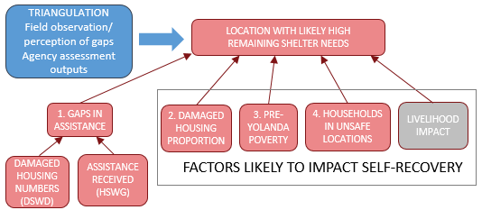
The diagram above shows the proposed framework for comparing relative shelter needs per municipality. This approach uses a number of data sources to act as proxy indicators of areas which had a high impact and limited assistance, and locations where self-recovery capacities may be more limited. By bringing together these factors, we can infer which areas are likely to have the highest remaining need for shelter assistance.
It has not been possible as yet to locate a suitable data set for livelihoods impact, therefore this is not included in this analysis – however, it has been left within this framework in order to acknowledge that this would be a valuable additional source of information, if a suitable data set can be identified.
This approach is not a quantitative measure of needs, but rather a prioritisation based on available information.

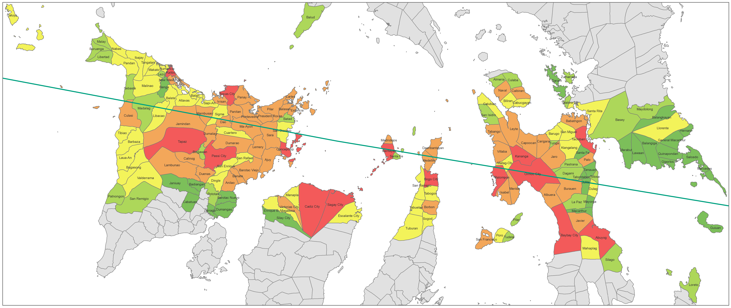
1. GAPS IN ASSISTANCE

Potential shelter gap (HH) | Score
>1000 | 0.00
1000 - 2499 | 0.25
2500 - 4999 | 0.50
5000 - 9999 | 0.75
10,000+ | 1.00

CALCULATION:
STEP 1: Damaged houses – HH receiving assistance. The number of households receiving ANY type of recovery shelter assistance (HSWG) subtracted from municipal damage data (preference given to data from mayors, or if unavailable then data from MSWD, and if that is not available then DROMIC).
STEP 2: Damage numbers classified into five levels and allocated a score between 0 and 1.

1a. Damaged Housing Numbers (data sources are listed in order of priority for use in the analysis. 1b. Assistance received
Data Source | Limitations/constraints |  | Source | Limitations/constraints
Municipal Mayors:  Damaged houses by municipality | Data collected by OCHA as part of a process to establish a repository of municipal data. Whilst these numbers come validated by the mayor’s office, only a limited number of municipalities are covered by this exercise (22 in Region VIII). It is not clear as to whether this represents the remaining damaged house caseload, or the caseload immediately after Yolanda. |  | Households receiving shelter assistance - HSWG database | Smaller agencies, church groups and civic society will not be taken into account, as these groups generally do not take part in humanitarian coordination processes. This data does not include all government assistance, as this has not been consistently reported to the HSWG. HSWG database records activities undertaken by partners (products distributed). It should not be assumed that the distribution of products results in households no longer having any further shelter needs.
Municipal Social Welfare Department | Provided by MSWD as validated damage numbers (often based on DAFAC registrations). |  | Households receiving shelter assistance - HSWG database
DROMIC damaged houses by municipality | Reported soon after Yolanda, before validation could be undertaken. Feedback from several municipalities have indicated that this is not the correct data for their municipality. |  | Households receiving shelter assistance - HSWG database
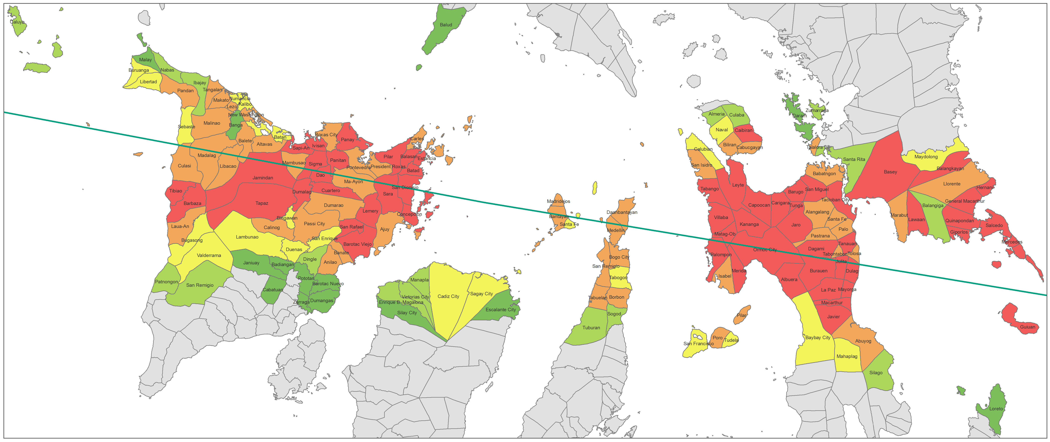
2. DAMAGED HOUSING PROPORTION

Damaged housing proportion | Score
0 – 0.2499 | 0.00
0.25 – 0.4999 | 0.25
0.5 – 0.7499 | 0.50
0.75 – 0.9999 | 0.75
1+ | 1.00

CALCULATION:
STEP 1: Damaged houses / Total number of houses. The number of damaged houses (partial and total) (preference given to data from mayors, or if unavailable then data from MSWD, and if that is not available then DROMIC) divided by the estimate of households based on 2013 projections of census data.
STEP 2: Damage proportions classified into five levels and allocated a score between 0 and 1.

There is no municipal dataset that can be claimed as measuring household self-recovery. However, it is possible that other datasets could be used as proxy indicators for the relative levels of self-recovery per municipality. Anecdotal accounts from some partner agencies have indicated that areas where a smaller proportion of houses were damaged, have been better able to recover more so than areas where a higher proportion of houses have been damaged.
2a. Damaged Housing Numbers 2b. Total number of houses
As per 1a | Data Source | Limitations/constraints
 | 2013 projection of 2010 Census data | This data is a projection of the last census data, based on provincial growth rates. The 2010 Census has the total individuals, therefore this projection is also for individuals. In order to infer the number of houses, the total was divided by the average family size (4.7). Whilst this is a very crude estimate, it still allows for a very rough relative indication of damaged housing proportions

NOTE: This is a very approximate calculation, due to the potential lack of correspondence between population estimates and damaged houses, therefore in some cases the proportion of damaged houses to families is greater than 1. For this reason, this has been treated as an indicator, rather than a precise measurement of damage density.
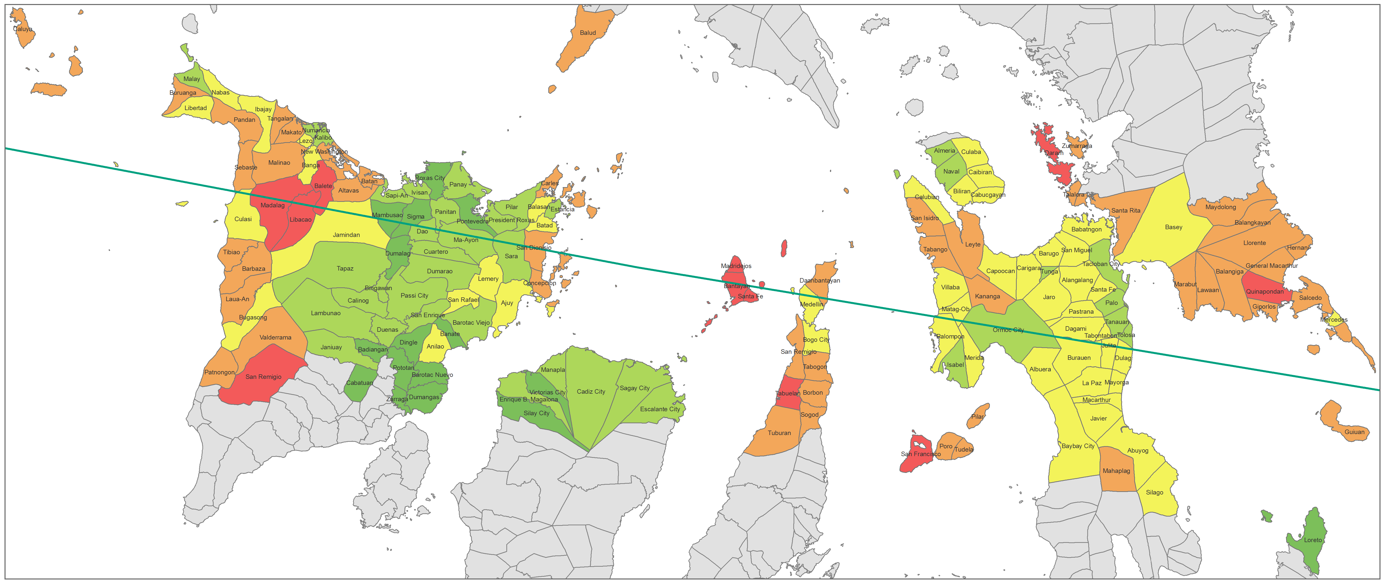
Poverty Rate (NSCB 2009) | Score
<20% | 0.00
20 – 29.99% | 0.25
30 – 30.99% | 0.50
40 – 49.99% | 0.75
>50% | 1.00

CALCULATION:
STEP 1: Poverty rate classified into five levels and allocated a score between 0 and 1.

3. PRE-YOLANDA POVERTY RATE

The overall poverty levels within a municipality may play a part in people’s self- recovery capacity. Whilst poverty levels will vary greatly from one household to the next within the municipality, it may still affect the overall ability of communities to recover.

3. Municipal poverty rates
Data Source | Limitations/constraints
National Statistics Coordination Board (NSCB) Estimated Poverty rate for 2009 | This is the latest available municipal poverty rate estimate, as the rates from 2012 have yet to be released. As such, this is a little out of date, and is only an estimate. A more accurate source of information could be the National Household Targeting Survey for Poverty Reduction (NHTSPR), who have lists of people under the poverty threshold as of August 2013. At the time of writing this document, this data source was available for only part of the affected area, therefore could not be used.

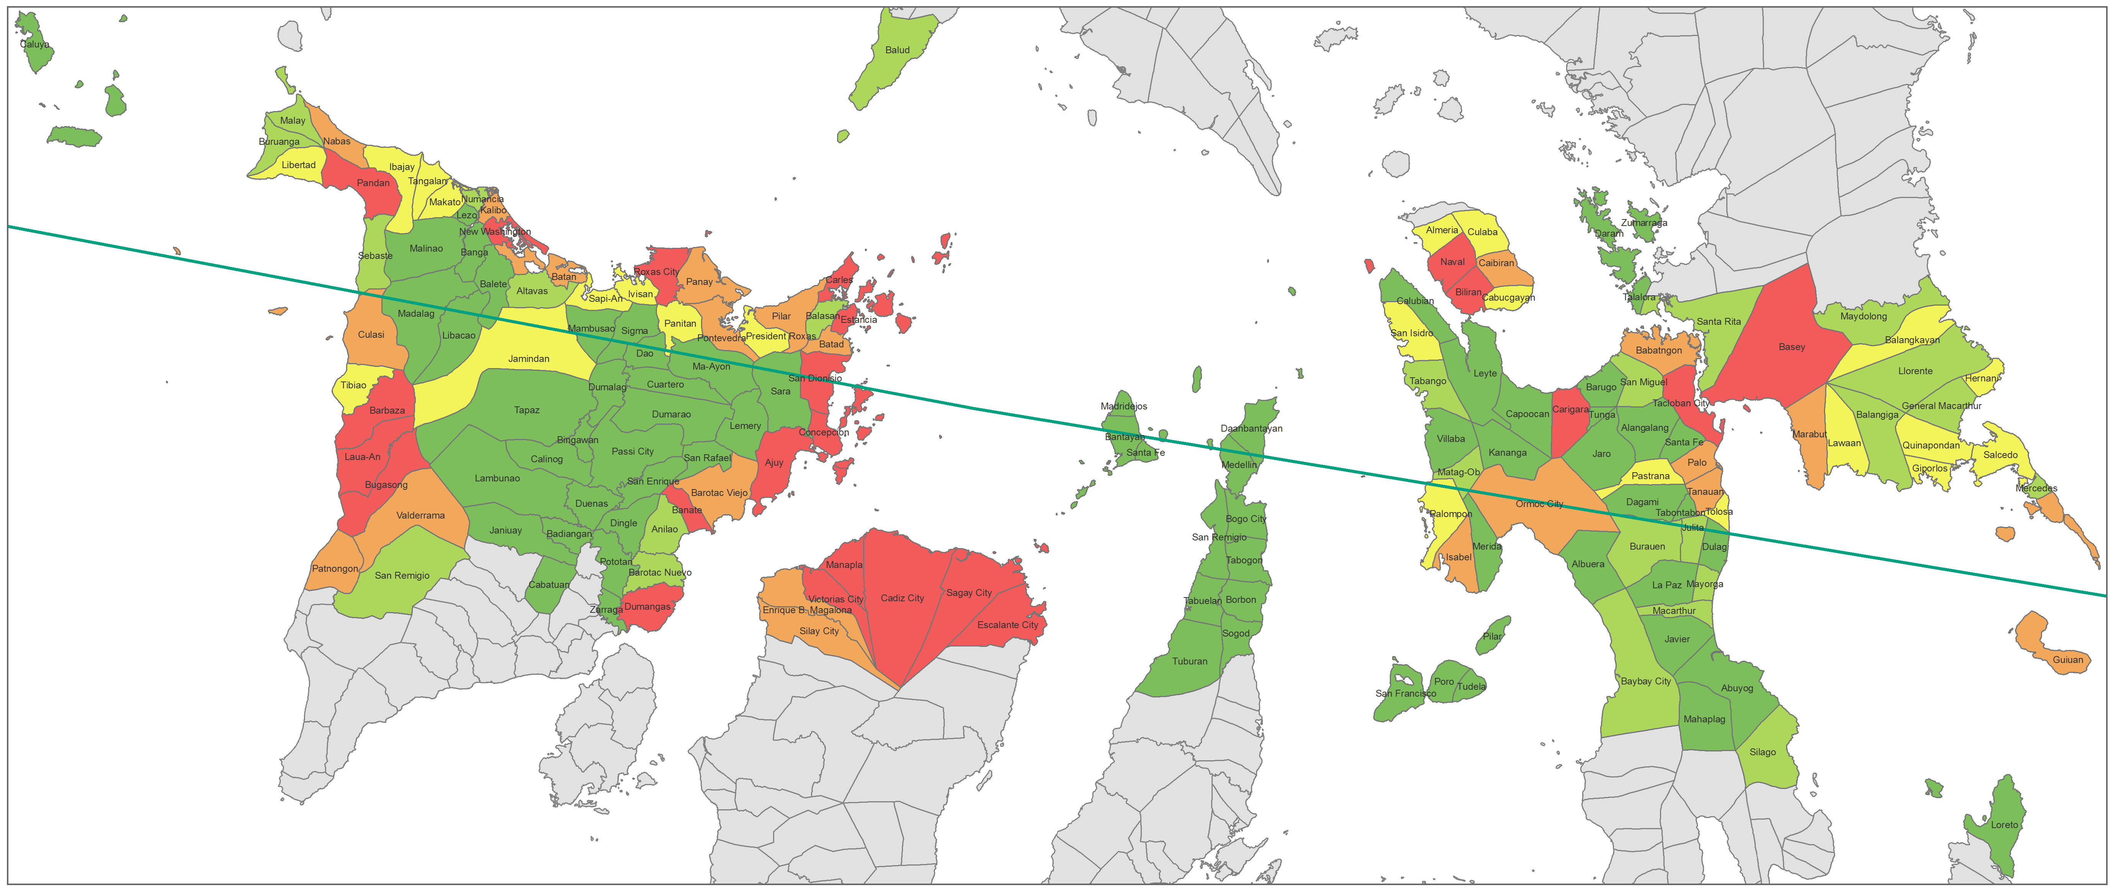
Number of HH in unsafe locations (CRRP) | Score
0 | 0.00
1 - 499 | 0.25
500 - 999 | 0.50
1001 - 1999 | 0.75
>2000 | 1.00

CALCULATION:
STEP 1: Number of households facing potential relocation has been classified into five levels and allocated a score between 0 and 1.

4. HOUSEHOLDS IN UNSAFE LOCATIONS

In the Government’s Comprehensive Reconstruction and Rehabilitation Plan for Yolanda, the Resettlement Cluster provides the numbers of families in unsafe locations, per municipality. These numbers are believed to have been identified based upon the arbitrary 40m no build zone. It is possible that some of these households will face relocation – however, it will be municipalities that will be the ones to decide if, how and when to relocate these people. Being located within an unsafe zone has in some cases been a barrier for receiving assistance, with some LGUs reluctant to allow in-situ support. This puts these people especially at risk, both in terms of not receiving assistance, and also facing further hazards in the short term, or relocation in the longer term.

4. Households in unsafe locations
Data Source | Limitations/constraints
Comprehensive Reconstruction and Rehabilitation Plan | It is not known exactly how these caseloads were identified; if solely based on 40m zone, this would not take into consideration other potential hazards than storm surge, such as landslides or environmental areas. Furthermore, it does not necessarily follow that these people will be relocated, or that they have not received in-situ assistance.

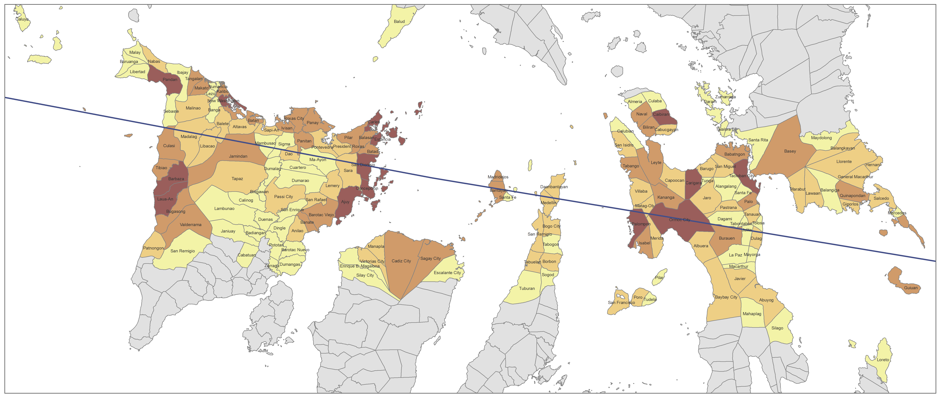
Composite score
0 – 0.4375
0.437501 – 0.5625
0.562501 – 0.6875
0.687501 - 1

CALCULATION:
(Gaps in assistance indicator + damaged housing proportion indicator + Poverty rate indicator + households in unsafe zones indicator)

4

5. LOCATION WITH POTENTIALLY HIGH REMAINING SHELTER NEEDS

Based on the previous data, it is possible to create a composite indicator incorporating the four factors for which data is currently available. This is demonstrated in the following map, which currently applies equal weighting to each of the four factors. The resulting score has been classified into four categories, according to four quantiles in the data.

NOTE: Whilst it was intended that this approach would be validated on the basis of feedback from partners in the field, providing input on observed gaps, it has not been possible to do this. Partners have indicated that as they are often working in only a limited number of Barangays, that they are unable to provide reliable feedback regarding shelter needs across the whole municipality. This reinforces the need for agencies to use this document only for guidance as to which municipal authorities to approach, in order to ascertain from them the gaps at a Barangay level.

The full breakdown of indicators and calculations can be found at the following location: https://www.sheltercluster.org/Asia/Philippines/Typhoon%20Haiyan%202013/Documents/141113%20Data%20for%20municipal%20shelter%20gap%20analysis.xlsx

