Cluster: |  |  | Shelter
Date of Meeting: |  |  | May 25th, 2015 |  |  | Time:
Meeting Facilitator: |  |  | Xavier Genot |  |  | Location: |  |  | Tanna, Lenekal PDC office
Minutes Prepared By: |  |  |  |  |  | Location: |  |  | NDMO

1. Meeting Objective
1. Introduction
2. Cluster objectives
3. IM update
3. Updates and discussion
4. Partners update and issues
5. AOB

Meeting attendance:
Tafea PDC, PWD, IFRC Shelter Cluster Coordination Team (SCT), WFP, Care, Samaritan’s Purse, Wash & Education clusters, Areas Council, Cultural centre

3. Agenda and Notes, Decisions, Issues
Topic |  |  |  |  |  |  | Note/Actions |  |  |  |  | Owner/Time
- Introduction  • Tanna Visit Sunday till Tuesday Xavier, Peter and Subesh. To held this meeting, visits some affected comunities and attend CARE Safe Shelter Awareness session  • Meet Director PWD to discuss on Shelter Cluster moving forward in Vanuatu.  • Upcoming Shelter Lessons Learnt Workshop Thursday 28th May. Note confirmed from 8:45 to 12:00 at PWD conference room  - Shelter and Settlement vulnerability assessments report finalised, thanks to all contributions from Shelter, Wash and Protection clusters |  |  |  |  |  |  | Note: Shelter LL workshop confirmed from 8:45 to 12:00 at PWD conference room  Note: Assessment report shared on Friday 22/05
- IM update for Tanna (20/05)
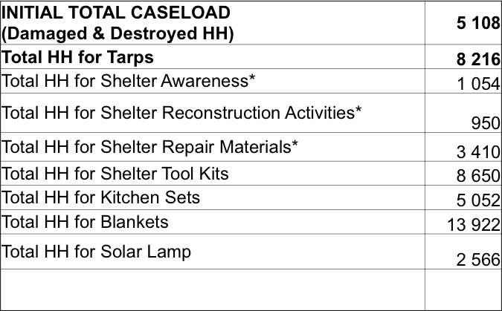

- This is the situation, as reported to the Shelter Cluster
- If some agencies implemented some related shelter activities, please provide SCT their contact, for SCT to reach them
- New matrix, mapping overlaping of shelter activities shows that in some area in Tanna, there is gaps as some HH did not received toolkits.

3. Updates and discussion  3.1 Shelter intervention survey  Survey with 21 questions to better map SC agencies recovery planning and activities. Individual inputs will remain confidential. Will be released in coming 10 days, for a one week possibilty to feed on for agencies. Will be relevant only if maximum of partners will response |  |  |  |  |  |  | Note: Survey published on May 29. Contributions till June 6
3.2 Recovery Framework  Governement presented recovery framework to donors on Friday 15/05. Still not clear on how clusters/HAP will feed on the recovery framework.  It will be part of the discussion of coming weeks. SC partners will be updated as it goes. |  |  |  |  |  |  | Note: To circulate presentation with minutes
Shelter Cluster has 3 objectives as defined in the HAP:

- CLUSTER OBJECTIVE 1: Provide emergency shelter and non-food items for people whose houses have been partially damaged or destroyed.
- CLUSTER OBJECTIVE 2: Assist affected people with repair and reconstruction of houses, water and sanitation facilities.
- CLUSTER OBJECTIVE 3: Investment in safer community buildings

3.4 VAT for shelter material  Information reported to log cluster that this deadline would be on June 12.  This is only concerning relief items within PAM response. |  |  |  |  |  |  | Note: Information confirmed on 22/05:  Confirmation from the Director NDMO that VAT exception  for all building materials will expire as from 12th/06/15. This means that anything ( building materials) that is purchase now until 12/06/15 can be excepted from VAT however, for any donated goods and as long as an approved letter is obtained from Director NDMO, the goods can be purchase with VAT excepted even after 12th/06/15.
3.5 Scoping for shelter lessons learnt workshop on Thursday 28/05  To respond to 3 key questions:  - What we have done  - What worked well  - What we need to improve  Outputs from the workshop will feed on 3 topics  1. Identify lessons learned from the shelter response to tropical cyclone PAM, in order to inform on-going shelter recovery strategy, but also preparedness and future disaster responses in Vanuatu.  2. Inform the NDMO-led TC Pam National Debriefing Workshop which will be held end of June.  3. Inform way forward for the Shelter Cluster in Vanuatu  Comments:  Lessons Learned outputs will be presented and discussed during next Tanna SC meeting in 3 weeks (tentatively on Monday June 15) |  |  |  |  |  |  | Note: The workshop is confirmed on Thursday 28/05, from 8:45 to 12:00 at PWD conference room
3.6 Vanuatu shelter cluster long term scenario
Meeting was organised last week between NDMO director, PWD director and Peter, Xavier and Subesh for IFRC.
Request from Vanuatu governement to IFRC came 3 weeks before PAM, to have a SC in Vanuatu. IFRC deployed coordination team from PAM response day one, with 3 successive coordinators and 2 Information Manager. Actual team (Xavier and Ryan) to be there till the end of the HAP, end of July.

- Partners updates and issues:  Samaritan’s Purse:  SP responded to some emergency shelter gaps, based on disability list sent by the Shelter Cluster.  SP will do further school projects with australian contractors.  SP has finished its shelter programme, they will therefore no distribute further materail as toolkit.  Comment: SC has mapped such type of gap to flag to other partners pottential areas for further activities.  CARE International  BBS safe shelter awareness in West tanna on Tuesday 26. PDC representatives welcomed to attend. SCT will attend the training.  Distribution of shelter material on going.  WFP:  Will distribute food following Gov plan.  Maybe food distribution baseline could be used to update initial affected population caseload baseline, as it seems to be the most accurate one.  Comment: SCT to discuss it during Wedn 27 intercluster meeting in Port Vila  General discussion:  There is a risk to loose traditional way to build shelter, due to knowledge transmission vs new material inclusion in construction technics. Shelter was almost free before, which is changing as people more and more imported material as CGI.  People used to use local material for construction as for natural rope. It is worth to include traditional knowledge within BBS approach for PAM response.  For roofing, due to PAM, there is lack of natural material for roofing, as almost all coconut leafs have gone. Might be good to include Nataronga plantation to increase use of it in Tanna. |  |  |  |  |  |  | Note: Issue on baseline discussed during the inter cluster meeting. Food cluster to look at possibilities.  Note to include discussion about seeds of Nataronga through Food Security and Agriculture cluster.  Done during Inter cluster meeting.
5.AOB
none

4. Action Items
Action |  |  |  |  |  |  |  | Owner |  |  | Due Date
- Next Shelter Cluster meeting in Tanna |  |  |  |  |  |  |  | Tentative date |  |  | Monday 15/06
- Idea to use Food distribution HH baseline to update original under estimated caseload |  |  |  |  |  |  |  | Discussed at inter cluster meeting |  |  | Wend 27/05
- Idea about Natangora seeds for Tanna in recovery to PAM to FSAC cluster |  |  |  |  |  |  |  | Discussed at inter cluster meeting |  |  | Wend 27/05
- Shelter Intentions survey to be finalised and circulated |  |  |  |  |  |  |  | Done |  |  | Friday 29/05
- BBS Training TWiG |  |  |  |  |  |  |  | Confirmed |  |  | Tuesday 02/06, AT PWD, 2PM
- Shelter Lessons Learned workshop |  |  |  |  |  |  |  | Confirmed |  |  | Thursday 28/05 at PWD, 8:45 to 12:00
5. Next Meeting (if applicable)
Date: |  |  |  |  |  |  |  | Mondy 15 June |  |  | Time:
Objective: Tanna coordination

