Cluster: |  |  | Shelter
Date of Meeting: |  |  | June 4th, 2015 |  |  | Time:
Meeting Facilitator: |  |  | Xavier Genot |  |  | Location: |  |  | PWD
Minutes Prepared By: |  |  |  |  |  | Location:

1. Meeting Objective
1. Introduction
2. IM update
3. Updates and discussion
  - Shelter Lessons Learned workshop key outputs
  - Building Back Safer Technical Working Group (TWiG) key outputs
  - Shelter cluster, preparedness and recovery timeframes
  - Communication With Communities (CWC)
  - Cash/vouchers programming?
  - VAT for shelter material
  - 2,000 tarps process
4. Partners update and issues
5. AOB

Meeting attendance:
Siobhan Talty CARE,
Augustine Garae VANUATU RED CROSS,
Damian Farrel DISABILITY DESK,
Jean D’Aragon UN HABITAT,
Alberto Preato IOM,
Adam Kalopsidiotis SAVE THE CHILDREN,
Divya Sama NDMO CWC
Robert David, VCC
Astrid Vachette, JW
Dick Abel, PWD
Xavier Génot, SCT – IFRC
Jean D’Aragon, UNHabitat
Bernhard Barth, UNHabitat
Matthias Leben, LDS Church
Yavannah Tagay, CARITAS
Dave Colbert, BUTTERFLY TRUST
Julien Lamberti, FRC
Geoffrey Payne, World Bank
Rumana Rhuque, World Bank
Rochelle Berry, IFRC

3. Agenda and Notes, Decisions, Issues
Topic |  |  |  |  |  |  | Note/Actions
- Introduction  Shelter Intervention survey deadline on Friday 5/06.  Meeting at PWD as for all coming Shelter Cluster events |  |  |  |  |  |  | Note: Due to two partners request after the meeting, the deadline postpone on Tuesday 9/06 evening
- IM update
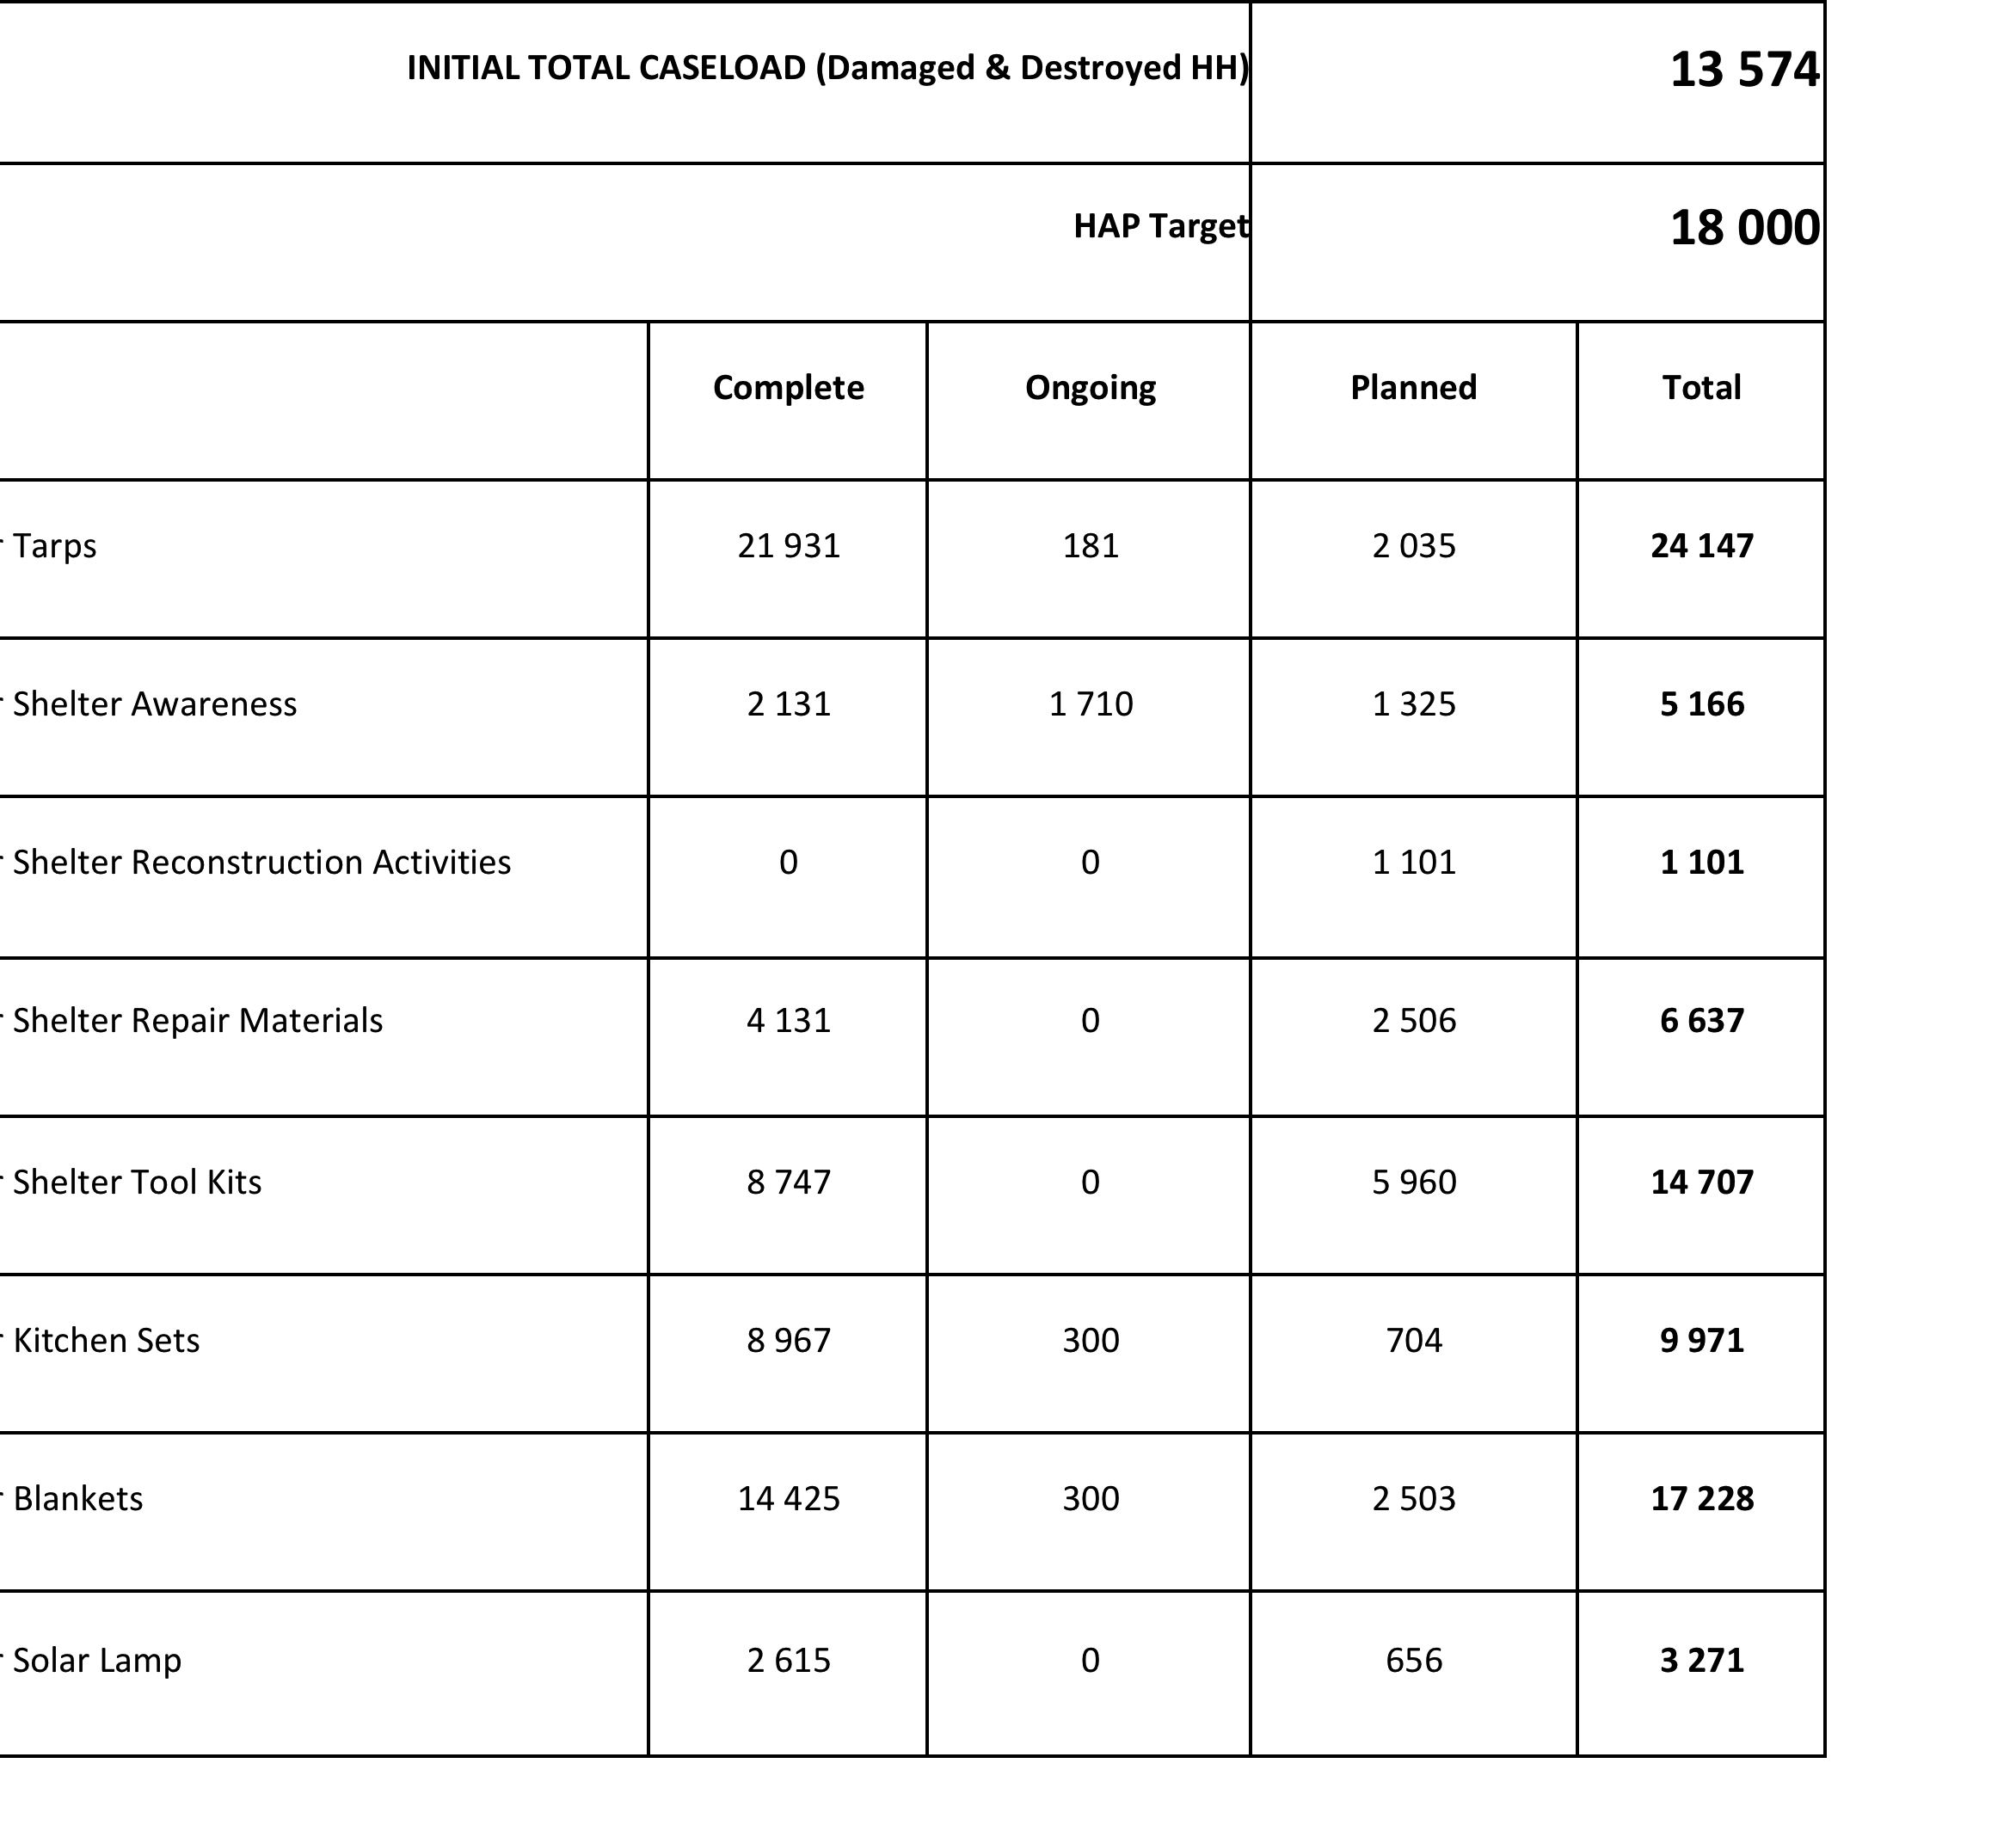
- Updates and discussion

3.1 Shelter Lessons Learned workshop key outputs

Report will be circulated soon in draft for partners to comments. Will be discussed with cluster lead and co lead to see on how to address some of the recommendation. Here are just presented what worked and what could be improved:

- What worked well?

- Relatively quick establishment of the shelter cluster, starting from scratch, and placing it clearly in the NDMO cluster system.
- Whilst the establishment of an official shelter cluster was new to Vanuatu, its operation was assisted greatly (albeit indirectly) at Provincial and community level through well organised and managed PDC’s and CDC’s. In addition, communities themselves commenced reconstruction of emergency shelter / housing immediately. This is a key strength of the Vanuatu humanitarian response mechanism and needs to be leveraged off by the shelter cluster to ensure efficient use of resources and avoid duplication. However, it was also noticed that CDC’s were not present in every community prior to TC Pam and further work is required to identify gaps and ensure trained CDC’s are in place.
- Clear and early division of geographical working areas to Agencies (notwithstanding some gaps in PV) and also evacuation centres provided clarity and supported planning at Agency level.
- Good co-operation, openness, sharing of resources and flexibility between different partners such as donors, govt., NGO’s amongst cluster partners who were “solution orientated”. This was evidenced by the generally successful distributions of emergency shelter and NFIs, and also following the “protest” at NDMO.
- IM – mapping and 3W’s enabled identification of duplications and gaps, resulting in positive collective action taken by cluster partners to resolve issues. Information is consistently updated and shared. (Note there were some concerns raised about the accuracy of the maps, leading to people being sent to the wrong NGO).
- Consistency of shelter cluster meetings (time and location), and low “churn” of shelter cluster personnel. (E.g. Tom and Ryan in place for a good length of time).
- Good link between shelter cluster and camp management working group who worked together (and with other clusters) to facilitate the prompt, proper and orderly closure of evacuation centres.
- Basic shelter trainings at community level in safe shelter awareness (although this has not been implemented widely as yet).
- Establishment of a regional shelter cluster in Tanna.

What Could be Improved?

Data management both at cluster level and national level. This was exemplified by the out of date census information that misinformed the initial assessments.

Moving forward, it was also felt that the cluster demand for Agency information (3W’s) was onerous, particularly early in the response.

Allied to this, there were too many expensive and unnecessary assessments, when the data was largely available from PDC / CDC.

Delays and expense of importing and distributing materials

Too many coordination meetings held early on (3 per week) with unclear objectives.

Evacuation centre preparedness in terms of identification of centres, physical standards, EC management training.
Overall, there is a need for a functioning CCCM cluster.

Increased need for ongoing training and raising awareness with respect to principles of building codes integrated with traditional construction methods, and reinvigoration of local materials.
This should be tied to Pacific partnerships to learn from what is / has happened in other countries.

Shelter early recovery needs to be included in the cluster discussions much sooner in the response.

Gender sensitivity of the shelter cluster.

General concensus on aknowledgement of these key outputs, nothing really missing from partners who attended (or not) the workshop

3.2. Building Back Safer Technical Working Group (TWiG) key outputs

AP1: Develop Common cluster baseline
AP2: Explore on skilling up PWD trainers pool
AP3: Explore funding scheme at RTC level
AP4: Map and invite vocational training institution for Next TWiG
AP6: Inputs on traditional construction technics
AP7: TWiG to be convened on Tuesday 2PM, all 3 weeks
AP8: Send pictures of partners of activities to document Shelter cluster PAM response

  - Shelter cluster, preparedness and recovery timeframes

HAP, till 31/07 – PWD Shelter Cluster Lead, IFRC co Lead
Cyclone season start in November. El Nino might also impact Vanuatu.

DRAFT Recovery framework:1 of priorities for reconstruction and reconstruction activity is: Rebuild/repair/upgrade private housing and infrastructure.
Who will take the lead?
Ministry of Internal Affairs
Ministry of Lands and Natural Resources
Who will support?
Prime Minister’s Office
Ministry of Finance and Economic Management
Ministry of Infrastructure and Public Utilities
Provincial Government Councils
Municipal Government Councils
Malvatumauri
Island Council of Chiefs

Strategic Advisory Group to be convened in second half of June (TBC) to address governance of the Shelter Cluster, cluster strategy concerning recovery and preparedness frameworks

UN Habitat: happy to engage to help on SAG. A lot is happening, need to include sustainable issues around housing. Need to look not only on response.

IFRC SCT: Agree to ensure that humanitarian shelter will liaise with housing, but Shelter Cluster need to ensure that emergency shelter and preparedness would be core of SAG discussion. Need to ensure that the SAG will refine shelter cluster recovery strategy, in order to feed Recovery strategy. SAG to ensure liaising shelter cluster with housing sector.

PWD: Every year has to deploy emergency response team, every year there is a risk of a new cyclone. PWD need up and running shelter cluster for next cyclone season which start in November and even sooner due to El Nino impact. Need to map and fix evacuation centers.

UN Habitat: PWD is well placed to develop strategy regarding evacuation centers

IFRC SCT: There is a risk of duplication for coordination, as EC are part of a lot of parallel discussions. TORs would be important to clarify coordination framework

IOM: We need to ensure that there will be good coordination on (permanent) housing sector, as a lot of parallel discussions are already on going

  - Communication With Communities (CWC)

NDMO has deployed a CWC specialist. Will work with all clusters and comunities to define minimum criteria on messages. Need to look at transparency and feedback loops, to mainstream assessment based on joined messaging, not to duplicate messaging. CWC need to look on affected population, not only on partners beneficiaries

BUTTERFLY TRUST (BT):
People don’t know what is or not happening. Need to know what is their future, what next, what after tarps.

CWC: will work on proactive and reactive messaging.

PWD: people need to know in the islands, what Governement is doing, when next is coming. Need to take care of expectations.

BT: Maybe the idea to have a weekly NDMO update with all clusters key messages
  - Cash/vouchers programming?

IFRC deployed a specialist to do a feasibility study on cash/vouchers programming, to support VRC operation

Based on discussion during the meeting, it seems that voucher might be preferable, especially in Port Vila and rural area. Cash seems not to be the preferred option but would need further investigation to see if usual risk associated with unconditional cash could not be overcome.

  - VAT for shelter material

The 12th June deadline will not concern relief and donations. It is recommended for shelter agencies to liaise with NDMO for importation of shelter related material.

  - 2,000 tarps process

The 2,000 tarps donated by Australian Red Cross have arrived in country, and agencies have started to pick up their earmarked stocks, as discussed during last meeting.

Distribution of these tarps would need to be reported through the shelter cluster 3W.
- Partners updates and issues:

WORLD BANK: Has deployed a team to look at National Housing Policy which is looking at long term issues. How to include guidance for building back better, for more resilient and affordable housing access.

BT: there is anecdotal evidence that tarps are or will be thorn out, bringing vulnerability to households. It has health incidence. What do we do about this?

This is a really important issue, which will need to be included in shelter cluster recovery strategy, what would be the best way to support shelter recovery from people, as emergency response is fading out and recovery framework is not finalised yet, and that resources and planning for shelter recovery still need to be mapped. The issue is even more important for urban and peri urban area, where self recovery might be less dynamic than in islands as for Tanna. We need also to take care not to harm resilience of people, and also to analyse which resources were used by people to recover. Some options might be explored, as for cash/vouchers programming.

We need to monitor the situation and gather evidences on these situation to feed the strategic discussion. Nevertheless in the meantime if some case require immediate action as for the anecdotal evidence reported here, better to provide a new tarp that nothing.

5.AOB
Lessons Learned in Protection (WASH, Shelter, Food Security, Cash for Work Activities) Session, which will form part of the Cyclone Pam: Women in Emergency Response and Recovery Forum. The Session will be held on Wednesday June 10 from 9am to 10.30am at the Vanuatu Institute of Technology, Port Vila and will be followed by a morning tea.

The overall purpose of the Forum is:
- For reflection on the strength and contribution of women, young women and women with disabilities in the response to Cyclone Pam;
- Develop recommendations on priority areas to better support women, young women and women with disabilities; and
- Provide input to the NDMO Lessons Learned Workshop in late June.

4. Action Items
Action |  |  |  |  |  |  |  | Owner |  | Due Date

5. Next Meeting (if applicable)
Date: |  | Thursday 11 June |  | Time: | 3PM |  | Location: | PWD
Objective: | Shelter Cluster meeting

