Cluster: |  |  | Shelter
Date of Meeting: |  |  | 26 June 2015 |  |  | Time: |  |  | 1500
Meeting Facilitator: |  |  | Dick Able, Jeffrey Kaitip, Xavier Genot |  |  | Location: |  |  | PWD
Minutes Prepared By: |  |  | Ryan Smith |  |  | Location: |  |  | PWD

1. Meeting Objective
- Attendance
  - SCT & PWD
  - DLA
  - NDMO
  - Salvation Army
  - Unitec NZ team
  - IOM
  - Butterfly Trust
  - Save the Children
  - Liberty of the Nations
  - UNHABITAT
  - IFRC

Agenda

1. Introduction
2. IM Update
3. Updates and discussion
- Shelter Governance & Strategic Advisory Group, objectives and membership
- Building Code current status, application and way forward
- Feedback on Building Back Safer TWiG
- Feedback from NDMO Lessons Learned Workshop
4. Partners update and issues
Salvation Army & Liberty for the Nations project
5. AOB

3. Agenda and Notes, Decisions, Issues
Topic |  |  |  |  |  |  |  | Owner |  |  | Time
IM
- Response & Early Recovery progress, outlook
- Need for 3Ws to include HH reached and to keep updating status changes
- 3Ws due next Monday 29 June
Shelter Governance & SAG
- Governance – Who is lead, how we liaise with into recovery framework, and governance to over preparedness and potential future response
- Dick explains SC governance – Shelter Cluster setup call to IFRC only just 3 weeks before Pam, PWD was been asked to take lead. Going into this next phase, we would want DLA and PWD to take lead, pending proposal and approval.
- Jeff – Note that they are NSTP proposal being drafted, plan for Vanuatu development over next 15 years. Recognize importance of shelter cluster role in this long term development. SC partners are putting in a lot of inputs to this response/recovery, and through sector analysists this will get report up to PMO.
- DLA/PWD and the SCT will form a SAG which will include relevant stakeholders, be transparent, and representative of different categories of stakeholders. Maximum will be 15 people
What is the SAG (from Global Shelter Cluster guidance)
- The coordination function seeks to engage many Cluster participants, representing various stakeholder groups, in decision-making through consensus management.
- The process confers legitimacy only through maximising participation and inclusivity.
- This small representative group of no more than fifteen people can be facilitated by the Cluster Coordinator or a representative from a cluster partner agency. Those representing larger NGO constituencies can rotate but this is up to the various NGO to decide.
- Meetings should be held according to ‘Chatham House Rules’ i.e comments are incorporated but are not attributable to any particular organization

- Composition all inclusive, and limited to about 15 members.
Input:
  - Military? – under DLA
  - PMO? – under PWD & DLA as representative
  - Disability? – Can cycle in with woman representative, and woman representative could have disability scope
  - Will every stakeholder still be here? – Besides one or two, probably yes
  - Important to know that TWiGs can be given task to come back with recommendations and guidelines
  - Need to balance number of stakeholders in the room to have constructive discussion and reach concensus, but must represent the right number of stakeholders to have good governance related to Vanuatu context

Foressen and agreed SAG membership
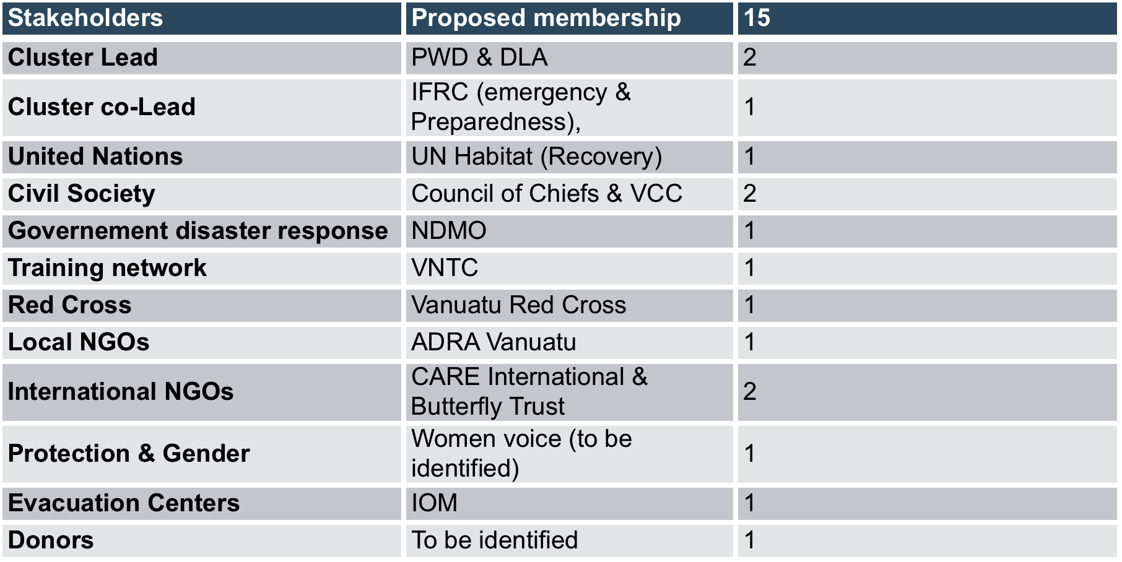

The first SAG meeting will be on Wednesday 8/07 at 2PM at PWD. Members will receive invitations as it is a closed meeting. Identified stakeholders could save the date in their agenda.

Building Code
- Published in 1990, building act came out 2013
- Available for sale at DLA
- NDMO – There have been some issues with building codes, like where and how applied.
- Go to government cashier at Ministry of Lands, Ministry of Internal Affairs, and office by Correctional Offices….all Ministry of Internal Affairs needs is receipt of payment
- Address and process will to obtain will be circulated
  - University – There have been long-standing issues with building to code in Vanuatu, in private, government and community buildings.
  - UNHabitat - We have to be sure we are not try to oppose, or defend, the building code but the purpose is to show what is existing.The problem with pushing or imposing the building code is that you marginilize vulnerable or informal settlements
  - University – Maybe we can put some recommendations through concerning specifically seismic load & wind speed.
- We have to focus on the objective of introducing the code, and the part it can play in the next phases. Recommendation that if there are technical issues with the Code, that a separate meeting being held to discuss and push forward that agenda
- ?? – It’s important that people understand how to understand and use the building code
Feedback BBS TWiG
- Had teaching representatives, vocational trainers, qualification and certification representatives, and local education reps present
- TVET/APTC are looking to do similar training, both accreditated and non-accreditated.
- One of the standards of competency for training includes building small structure, which could be community or tourism related
- INGO construction projects coul dbe opportunity for students to get good experience
- Need to understand locations of training, level of training, scope, etc.
- We know building code doesn’t apply to rural areas, but it was discussed that at least the principals of this construction can be conveyed
- Next TWiG will help to add to SAG, give standards for training, and standards for next response
- Input – Can we have skype-in sessions to follow TWiG?
- University – Can we adapt approach to retrofit and support natural building and recovery that’s already going on?
- Xavier – Our duty of care is to help cover most vulnerable in all affected areas, in many ways
- Our training must include the modern approach and the traditional building.
Feedback LL
- Many agency, cluster, government, private sector, donors, etc. attended
- Results will come out soon summarizing lessons learned
Salvation Army Presentation
- Salvation Army & Liberty for the Nations presentation on their Cyclone Pam response
- Have long term Vanuatu presence and have built building that withstood Pam, used as informal evac centers.
- Emphasis on reinforcing current building techniques to support with strong fixings, bracing, etc.
- Have guide to demonstrate building their structures, including building back safer illustrated guide
- What is criteria to choose beneficiaries?
- We may be able to blanket coverage our area, and if not, then most vulnerable
- Every part of this home you can buy in Port Vila.
- Incorporates some local material to the structure
- DLA – Do Tafea Provincial Council know about activities?
- Liberty for the Nations – yes, we think so
- Should go register with Tafea province representatives
- UNHABITAT – May not be appropiate for outer islands, may not be able to reproduce because of cost in places that don’t have cash economy and have less access
- University – Have to be aware of SPHERE standards and look at how it may be adapted in the future
- Xavier - Does any shelter awareness go with this?
- LFTN – yes, as much as we can.
- How will this structure be used?
- LFTN – It will be for sleeping
- Univeristy – site selection will be important
- University – How much input, and buy in, is coming from the community?
- LFTN – We are full staffed of Ni-Vans
Partner Updates
- None

4. Action Items
Action |  |  |  |  |  |  |  | Owner |  |  | Due Date
Procedure to obtain Building code to be sent |  |  |  |  |  |  |  | sct |  |  | done
SAG invitations |  |  |  |  |  |  |  | PWD - sct

5. Next Meeting (if applicable)
Date: |  | 2 July 2015 |  | Time: | 1500 |  | Location: |  |  | PWD
Objective:

