SHELTER TYPOLOGIES - Somalia

Location | Doolow / Gedo | Rural/Urban setting | Urban setting
Type of shelter | ISSB | Material source | Imported, locally procured
GPS Longitude | 4 9’ 49” | Main structural materials | Soil /Earth blocks
GPS Latitude | 42 5’26” | Main cladding materials | Soil & Cement
Year of construction | 2014 | Hazard resistance (earthquake) | N/A- Not resistant to EQ
Anticipated lifespan | 10- 15 years | Hazard resistance (wind) | Resistant
Climate type | Hot Environment | Hazard resistance (floods) | Not flood resistance
Disaster | Conflict | Hazard resistance (fire) | Resistant
Time to build (man-days) | 5 Persons - 4 Days | Pictures uploaded | Yes
Number of rooms | 1 room | BOQ uploaded | Not yet
Labor method | Owner-driven | Drawings uploaded | Not yet
 |  | Satellite pictures uploaded | Not yet
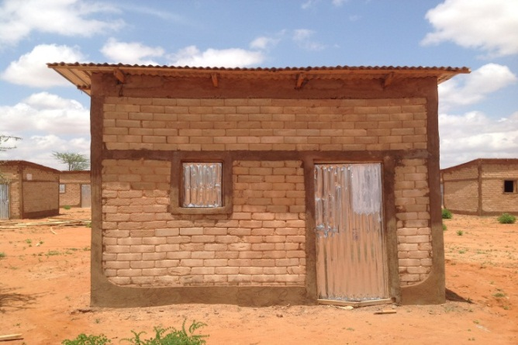
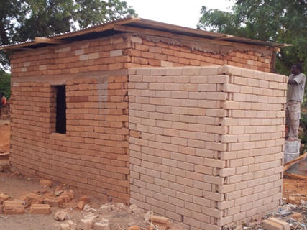
Pictures of prototype

Size of built area (m2) per unit | 16 Sq. | Can the units be accessed by persons with disabilities without help from others? (universal design) Y/N | No
Cost per unit (approximately in US $) | 1,000 USD | Do the construction principles, tools and materials need specialist support during construction? | No
Cost of building material per unit (approximately in US $) | 900 USD (Including transport and security of the material site) | Does the maintenance can be done by beneficiaries themselves? (Knowledge, tools, affordable materials…) | Yes
Cost of labor per unit (approximately in US $) | 100 USD | Are the shelters natural disasters resistant? Y/N | No

Shelter description
Shelter description | ISSB shelter (4x4m) with 2 windows and 3m Ceiling height
Durability and lifespan | 10 - 15 Years
Live-ability/Comfort/Notes on possible upgrades | - Comfortable, safe and provide good privacy  - Upgradable and easy to construct  - Suitable for the hot climate  - It has 2 windows for better ventilation  - 1 Shared latrine for every 2 HHs
Ecology | Environmentally friendly (Since ISSB is not fired; no trees chopped down to fuel bricks. Forests are preserved and therefor CO2 emissions are drastically reduced.
Protection issues | - Very safe  - Lockable (door and windows)  - Ensuring physical layout of the blocks including placement of latrines and other communal facilities i.e. shelter is done with the involvement of the community and minimizes the risk of GBV.  - Selection of 40 fire marshals and conducting fire prevention and response training  - Procurement of fire equipment

Extra Documents

SWOT analysis (Strengths, Weaknesses, Opportunities, Treats)

Strengths | Weaknesses | Opportunities | Threats
 | Scalability

Pros and cons

Benefits | Limitations
Cost-effective  Materials locally available  Training of local laborers on making of blocks  Easy to upgrade  Has tie-beam | Design needs to change – overhang of roof too long (not wind-resistant), yet roof should be wide to protect the walls  Not flood resistant  Skills are necessary for IS – needs a lot of follow-up  Soil/cement ratio must be closely monitored  Latrines should be detached  Fixed cost = $1000  Too permanent – should not be used in refugee contexts  Scalability?

