Location | Puntland | Rural/Urban setting | Urban setting
Type of shelter | Transitional shelter | Material source | Imported, locally procured
GPS Longitude | 49°12'39.26"E | Main structural materials | Timber 2”x2”, 9mm Plywood and iron sheets
GPS Latitude | 11°16'14.58"N | Main cladding materials | 9mm thick Plywood, iron sheets
Year of construction | 2015 | Hazard resistance (earthquake) | N/A
Anticipated lifespan | 4-5 years | Hazard resistance (wind) | Resistant
Climate type | Hot weather | Hazard resistance (floods) | Good resistant
Disaster |  | Hazard resistance (fire) | Resistant partially
Time to build (man-days) | 3 days, max | Pictures uploaded | Not yet
Number of rooms | 1 room | BOQ uploaded | Not yet
Labor method | Owner-driven approach | Drawings uploaded | Not yet
 |  | Satellite pictures uploaded | Not yet
SHELTER TYPOLOGIES - Somalia

Pictures of prototype
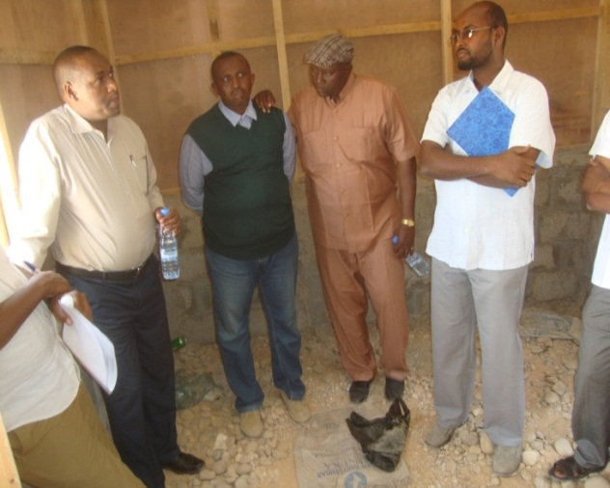
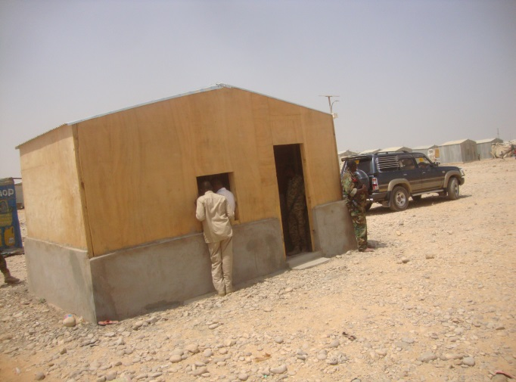

Size of built area (m2) per unit | 16.15 sq. | Can the units be accessed by persons with disabilities without help from others? (universal design) Y/N | Yes
Cost per unit (approximately in US $) | 850-950 USD | Do the construction principles, tools and materials need specialist support during construction? | No
Cost of building material per unit (approximately in US $) | 700/800 USD | Does the maintenance can be done by beneficiaries themselves? (Knowledge, tools, affordable materials…) | Yes
Cost of labor per unit (approximately in US $) | 150 USD | Are the shelters natural disasters resistant? Y/N | Depends the nature of the disaster
Are the beneficiaries satisfied with their opportunity to contribute to the design/planning of the project? | Yes

Shelter description
Shelter description | Transitional New hybrid shelter, with a strong solid foundation and an upper structure of plywood (see below)
Durability and lifespan | - The foundation (1m high) is well plastered and strong to stay long  - Upper wall is 9mm thick plywood which is temporary but can stay some years and easily upgradable  - One weakness can be resistance of the plywood against rain, but Puntland gains less rain once a year, and especially once in 2-3 years Bossaso.  - As a contribution and to enhance the ownership aspect, beneficiaries can upgrade by using oil paint/water proof to increase the lifespan
Live-ability/Comfort | - Cooler comp  - 16.15 sq. shelter space with 70 sq. plot  - 2 opposite windows for cross ventilation  - Culturally acceptable
Notes on possible upgrades | - Flooring  - Painting  - Wall can be transformed into block wall  - Extension can be added  - Availability of materials for upgrading in the local market
Ecology | - All materials except sand is imported thus no effects on the environment.  - Has iron sheeting roof preventing rain  - Block/plywood wall preventing heat
Protection issues | - 7 years land tenure agreement  - Good quality of Structural materials preventing theft  - Has Lockable doors

Extra Documents

SWOT analysis (Strengths, Weaknesses, Opportunities, Treats)

Strengths | Weaknesses | Opportunities | Threats
New type  Quick construction | Material imported  Too permanent to be T-shelter and too temporary to be permanent | Funding | Insecurity  Lack funding

Pros and cons of the shelter

Benefits | Limitations
Rectangular – can be divided  Concrete base to prevent fire  Good typology for the hot environment  Windows for ventilation  Quick construction  Flood resistant  Good foundation  Site planning exists | Too permanent to be transitional shelter, too temporary to be permanent shelter  Plaster foundation makes difficult to expand  If blocks of foundation stuck out, it could be more easily expanded  Plywood degradation possible  Not cost effective  3 men days – questionable  Size of door small  Roof may need to be better anchored  Provide text/description on topology  Slope?

