SHELTER TYPOLOGIES – Somalia
Location | Gaalkacyo/ Mudug | Rural/Urban setting | Urban
Type of shelter | Permanent | Material source | Local
GPS Longitude | 47⁰26’32.38’’ | Main structural materials | Stone block, timber, wood
GPS Latitude | 6⁰51’39.82’’ | Main cladding materials | Local
Year of construction | 2014-2015 | Hazard resistance (earthquake) | The construction is solid (hard rocks) and can withstand seismic and wind
Anticipated lifespan | 20 years | Hazard resistance (wind) | Yes
Climate type | Hot Weather | Hazard resistance (floods) | Good
Disaster |  | Hazard resistance (fire) | Yes
Time to build (man-days) | 10 days | Pictures uploaded | Yes
Number of rooms | 1 room | BOQ uploaded | Yes
Labor method | Community driven approach | Drawings uploaded | Yes
 |  | Satellite pictures uploaded | Yes
Pictures of prototype
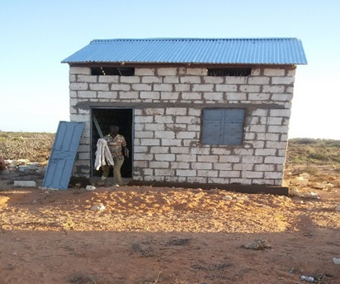
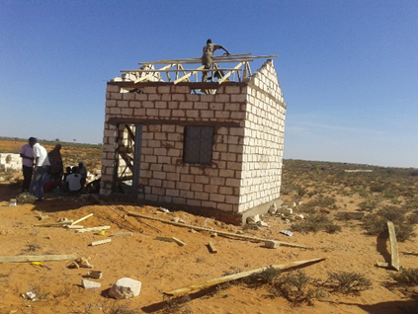

Size of built area (m2) per unit | 19.36 Sq meters
Can the units be accessed by persons with disabilities without help from others? | Yes, the door is designed for easy access by disable persons. (universal accessible)
Cost per unit (approximately in US $) | $2.227,45
Do the construction principles, tools and materials need specialist support during construction? | Yes. Prior the construction the Community is given of a Technical Training in order for them to have the skills to construct their own units. The Training is provided under the supervision of construction workers.
Cost of building material per unit (approximately in US $) / cost of labor/unit | $1.537,45
Does the maintenance can be done by beneficiaries themselves? (Knowledge, | Yes
Cost of labor per unit (approximately in US $) | $ 680
Are the shelters natural disasters resistant? Y/N | The building could be considered resistant although it isn’t provided of specific earthquake resistant structure. The foundation is in concrete which may help to hold the building not to collapse and to be protected from floods.
Are the beneficiaries satisfied with their opportunity to contribute to the design/planning of the project | This project is based on Community Driven approach. Hence, the Beneficiaries are involved in the design since the beginning. This is to have them owing the project and to gather that sense of responsibility that will make last longer the shelter.
Shelter description
Shelter description | The shelter has a rectangular layout with a CGI (Corrugated Galvanized Iron-sheet) roof and floor area approximately 4X4 m. The exterior walls are built with stone blocks that stone contain the following material: cement, mortar, 2 windows, 1 door, timber, nails and ventilation over the door and windows. There’s also a Small toilet on the compound which stands on a plot of 10X10 meters which allows for future upgrading.
Durability and lifespan | In general the shelter is well designed and it’s constructed of high quality using durable materials.  The shelter is expected to last long if properly maintained: 10-15 years.  The Stone blocks are new and the mostly used by the local community.
Live-ability/Comfort | It has enough space for the family to relax their children play around, to receive guests.  It’s cool inside and families feel safe.
Notes on possible upgrades | Yes. Of the 10X10 meters of the plot only 4 meters were used and the reaming space can be addressed to future family extensions (i.e. an additional room).
Ecology | In general the environmental context in Gaalkacyo is rocky and therefore is very good for more solid/permanent shelters.  The shelter material is locally purchased and so it doesn’t affect negatively on the environment.
Protection issues | The security is very good.  The shelters are lockable from inside and it has a separate toilet for the household. Moreover, there’re street solar lights.
Extra Documents
SWOT analysis (Strengths, Weaknesses, Opportunities, Treats)
Strengths | Weaknesses | Opportunities | Threats
Cost-effective  Promotion of livelihoods | Not disabled-friendly

Pros and cons
Benefits | Limitations
High quality stone blocks-durable  Quarry stones (only imported elements is CGI)  Community-driven  Cost-effective  Joint effort of two agencies  Promotion of livelihoods  Government involved  Good ventilation | Stones must be cut and transported from elsewhere, High ceiling is expensive, Not earthquake resistant – no tie beam, Disabled-friendly?, Design = community-driven, Beneficiaries trained to build themselves-should be promoting skilled laborers with oversight by beneficiaries  Machine, fuel required – only a couple companies that have this capability, Not plastered, Are there services nearby?, What is the land tenure situation?, Should be stated that it’s square-not rectangular  Design is very nice, so may get demands from government to build this for urban poor.

