SHELTER TYPOLOGIES – Somalia

Location | Mogadishu / Banadir | Rural/Urban setting | Urban and rural
Type of shelter | Hybrid shelter | Material source | Locally available
GPS Longitude |  | Main structural materials | Timber. Use of CGI helps stiffen the structure.
GPS Latitude |  | Main cladding materials | CGI and plastic sheeting
Year of construction | 2015 | Hazard resistance (earthquake) | Limited
Anticipated lifespan | More than 3 years (However, the plastic sheet needs to be replaced every year if the wall materials is not upgraded | Hazard resistance (wind) | Limited wind resistance. May require bracing.
Climate type | Semi-arid, humid and temperate. | Hazard resistance (floods) | No, but consideration should be made to place the shelter on higher ground.
Disaster | Displacement caused by conflict, fire. | Hazard resistance (fire) | The timber and plastic sheeting are highly flammable.
Time to build (man-days) | Less than a day. Depending on the size of teams, several shelters can be erected in a day | Pictures uploaded | Yes
Number of rooms | 1 room | BOQ uploaded | Yes
Labor method | Skilled and unskilled | Drawings uploaded | Yes
 |  | Satellite pictures uploaded | No
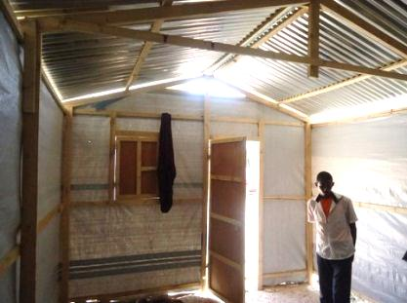
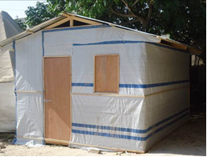
Picture of prototype

Size of built area (m2) per unit | 16 Sq. | Can the units be accessed by persons with disabilities without help from others? (universal design) Y/N | Yes. If on raised ground, a ramp may need to be constructed.
Cost per unit (approximately in US $) | 300 USD | Do the construction principles, tools and materials need specialist support during construction? | Yes but limited especially for site planning and initial shelter.
Cost of building material per unit (approximately in US $) | 250 USD | Does the maintenance can be done by beneficiaries themselves? (Knowledge, tools, affordable materials…) | Construction and maintenance can be undertaken by beneficiaries, with limited training / support.
Cost of labor per unit (approximately in US $) | 50 USD | Are the shelters natural disasters resistant? Y/N | Offers minimum resistance to strong wind loads, floods and earthquakes.
Are the beneficiaries satisfied with their opportunity to contribute to the design/planning of the project | Not fully, at some point the beneficiaries have complained about the hybrid shelter because of security, the plastic materials can be torn easily.

Shelter description

Shelter description | An upgradable, transitional shelter made of a timber structure, corrugated galvanized iron sheet roofing and plastic sheeting wall cladding.
Durability and lifespan | Structure can last for more than 3 years, if protected from termite attack while the roof could last more than 5 years if humidity levels are low. However, the plastic sheeting needs to be replaced every year if the plastic sheeting is not changed.
Live-ability/Comfort | Covered space meets the sphere standard for a family of 4. Lacks privacy, and physical protection as the plastic sheeting can be easily cut and accessed. Not well ventilated, making the internal thermal climate quite uncomfortable.
Notes on possible upgrades | Wall needs to be upgraded, from plastic sheeting to another material that can offer better physical protection and privacy. Possible upgrade materials include bricks, CGI, plywood, etc.
Ecology | With nearly all materials (timber, plastic sheeting and nails) imported from outside the country, the local environment is largely protected from harmful exploitation.
Protection issues | Plastic sheeting affords limited privacy and protection against intrusions, hence the need for upgrades.
Extra Documents

SWOT analysis (Strengths, Weaknesses, Opportunities, Treats)

Strengths | Weaknesses | Opportunities | Threats
-Local integration  -Site planning exists | -Insecure | -Land tenure | -Cyclone winds and excessive floods

Pros and cons of the shelter

Benefits | Limitations
-Cheap  -Moveable and dismountable  -Quick to build  -Environmentally-friendly  -Local markets supported  -Can be upgraded  -Good structure | -Insecure  -Short lifespan  -Fire-resistant? The timber and plastic sheeting are highly flammable.  -Very hot  -No privacy  -Toilets?  -Community participation?  -Contractor-driven

