SHELTER TYPOLOGIES – Somalia

Location | Gaalkacyo/Puntland | Rural/Urban setting | Urban setting
Type of shelter | Transitional shelter | Material source | Locally available/purchased
GPS Longitude | Mustaqbal IDP settlement | Main structural materials | White wood
GPS Latitude | Mustaqbal IDP settlement | Main cladding materials | CGI sheets
Year of construction | 2011 | Hazard resistance (earthquake) | ***
Anticipated lifespan | 1-2 years | Hazard resistance (wind) | **
Climate type | Dry arid | Hazard resistance (floods) | *
Disaster | Conflict related IDP | Hazard resistance (fire) | ***
Time to build (man-days) | 2-5 man days | Pictures uploaded | Yes
Number of rooms | 1 room | BOQ uploaded | Yes
Labor method | Self-help/contract | Drawings uploaded | Yes
 |  | Satellite pictures uploaded | No

Pictures of prototype
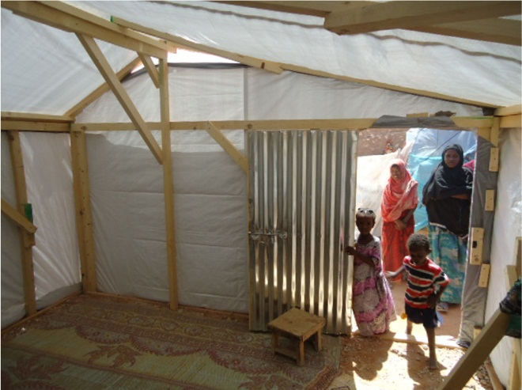
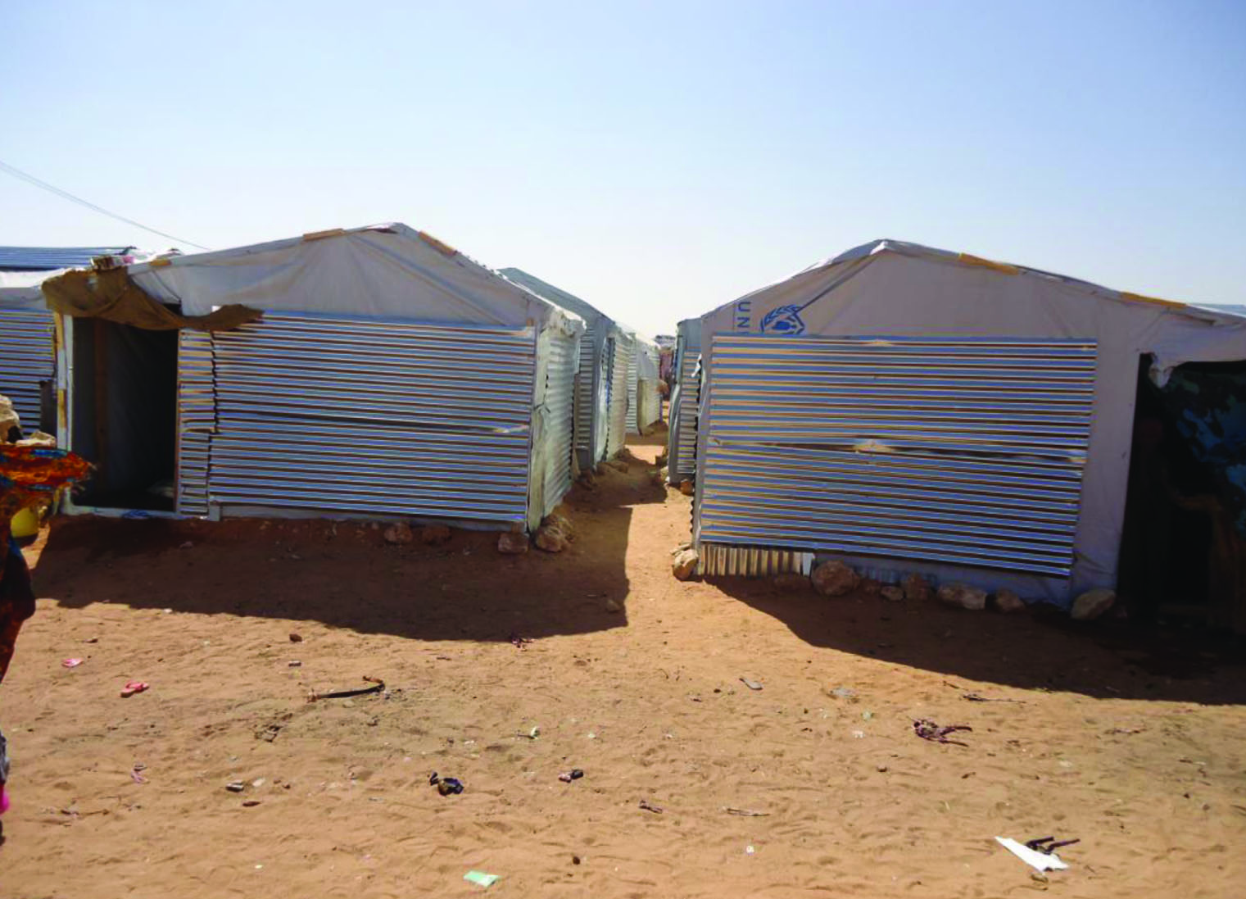

Size of built area (m2) per unit | 12.96 sq. | Can the units be accessed by persons with disabilities without help from others? (universal design) Y/N | Yes
Cost per unit (approximately in US $) | 405 USD | Do the construction principles, tools and materials need specialist support during construction?
Cost of building material per unit (approximately in US $) | 375 USD | Does the maintenance can be done by beneficiaries themselves? (Knowledge, tools, affordable materials…)
Cost of labor per unit (approximately in US $) | 30 USD | Are the shelters natural disasters resistant? Y/N
Are the beneficiaries satisfied with their opportunity to contribute to the design/planning of the project? | Yes

Shelter Description
Shelter description | The shelter is built out of a white timber frame, covered with plastic sheeting and walls covered with CGI sheeting for protection issues. There is no foundation as the IDPs preferred having more CGI sheets than cement bags.
Durability and lifespan | The wood is not treated, but there is no major problem with termites in the area.  The wood is imported and of good quality  The CGI sheets are galvanized and are temporary connected to the wooden structure  Protection from UV degradation and from ripping
Live-ability/Comfort | Two windows and one door  Good ventilation  As the height of the shelter is low, the shelter can easily heat up. Improvements can be done by insulating the roof with local materials
Notes on possible upgrades | All materials can be easily dissembled and re-assembled in a different design.  Improvements can be done by insulating the roof with local materials  Improvements could be done to tighten the structure more to the ground
Ecology | The design of the shelter has been made to use the wood as economical as possible  The CGI sheets are un-cut and can easily be re-used or sold.  The is no need of water in the design
Protection issues | The shelter provides improved protection as 80% of the walls are reinforced with CGI and 100% by plastic sheeting  As this shelter option also provides doors and windows, it is easily lockable and provides good security even if they leave the shelter.

Extra Documents

SWOT analysis (Strengths, Weaknesses, Opportunities, Treats)

Strengths | Weaknesses | Opportunities | Threats
-Materials are locally available and familiar to most of the population  -Use = common local building skills | -Very hot/cold | -Creates livelihood | -Lack of land

Pros and cons of the shelter (not discussed)

Benefits | Limitations

