Location | Baidoa / Bay / Southern Somalia | Rural/Urban setting | Peri-urban
Type of shelter | Transitional | Material source
GPS Longitude | 3,14’ | Main structural materials | Timber/Bamboo
GPS Latitude | 043 | Main cladding materials | Corrugated iron sheet
Year of construction | 2014 | Hazard resistance (earthquake)
Anticipated lifespan | 2 – 5 years | Hazard resistance (wind)
Climate type | Dry and semi-arid | Hazard resistance (floods)
Disaster | Conflict | Hazard resistance (fire)
Time to build (man-days) |  | Pictures uploaded | Yes
Number of rooms | 1 | BOQ uploaded | Yes
Labor method | Self-help / contractor | Drawings uploaded | Yes
 |  | Satellite pictures uploaded | No

SHELTER TYPOLOGIES
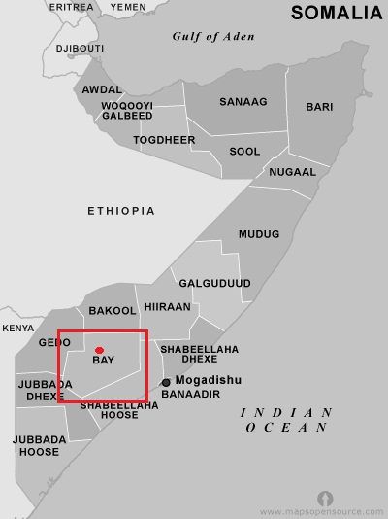
Picture of prototype
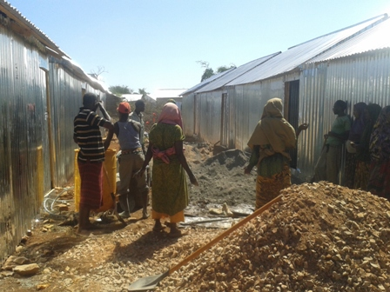
Size of built area (m²) per unit | 15.84 | Can the units be accessed by persons with disabilities without help from others? (universal design) Y/N
Cost per unit (approximately in US $) |  | Do the construction principles, tools and materials need specialist support during construction? | Materials are easy to transport by the beneficiaries
Cost of building material per unit (approximately in US $) | 323,55 | Does the maintenance can be done by beneficiaries themselves? (Knowledge, tools, affordable materials…) | Yes, some of the beneficiaries selected managed to construct their own shelter without employing workmanship
Cost of labor per unit (approximately in US $) |  | Are the shelters natural disasters resistant? Y/N
Are the beneficiaries satisfied with their opportunity to contribute to the design/planning of the project | Yes, women contributed to the design of the shelter and was culturally accepted
Shelter description (Brief description of materials used…) | The construction of the transitional shelter took 3 months with a total of 250 transitional shelters. Shelter design, site plans were provided to the implementing partner. The shelter is built out of a timber/bamboo frame, wall covered with CGI sheeting for protection issues. Materials are recyclable by the beneficiaries and easy to transport.
Durability and lifespan | The durable life on the T-Shelter is between 2 and 5 years. As the climate is dry, the wood will have a long time-span can be re-used in upgrading projects.
Live-ability/Comfort (Ventilation, thermal capacity…) | The shelter has two windows and one door. The two windows are put on opposite walls to increase cross ventilation. At the top of the gable walls, there is a space for ventilation.
Notes on possible upgrades | The design is quite upgradeable and the beneficiaries can reinforce or add extension
Ecology (Use of water, use of materials….) | The design of the shelter has been made to use the wood as economical as possible. The CGI sheets are un-cut and can easily be re-used or sold. There is no need of water in the design.
Protection issues | To improve security, all doors are lockable both from inside and outside. Windows properly fixed. Closing doors and windows depends on the context especially if there are imminent threats. Beneficiaries were educated on the risks of fire and its imminent threat.
Shelter description

Extra Documents

SWOT analysis (Strengths, Weaknesses, Opportunities, Treats)

Strengths | Weaknesses | Opportunities | Threats

Pros and cons of the shelter

Benefits | Limitations

