Location | Kismaayo / Middle-Lower Jubba | Rural/Urban setting | Urban
Type of shelter | Transitional | Material source | Imported
GPS Longitude |  | Main structural materials | Timber
GPS Latitude |  | Main cladding materials | Corrugated iron sheet
Year of construction | 2014 | Hazard resistance (earthquake)
Anticipated lifespan | 1-3 years | Hazard resistance (wind)
Climate type | Dry semi-arid | Hazard resistance (floods)
Disaster | Conflict, droughts | Hazard resistance (fire)
Time to build (man-days) |  | Pictures uploaded | Yes
Number of rooms | 1 | BOQ uploaded | No
Labor method | Contractor | Drawings uploaded | Yes
Anticipated duration of displacement |  | Satellite pictures uploaded | No

SHELTER TYPOLOGIES
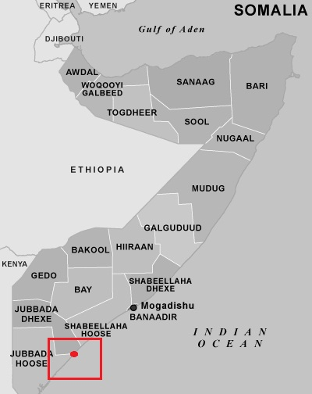
Picture of prototype
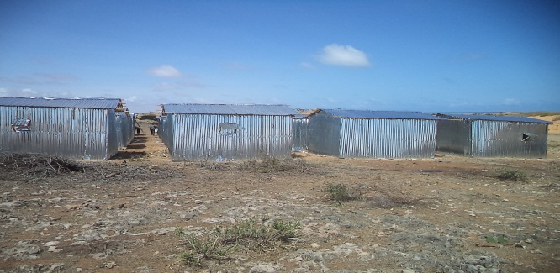
Size of built area (m²) per unit | 14 | Can the units be accessed by persons with disabilities without help from others? (universal design) Y/N
Cost per unit (approximately in US $) |  | Do the construction principles, tools and materials need specialist support during construction? | Construction techniques are well known skilled labor are part of IDPs
Cost of building material per unit (approximately in US $) |  | Does the maintenance can be done by beneficiaries themselves? (Knowledge, tools, affordable materials…)
Cost of labor per unit (approximately in US $) |  | Are the shelters natural disasters resistant? Y/N
Are the beneficiaries satisfied with their opportunity to contribute to the design/planning of the project? | Women took their consultation role in times of design implementation of the projects.
Shelter description | The shelter is built out of a timber/bamboo frame, wall covered with CGI sheeting for protection issues. Materials are recyclable by the beneficiaries and easy to transport.
Durability and lifespan | The durable life on the T-Shelter is between 1 and 3 years.
Live-ability/Comfort

Notes on possible upgrades | Materials are transportable and can be maintained.
Ecology

Protection issues | To improve security, all doors are lockable. Sufficient lighting because NRC distributed household solar lamps. Land issues in Kismaayo are very difficult.
Shelter description

Extra Documents

SWOT analysis (Strengths, Weaknesses, Opportunities, Treats)

Strengths | Weaknesses | Opportunities | Threats

Pros and cons

Benefits | Limitations

