Location | Mogadishu / Banadir | Rural/Urban setting | Urban
Type of shelter | Transitional | Material source | Locally
GPS Longitude | 45’17’27,08 | Main structural materials | Timber / Bamboo
GPS Latitude | 2’2’44,01 | Main cladding materials | Corrugated iron sheet
Year of construction | 2012 - 2013 | Hazard resistance (earthquake)
Anticipated lifespan | 2 – 5 years | Hazard resistance (wind)
Climate type | Dry and semi-arid | Hazard resistance (floods)
Disaster | Conflict | Hazard resistance (fire)
Time to build (man-days) | 3 men-day / unit | Pictures uploaded | Yes
Number of rooms | 1 | BOQ uploaded | Yes
Labor method | Implementing partner | Drawings uploaded | Yes
Anticipated duration of displacement | More than 3 years | Satellite pictures uploaded | No

SHELTER TYPOLOGIES
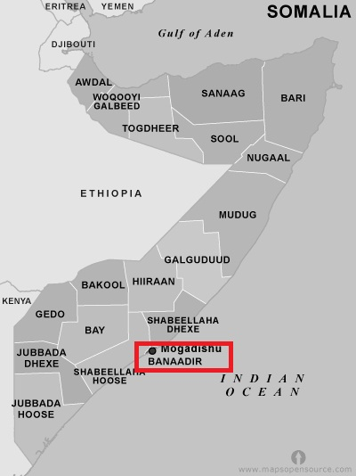
Pictures of prototype
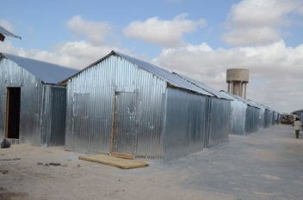
Size of built area (m²) per unit | 15,84 | Can the units be accessed by persons with disabilities without help from others? (universal design) Y/N
Cost per unit (approximately in US $) | 376,86 | Do the construction principles, tools and materials need specialist support during construction? | Some of the skilled labors are among the beneficiaries
Cost of building material per unit (approximately in US $) | 331,86 | Does the maintenance can be done by beneficiaries themselves? (Knowledge, tools, affordable materials…) | The design is upgradeable and maintenance is easy and acknowledged to the beneficiary
Cost of labor per unit (approximately in US $) | 45 | Are the shelters natural disasters resistant? Y/N
Are the beneficiaries satisfied with their opportunity to contribute to the design/planning of the project? | Women have been consulted in the design
Shelter description | Shelter design, site plans were provided to the implementing partner. The shelter is built out of a timber/bamboo frame, covered with plastic sheeting and wall covered with CGI sheeting for protection issues. One door and two windows are made out of CGI Materials are recyclable by the beneficiaries and easy to transport if properly dismantled.
Durability and lifespan | The durable life on the shelter is between 2 and 5 years. As the climate is dry, the wood will have a long time-span can be re-used in upgrading projects.
Live-ability/Comfort (Ventilation, thermal capacity) | The two windows are put on opposite walls to increase cross ventilation. At the top of the gable walls, there is a space for ventilation.
Notes on possible upgrades | The design is quite upgradeable and the beneficiaries can reinforce or add extension, kitchen and other areas allocated for every HH. Beneficiary can put curtains for separation.
Ecology

Protection issues (Personal safety and protection…) | To improve security, all doors and windows are lockable.

Picture of detail
