DRAFT Technical Guidance
01 Nov. 2016

1.0 INTRODUCTION
This document contains technical guidance for shelter working group partners in response to Hurricane Matthew in Haiti in October 2016. It is intended to promote consistent technical standards and approaches across the response.

The aim of this document is to build on previous responses, applying learning to the specific context in Haiti. This document should be viewed as a working document, which will reflect the evolving needs of the affected population, and the cluster members’ associated shelter interventions. It should be read along with other cluster strategic documents and guidance on key topics.

1.1 Shelter and NFI Sectoral Objectives
- To safeguard the health, security, privacy and dignity women and men, boys and girls affected by Hurricane Matthew through the provision of emergency shelter and NFI assistance.
- To support durable solutions and to avoid protracted displacement (avoiding the creation of camps and allowing safe return from collective centres).
- To promote early self-recovery through a participatory neighbourhood/settlements approach that integrates WASH, health, livelihood and protection.

Contents
1.0 INTRODUCTION 1
1.1 Shelter and NFI Sectoral Objectives 1
Contents 1
2.0 SHELTER INTERVENTIONS 2
Annex 1: Specifications 3
Annex 1.1: Tarpaulin Specifications 3
Annex 1.2 Tool Kit Specifications 4
Annex 1.3 Fixing Kits & Durable Cover Kit Contents and Quantities 5
Annex 1.3.1 Polypropylene Rope 6
Annex 1.3.2 Nails 6
Annex 1.3.3 Tie wire 7
Annex 1.3.4 Nail, for roof sheets 7
Annex 1.3.4 Optional: Plastic Washers 38mm dia. 7
Annex 1.4: Corrugated Galvanised Iron (CGI) Specifications 8
Annex 1.5 Timber Specifications 9

ANNEXES to follow:
- Guidance on distributions
- Guidance on social engagement
- GBV constant companion – Creole translation provided.
- IEC materials – plastic sheeting, safer construction.

2.0 SHELTER INTERVENTIONS

Shelter response consists of shelter assistance, to support people to incrementally repair or rebuild their shelters and the provision of household NFIs.

Below is a summary of the envisaged shelter interventions. These range from the emergency provision of tarpaulin to the provision of more durable materials, tools and fixings possibly with the provision of some cash assistance. Wherever possible, distributions should be accompanied with technical assistance to ensure better shelter outcomes, particularly for the most vulnerable people who will be unable to rebuild themselves.

The standards and the quantities represent minimum guidelines and quantities. Estimates of costs are only estimates – prices will vary by location and as a function of the supply. No price estimates include transport costs.

Emergency cover (1 tarpaulin per HH)
Tarp fixing kit
Community Tool Kit

Cash / Vouchers – to be addressed in another document
Durable cover kit (CGI and timber)
CGI / Wood Fixing kit
Community Tool Kits

With technical assistance and neighbourhood approaches

Detailed specifications and kit contents are included in annex 1.

Annex 1: Specifications

Annex 1.1: Tarpaulin Specifications

Tarpaulin is also known as, tarp, or polyethylene sheet. It is a sheet of strong, flexible, waterproof material.

Some of the specifications such as UV resistance can only be found by detailed laboratory testing. As such, it may not be possible to verify all of the specifications when sheeting is procured locally.
A standard sheet has a black woven core and is laminated on both sides. All tarpaulins must reach minimum performance standards outlined below.

International humanitarian standard grade is summarised below. Minimum 20m² provided. (See note below regarding current supply situation.)*
For more on specifications: http://procurement.ifrc.org/catalogue/

Weight: 200g/m2 ± 5% (ISO 3801). Add 10% for reinforcement.
Lighter versions (180g/m²± 5%) that meet the material performance specifications below might also be considered.
Core material: woven fabric High-Density Polyethylene (HDPE). Black colour, as this provides privacy, reduces heating under the sheeting due to the sun, and is the cheapest way to reduce UV degradation.
Lamination material: Low-Density Polyethylene (LDPE).
Reinforcement: eyelets (sheets only) or reinforcement bands (rolls and sheets).
• Option 1: eyelets (on edges), one strong aluminium eyelet every 1.00 m ± 5% on edges. Sealed on all sides (or 2 sides heat sealed and two sides double stitched), with nylon or HDPE ropes in hem.
• Option 2: reinforcement bands, bands of 7.5 cm width made from black woven HDPE laminated on both sides.

* Currently it is being recommended to distribute only 1 tarp per household because the number of tarps in the pipeline, versus the need for tarps, does not currently support more than one per household.

Annex 1.2 Tool Kit Specifications

Toolkits should be provided for groups of up to 5 households. Efforts should be made to ensure that all families, including the most vulnerable, have access to any tools provided. Agencies are responsible for good distribution practice and mitigation of any potential issues. Toolkit is based on IFRC standards with adaptations for the Haitian context.

Shared for a community of 5 households – shared between fewer in dispersed settlements
B |  | Toolkit | Unit | Qty | Approx. cost USD
Priority Items | Shovel | Pressed carbon steel, hardened and tempered; Size: (295x225) mm, hole diameter: front side 36mm, back side 40 mm; Weight: 1000 gram without handle; Handle: Length 1070 mm, smooth polished, varnished surfaces with Dry, strong and flexible wood. | pc | 1 | 8.00
Priority Items | Tin Snips / Metal Shears | Straight, for metal sheet, semi-hard 0.8mm maximum, 260mm long. Tin snips for intensive use and easy maintenance. Each blade and handle forged as one piece, symmetrical blades. Hot-forged carbon steel, hardened and tempered; special  treatment applied to the blade edge. Rustproof Protected against corrosion with special paint. Maintenance Dismountable in two parts only, with bolt and self-locking nut.  Total length: ~260mm. | pc | 1 | 4.00
Priority Items | Hand Saw | Carpenter hand saw, 400-450mm blade, lacquered, overall length 550mm±50mm; Blade thickness: 1 mm, protected against oxidation; Protective cardboard, teeth protection with hard plastic cover; 7 teeth per inch; Wooden dismountable handle, polished varnish hardwood | pc | 1 | 5.00
Priority Items | Claw hammer | Carpenter hammer, head and handle, hammer head with flat and claw side: High carbon steel head, treated to achieve a martens tic structure, with dressed striking faces; Weight of head: 750 gram; Handle: Smooth polished, varnished surfaces with Dry, strong and flexible wood. | pc | 1 | 5.00
Optional items | Combination pliers | Heavy duty Hot-forged carbon steel, side cutting pliers known as linemen pliers or side cutter; protected against corrosion with special paint; having gripping jaws, a cutting edge and insulating handle; Size 200 mm; | pc | 1 | 3.50
Optional items | Gall / Crow bar | Iron; Circular shape, smooth and sharp in one end for digging; Size : Dia 25 mm, Length 1000 mm; Weight: 4 kg | pc | 1 | 5.00
Optional items | Sack | New, woven polypropylene; Size : 1300x400mm; Colour : White; | pc | 1 | .50
Optional items | Bucket | Suitable for on-site construction. | pc | 1 | 3.00
Optional items | Wheel barrow | Suitable for on-site construction. | pc | 1 | 25.00
Optional items | Sledge hammer | For demolition. | pc | 1 | 15.00
Optional items | Work gloves | For handling sheet metal. | kit | 5 | 15.00
**All items approximately 90 USD. Priority kit items approximately 23 USD. All prices exclude transport.

Annex 1.3 Fixing Kits & Durable Cover Kit Contents and Quantities

Emergency Cover Fixing kit contents | Quantity
Rope - 12mm dia. | 30m length
Nails – HDG common, 89mm lg. | 0.5kg
Nails – HDG common, 38mm lg. | 0.5kg
Galvanized tie wire 1.5mm dia. | 25m length
Stiff plastic washers – 38mm dia. | 350
Approx. Cost = 20 USD

Durable Cover Fixing kit contents | Quantity
Rope - 12mm dia. - 30m lg | 30m length
Nails – common, 89mm lg. | 0.5kg
Nails – common, 38mm lg. | 0.7kg
Roofing Nails - 63mm lg. with rubber washers/gaskets - 0.5kg (provide rubber gaskets separately if not included) | 0.5kg
Galvanized tie wire 1.5mm dia. 25m length. | 180m length
Galvanized Metal strap – 30mm x 1mm | 30m length
Approx. Cost = 23 USD

Durable Cover kit contents | Quantity
CGI sheets – enough for 10 sq.m. See guidance notes on thickness and sizes.* | Enough for 10 sq.m. of roofing
2x4 timber – 8 foot length | 11
2x4 timber - 16 foot length | 8
Approx. Cost = 200 USD

*The quantities are set as a jump start for the Owner driven reconstruction. It is not intended that this quantity of material will rebuild an entire roof. Note that these are minimum guidelines.

Annex 1.3.1 Polypropylene Rope

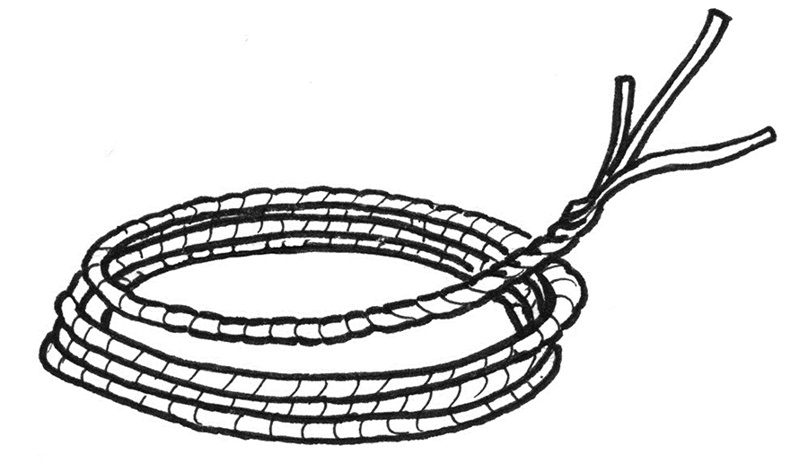

Black polypropylene rope, 12mm diameter, twisted.

Diameter | 12mm ±0.5mm
Length | 30m
Weight | 1.9kg
Number of strands | 3 minimum
Type | Twisted
Material | Polypropylene, no recycled fibres, UV stabilized
Colour | Black
Tensile strength | 300kg

Annex 1.3.2 Nails
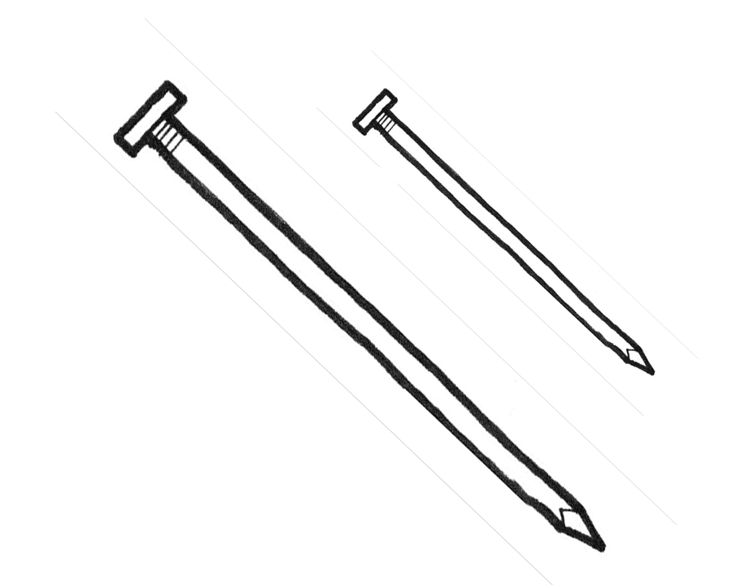

Iron nails, for wood, two sizes, 89mm long (3.5”) and 38mm (1½”). Note the nails are slightly longer than those in the IFRC kit to reflect the common use of rough sawn lumber in Haiti. hot dipped galvanized ‘common’ nails – should have a dull gray appearance with a rough finish. Nails with a shiny metallic finish are also galvanized but are not nearly as good as the hot dipped galvanizing – use only hot dipped galvanized to ensure longevity.

Length of nails used should correspond to length required for particular usage. Smallest effective nail is usually the best choice to help avoid splitting.

Type | Iron nails, made of polished low-carbon steel; cold processed, not heat treated except for galvanization
Rustproof | Hot dip galvanized at 300g/m2 ± 10%
Tensile strength | Minimum 650N/mm2
Shape | Flat, smooth, circular head; plain, round shank and diamond point
Dimensions (+/-5%) | Large type – ‘common’ nails, length x diameter: 89 x 4.2mm, head diameter: 7.7mm,  and  Small type – ‘common’ nails, length x diameter: 38 x 2.8mm, head diameter: 5.5mm
Packing | Packed in strong, thick plastic bag
Quantity | Net weight: 0.5kg per type

Annex 1.3.3 Tie wire

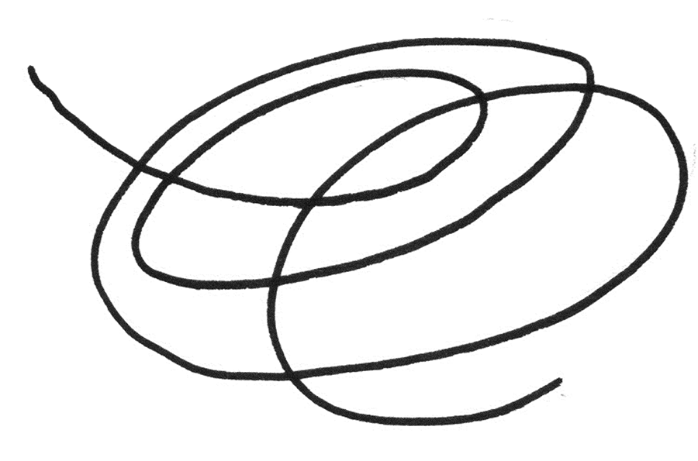

Galvanised wire, 1.3 mm diameter, 25m length, roll

Material | Low carbon steel, galvanised binding / tie wire.
Quantity | Roll of 25m
Dimension | Diameter 1.3mm ±5%
Tensile strength | Minimum 500 N/mm² to Maximum 700N/mm²

Note that galvanized metal strapping – 30mmx1mm is a very effective equivalent (or better in some cases) to tie wire, however is quite cost prohibitive.

Annex 1.3.4 Nail, for roof sheets
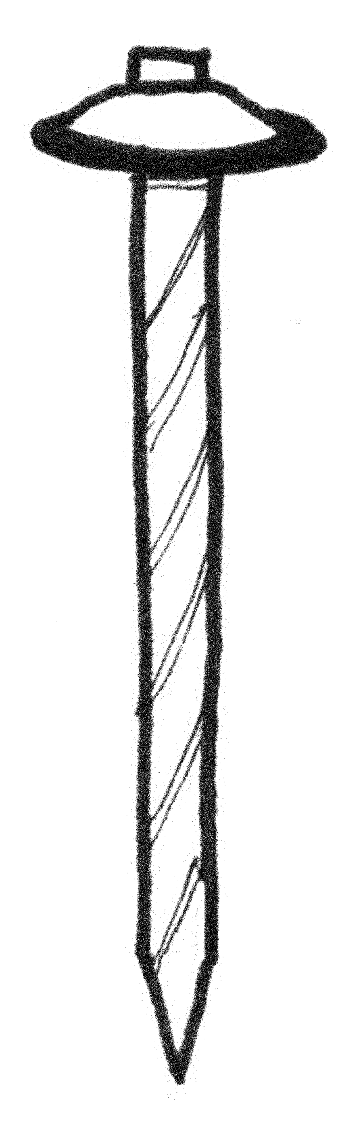
Galvanized with watertight rubber washer, 63mm long (2.5”), umbrella type. Note that longer nails of this type would be desirable though are not typically available in local markets.

Type | Iron nails, made of polished low-carbon steel, cold processed, not heat treated except for galvanization.
Shape | Spiral rolled or twisted shank, sealed umbrella-type spring-head.
Corrosion treatment | Galvanized
Tensile strength | Minimum 650N/mm2
Accessories | Attached rubber washer to each nail
Dimensions (+/-5%) | Shank: 63x3.6mm; head diameter: 22mm
Rubber washer | Diameter 26mm x 2mm thickness
Packing | Packed in a strong, thick plastic bag
Quantity | Net weight: 0.5kg

Annex 1.3.4 Optional: Plastic Washers 38mm dia.

Washers cut from sturdy plastic to enable secure fixing of tarpaulin with nails.

Type | Stiff Plastic Washers
Shape | Round flat disc shaped.
Material | Stiff plastic of any kind. (Not steel)
Dimensions | 38mm dia. min., 3mm thick min., predrilled 2.5mm hole in the centre.
Quantitiy | 350

Alternatively - use materials as readily available – cut up water bottles, plastic caps, rubber from tires etc. Do not use metal or any material with sharp edges that can pierce the tarp.
Annex 1.4: Corrugated Galvanised Iron (CGI) Specifications

Corrugated Galvanized Iron or Steel sheets, commonly called CGI sheets, are a lightweight roofing material made of thin sheets, stiffened by corrugations. Corrugations, such as waves, considerably increase the strength and stiffness of the lightweight material. Indeed, without these waves, the metal sheets are fragile and highly deformable. The steel used is mild steel for forming, which is galvanized to increase the durability of the metal sheets, and consequently allowing them to better withstand the weather.

CGI Specifications
Corrugated Iron Sheets – sine wave profile, 19mm depth, ~75mm peak to peak
24 / 26 / 28 gauge, galvanized, 6’ sheets, 2’8” wide. (Longer lengths are available and should be considered.)
Tensile strength: 300N/mm²
Coating: hot dip galvanization with minimum 120g/m² zinc or aluminium-zinc on each side that is 240g/m² total coating weight.
Hardness HRB: 85 HRB minimum
Note testing will be required, and it is suggested that agencies use reputable inspection companies, and use their own quality control processes. Callipers or measuring devises to check thick-ness are a minimum
For procurement also ensure that sheets are free of rust or other visual defects.

 | Ideal |  |  |  | Too thin
SWG | 24 | 26 | 28 | 30 | 32 | 34
Mm | 0.701 | 0.551 | 0.475 | 0.399 | 0.34 | 0.234

The Quality Of A CGI Sheet Is Determined By:
- Corrugated Galvanized Iron or steel (CGI) sheets are lightweight material used to cover the roof.
- Thin material shaped with corrugations to provide stiffness.
- CGI sheets come in various sizes.
- The thickness is expressed in gauge to avoid confusion, recommended to use mm.
- 24 gauge (0.701mm) CGI sheets are the ideal recommendation for permanent shelters.
- 26-gauge (0.551 mm) CGI sheets are recommended for permanent shelters.
- 28-gauge (0.475 mm) CGI sheets are a good compromise for shelters.
- 30-gauge (0.399 mm) CGI sheets is the minimum thickness that should be used for shelters.
- The major problem with CGI sheets is corrosion zinc coating is applied to protect the steel base (the most efficient process is hot-dip continuous galvanizing).
- The service life (durability) of the CGI sheets depends on the zinc coating thickness and environment of the shelter.
- Zinc coating should be 275 g/m² for both sides (equivalent of 20 µm/side)
- Online tool can be used to predict the service life of the CGI sheet based on the environment (link: http://www.galvinfo.com:8080/zclp/).
- CGI sheets are available in the Emergency Items Catalogue EIC (link: http://procurement.ifrc.org/catalogue/detail.aspx?itemcode=EBUIBSHEGR20&from=kit)

Tips for People Purchasing CGI Sheets and Galvanized Steel Items:
- Always purchase CGI sheets (hot-dip galvanized steel) with zinc coating thickness = 20 µm/side equivalent of 275g/m² (Z275 according to the ASTM and EN).
- Fixings/fasteners and sealing washers must be made of galvanized steel, with similar zinc coating thickness to avoid corrosion and breakage.
- Always verify the zinc coating thickness, by using a coating thickness gauge – magnetometer supplier may want to sell electro-galvanized steel which looks like hot-dip galvanized but can have a zinc coating thickness 10 times thinner.
- If the price for items made of galvanized steel seems expensive, you should check if the items are not made of stainless steel (3 times more expensive than galvanized steel) use a magnet, if the magnet does not stick to the item, then it is made of stainless steel.
- If you are buying galvanized steel items which are intended to be in contact with the ground (anchors), then the zinc coating thickness should be approximately 30 µm/side equivalent of 400g/m² (Z350 – Z450 according to the ASTM and EN).

Annex 1.5 Timber Specifications

Lumber - Borate pressure treated, non incised, Spruce / Pine / Fir (SPF) or Douglas Fir/Hemlock (DF/Hem) wood of traceable origin, with certificates of origin and phytosanitary certificate. (Ideal)

Post treatment with a borate solution (Boracare or something similar) is a possible solution if untreated wood is used. (Okay)

Typically borate treated wood is not available in Haiti and must be imported.

Avoid using wood with typical treatment types available here – Chromated Copper Arsenate (CCA), Copper Azole (CA), Copper Naphtenate, gasoline/oil/petroleum products and Aqueous Copper Quartenary (ACQ) because of issues with the environment, disposal and handling. These types of treatments can also accelerate the corrosion of fasteners. Burning of the offcuts is also an additional health concern, and thus these should be avoided as it is impossible to mitigate these risks with Owner driven construction.

Untreated wood will not have a long lifespan in the field due to the many threats to wood in Haiti – termites, moulds, fungi and boring insects are all common (if not thriving) in Haiti.

‘Zicomat’ is another local treatment that is available – however it has been impossible to date to determine the chemical makeup of it or obtain any MSDS information on it – thus it is to be avoided until further research / information can determine its suitability.

Chromated Copper Arsentate (CCA) and gasoline/oil/petroleum type treatments should be avoided completely, without exception, due to the health and environmental hazards that they present.

See also www.plastic-sheeting.org. text edited from “selecting NFIs for shelter”, IASC shelter cluster http://www.sheltercentre.org/sites/default/files/Selecting NFIs for Shelter.pdf
Information referenced from ‘CGI Sheet Roof Covering Manual’ – a guide on the use of CGI sheets for roof covering _ Shelter Research Unit, IFRC, Benelux Red Cross. http://ifrc-sru.org/
More information on CGI and fixings can be found in Annex A information provided by http://ifrc-sru.org/
Agencies should assess the transport and accessibility requirements for Hard to Reach locations.

