IRAQ: Tent Information Note
DRAFT v01

V1 – January 2016
This document provides information to agencies delivering family tents to conflict-affected communities to preserve health, safety, dignity and well-being. Partners should provide assistance based on needs, intentions, capacity and actual family size. Household shelter construction support items, including mobile and basic Emergency Shelter Kits (MESK and BESK), Emergency Sealing-Off Kits (ESOK) and NFI technical guidance are described in other Shelter and NFI Cluster guidance.
Tents are not a long-term habitat solution and should only be used for emergency situations. However, it is still essential to ensure that the durability and quality of selected tents meet needs adequately, are fit for purpose, and don’t pose a risk to users. Shelter Cluster Iraq strongly recommends agencies accompany distributions with clear guidance and/or training to ensure the safe and proper usage of items and the avoidance of injury or risk. In each case, the provision of tents will depend on safety and security considerations, the mobility of and access to affected populations, as well as settlement typology and intentions. Tent distributions can be feasible for initial distributions and/or replacements in camp/emergency sites or in out-of-camp (informal settlements, host communities, home sites, etc.) situations.
Prior consultation and approval for tents and distributions from local authorities and communities are strongly recommended.
Like with all shelter provision where tents are distributed they should provide a covered space of 3.5 sq. m per person (more than one tent may be necessary for larger families) and the site should allow for 45 sq. m of overall space per person. Site safety (whether home-site, mobile or camp) must be taken in to consideration, including a pre-distribution analysis of political, environmental, social, technological and legislative factors. Details on these, as well as site planning can be found here: http://www.globalcccmcluster.org/tools-and-guidance/publications/camp-management-toolkit-2015
This document should be read in conjunction with the overall Shelter/NFI Cluster Strategy and other technical guidance published by the Shelter/NFI and CCCM Clusters, including:
- Climatisation and Seasonal Support Guidance
- Emergency Shelter Kits (MESK / BESK)
- Emergency Sealing-Off Kits (ESOK)
- Cash and Shelter guidance
- Non-Food Items (NFI) Technical Guidance
- CCCM Cluster’s Camp Management Toolkit

There are a significant variety of tents currently in use by IDPs and refugees in Iraq. Some of them have footprints that are not similar to the varieties indicated here. In these cases a like-for-like footprint will often be required to ensure parity and to preclude a complete re-design of existing camps where funding, space, layout, existing plot size and engineering restrictions make this unfeasible.
For new distributions, however, the example of tents indicated below have been found to be effective in this context for their indicated purposes.

Tent type | Description, including settlement typology appropriateness | Durability (projected life-span in Iraqi climate) | Weight and Dimensions packed | Footprint | Non-exhaustive international procurement list | Winterisation Options
IOM/MoMD  (tunnel type) | In and out-of-camp- fixed position only.  IOM Emergency Tent – MoMD approved tent: IOM Iraq shared the details with MoMD which now provides basically the same model.  Tent height is 210 cm, the galvanised steel frame is made from 3.81cm diameter tubing  Top cover contains 3 layers with the top layer having an extended mud flap (extra 45cm)  Flooring material is a tarpaulin mat.  White top cover must have extended mud flap (extra 18”) | Up to 5 years (manufacturer claim) | 180kg (?), comes in separate packages | 420x600cm | Dar Al Aman Company, Engineer Saher – +9647509356911  Al-Rubeiy Group,  Mehboob Sadiq +9647718603063  +9647807736950  mehboobsadiq@yahoo.com, or hr@alrubeiygroup.com | Top cover contains 3 layers (white PVC canvas/ water proof; second layer is a grey colour insulation material; the third layer is a canvas lining white colour)  Where UNHCR provides winterisation to MoMD tents they have developed a local context-specific option: plastic sheeting and 6 synthetic mats/sleeping mats
ShelterBox DR Tent (semi-geodesic dome type, self-supporting) | Lightweight, short-term option that can be quickly assembled. Self-supporting, so it may be erected inside buildings without the need for drilling holes for stakes/pegs. Fire resistant | 6 months, extendable with the addition of tarps and fixings | 36.2 kg, 70 x 42 x 34 cm | 430x430cm  (Octagonal, with vestibule/porch) | NB: ShelterBox is not a commercial supplier but an NGO working through partners in Iraq.  Sam Hewett  Operations Coordinator (UK/KRI)  samhewett@shelterbox.org  +447949992947  +9647517541065 | N/A
UNHCR/IFRC Spec Family (ridge type) | In and out of camp – fixed position only.  Further details can be found here: http://procurement.ifrc.org/catalogue/detail.aspx?volume=1&groupcode=111&familycode=111001&categorycode=TENT&productcode=HSHETENT01  (note that IFRC also makes a similar tent in a self-supporting, “Frame” type which is not described here)  Used by the UNHCR, ICRC and IFRC, the standard tent for a family of five conforms to the recommended minimum-standard living area for hot and temperate climates (3.5m² per person); it provides additional space for cold climates. As an addition, the Kit HSHETENF16I, Improved insulation for family tent, is recommended for cold climates.  Some models are fire-resistant | Minimum 1-year lifespan, irrespective of climate. | 58 kg, 230 x 25 x 30 cm |  | Family tents are subject to international purchase frame agreements with validated manufacturers. Consult with the IFRC, ICRC or the UNHCR prior to purchasing to obtain frame agreement information.  Generic design specifications ensure that the product can be manufactured in numerous countries by suppliers with standard technical know-how and standard tent-industry equipment.  Validated manufacturers have had their samples laboratory-tested prior to the issuing of the frame agreement, and are subject to regular quality controls. | Tent-specific winterisation kit available from suppliers.

Emergency sites / camps:

Even for phase 1 in emergency sites/camps in Iraq the following minimum indicators should be observed (in line with the agreed ‘Emergency Camps Scope Guidelines’):
- During the initial emergency phase a minimum 20 square meters (m2) per person is recommended for living and minor services space. This should be expanded to 30 – 45 m2 per person as soon as possible.
- The covered minimum living space per person is 3.5 m2
- A minimum of 2 meters between tents is required, but should be increased if at all possible (2.5 times the height of the tent).
- A 30 meter firebreak should be place every 300m of the tented area.
- Roads should be 6 meter in width graveled roads with an additional two times 0.5 meter for drainage.

IOM/MoMD Tunnel Tent:

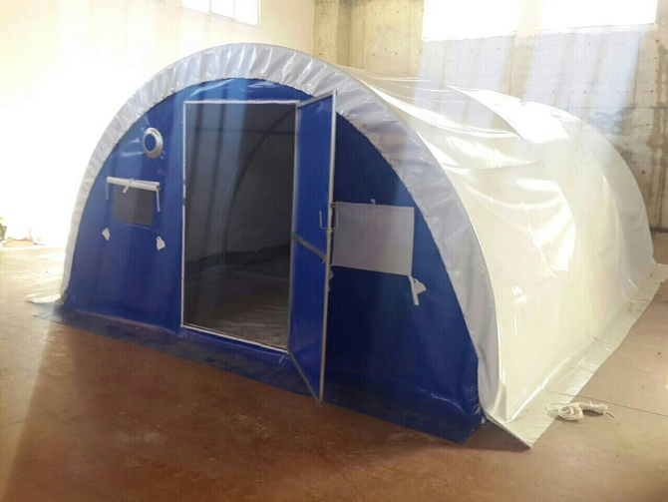
ShelterBox tent:
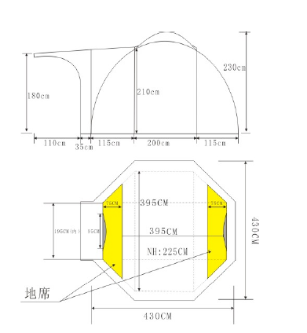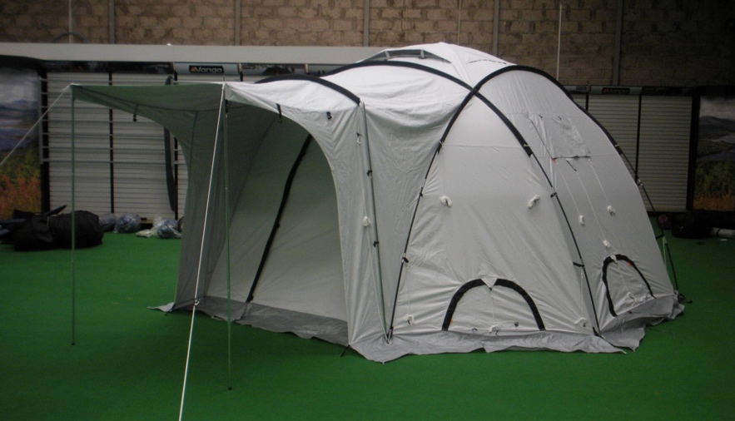
ICRC/ IFRC/UNHCR Spec Family Tent (ridge-type):
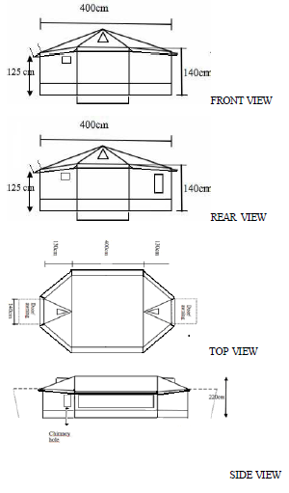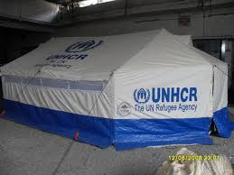

Winterisation package for IFRC/UNHCR Spec Family Tent

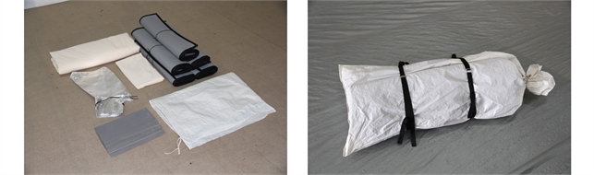
Code (IFRC EIC) | Description | Ship. weight | Ship. vol.
KRELSHEKTW01 | WINTERISATION KIT, for the Family Tent 16m2 | 30kg | 0.25m³
General information
When only tents can be used as emergency shelters in cold climates, it is advisable to supply the Winterisation Kit for Family Tent. This kit includes the essential items to improve the insulation against the cold. It also includes the necessary protection to install certain stoves and heaters inside the tent.
The components of these kits are designed to fit the standard Family Tent. All the components are fire retardant to the level of the CPAI84 regulation.
This kit does not include any stove or heater, nor fuel. These items must be supplied separately, according to fuel type and availability.
The kit is packed individually in a strong waterproof plastic bag, made of plastic tarpaulin.
Standard winterisation kit, for the standard Family Tent includes the following:
Description | qty
INSULATING FLOOR MAT, aluminized, fleece covered, 0.9x1.8m | 5
LINER, winterisation for the standard Family Tent | 1
PARTITION, winterisation for the standard Family Tent | 1
FLOOR PROTECTION, heat resistant, for tent heater, 0.5x1m | 1
SLEEVE, heat resistant, for tent heater fume pipe, 0.7x0.35m | 1

Fire safety

A good general rule is that there should be a fire gap between tents of at least 2.5 times the height of each tent and fire breaks of a minimum of 50 metres of empty space every 300 metres of built-up area. In Iraq the ‘Emergency Camps Scope Guidelines’ specify different minimum requirements as discussed above.
Agencies should develop Fire Safety awareness messages and training / awareness raising measures to accompany distributions of cookers/stoves and heaters. This should be undertaken in conjunction with any site management authorities, fire services and CCCM where relevant to ensure that messages are consistent, reflect best practice, and correspond with available fire-fighting and fire safety measures on site.
Example guidance material:
The flame and fire retardant properties of tents should considered during selection. An understanding of how and where the tents will be used, in relation to stoves, kitchens, water ingress, electrical circuits and fuel storage areas will help to ensure safety. Consider developing guidance and awareness that can be targeted towards specific households or settlements, identify potential hazards, and allow mitigation of these risks. Availability of and training in the use of fire-fighting equipment should comprise part of the overall fire risk analysis of a shelter or settlement. Also consider the design or upgrading of shelters to take into consideration the need for adequate ventilation of cooking areas and heated spaces during winter, and other features such as partitioning (and associated use of appropriate materials to limit fire spread), compartmentalisation, and fire evacuation routes.

The largest cause of fires in camp settings in Iraq has been poor (and unauthorised) electrical connections. Proximity of flammable materials and items (such as insulation or tent walls) to circuitry should be taken into consideration when awareness raising activities or shelter upgrading works are undertaken. Likewise, site planning, distances between shelters and fire breaks should be integrated into an overall strategy for fire risk reduction.

