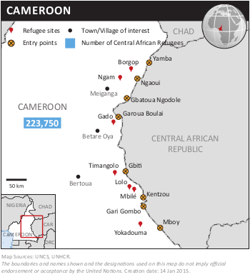
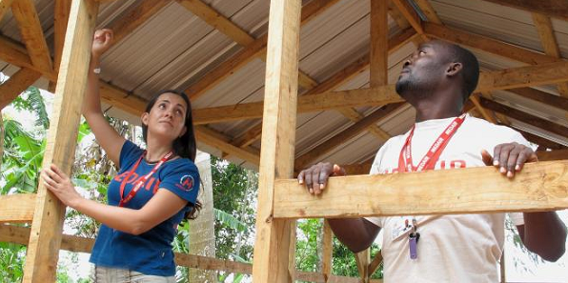
NEED ANALYSIS
- Provide a short overview of the key needs in terms of shelter and NFI, this can for instance be based on the cluster strategy, recent assessments or submissions for OCHA situation reports.
- Provide a short overview of the key needs in terms of shelter and NFI, this can for instance be based on the cluster strategy, recent assessments or submissions for OCHA situation reports.

RESPONSE
- Provide a short overview of the response in terms of shelter and NFI, this can for instance be based on the cluster 4W, post-distribution monitoring reports or submissions for OCHA situation reports.
- Provide a short overview of the response in terms of shelter and NFI, this can for instance be based on the cluster 4W, post-distribution monitoring reports or submissions for OCHA situation reports.

GAPS / CHALLENGES
- Provide a short overview of the gaps and/or challenges in terms of shelter and NFI, this can for instance be based on the cluster gap analysis, partner feedback or submissions for OCHA situation reports.
- Provide a short overview of the gaps and/or challenges in terms of shelter and NFI, this can for instance be based on the cluster gap analysis, partner feedback or submissions for OCHA situation reports.

COVERAGE AGAINST TARGETS (HH)

Photographer / Organisation, Year
CLUSTER TEAM
National Coordinator
First name Last name (organisation)
function.country@sheltercluster.org / +1234567890

National Co-Chair
First name Last name (organisation)
function.country@sheltercluster.org / +1234567890

Sub-National Coordinator
First name Last name (organisation)
function.country@sheltercluster.org / +1234567890

Information Management Officer
First name Last name (organisation)
function.country@sheltercluster.org / +1234567890

Technical Coordinator
First name Last name (organisation)
function.country@sheltercluster.org / +1234567890

KEY DATES
Provide a short description of the key events and dates before and/or after cluster activation.

Activation of cluster: Month Year

KEY DOCUMENTS
- Shelter/NFI Cluster Strategy
- Technical guidance
- Maps

KEY LINKS
- Country page on ShelterCluster.org
XX page views in Month Year
- Country page on HumanitarianResponse.info
- Country page on ReliefWeb

KEY FIGURES
XX X.X M / X.X M
Cluster partners People in need / targeted

FUNDING (source: OCHA Financial Tracking Service)

