Location: WebEx link to Baghdad, Erbil and Basrah
Time: 12:30 – 14:30
RCC3: Omar Al Dabbagh – UNHCR; Cornelius Weira – Shelter Cluster; Francesca Coloni- Shelter Cluster; Bassim Al Tameem – UNHCR; -Laith Al Anbari -UNOCHA; Omar- Al Najim – PUI; Yasir Al Jaborf -PUI; Ahmed Jihad Qader- UNHABITAT; Maan Sami- UNHABITAT; Hiwa M Ali-CRC; Manar Jalil – UNHCR; - Raad Hammodat -IOM
Erbil: Abdoulaye Diaye -Shelter Cluster
Baghdad UNHCR Conference Room: Maha Sidky
Basra:- Elaf Kandouo -UNHCR

Summary of Action Points:
No. | Action points from the meeting (21st February 2018) |  | Who: | Completed by When:
 | IMO to share by mail chimp A.I am training timetable. |  | Michel/ Abdoulaye | 7th March 2018
 | Partners to submit proposals for the 1st IHPF allocations by mid night 4th March 2018 |  | Interested Partners | 4th March 2018
 | Refer Kilo 18 extension camp access by IDPs to Protection Cluster |  | Sub National Shelter Cluster Coordinator | 7th March 2018
 | Follow with DRC / CCCM of missing names of IDPs in HTC |  | Sub National Shelter Cluster Coordinator | 7th March 2018

Minutes:
Agenda Item | Key Points | Action points
- Review of minutes of previous meeting | - Meeting reviewed and endorsed minutes of the previous meeting held on 21st February 2018 and noted the following key highlights: -  - As a follow up on previous action points, UNHCR reported that Government has distributed 40 liters of kerosene per family in Kilo 18, HTC and AAF in Anbar governorate. Similar distributions have been carried out in Salah a Din and Baghdad governorates. JCMC reports will reflect these distributions and UNHCR will share official reports from government when they are obtained.  - The cluster will share activity info training timetable with partners.  - UNHCR reported findings of assessments carried out in Al Khalidiya camps. Findings indicate that IOM last distributed NFI kits in A.K camps in 2015, hence UNHCR will distribute CRI replenishment kits to all eligible IDPs in these camps.  - The shelter cluster shared Considerations for use of tents upon camp closure with Partners highlighting that there is mixed opinion on this issue from different governorates, this will be handled as a case by case basis by each of the governorates as there is strong concern for new settlements mushrooming everywhere countrywide. Tent providers should ensure that logos are sprayed where IDP are allowed to carry tents upon camp closure.
- Information Management Updates. Information Management  - A.I training timetable  Iraq 3W  - Shelter Cluster HRP Snapshot  - Shelter Cluster Online Dashboard | - All users have been added in the database and the reporting will start in early  - March for January, February and March  - Tentative Activity Info trainings time table 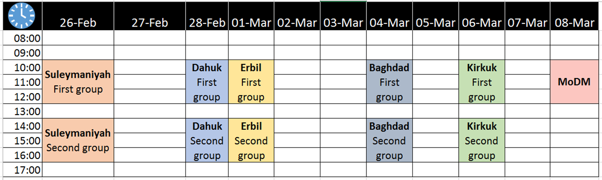  - Advantages of reporting regularly: IM products updates, gap analysis, improve advocacy  - Mosul planned and operational presence  - Iraq 3W  - Shelter Cluster HRP Snapshot  - Shelter Cluster Online Dashboard | - IMO to share by mail chimp A.I am training timetable.
3. Key Issues  a. 1st IHPF Allocation 2018 Updates  b. War damaged Shelter Categories, repairs in the humanitarian context c. Shelter and NFI Response for flood affected IDPs d. Camp Consolidation and Closures Updates | - 1st IHPF Allocation 2018 Updates  The Humanitarian Coordinator (HC), in consultation with the clusters and the advisory Board (AB) have issued the 1st 2018 IPF allocation. A total amount of up to US$ 34.55 million is available for this allocation.  The HC in discussion with the AB has set the allocation priorities as follows;  • Activities supporting highly vulnerable populations in return areas  • Activities supporting principled returns (protection, the JCMC centers/Community Recourse Centers (CRCs), etc.  • Activities to maintain the camp services for the remaining IDPs  - Cluster Priorities:  - Coverage of current gaps and future newcomers in the “transition camps” which have not had a dedicated NFI partner for the last 6-9 months in Ninawa: Jedda and Qayyarah Airstrip  SAD: Basateen, Anbar:  - Kilo 18 Provision of basic NFIs; ( mattresses, blankets, kitchen sets, etc.) for camp residents who have not been assisted yet.  - Provision of basic NFI kits for newcomers that will move into camps over the next three months --- ( Total for the above 3 bullet point priorities USD 3,185,000)  - Emergency shelter repairs and transitional shelter solutions for extremely vulnerable returnees in underserved areas in Ninewa: Zumar, Rabia, Wana (village info available)  Diyala, Khanakin, Jalawala, Jomila Village Anbar: West Anbar, Al Qaim city, Al-Obaidi; Al-Rumanah, Kirkuk: Hawija  - Provision of Sealing-Off Kits,  - Provision of emergency shelter repairs for extremely vulnerable families in order to support durable returns for the most vulnerable families residing in category 2 war-damaged houses,  - Provision of transitional shelter solutions to support extremely vulnerable returnees in their area of origin in category 3 and 4 war-damaged houses. ( Total for the above 4 bullet point priorities USD 1,820,000)  - Deadline for submission of proposals is 4th March 2018, Midnight  - War damaged Shelter Categories, repairs in the humanitarian context  The National Shelter Coordinator made a presentation on War Damaged Shelters, the below are the highlights: -  - Summary of the shelter cluster goal for Emergency shelter repairs are: -  - Provide most vulnerable populations/ returnees with appropriate shelter solutions for returnees with no place to live upon returning home.  - Provide most vulnerable returnees with appropriate shelter solutions with places NOT good enough to live such that if no action is taken these returnees will either return to camps or stay with host communities.  - Partners have been reminded to stick only to humanitarian activities due to the small number of beneficiaries the shelter cluster will assist regarding war damaged shelter repairs under the 2018 HRP. Partners should be aware of the Recovery and Resilience program that can support recovery oriented activities / war damaged shelter repairs under UNHABITAT and UNDP.  - Under the current HRP, the shelter cluster would to like to reach as many beneficiaries as possible, and will only consider categories 0 - 2.  - Partners should ensure to DO NO HARM. Currently, there are many assessments being undertaken without any follow up actions. Partners should ensure they have expert input/ an engineer on board during assessments to provide expert opinion.  - The shelter cluster recommends provision of 33 square meters of living space as appropriate for families to live for emergency shelter repairs, i.e. 5 square meters per individual.  - The following are the challenges, Partners may face 1.) different house designs, architecture,  2.) Different construction materials 3.) different levels of damage of houses in same area 4.) Different damages on same house.  What is feasible?  - The shelter Cluster has developed 2 documents to consider what is feasible:  - War Damaged Shelter Categories 0 – 4  - Minimum scope of repairs  - Both documents can be found on the shelter cluster website in both English and Arabic.  Comments from Participants: -  - Adhering to 33 sq. meters is good but the cluster should allow flexibility to follow the foundation of the house while doing the emergency repairs.  - Contamination of houses, booby traps and remnants of war remain a challenge to Partners, there is limited capacity in this area.  - There are overlaps amongst Partners working on war damaged shelters, coordination is important, government should be on board considering need to amalgamate public utilities in house repairs.  - Rubble removal is still a challenge.  The Cluster stressed that Partners should adhere to Iraqi building codes, of course Partners should take into consideration the foundation of the house. Urban authorities should lead the process and coordination on repairs on war damaged houses. UN Habitat has development a very important portal that should support coordination.  - Shelter and NFI Response for flood affected IDPs  - UNHCR is leading the response for flood affected camps in Anbar and Salah a Din  - The shelter Cluster emphasized that IHPF funds will not be available for the flood response.  - Floods reported in Kilo 18, IDPs are prevented from accessing Kilo 18 extension with better infrastructure and tents with threats of not being able to access assistance if they moved to the extension.  - Camp Consolidation and Closures Updates  No information has been shared yet on which camps will remain open. However, the shelter, Protection, CCCM and WASH clusters recommendation in step 3 as criteria for camp closure that camps without proper services, market access, having tensions with host communities should be considered first for camp closure. | - Partners to submit proposals for the 1st IHPF allocations by mid night 4th March 2018  - Refer Kilo 18 extension camp access by IDPs to Protection Cluster
- Governorate Updates | - IDP names missing on camp register in HTC. | - Follow with DRC / CCCM of missing names of IDPs in HTC
- AoB
Next Meeting: 7th March 2018

