Shelter Projects Asia-Pacific Workshop – Report

Bangkok, 17 May 2018

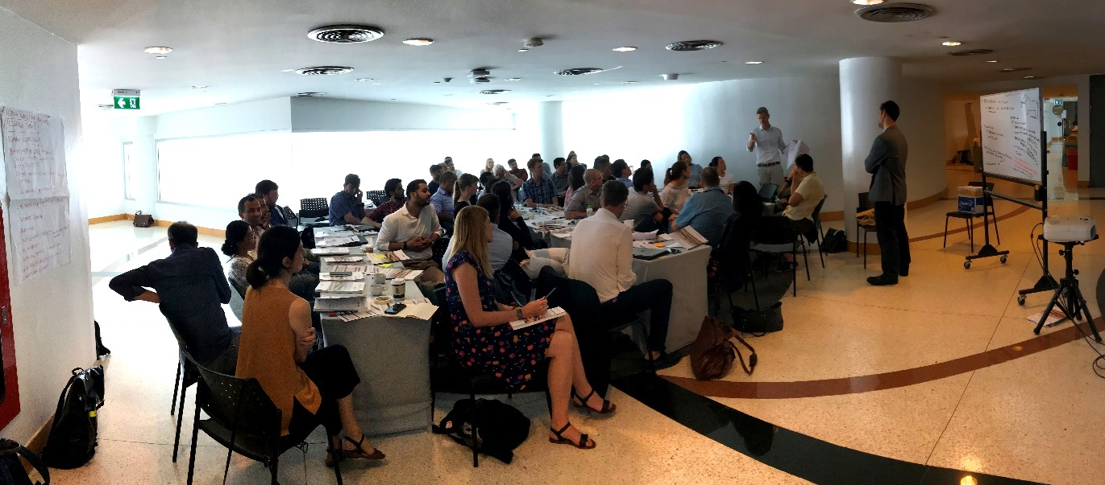
Location and time: Bangkok Art and Culture Centre (BACC), 10:00—18:00
Workshop Objectives: the event focused on learning from past experiences of shelter and settlement responses in the Asia-Pacific region by actively engaging actors using case studies from the Shelter Projects publication. It brought together practitioners and other relevant local stakeholders to collectively review case studies from past editions, focusing on “what worked well” and “what didn’t work well” in the past. It also provided an opportunity to share experiences from recent shelter and settlement responses in the region, which will be reviewed and considered for inclusion in the next edition of Shelter Projects.
Agenda: See Annex 1.
Participants: A total of 57 participants from 22 organizations (plus independents) attended the Shelter Projects Workshop (SPW) and subsequent Asia Shelter and Settlements Forum #2 (ASSF2). These included a mix of national and international practitioners (at various levels of experience) from 14 countries plus global shelter advisors, as well as regional and global humanitarians and development actors working across different sectors, and two government representatives.

SUMMARY
The workshop, organized by IOM on behalf of the Global Shelter Cluster (and supported by USAID/OFDA and ECHO) was conducted following the Global Shelter Cluster NFI Workshop (organized by the GSC) and followed by the Asia Shelter and Settlements Forum #2 (organized by IOM). The workshop was the first of its kind in focusing almost exclusively on the case studies included in the Shelter Projects publication and using it as a learning and discussion tool. Overall, the feedback from participants was positive both in terms of content and facilitation, and the choice of location and focus on the region was well appreciated. However, some improvements can be done in regards to the time management for presentations, the choice of room and its capacity, as well as in inviting more actors outside humanitarian agencies, including national governments and donors.

METHODOLOGY
The Shelter Projects Workshop included a mix of plenary presentations and group discussions, but the core of the meeting was focused on the latter, to enable smaller groups to have more time to discuss in depth, also given the high number of participants. Plenary presentations focused on setting the scene, opening remarks and, at the end of the meeting, to allow participants to present recent or ongoing projects from the region, highlighting their key strengths, weaknesses and lessons to be learned. The group work was done in two sessions by using the latest edition of the publication to review i) the introduction section and ii) individual case studies from the region, previously selected. Groups were of about 10 people each and were asked to discuss about key questions and then report to plenary at the end of the session.

DISCUSSION
INTRODUCTION SECTION
This session of the workshop focused on the collective review of the introduction section of the publication, particularly looking at the following components: 1) Overview of major crises and responses, including analysis of some shelter responses; 2) Recurring themes emerging from case studies; and 3) Defining factors for the success of projects. Breakout groups reviewed and discussed for about 30 minutes, before reporting the highlights of their discussion to plenary. The outcomes of the discussion are summarized below, according to the three headings as mentioned above.

Overview of crises and responses:
- Case studies may not be representative of a whole response, so it is good to have overview pieces and an overall analysis in the introduction, as readers may be browsing quickly through the content.
- Graphs in the introduction should have a more thorough analysis.
- This section is useful, but could be improved by also giving funding coverage (globally and in key countries) for the sector, as well as comparing with other sectors. Comment: this should be covered more substantially by the State of Humanitarian Shelter and Settlements Report, but the introduction of Shelter Projects could also take this into account to give a full picture, and add specific reference to the SoHSS report which will be released before Shelter Projects.
- Add an analysis of cost effectiveness of projects in the introduction.
- Highlight urban responses, and understand why there seem to be less case studies in urban areas: is it the sector that is doing less in urban compared to than rural settings, or is it challenging to collect case studies?

Recurring Themes:
- Links with recovery and reconstruction should be a clearer theme, more explicitly coming out of the case studies. A heading/question in the data collection form could be added.
- In addition to recurring themes, the introduction could include a section analyzing/ summarizing the strengths/ weaknesses and learnings, across case studies.
- Some very important themes are missing: inclusion, women’s participation and empowerment, local construction capacities, preparedness, integrated programming, private sector engagement, debris removal and management, distribution modalities, legal documentation, innovation, etcetera… More case studies on these themes should be sought for inclusion.
- Can we include more small scale pilot projects, especially where there is a significant learning, mainly from failures? How can failed projects be share openly, focusing on honest learning and without being overly critical/negative? This issue has been discussed and overall, it was agreed that projects always have both positive and negative elements, and the peer review process and editing team should play a key role in identifying which weaknesses are there and should be highlighted. Purely failed projects may be difficult to document by agencies, though this could be done by independents.
- Suggested themes could be added in the case study template, for contributors to reflect upon, although not prescriptive.

Defining Success:
- Success indicators should be captured and analysed more systematically. At the moment, they appear only as a self-reported list from contributors, and they are quite different types of indicators. They could be grouped in different categories and also prompted more clearly.
- Immediate satisfaction and longer-term impact are different things. Impact is harder to measure, but Shelter Projects could try to do this where possible. The timeframe for the write-up of the case study is the issue, there is therefore the need for more longitudinal studies, conducted by independents, not by the same agency.
- Who defines success? Are we asking the people supported by the project? Are we asking authorities? Or is it only from the agencies’ perspective.
- We should try to measure the success of the process, more than the product/output of the projects.
- The support methods options should also include different types of technical assistance, not only training.

Other comments:
Missing case study types
- There should be more case studies on host community support projects, or more broadly projects implemented in host community settings. In countries like the Philippines, these are very relevant and numerous, but are not represented in the publication.
- Missing or poorly represented in past editions: governments projects (or focus on the role of governments within projects/responses), donors, and community-based organizations.
- Integrated programming and linkages with other sectors should be better highlighted.
- More long-term studies, or follow-up studies after 5 years or more (e.g. from case studies in past editions), should be conducted. Additionally, to understand longer-term impacts of projects, the case study template could include a prompt on how project design incorporated links to recovery or long term in general, even for relief/early recovery projects.
- More recovery projects, or longer-term projects, using settlements approaches and not only sectoral, with organizations that have better contacts with communities, should be considered for next editions.

Other
- Adding a search function based on keywords would be helpful.
- How to ensure that we actually learn as a sector? How can we be proactive, using Shelter Projects and other resources, to ensure that people learn from past experiences before the next major disaster strikes? Some suggestions include:
  - Regional and country level workshops;
  - National NGO forums, to ensure they also are aware of these case studies;
  - Project review and endorsement from HQ/Regional level;
  - At cluster level in countries, both in the preparedness and response phases, for advocacy or contingency planning;
  - Sharing the publication and key messages with host governments;
  - Trainings of coordination and operations teams;
  - Dissemination internally within own respective agencies.

CASE STUDIES SECTION
This session focused on reviewing individual case studies, discussing and reporting on a) Project strengths; b) Weaknesses and challenges encountered; c) Wider impacts and key lessons learned; and providing feedback on d) The format and structure of the case study itself.

General comments:
- Longer timelines – beyond project timeframe only – could better capture a longer spectrum and be useful to situate the project in wider context/processes.
- The case study should be more critical on the “why” choices were made, at different levels and stages of the projects.
- The way case studies are selected could be improved, for example by reaching out to cluster/sector coordinators in country, to highlight and encourage submission of relevant cases. This would also in part contribute to the buy-in and learning process.
- The S/W/LL section could be better structured, asking only to elaborate on three key S, W, LL/recommendations to work on this type of programmes, and with a clearer/consistent format.
- It is interesting to keep the information on the operational set-up e.g. number of staff, costs and time involved in the project implementation.
- Case studies should be more process oriented rather than product oriented. Drawings and BoQs are not always needed and should not be the central element in any case.
- For case studies in the same response or country, more comparative analysis between projects would be interesting.

1. A.6 SP 2015-16: Nepal, 2015, Transitional shelter kits and training.
- More background could be added to justify the decisions of the organization. However, the background on the disaster and wider context is normally included in the overview. In the case study, the background could be kept at the minimum needed to illustrate specific project or organizational decisions, and refer to the overview for the rest (where present, like in this case for Nepal).
- More technical information could have been included and a link to the manual developed, for readers to get a better understanding.

2. A.7 SP 2015-16: Nepal, 2015-2016, Winterization, Cash-based.
- The process (and the kits) could be better illustrated through graphics.
- Links to other documents and tools on winterization could have been added for the reader to expand / learn more.
- Better link with overview.
- Guidance on how to select modalities (and how modalities were selected in the project) could be added or external references be used.
- Operational aspects and more critical reflection could be kept more clearly separate.
- The impact on the environment and an analysis of cost implications have not been considered.
- There is no discussion on why winterization happened so late. This could rather be done in the overview, though.

3. A.10 SP 2015-16: Philippines, 2013-2015, Core shelters and sanitation.
- The project adopted a previous design and used a relatively top-down approach, focusing on the product more than on the process. It is recommended that case studies should be more process oriented and performance based, rather than prescriptive.

4. A.11 SP 2015-16: Philippines, 2013-2015, Debris to Shelter.
- Procurement systems were adapted to local systems, which was one of the main strengths.
- Use of local materials and salvage of debris from the typhoon.
- Link of emergency to recovery.
- Continued assessment of markets and their capacities.
- Development of an SOP for knowledge management.

FEEDBACK
Feedback was collected at the end of the first day through five groups evaluation form, so they do not necessarily represent a majority or consensus, but were agreed at least amongst groups of 5 to 10 people. Most feedback was taken into account when planning the workshop in Nairobi in June.
Things participants liked included:
- Project presentations (Pecha Kucha style)
- Materials and case studies
- Critical review of past experiences
- Food
- Overall time management
- WIFI free area
- The fact that the workshop was held in Asia and had a focus on the region
Things participants did not like included:
- The room layout, equipment and space available (for day 1)
- Instant coffee
- Presentations being too short
- The unclear introduction of the workshop
Suggestions of things to improve were:
- The type and number of energizers
- Name tags (these were available, but most participants did not use them)
- To share the schedule at least one week before for presenters
- Have a clear objective and explain the final outcome of the workshop at the end
- Presenters should better adhere to time slots and presentation style (Pecha Kucha)
- More time should be allocated for the presentations (or fewer presentations selected)

CONCLUSIONS AND NEXT STEPS
- Share presentations and other resources from the two events;
- Facilitate the handover to the host of the next edition of the Asia Shelter and Settlements Forum (Humanitarian Benchmark Consulting in Indonesia, TBC);
- Feedback on the events to be used to plan the following Shelter Projects Workshop in Nairobi, and the feedback and comments on the publication itself will be critical in the inception phase for its next edition, Shelter Projects 2017-2018, due to be published in Spring 2019.

ANNEXES
1. Agenda
2. Individual feedback on how to improve Shelter Projects
3. Presentations from both days
4. Pictures from the events

ANNEXES

A.1 AGENDA
See attached.

A.2 INDIVIDUAL FEEDBACK ON HOW TO IMPROVE SHELTER PROJECTS
The following list has been collected from individual feedback from participants at the end of the workshop. This summary only reflects the comments on improving the publication.
- More capacity building for staff using case studies
- Can be improved by views from local people and after some years
- Better vetting of projects, more actors, more process oriented
- An on-line interactive and user-driven platform will be very interesting
- Please mention the name of author or organization in the case study
- Standardize the format, esp. strength and weaknesses as well as key takeaways are more absorbed through bullet points rather than essay format
- Revisit previous editions case studies as a way to reflect on the long-term impact and contextualize the situation more, ie. governments involvement to facilitate critical thinking.
- Involving more diverse contributors to provide different perspective
- More rigorous peer review perhaps (only to help catching all statements that cannot be backed up)
- It can be improved by involving the community groups in the process of designing the program
- Rephrase the title to "Shelter Processes"?
- Add templates on how to collect a case study
- Involvement of shelter projects in development projects
- More emphasis on technical assistance, contextualization of graphics, explaining all the constraints e.g. government policies affecting shelter programs
- Provide detailed info on project, resource contacts, technical specs, tools used, templates, etc
- Considering that the case studies are generic, this limits the use of the tool. Enhance the recurring themes.
- To add some themes such as monitoring and evaluation, environmental impact and reference for further information regarding case studies
- Section on innovation, not necessarily large scale but to highlight what we need to trend
- Integration with other key documents
- Follow ups on past case studies
- More critical reflection and input from various stakeholders on the same case study to provide different perspectives.
- Suggest to collate as many case studies as possible and then select the best ones
- Visual resources could be more directly related to the strengths and weaknesses
- Subtitles could be added to highlight the thematic issues that the case studies focus on
- More infographics could be added
- More long-term impact studies and evidence can also be included.
- Could include better analysis of s/w and lessons learned across case studies.
- Create overall analysis of s/w of programmes to help identify consistent s/w.
- Increasing overall background info on major disasters/crises to better substantiate response projects.
- It could reflect more diverse perspectives -- govt, private sector, beneficiaries.
- Could reach out to universities to help get case studies or to local associations, or NGOs supporting this sector.
- Promote more local shelter activities
- It could include evaluations of Government shelter programmes, and indicate how humanitarian shelter projects complement/enhance govt responses.
- Could widen the theme coverage
- Case studies could be more focused on specific learnings and recommendations

A.3 PRESENTATIONS
These are available at the following link: https://bit.ly/2Jg5RzM

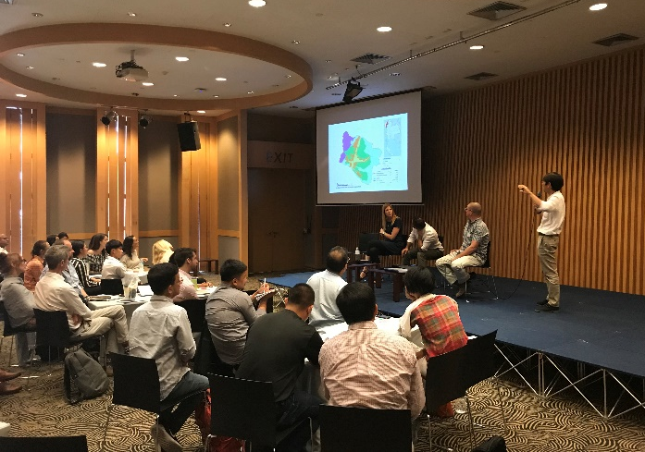
A.4 PICTURES
