

Shelter Cluster Nepal
ShelterCluster.org
Coordinating Humanitarian Shelter

DRAFT FOR CONSULTATION

Shelter Cluster Nepal Contingency Plan for the Coordination of Shelter Preparedness and Response in Nepal

August 2009
Updated 2011
Updated January 2014
Updated (draft for consultation) May 2018

Proposed next revision: May 2019

Acronyms

CNDRC Central Natural Disaster Relief Committee
CP Contingency Plan
CCCM Camp Coordination and Camp Management
DDRC District Disaster Relief Committee
DUDBC Department of Urban Development and Building Construction
EOC Emergency Operation Center
ESC Emergency Shelter Cluster
GoN Government of Nepal
IASC Inter-Agency Standing Committee
IFRC International Federation of Red Cross and Red Crescent Societies
INGO International Non-governmental Organizations
IOE Institute of Engineering
HCT Humanitarian Country Team
LC Logistic Cluster
MoHA Ministry of Home Affairs
MoFALD Ministry of Federal Affairs and Local Development
MoUD Ministry of Urban Development
NDRF National Disaster Response Framework
NFRIs Non-Food Relief Items
NGO Non-Governmental Organization
NEOC National Emergency Operations Centre
NRCS Nepal Red Cross Society
NSET National Society for Earthquake Technology-Nepal
SAG Strategic Advisory Group
SC Shelter Cluster
UN-HABITAT United Nations Human Settlements Programme
UN OCHA United Nations Office for Coordination of Human Affairs
UNDP United Nations Development Programme

Table of Contents

Acronyms
1. Introduction
2. Hazards and Risk Analysis
3. Disaster Scenarios
4. Objective and strategy:
5. Overall management and Coordination arrangements
6. Response and Preparedness Plans
7. Key Common services
8. Security
9. Media Relations, Information, and Public Information
10. Preparedness Actions
11. ANNEXES

Introduction
The Shelter Cluster is an emergency coordination platform that supports the Government of Nepal to meet the immediate shelter needs of people affected by disaster. The Shelter Cluster provides coordination support in three key areas:

- The development of an overall strategic direction for humanitarian shelter response;
- The development of agreed technical guidelines to ensure consistency of response across agencies and geographical areas; and
- Analysis of humanitarian needs and gaps through information management.

Specifically, the Shelter Cluster seeks to ensure coordination around each element of the humanitarian programme by:

- Supporting service delivery that is driven by the agreed strategic priorities and avoids duplication.
- Informing strategic decision-making of the HC/HCT for the humanitarian response through coordinated needs assessment and analysis.
- Planning and strategy development for the sector, in accordance with existing standards and guidelines and including clarifying funding requirements, prioritisation and the cluster’s contribution to overall humanitarian funding considerations.
- Advocacy, both identifying concerns and undertaking advocacy activities.
- Monitoring and reporting on the implementation of the cluster strategy.
- Contingency planning/preparedness/capacity building in situations where there is a high risk of recurring or significant new disasters (and where there is capacity to do this).

This document builds on existing contingency planning processes through the Government of Nepal and the UN Resident Coordinator’s Office. The document outlines most likely disaster scenarios in Nepal, their likely impact on humanitarian shelter needs and how the shelter cluster will support the Government of Nepal in coordinating the humanitarian response. In this context, it is noted that the Government of Nepal is currently revising its federal structure and disaster management functions. The next revision is proposed for May 2019 in order to capture rapid changes in roles, structure, and responsibilities of government agencies in disaster management.

The target audience for this document is all humanitarian stakeholders in the Nepal, notably regional, national and local NGOs, UN agencies, National Disaster Management Offices, donors and the Red Cross Movement. This guide is also a reference document for line ministries involved in disaster preparedness and response.

The contingency plan is maintained and updated by the Shelter Cluster lead agency: the Nepal Red Cross Society (NRCS), supported by the International Federation of Red Cross and Red Crescent Societies (IFRC). This contingency plan is a living document updated regularly. Lessons learned from previous disasters are reflected and included in the updates. This contingency plan was drafted in August 2009, updated in 2011, 2014 and 2018. The next revision is scheduled for May 2019.

Context Analysis, Hazards and Risk
Nepal is exposed to a variety of natural hazards and human induced disasters. More than 80 percent of the total population of Nepal is at risk of natural hazards; such as floods, landslides, windstorms, hail storms, fires, earthquakes and Glacial Lake Outburst Floods (GLOFs). The country is among the 20 most disaster-prone countries in the world, with a high probability of earthquakes and landslides as well as regularly recurring severe flooding. Floods and earthquake, have the highest recorded impact on shelter. Further hazards with comparatively high impact on shelter are landslides and fire.

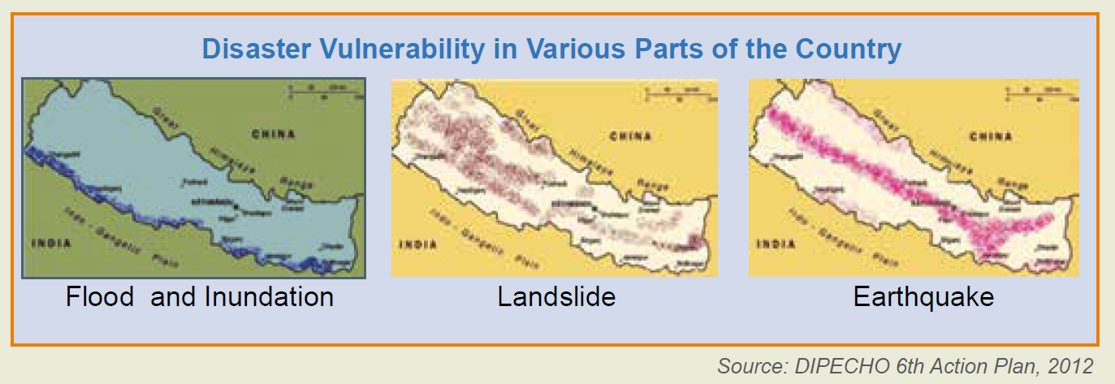

To get a general perspective of the frequency of different disasters, the number of families affected and the number of houses affected by per type of events data from the Nepal disaster reports 2013, 2015 and 2017 DRAFT has been analyzed. These reports present data collected since 1971.
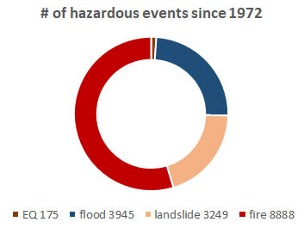
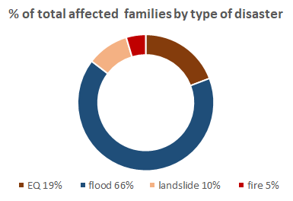

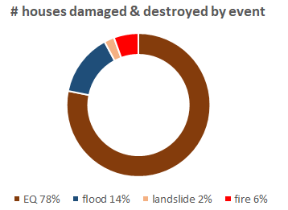
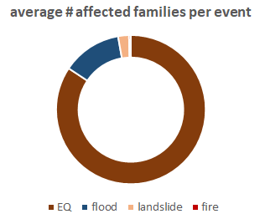

Earthquake and Flooding:
As the statistics show flooding has affected the highest number of families over the course of the years (66% of all families registered affected since documenting), and continues to affect families as it occurs rather predictably every year during monsoon season, although with different intensity. Earthquakes by far effect the highest number of families per single event and cause the most damage to housing and other building stock, but occur much less frequently and unpredictably.

The Government of Nepal in agreement with the Humanitarian Country Team (HCT) have chosen to focus on Earthquake and Monsoon Flooding as scenarios to be used for contingency planning.

Disaster scenarios
The following scenarios for the contingency plan are based on experience and data from the 2015 Ghorka EQ and trends analysis of recent flood events. The Flood scenario is in line with the HCT contingency planning scenario. The EQ scenario will be updated to align with HCT scenario once it is confirmed.

Major earthquake in Western Districts of Nepal
A large earthquake is most likely to occur in the Western Provinces of Nepal. The districts with highest earthquake vulnerability are Mugu, Kalikot, Pyuthan, Jajarkot. The scale and effect of such an event could be comparable to the 2015 Ghorka EQ, maybe with even more challenges regarding accessibility and vulnerable populations.

Areas affected: Western Provinces of Nepal, namely provinces Karmali Pradesh and 6, as well as 5 and 7

Affected population: Approximately 5 million

‘Worst-case’ scenario disaster impacts:
- A major EQ with several aftershocks throughout the western Districts of Nepal’s hill and mountain districts, causing some 10,000 fatalities and 25,000 injured.
- 800,000 houses destroyed or badly damaged with approximately 50% of total damage occurring in urban areas.
- In hilly and mountainous areas, key access roads, bridges and many airfields are covered by landslides or structurally unsafe for days or weeks blocking access to affected areas and rendering distribution of relief materials to very challenging.
- Breakdown of communications and information networks complicates exchange of information, collecting first assessments, coordination of arriving actors and hinders identification of needs and managing supplies of relief materials and services.
- District coordination structures weakened by loss of administrative buildings and government employees not reporting to work as they are also affected.
- Especially densely built up urban areas heavily affected with approx. 70% of the housing stock in urban areas will collapse or be uninhabitable, leading to substantial urban displacement.
- Winter approaching adding risk to life and health to inadequately sheltered populations.

Assumption: Government of Nepal will call for international assistance.

Floods in the Terai
Flooding in Nepal is becoming an annual episode particularly in the Terai region displacing tens of thousands of families for weeks. Flooding often lasts for weeks, damaging and destroying homes and livelihoods as well as public infrastructure, roads and bridges and causing additional health hazard due to waterborne diseases, flooded sanitation facilities disruption of drinking water supply.

The HCT’s contingency planning efforts focus on the annual hazard of flooding in seven provinces with a specific focus on highly flood prone municipalities, rural municipalities and metropolitan locations in the Terai. The HCT’s planning assumptions for 2018, which are based on a trend analysis of previous flood events, include:

Areas affected: Provinces 2 and 5 (Banke, Bara, Bardiya, Chitwan, Dang, Dhanusha, Jhapa, Kailali, Kanchanpur, Kapilbastu, Mohattari, Morang, Nawalparasi, Parsa, Rautahat, Rupendhi, Saptari, Sarlahi, Siraha, Sunsari, Surkhet and Udaypur).

Affected population: Approximately 1.26 million people.

‘Worst-case’ scenario disaster impacts:
- An overall of 1.26 Mio people affected by the floods
- 21,000 Houses destroyed and/or submerged under flood waters causing displacement of those HH for short term -until the floods recede and people can return- and even long-term for HH whose houses and land may have been washed away or destroyed by landslides triggered by the heavy rains.
- Heightened exposure to protection risks for vulnerable groups particularly single women, children, elderly and physically disabled persons. Specific social and caste groups are also exposed to increased protection risks during times of crisis.
- Critical infrastructure including bridges, roads, airports and electricity and communication networks sustain major damage and in some cases are inoperable for 2-3 weeks
- Road links to India and within specific areas of Nepal are rendered impassable.
- Schools and health facilities damaged and destroyed and related service provision impeded.
- Water and sanitation facilities destroyed leading to an increased risk of disease outbreaks both water and vector borne diseases.
- Agricultural livelihoods adversely affected as large areas of standing crops are flooded and destroyed. Significant numbers of livestock and poultry killed by flood waters in addition to fish ponds destroyed. This has knock-on consequences for food security and nutrition.
- Local government services severely impacted.

Assumption: Government of Nepal will lead the response with support of the HCO and the Clusters without requesting international assistance.

Risks and challenges related to the provision of SHELTER & basic household relief items (NFRI)

Common to both flood and EQ scenarios
Assumption | Consideration/impact
Destroyed or blocked transportation infrastructure (roads, bridges) | Access to affected areas blocked or very difficult:  - delay of first assessments due to lack of access  - constraints to transport relief items delays the provision of NFI’s and emergency shelter.
Damage to electricity supply networks and breakdown in telecommunication | No communication with affected areas:  - delay of first needs assessment data from field  - very little coordination between district, province and national level during first days/week
Shortage of transport capacity due to high demand | ‘Competition’ amongst Clusters and agencies:  - need for close coordination with other Clusters and clear prioritisation of first live savin support items  - Logistics Cluster activated to provide additional transport capacity and logistics coordination
Families who have lost their house (or house is inaccessible) will have different shelter needs and coping strategies. Some will set up emergency shelter in safer locations, others will seek shelter in camps and collective centres or try to leave the affected areas to seek shelter with families and friends. | The affected populations might be scattered in different locations, which makes identification of beneficiaries and supply of well targeted relief more challenging. Families need shelter support targeted to where they are and what they need:  - emergency shelter kits and NFIs  - allocation of safe sites for camps  - provision of collective centres in safe structures  - support for people who have left the affected areas (IDPs)
Lack of prepositioned shelter relief and NFI stock in country | - only a very small number of most vulnerable families in need of shelter can be supported with a minimum  - critical support for seasonal adaptation (e.g. winter kits) is not available
Restructuring of government to federal system not yet completed leaving confusion over responsibilities and HR gaps in disaster management | - Lack of clear coordination mechanisms and leadership to guide the response on field leads to uncoordinated possibly inadequate and inequitable support.  - lack IM capacity mainly on field level results in poor assessments, lacking mapping of response will result in haphazard coverage, leading to duplication and gaps in coverage.
public/communal buildings and communal grounds (e.g. schools, community centre, stadion etc.) will be made available for “emergency response” | - occupation of safe public buildings ( e.g. schools, etc.) for collective centres impedes the use for the normal functions and can have adverse effects on recovery
No relevant funding pledged for the shelter response | - Lack of appropriate emergency shelter support will significantly increase vulnerability of affected families towards health and protection risks.  - overall recovery efforts will be significantly delayed as families have to invest potential resources in securing basic shelter.
Major access roads to bordering countries (mainly India) might be damaged by the disaster or closed due to political tension | bottleneck in the supply chain of relief items and basic commodities needed for operations (e.g. fuel)
knock-on effects of the disaster (landslides, loss of land through flooding etc.) cause permanent destruction of housing and land | affected families/communities need to be relocated to safer grounds and are willing to:  - challenge to find land and resolve HLP issues  - additional efforts needed to provide shelter & settlements (e.g. community infrastructure, livelihoods etc.) recovery support

Specific to earthquake
Assumption | Consideration/impact
Large amounts of rubble from collapsed buildings and infrastructure. | - Rubble blocking access as well as sites impedes the provision of shelter relief and cause restriction in providing space to accommodate emergency shelters.  - Rubble removal, recycling and disposal has a major impact on the response and recovery efforts
uncertainty about the level of safety (structural damage) of buildings and infrastructures | - Families returning to or sheltering in buildings that are structurally damaged and unsafe are at high risk  - High risk also to surrounding buildings or people sheltering close to hazardous buildings at risk of collapse  particularly in affected urban areas:  - high number of affected renters from collapsed or damaged multi-storey buildings complicates providing shelter assistance  - high challenge for safe demolition to mitigate further risk and free the way for recovery
Only 25% of buildings remain structurally safe | - lack of housing and operational facilities also for relief providers and government  - high competition over “safe buildings” and what uses to prioritize (e.g. to use for emergency health facilities, collective shelter, or emergency coordination command centres)
GoN will request international support | - GSC will deploy surge capacity and mobilize further capacity to reinforce the team as per identified need  - a considerable number of new actors not familiar with the context will arrive adding challenges to coordination

Specific to floods
Assumption | Consideration/impact
Houses are flooded and inaccessible for several weeks; | - Affected populations will leave the or need to be evacuated from flooded areas and need to emergency shelter for the duration of the flooding.  - Scale of housing damage can only be assessed after waters recede
Water supply and sanitation facilities are flooded increasing risk of disease outbreaks both water and vector borne and resulting in lack of drinking water | - Restoration of water and sanitation facilities should to be included in any shelter recovery support  - Close coordination with WASH actors needed especially for the recovery phase
Houses of affected populations are located in flood prone areas and at risk of future flooding | Any investment in recovery of houses in hazard prone areas is at high risk:  - Consider introducing and promote adequate flood mitigation measures for the houses (raised plinths, stilts, or flood protection infrastructure) as Technical assistance for recovery  - for extremely hazardous site, consider relocation support of feasible
GoN will not request international assistance | - Cluster has to function with in country capacity relying highly on agency staff made available to support district and provincial level coordination

Contingency Plan Objectives and Strategies

- To model most likely emergency scenarios and to outline coordination arrangements and preparedness actions to ensure a response that addresses the shelter needs of vulnerable people and communities;
- To promote cooperation and coordination among relevant organizations, including the Government of Nepal, NGOs,INGOs, UN Agencies, and the private sector.
- To provide agreed minimum technical packages for emergency and recovery shelter and winterisation to guide the initial shelter response.

As a coordination platform the Nepal Shelter Cluster, in conjunction with the Government of Nepal, has the following roles and responsibilities in preparedness and response.

Strategic direction:
  - Develop response strategy that identifies needs, gaps, vulnerabilities, and resources in order to ensure an overall response that is coherent, effective, and targeted in consultation with an inclusive Strategic Advisory Group.
  - Support the Government of Nepal respond effectively to natural disasters at national and sub-national levels through strategic direction, technical advice, and information management support.
  - Provide a coherent, consistent and inclusive framework for response coordination for humanitarian agencies including NGOs, INGOs, UN Agencies, and the private sector.
  - Identify and develop institutional relationships, common approaches, and appropriate fora (strategic advisory groups, technical working groups) to ensure participatory problem-solving for ongoing and emerging humanitarian needs.
  - Promote longer-term recovery from the earliest stages of the response and identify key partners and institutions that can continue to recovery programming and coordination beyond the emergency phase.

Technical Guidance:
  - Agree on standardised technical approaches to emergency and recovery shelter and winterisation packages.
  - Agree cash equivalents to emergency and recovery shelter and winterisation packages, as well as guidance on the appropriateness of cash interventions in specific disaster contexts (for example distance from markets, absence of banking facilities, impact on price inflation).
  - Develop framework for analysing the contribution of technical assistance packages to emergency response and recovery.
  - Call for and manage Technical Advisory Groups to address specific technical needs for response as they arise.

Information Management:
  - Provide overall analysis of humanitarian needs and gaps.
  - Develop an agreed template for tracking ‘who, what, where’ information to manage, account for, and monitor response and recovery needs, gaps, and relief distribution.
  - Develop a means of tracking, analysing, and accounting for the provision of technical assistance.
  - Develop tools and collaboration with the Cash Working Group and other clusters to track, monitor and account for the distribution of cash across sectors.
  - Lead the development of assessment tools and methodologies to establish emergency and recovery needs and gaps.
  - Contribute to the development of approaches to outcome monitoring to understand better the quality of shelter recovery.

Overall Management and Coordination arrangements
As the ultimate coordinator of all actions involved in an emergency response, the Government of Nepal holds the responsibility for disaster prevention, mitigation, preparedness, response and recovery.
The MOHA is the focal ministry for emergency response assisted by the relevant line ministries. The Department of Urban Development and Building Construction (DUDBC) under the Ministry of Home Affairs (MOHA) is the focal department for coordination of shelter activities. NRC supported by IFRC acts as convener of the shelter cluster.

Nepal Coordination Structure
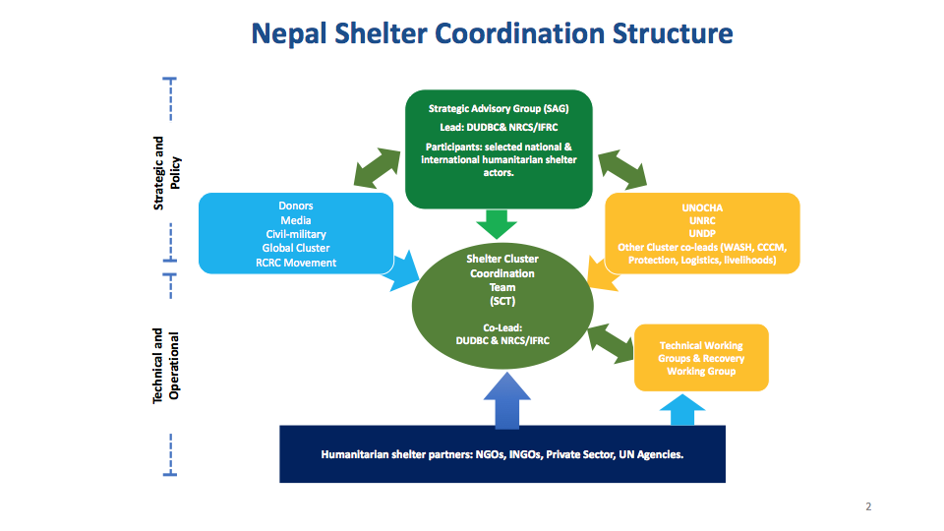

Lead and Co-leads
• Cluster lead: The Government of Nepal, the Department for Urban Development and Building Construction (DUDBC)
• Co-lead: International Federation of Red Cross and Red Crescent (IFRC)/Nepal Red Cross Society (NRCS)

Shelter Cluster partners
• Shelter Cluster partners are those agencies, organisations and individuals providing shelter assistance that are reporting their activities through the Shelter Cluster and have joined the mailing list.

Strategic Advisory Group (SAG):
• Highest level decision-making body.
• To review / approve official Shelter Cluster strategies, approaches and key documents.
• To provide guidance and support to the Shelter Cluster Coordination team, providing inputs into strategies, approaches and key documents prior to review by the SAG.

Technical Working Groups (TWGs):
• TWGs to be determined and tasked by SC technical coordinators based on requests from SC partners and with approval from the CSG and/or the SAG, activated with a TOR listing clear and time-bound objectives and outputs.
• Facilitated by Shelter Cluster partners, supported by Shelter Cluster Technical Co-ordinators as appropriate.
• Composition will be limited to agencies with relevant expertise/interest in the topics, as identified in the TOR or at the discretion of the facilitator.

Recovery Working Group (RWG):
• To facilitate connections between emergency and recovery programming, the Shelter Cluster may convene a Recovery Working Group to plans for longer-term interventions.
• Comprised and led by partners engaged in the longer term recovery process.

Sub-national Coordination:
• Shelter Cluster Focal Points to support coordination at sub-national level supported by other agencies and/or supported by the Shelter Cluster (see Terms of Reference: https://www.sheltercluster.org/nepal-earthquake-2015/documents/tor-districts-focal-points)

Outline of roles and responsibilities

 | Organization | Responsibility
 | Organization | National | Global
1 | Ministry of Home Affairs (MoHA). | Overall responsible Ministry for disaster risk management/response.
2 | Ministry of Urban Development (MoUD). | Government lead ministry for shelter response.
3 | Department of Urban Development and Building Construction (DUDBC). | Government lead agency for shelter cluster for emergency to recovery.
4 | International Federation of Red Cross and Red Crescent Societies (IFRC). | Lead agency to coordinate emergency shelter with humanitarian partners at national to international level. | Global convener of the shelter cluster for natural disaster in non-conflict areas.
5 | Nepal Red Cross Society (NRCS). | Co-lead agency and focal organization for small and medium scale disasters for emergency shelter.
6 | Recovery Working Group | Working Group led by and comprised of agencies working toward longer-term recovery. | Focal point for recovery and settlement in Shelter Cluster under the Government/UNDP led recovery network.
7 | (I)NGOs and other UN agencies and donors. | Operational partners and members of the shelter cluster.
8 | The UN Humanitarian Coordinator (HC) is responsible for coordinating the HCT emergency response. Under the guidance of the HC, the HCT is responsible for the effective and efficient implementation of inter-agency disaster management activities in Nepal.

Principles
• Cultural: Respect expression of cultural identity and ways of life using locally available material, design, and technologies.
• Local context: Addressing the particular needs of communities and households such as Hard to Reach, Rural and Urban context.
• Environmental: Minimise adverse impact to and from the local and natural environment, enhancing the environment where possible, reusing and salvaging materials where possible.
• Alignment: With best practice, laws, regulations, policies and code agreed through the humanitarian response plan and mechanisms agreed at cluster levels.
• Coordination: With DUDBC, local government (CDO, DDRC, DDC, and DTO), coordinating agencies and other actors to avoid overlapping, gaps and ensure efficiency.
• Transition: Ensuring a smooth transition from emergency and relief phases supporting self-recovery and building to permanent solutions. Avoiding households becoming “stuck” on their pathway to recovery.
• Markets: where appropriate (where markets are able to provide items in sufficient quality and quantity) cash and / or vouchers support local procurement and local trade.
• Life Saving: Ensuring that households in priority caseloads are supported to design, rebuild and maintain their shelter and settlements in ways that promotes resilience to future hazards
• Participation and Consultation: Ensuring participation of affected populations at all stages of a shelter solution, suing a process driven and inclusive approach, including involvement in assessments, procurement, design, construction, monitoring and evaluation.
• Integrated Software and Hardware approach: Ensure that software (for example, community training sessions in the use of materials distributed) is integrated into assistance to ensure the quality of assistance.
• Engagement: Shelter assistance solutions should be negotiated with local government, addressing specific vulnerabilities, hazards, local policies and capacities, actively engaging affected communities in the discussion of their future and planning for permanent solutions.
• Accountability & Transparency: particularly to affected populations, should be mainstreamed in all shelter programs from the beginning.
• Protection, Safety And Security: Programs must ensure that human rights are respected
• Gender & Diversity: Women, men, girls and boys of different ages and backgrounds have distinct needs and capacities and it is vital that shelter programmes incorporate these into the design and implementation of projects.
• Vulnerability: The most vulnerable members of the affected population are identified, prioritised and appropriate solutions are found to target specific needs that are suitable to specific contexts.
• Livelihoods: Ensuring that programmes are designed with an understanding of livelihoods and markets, which are supported and kick-started through the emergency and relief phases, through markets, labour, transport and other opportunities.
• Evaluation: Determining whether appropriate outcomes have been achieved will include evidenced based triangulation of input from household-level surveys, community-level participative approaches, along with the reporting of agencies to the Shelter Cluster and the Government.

Cross-cutting Issues
For more information refer to Shelter Cluster Nepal Earthquake 2015 – Cross Cutting Issues – https://www.sheltercluster.org/response/nepal-earthquake-2015

Gender and Diversity
Understanding that females and males of all ages, including those with specific needs, face different obstacles can help the development of more effective programmes and ensure that people’s needs are met. Consequently, emergency response [shelter] programming needs to be tailored to meet the specific and diverse needs of all. This is achieved through consultation and gender and diversity analysis, design and implementation. Adopting a gender and diversity perspective also highlights opportunities and resources that support reconstruction and recovery efforts.. Of particular concern in Nepal are the disproportionately high number of female headed households (as much as 20 percent in some areas) owing to male labour migration. The Shelter Cluster will take a ‘do no harm’ approach to ensure that the distribution of relief and recovery does not exacerbate gender based violence.

The Shelter Cluster acknowledges structural causes of injustice and that disadvantaged groups can experience multiple forms of exclusion. The Shelter Cluster is committed to be inclusive and enable the full and equitable participation of women and men, people with disabilities, indigenous and minority communities and Dalits in all programs and decision-making processes.

Disability
The Shelter Cluster promote socially inclusive shelter programming that ensures the participation of people living with disabilities in all aspects of relief and recovery planning, design, implementation and monitoring.

Environment
When planning, designing, and implementation shelter programmes, it is important for shelter agencies to consider the environment throughout the programme cycle. This includes relief programmes and longer-term recovery programmes. Good environmental planning of projects supports disaster preparedness and reduces exposure to natural hazards and therefore mitigates against the risk and decreases households and communities vulnerability. This is especially important given existing levels of deforestation in Nepal.

Housing, Land and Property
Security of land tenure is essential to effective humanitarian action and can promote early and longer term recovery. Equally, insecure land tenure or displacement can undermine recovery. Where possible, the Shelter Cluster will work with partners to ensure housing, and property obstacles to recovery are addressed so that people whose houses have been lost can begin to rebuild with certainty.

Response and Preparedness Plans

Preparedness activities for both scenarios
Timeframe | preparedness Activities | Who is responsible
before onset of monsoon/ flood season;  continuous | map agency presence (field offices), and HR capacity that could be made available by agencies for coordination, IM, technical and assessment, as well as advisory roles such as gender, HLP, environment, communications. | Cluster focal point & partners
before onset of monsoon/ flood season;  continuous | identify gaps in capacity and train relevant staff where possible (e.g. organize joint trainings for IM, coordination etc.) | Cluster focal point & partners
before onset of monsoon/ flood season;  continuous | develop and share ToR for agency staff made available in support of the Shelter Cluster (e.g. as district coordinators). Develop a roster of trained and deployable national staff, agree modalities and set up pre-agreements for such support roles. | Cluster focal point with GSC team support and partners
before onset of monsoon/ flood season;  continuous | endorse joint needs assessment format and commit to use it | Cluster focal point & partners
before onset of monsoon/ flood season;  continuous | train (or refresh) volunteers and staff on agreed assessment formats | Cluster partners
before onset of monsoon/ flood season;  continuous | conduct coordination training and field simulation to test coordination mechanisms | Cluster focal point with GSC team support and partners
before onset of monsoon/ flood season;  continuous | map in country stockpiles of emergency shelter and relief items | Cluster focal point & partners
before onset of monsoon/ flood season;  continuous | refill and maintain stocks with agreed emergency and recovery shelter kits and NFI; especially in the provinces at risk | Cluster partners
before onset of monsoon/ flood season;  continuous | identify suitable premises from which the CLuster should ideally operate from at Kathmandu level (NRCS office, DUDBC, UN offices…?) | Cluster focal point & IFRC HoD
before onset of monsoon/ flood season;  continuous | conduct market and supply chain assessment for relevant NFI and shelter items (e.g. tarpaulins, blankets, kitchen sets, bamboo); Aim to develop pre-agreements (for procurement and/or stocking) with suppliers of most relevant shelter / NFI stocks. | Cluster partners
before onset of monsoon/ flood season;  continuous | finalize standard shelter & NFI kits, and emergency shelter model designs and get final MoHA (?) approval; disseminate to all cluster partners | Cluster focal point & partners
before onset of monsoon/ flood season;  continuous | agree on the technical assistance to be provided together with shelter materials (IEC, short trainings, model shelter construction) | Cluster focal point & partners
before onset of monsoon/ flood season;  continuous | disseminate guidance on cash for shelter; agree on conditions | Cluster focal point
before onset of monsoon/ flood season;  continuous | assess feasibility of cash transfer programs in the different areas at risk. Where feasible, consider setting up pre-agreements with suppliers (banks) | Cluster partners
before onset of monsoon/ flood season;  continuous | Map private sector capacity and start dialog to include relevant actors in the Cluster | Cluster focal point/ interested partner
before onset of monsoon/ flood season;  continuous | share experience/discuss how to utilize manageme new/untrained volunteers during the emergency response | Cluster focal point/NRCS, interested partners
before onset of monsoon/ flood season;  continuous | Develop a mechanism for beneficiaries´participation/feedback/complaints with regard to the quality / quantity/ availability of emergency shelter/ NFIs | Cluster focal point & partners
before onset of monsoon/ flood season;  continuous | regularly liaise with donors to advocate for the importance of shelter & stay updated on funding mechanisms and opportunities | Cluster focal point & GSC team
before onset of monsoon/ flood season;  continuous | Get clarity (ideally an official statement) from GoN on taxation policies for emergency shelter and relief items | HC (supported by Cluster focal point, NRCS and IFRC)
before onset of monsoon/ flood season;  continuous | Advocate with relevant authorities of GoN the possibility to introduce regulatory policies to prevent price hike of shelter & relief items after a disaster (cap prices at fixed level) | HC (supported by Cluster focal point, NRCS and IFRC)
before onset of monsoon/ flood season;  continuous | pre-discuss possible arrangements for transition from emergency to recovery (e.g. handover to HRRP) | Cluster focal point

  - Emergency response

Earthquake scenario : The following table outlines the activities of the shelter cluster in the event of activation of international assistance following a major earthquake:
Timeframe | Response Activities | Who is responsible
0 hrs – 1 week  set up Coordination structure  coordinate first assessments  draft first response strategy  appeal for funding | GoN activates state of emergency and requests international support and activation of the Cluster system | GoN, HC
 | deployment of Shelter Cluster core coordination Team to set up a efficient coordination structure on all levels (National, Provincial, District) with support from work with partner agencies | IFRC, Cluster Coordinator
 | set up first IM structure to support data collection and analysis | Cluster IM
 | contribute to and participate in first joint needs assessments | Cluster IM & partners
 | coordinate and liaise with all relevant stakeholders (GoN,Donors, media, other Clusters, partners, etc.) | Cluster Coordinator
 | draft initial emergency response strategy for shelter | Cluster Coordinator, SAG, partners
 | provide shelter input for CERF, Flash Appeal, IFRC DREF and Appeal, and other possible funds | Cluster Coordinator, SAG, Par
 | support registration of new actors and aim to assure coordinated first responses | Cluster Coordinator, IM, partners
 | initiate and coordinate first response (distribution of stocks) and launch procurement for further relief items | Cluster Coordinator & partners
1 week - 1 month | establish and staff Cluster coordination structure on field level in close collaboration with and in support of government coordination structures; set up necessary coordination and reporting | GoN, Cluster Coordinator, partners
1 week - 1 month | Create and coordinate Technical Working Groups as per need (e.g. on technical support, specifications, etc.) | Cluster lead, GoN and cluster members
1 week - 1 month | plan for more detailed assessments as per need (e.g. market analysis, damage assessments, beneficiary satisfaction etc.), agree on criteria, methodology etc. | Cluster members
1 week - 1 month | start mapping of partner agencies response (§W), analyse data, provide information on gaps or overlaps | Cluster IM & partners
1 week - 1 month | review and update shelter strategy as required including agreed core / minimum package of socio-technical assistance for housing recovery http://www.hrrpnepal.org/upload/resources/6lpmjTYZ5Rc9BQFioLJx_2017_11_15.pdf | Cluster Coordinator, SAG, partners
1 week - 1 month | reinforce Coordination team as per identified need (e.g. recovery advisor, environmental advisor, comms advisor, govt Liaison officer, more IM or technical capacities etc.) | Cluster Coordinator, IFRC
1 month – 6 months or longer  as per need | Continue coordination on National, Provincial and District level | Cluster Coordinator, partners
1 month – 6 months or longer  as per need | coordinate detailed assessments (e.g. REACH) and share analysis | Cluster Coordinator, SAG, partners
1 month – 6 months or longer  as per need | review shelter strategy to include recovery (if not yet included) | Cluster Coordinator, SAG, partners
1 month – 6 months or longer  as per need | develop relevant technical guidance (e.g. training, material specs, shelter designs, etc.) through TWIGs as per need | Technical Coordinator & partners
1 month – 6 months or longer  as per need | Assure monitoring and evaluation of shelter response | IM & partners
1 month – 6 months or longer  as per need | identify key issues and advocate with relevant stakeholder | Cluster Coordinator, partners

Flood scenario : The following table outlines the activities of the shelter cluster in the event of a major flood-response handled on National level without request international assistance:
Kathmandu (National level)
Timeframe | Response Activities | Who is responsible
0 hrs – 1 week | GoN activates state of emergency for affected areas and call on in country Cluster representatives to support disaster Management with coordination on all levels | GoN
0 hrs – 1 week | mobilize all partners’ available capacities to establish and staff an efficient Shelter Cluster coordination structures on all relevant levels, in close collaboration with and in support of government coordination structures; set up necessary coordination and reporting mechanisms | Cluster focal point (IFRC), NRCS & partners
0 hrs – 1 week | identify capacity gaps and request support from IFRC surge capacity as per need | Cluster focal point (IFRC)
0 hrs – 1 week | establish IM structure for data collection and analysis | IM/relevant govn. body
0 hrs – 1 week | contribute to and participate in first joint needs assessments | IM & partners
0 hrs – 1 week | coordinate and liaise with all relevant stakeholders (GoN,Donors, media, other Clusters, partners, etc.) | Cluster focal point (IFRC)
0 hrs – 1 week | draft initial emergency response strategy for shelter including agreed core / minimum package of socio-technical assistance for housing recovery http://www.hrrpnepal.org/upload/resources/6lpmjTYZ5Rc9BQFioLJx_2017_11_15.pdf | Cluster focal point (IFRC), SAG, partners
0 hrs – 1 week | initiate and coordinate first response (distribution of stocks) launch procurement for further relief items | Cluster focal point (IFRC) & partners
1 week - 1 month | coordinate scale up of operations on all relevant levels (national - district) | Cluster focal point (IFRC)
1 week - 1 month | Create Technical Working Groups as needed (e.g. HLP, standards for reconstruction, etc.) | Technical coordinator & partners
1 week - 1 month | revise and update Shelter Cluster strategy (in coordination with the field) including recovery. | All
1 week - 1 month | Continue 3W reporting, data analysis and information sharing | IM & partners
1 week - 1 month | set up monitoring and beneficiary accountability mechanisms | partners, IM
1 week - 1 month | coordinate detailed assessments (according to agreed criteria and indicators) as per need | IM, partners
1 -3 months  or longer if needed | Identify and gain agreement with lead agency for shelter early recovery coordination | Cluster focal point (IFRC), relevant Government counterpart, HRRP
1 -3 months  or longer if needed | support continuous monitoring and evaluation of shelter interventions | IM, partners
1 -3 months  or longer if needed | address cross cutting issues (e.g. environment, gender, protection) and support | Cluster focal point (IFRC) & relevant partners

- Response Modalities

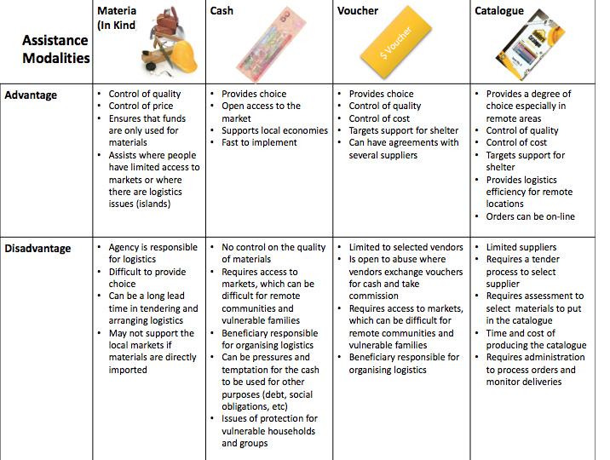

Media Relations, Information, and Public Information

Purpose | Organisation | Activity
General shelter advocacy & awareness raising | Local & international media:  radio/television/newspapers | · Interviews with media outlets  · Newspaper articles (online & print)  · Feed stories to journalists
Communication of Cluster Strategy | Shelter Cluster, SAG & Govt of Nepal, UN System | · Discussion/presentation in SAG & at Cluster meetings  · Promotion through UN system: HCT, humanitarian bulletins  · Brief note/presentation to donors
Communication with partners | Participating humanitarian organisations | · Cluster meetings  · SAG/TWiG  · Cluster website  · Mailing list  · Consistent messaging with sub-national hubs.
Communicating with communities | Cluster agencies, hub coordinators, CWC Working Group, BBC Media Action, Common Feedback Project | · Develop Shelter CWC Working group  · Develop system of two-way communication with agencies, especially at hub-level (eg. talk back radio, local papers).
Feedback & accountability | Common Feedback Project, Cluster Assessment Teams (eg. REACH), Voice of Senior Citizens Nepal, BBC Media Action | · Engage with agencies & programs consulting communities.  · Provide questions and issues for feedback.  · Include local NGOs at all levels of cluster decision-making.  · Include beneficiary representatives in cluster decision-making, especially at hub-level.

ANNEXES

ANNEX 1: agreed shelter needs assessment format

to be included once finalized

ANNEX 2: agreed emergency shelter and essential household NFRI kit content (minimum life saving) with basic specs.
Kits based on a family size of an average size up to 6 persons.
Sn | Items | Specification | Unit | Quant.
1 | Tarpaulin | Woven high-density polyethylene (HDPE) black fibers fabric laminated on both sides with low-density polyethylene (LDPE) coating; Size (12'x18') m; Weight: 5 kg; No welding is allowed in the middle of the sheet; Number of eyelets 18;  for more detailed specs see tarpaulin int. specs. | pc | 2.00
2 | Nylon rope | 8mm dia; Polypropylene recycled fibers UV stabilized; minimum 3 strands; color black/blue; Packed in roll | kg | 1.5
3 | Blanket | 80% wool, 1.5mx2.25m, high thermal resistance | kg | 2
4 | foam (mattress) | closed cell PPE (Polyphenylene Ether), min. density 27 kg/ m3; min thickness 12mm, size according to blanket | pc | 6
5 | kitchen set | as specified in ANNEX 2a | pc | 1
6 | Water Bucket | Capacity : 20 liters, Heavy duty food grade HDPE with metal handle, Weight 900 gm (± 5 gm) including lid and handle | pc | 1
7 | Female Sari | Width 110-115 cm, Length 5 m; 100% cotton | pc | 1
8 | Male Dhoti or Lungi* | Width 110-115 cm, Length: 4.5 m 100% cotton | pc | 1
9 | Teri-Cotton Cloth | 65% cotton and 35% polyester (?) Width: 115 cm (45 inch) x length 5m | m2 | 5.75
10 | Print Cloth | 65% cotton and 35% polyester, Width: 100 cm (40 in)x length 7m | m2 | 7
11 | Plain Cloth | 100% cotton, Width: 100 cm (40 in)x length 6m | m2 | 6
12 | Packaging Bag | woven polypropylene; Size app. 1300x400mm (confirm with items to be packed); with eyelets and 4 mm dia nylon rope on top to tie | pc | 1

optional items to be added as per need and capacity
item | suggested specs
solar lamp | 12 leds, built in solar panel, 2 AAA batt; more detailed specs
stove | Nepal Shelter Cluster recommendation
fuel
winterisation kits | Nepal Shelter Cluster winterisation guidance

ANNEX 2a proposed specifications for Kitchen set:
S.N. | Description | Inner dia.  (mm) + 1% | Depth mm) | minimum Weight (g) | min thickn. (mm) | quant.
1.(a)  (b)  (c) | A-Class Dekchi  Cover  B - Class Dekchi  C - Class Dekchi  (Aluminium/rust proof) | 225  225  170  160 | 105  -  83  75 | 350  150  180  175  =855 | 2.0  1.2  1.0  0.7 | 1 Pc  1 Pc  1 Pc  1 Pc
2. | Dinner plate  stainless steel/ rust proof | 280/220 | 32 | 205x3 =615 | - | 3 Pcs.
3. | Cup with hem (Kachaura)-  Stainless steel/rust proof | 90 | 36 | 75x2 =150 | 1.2 | 2 pcs.
4. | Glass with hem-  Stainless steel/rust proof | 70/50  Top x bottom | 80 | 50 x2 =100 | 1.2 | 2 pcs.
5. | Dadu-  Stainless steel/rust proof | - | - | 105 |  | 1 pc
6. | Panyu (Spoon) Stainless steel/rust proof | - | - | 105 |  | 1 pc
Total weight of aluminium items: |  |  |  | 855 gms. |  | 13 pcs.
Total weight of stainless steel items: |  |  |  | 1075 gms
Total weight of utensil set: |  |  |  | 1930gms (± 3%)

If market assessment and context (accessibility to markets, availability of items in market, cash service providers, beneficiaries have means to receive cash) etc. are favourable for cash distribution, then cash equivalent to the worth of the kit items can be considered. Maximum amount of cash for distribution is subject to government directives.

ANNEX 3: agreed earley recovery shelter kit with specs

Sn | Items | Specification | Unit | Quantity | Remarks
A | Construction materials
1 | CGI min 26 Gauge | Nepal Shelter Cluster recommended specs | bundles | 2
3 | Nylon rope | 8mm dia; Polypropylene recycled fibers UV stabilized; minimum 3 strands; color black/blue; Packed in roll | kg | 1.5
4 | Tie wire | Low carbon steel, galvanized binding wire; 16 gauge; Commercial type medium coated, Packed in roll; | kg | 2
5 | roofing nails | Iron nails, made of polished low carbon steel, cold processed, not heat treated except for galvanization; Spiral rolled or twisted shank, sealed umbrella-type spring-head Size: 75x3.6mm, Attached rubber washer to each nail; head dia 22 mm thick; Packed in strong and thick plastic bag | kg | 0.25  confirm procurement packages
6 | Nails for wood | Iron nails, polished low-carbon steel; cold processed, not heat treated except for galvanization; Large type-(75x3.6) mm, head dia 7.7mm and Large type-(40x2.2) mm, head dia 5.5mm; Packed in a strong and thick plastic bag | kg | 0.5
7 | Bamboo or cash for bamboo | Treated and at least two year matured bamboo; Size: length 7 m, Circumference: 7 inch to 9 inch; Type: Mal Bas or equivalent | pc | 15.0 | Optional

ANNEX 4: agreed Shelter tool kit with specs (for more detailed specs see
Nepal being a country with high percentage of rural population depending on agriculture for livelihood, the shelter tool kits distributed will also assist the affected families to make use of the tools for farming to support their livelihoods.

B | Toolkit (packed separately) detailed specs for procurement
1 | Hand saw | Carpenter hand saw, 400-450mm blade, lacquered, overall length 550mm±50mm; Blade thickness : 1 mm, protected against oxidation; Protective cardboard, teeth protection with hard plastic cover; 7 teeth per inch; Wooden dismountable handle, polished varnish hardwood | pc | 1.0
2 | Shovel | Pressed carbon steel, hardened and tempered; Size: (295x225) mm, hole diameter: front side 36mm, back side 40 mm; Weight : 1000 gram without handle; Handel : Length 1070 mm, Smooth polished, varnished surfaces with Dry, strong and flexible wood. | pc | 1.0
3 | Machete | Curved blade, 405 mm (16 inch), lacquered against oxidation, overall length 55 cm; Black smith made and locally available ; | pc | 1.0
4 | Combination pliers | Heavy duty Hot-forged carbon steel, side cutting pliers known as linemen pliers or side cutter; protected against corrosion with special paint; having gripping jaws, a cutting edge and insulating handel; Size 200 mm; | pc | 1.0
5 | Claw hammer | Carpenter hammer, head and handle, hammer head with flat and claw side: High carbon steel head, treated to achieve a martens tic structure, with dressed striking faces; Weight of head: 750 gram; Handel: Smooth polished, varnished surfaces with Dry, strong and flexible wood. | NRP | 1.0
6 | Gall (Crow bar) | Iron; Circular shape, smooth and sharp in one end for digging; Size : Dia 25 mm, Length 1000 mm; Weight: 4 kg | pc | 1.0
 | Woven sack | woven polypropylene; Size : 1300x400mm; Colour: White; All tools (1 to 7 items) should be packed in woven sack with eyelets and 4 mm dia nylon rope on top to tie | pc | 1.0

ANNEX 5: proposed emergency shelter model designs (to be complemented by further successful models from partner agencies)

Tunnel shape Model: This model is suitable especially for southern parts (Terai) and humid region.
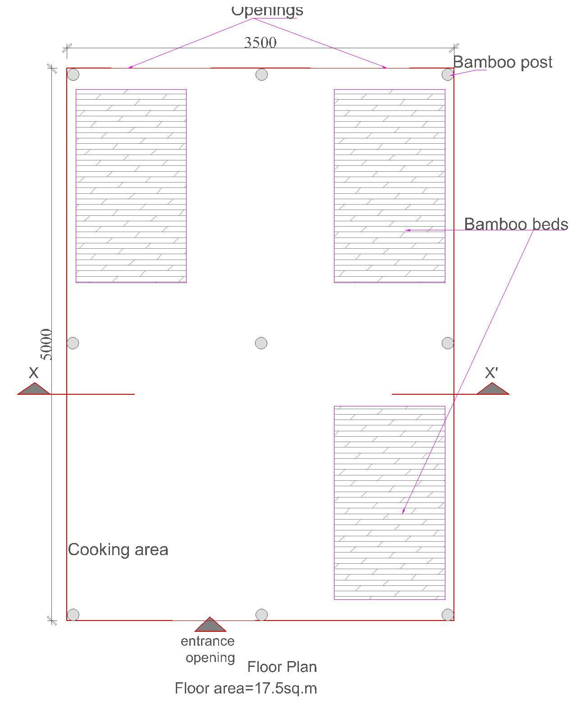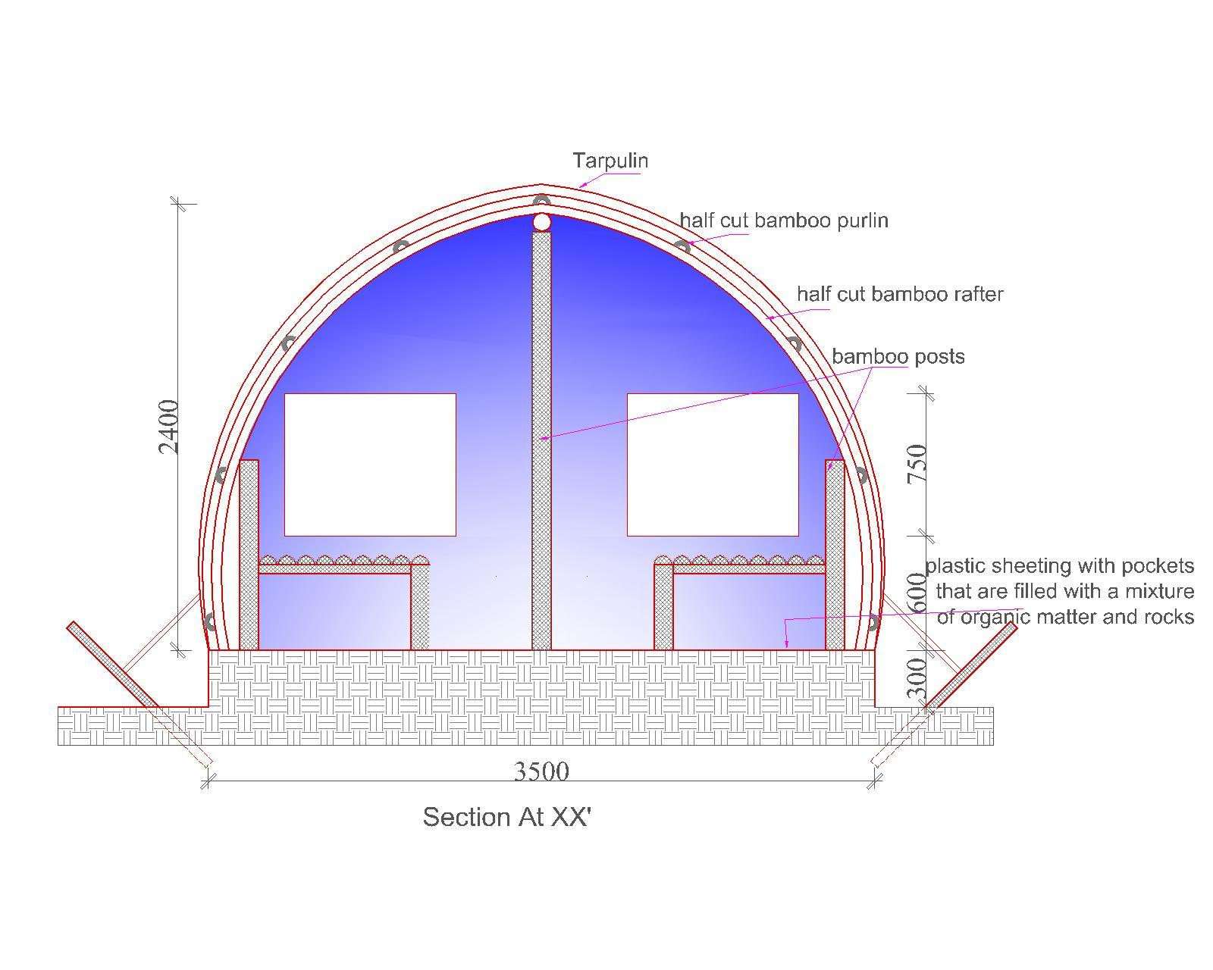

BoQ Updated in January 2014
Sn | Particulars | Unit | Rate | Amount  NPR. | remarks
1 | Tarpaulin | 2pcs | 1600 | 3200
2 | Labour | 4nos | 500 | 2000
 | Plastic sheet | 3kg | 200 | 600 | optional
3 | Bamboo | 15pcs | 250 | 3750
4 | Nails for roof | 1.5kg | 200 | 300
5 | Nails for bamboo | 1.5kg | 110 | 215
6 | rope | 1.5kg | 250 | 375
7 | Binding wire | 1.5kg | 110 | 215
8 | Total |  |  | 10655

basic house type Model: This model is applicable to all geographical regions.
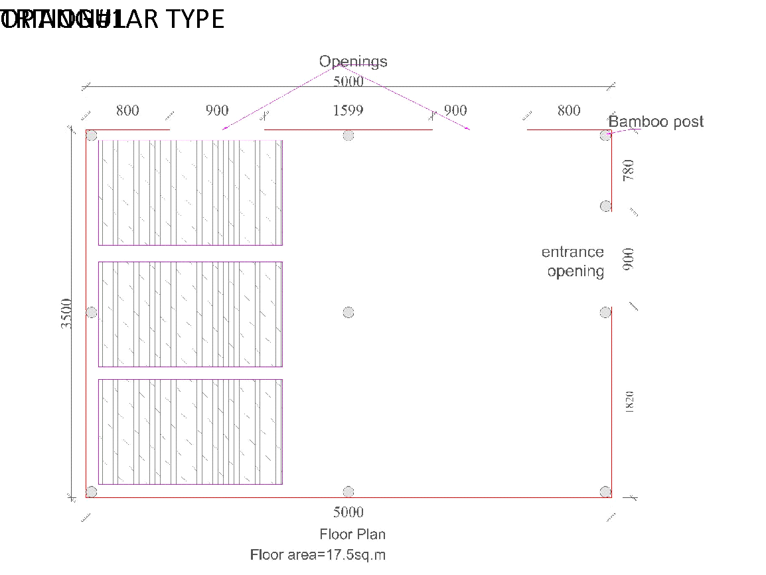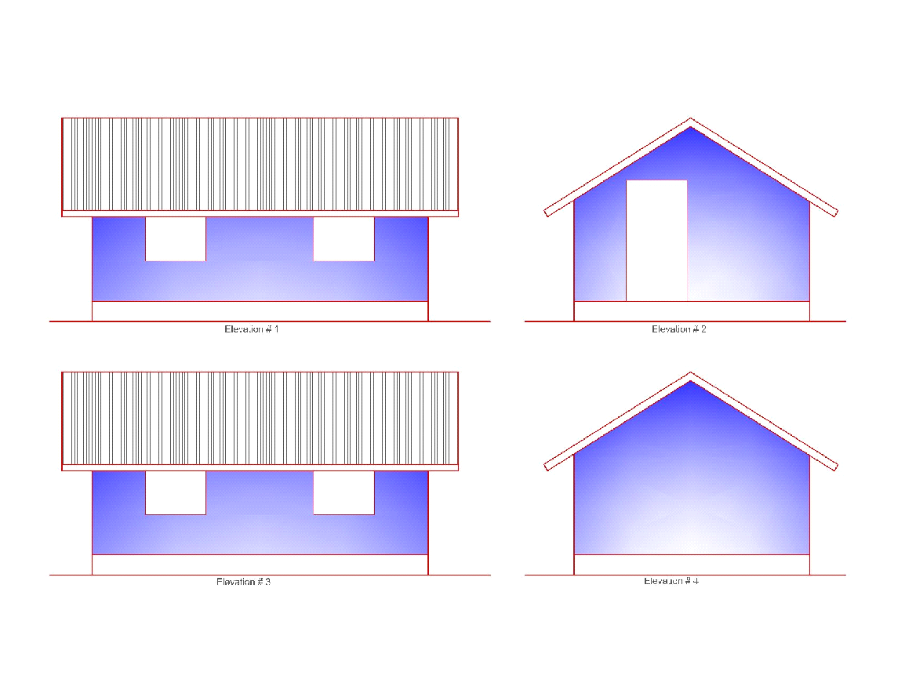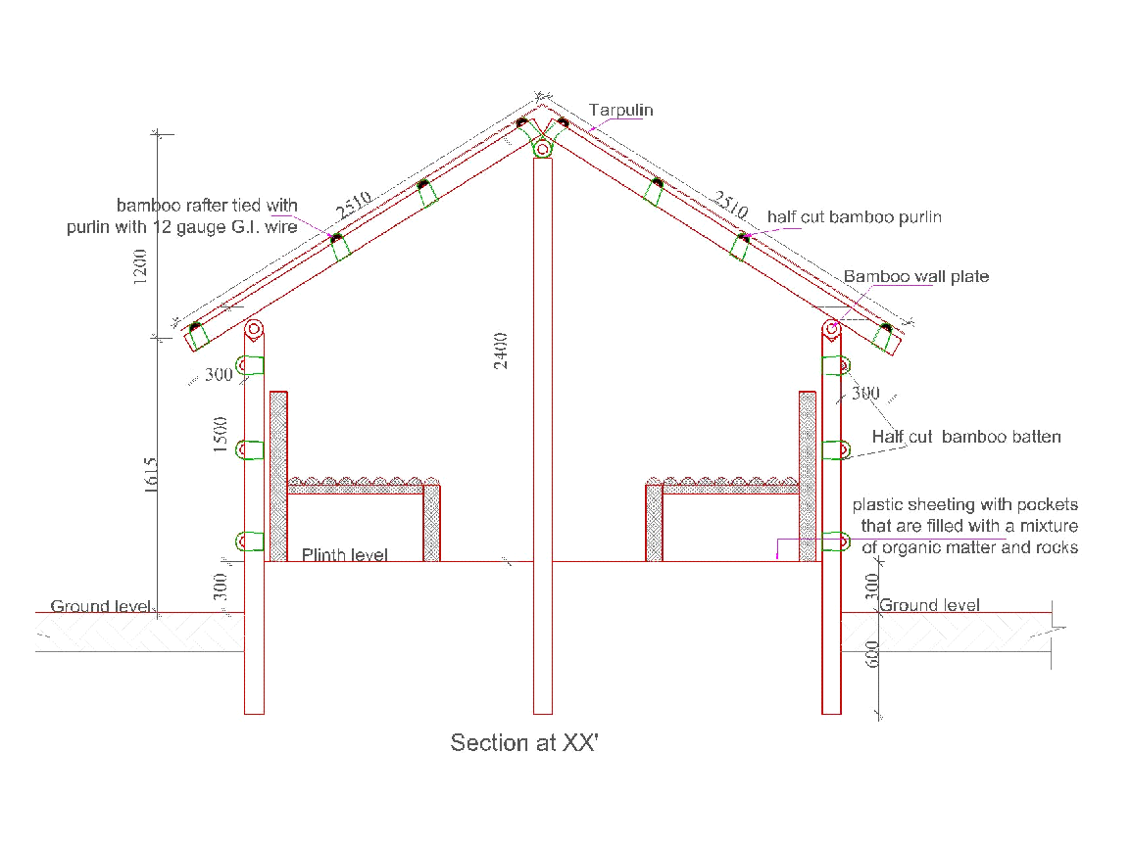

BoQ Updated in January 2014
Sn | Particulars | Unit | Rate | Amount  NPR. | remarks
1 | Tarpaulin | 2pcs | 1600 | 3200
2 | Labour | 4nos | 500 | 2000
 | Plastic sheet | 5kg | 200 | 1000 | optional
3 | Bamboo | 15pcs | 250 | 3750
 | Nails for roof | 1.5kg | 200 | 300
 | Nails for bamboo | 1.5kg | 110 | 215
 | rope | 1.5kg | 250 | 375
 | Binding wire | 1.5kg | 110 | 215
 | Total |  |  | 11055

Further references

  - Shelter after disaster
  - IASC reference module for cluster coordination at country level
  - IFRC Shelter Coordination in Natural Disasters
  - Nepal Earthquake Shelter Cluster Strategic and Technical Guidance Doc
  - Nepal Earthquake Shelter Cluster Position Paper, June 2015
  - Kashmir Earthquake 2005, Learning from the Shelter Response and Rural Housing Recovery
  - Evaluation of Nepal Earthquake Shelter Cluster – apparently complete but can’t find it online. It would be good to get a copy of this before the workshop if possible.
  - Evaluations of HRRP earlier phases
  - Global Shelter Cluster Position Paper Cash & Markets in the Shelter Sector
→ to be completed !

Based on modelling by Durham University for the UN RCO.

