Location: Baghdad – UNHCR conference room - BGD-IZ
Time: 11:30 am – 12:30 am
Present: Sub-National S-NFI Cluster (Michel Tia); National CCCM Cluster (Marguerite Nowak); Caritas (Ahmed Jamal A., Sinan Sameer, Hiba Muwafaq R.); Caritas Czech Republic (Ali Aied Shabab); CRS (Ali Jasim, Azher Subhi); IOM (Munir Ali); UNHCR (Layth Al-Azzawi); YAO (Mohamed Majed); DRC (Riadh Mohammed); UNDP (Ali Al-Najjar); OXFAM (Alan Jaff);
WebEx: UNHCR Kirkuk (Sameer Al Jobori)

The following are additional points to the PowerPoint presentation of the meeting.

Summary of Action Points

# | Action Points | Focal Point | Status
1 | Housing rehabilitation: Shelter Cluster to continuously follow up with partners, to support collecting their latest interventions details. Partners can reach out to the WDS IM Unit for support if needed (Emmanuel - im3.iraq@sheltercluster.org and Hoveen - hoveen.yaseen@un.org). | Shelter Cluster | Ongoing process
2 | Housing rehabilitation: UNHCR to share their housing and rehabilitation area-based approach once ready. | UNHCR – Baghdad | Follow up
3 | 2019 Summer response plan: Support Partners summer response plan. | Shelter Cluster | Ongoing
4 | SEVAT - Socio-Economic Vulnerability Assessment Tool: Interested partners to liaise with the Cluster Hub Coordinator for guidance. | Partners | Follow up
5 | Interactive dashboard on Iraq Housing Rehabilitation Interventions: Five partners volunteered to share feedback / comments to help the cluster IMOs improve the dashboard. | UNHCR, CRS, UNDP, OXFAM and IOM | Follow up
6 | From the update been presented during the meeting, partners will be sharing the full details of their Housing Rehabilitation Interventions and RHU plans, with the SNFI Cluster & UN-Habitat IMOs in charge of the concerned database & platforms. | UNHCR, UNDP, CRS, DRC | Follow up
7 | Update on 2019 assessments (planned, ongoing, completed): Since this point was not covered due to time, the Hub Coordinator will follow up with partners. | Cluster Hub Coordinator | Follow up
8

Key Points

Agenda Item | Key Points | Action points
- Review of action points from minutes of previous meeting | - Minutes of Previous meeting were endorsed without any changes. However further follow up are required for some of the action points (1-4 in above table)
- Key issues and Partners to update on their planned, ongoing and completed interventions  - Interactive dashboard for the Housing Rehabilitation Interventions  - UNDP - 2019 Housing Rehabilitation Interventions in Centre & South Regions  - Partners - Housing Rehabilitation Interventions  - NFI - distributions in camps and out of camps  - Information Management  - Planning of proposed trainings  - Update on 2019 assessments (planned, ongoing, completed)  - ActivityInfo report & the new 4W for planning | - Key issues and Partners to update on their planned, ongoing and completed interventions  - Interactive dashboard for the Housing Rehabilitation Interventions  SNFI Cluster & UN-Habitat IMOs have been designing an interactive dashboard on Iraq housing & rehabilitation interventions. The development of a new, publicly accessible Power BI dashboard is to help address the access to shelter rehabilitation information, where partners will have access to key overview of rehabilitation efforts across the country. During the meeting, the first draft of that dashboard was presented to the C&S partners for comments & feedback on key improvements. UNHCR, CRS, OXFAM, UNDP and IOM volunteered to share feedback. The Hub Coordinator will follow up with mentioned partners and update the IM team accordingly.  - UNDP - 2019 Housing Rehabilitation Interventions in Centre & South Regions  UNPD presented their 2019 housing & rehabilitation plan for Centre & South. The partner has targeted around 4,106 houses (subject to changes). Assessments have been completed (in Haditha and in Ana) and ongoing in some of the targeted areas. Full details of this 2019 plan will be shared, with the SNFI Cluster & UN-Habitat IMOs in charge of the concerned database & platforms.  Below is the summary table.  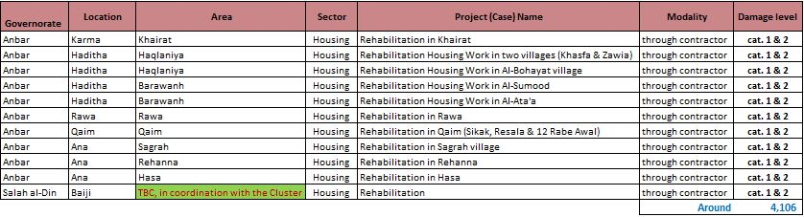  The SNFI Cluster has been working closely with UNPD, to support their housing & rehab. programming. The following document have been made available.  - list of all partners operating in Baiji area & potential area yet to be covered in Baiji  - list of partners operating in Rehana in Ana & potential area yet to be covered in Rehana  - the raw data of the return index  - Partners - Housing Rehabilitation Interventions  UNHCR  - UNHCR has started their Shelter rehabilitation program in Salah Al-Din governorate, targeting 1,250 houses (Cat 2). The rehabilitation program is through a contractor and very well coordinated with other partners already operating in Baiji to avoid overlapping.  - UNHCR has started beneficiary’s selection process for their RHU construction project for returnees. The project is targeting 900 HHs (units) include 150 in Diyala, 75 in Anbar, 50 in Baghdad and 625 in Salah al-Din governorates. The figures are subject to change based on selection criteria and scoring system.  Below is the summary table.  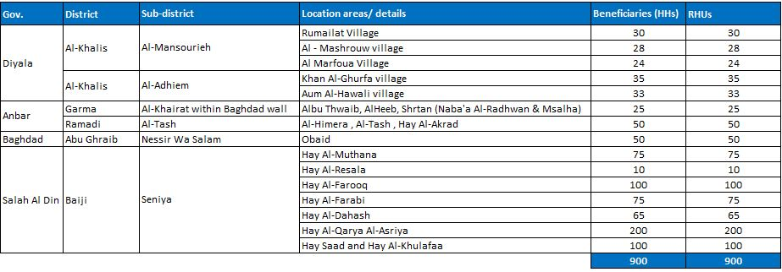  Full details of this RHU plan will be shared, with the SNFI Cluster & UN-Habitat IMOs in charge of the concerned database & platforms.  IOM – as a follow up from previous meeting (17 April 2019), on IOM Cash for Rent & Shelter rehabilitation programs in Centre & South of Iraq:  - Shelter rehabilitation programs  - 200 houses (returnees) in Ana district in Anbar governorate, in Rayhanna neighbourhood: the project has started with around 25% of completion.  - 215 houses (returnees) in AL-Khalis district in Diyala governorate: the project has started with around 60% of completion.  - 400 houses (IDPs) in Najaf district in Najaf governorate: the project has started with around 40% of completion.  - Cash for Rent program in Anbar (168HHs) and Baghdad (218 HHs), the beneficiaries will be receiving 6 months Cash for Rent allocation with the total amount of US $200 /HH/month.  - The first payment (for March and April) has been completed.  - The second payment (for May and June) has been planned and will soon be distributed.  - The third payment (for July & August) will be scheduled on due time.  CRS – as a follow up from previous meeting (17 April 2019), on CRS shelter repairs through Cash & shelter upgrade programs in Centre & South of Iraq:  - Shelter repairs through Cash - 100 houses (returnees) in Fallujah/Anbar:  - CRS just finalized the technical assessment and BOQs for 40 houses as phase#2. The 1st tranche of cash (equivalent to 60% of BOQ total cost) will be distributed to the selected beneficiaries in the next two weeks.  - CRS is planning to launch the technical assessment for the remaining 40 houses as phase#3 to achieve their project target of 100 houses in Fallujah, of which:  - 20 houses in phase#1 – have been Completed  - 40 houses in phase#2 – are ongoing  - 40 houses in phase#3 – technical assessment will be scheduled on due time.  - Shelter upgrade - 100 house (IDPs) in Abu-Ghraib/Baghdad and in Falluja/Anbar:  - 48 houses (23 houses in Abu-Ghraib and 25 houses in Fallujah) have been completed during phase#1 and Phase#2.  - For phase#3, CRS will be starting the technical assessment for around 40 houses in Abu Ghraib district and 20 houses in Falluja.  - The initial project target (100 houses) may be exceeded based on CRS current capacity and availability.  DRC  - Shelter rehabilitation (cat. 2): DRC has completed assessments and has targeted 48 houses in Fallujah & Saqlawiyah district in Anbar governorate, 35 houses in Muqdadiyah district in Diyala governorate, and 80 houses in Baiji district in Salah al Din governorate. The work will be referred to contractors as soon as completion of the tender process.  - Customized Shelter kits (CSK): This customized Shelter kits has been designed for shelter that does not fall under DRC technical selection criteria for Shelter rehab. (cat. 2). Almost 100 items are in the CSK (include PPR pipes, pipe connections, electric connections, electric switches; PVC doors and windows; water tanks, etc..). The eligible beneficiaries can select the items based on needs but also up to an average cost of US $200 to US $230 per Household. DRC has already selected 160 HHs in Anbar, 100 HHs in Diyala and 150 HHs in Baiji in Salah al Din. The beneficiaries will be able to rehabilitate their own houses with the support of DRC Shelter Team.  - NFI - distributions in camps and out of camps  In camps  - UNHCR, IOM and CRS can support summer NFI distributions, though no proper plan has been put in place. The Shelter Cluster partners can request support from the mentioned partners if needed. However, CRS is planning assessment in AAF camps in coordination with all active partners in those camps.  Out of camps  OXFAM  Based on need assessments, OXFAM has targeted 515 HHs (the newly returnees) in Al Muhandisin neighbourhood in Siniyah sub- district for basic NFI kit distributions in the coming two weeks (19-31May). More locations in the areas will also be assessed for the purpose.  IOM  - Planning to assist 4,000 (IDP & Returnees) with basic NFI kits, in Salah Al-Din, Diyala, Anbar and Baghdad governorates. Detailed plan can be shared as soon as available.  - Flood response: IOM distributed around 800 basic NFI kits to flood affected households in Missan in coordination with local authorities.  CRS – Emergency Response (NFI – Summer kit distributions).  - CRS just completed need assessment in Falluja in (low cost houses and widows’ houses sectors) for around 1,000 HHs, and in Falluja (Jbel and Hay Al Shuhad’a) for around 1,500 HHs. Contract has been signed with two vendors for the NFI distributions. Data cleaning and analysis in ongoing and the distribution will be scheduled on due time.  - Information Management  - Planning of proposed trainings: referring to the meeting presentation, the trainings venue, dates and time were discussed and confirmed with partners. The Cluster will be sending invitations on due time.  - Update on 2019 assessments (planned, ongoing, completed): Since this point was not covered due to time, the Hub Coordinator will follow up with partners.  - ActivityInfo report & the new 4W for planning: referring to the meeting presentation, AI reporting process and timeline were fully explained to partners. Partners were also informed about the new 4W for planning in AI and were encouraged to report accordingly. | Refer to above table
- AOB | With the support of CCCM & SNFI Clusters, Activity Info training section was conducted right after the Cluster meeting. 11 participants from 4 organizations (CRS, Caritas Iraq, DRC and IOM) were able to attend.

Note: Next Centre and South Hub Cluster Coordination meeting, will be held on June 12th, 2019, invitation will be sent out on due time.

