Interim Build Back Better Guidance – House Repairs/Rebuild
(No Objection received by Government of Bahamas, Buildings Control Officer on 14 Feb 2020 for these messages to be used to promote Build Back Better, i.e. they are consistent or above requirements of 2003 National Building Code)
Anticipated that UNDP supported Build Back Better Booklet will not be ready till at least March 2020. This interim document is to support agencies working on house repairs to promote Build Back Better messaging for the audience of Agency staff and Contractors/Skilled Labour/Semi-Skilled Labour. It is expected that the UNDP supported booklet will provide the document for use with Households (and also Contractors).
If agencies are trying to tailor these messages for use with households they are expected to select as few messages as possible from this list for the typology, risk and damage, to increase impact and tailor wording to be non-technical and accessible to the households. Images, videos & models would convey these messages better to households than words.
Interim Key BBB Agency & Contactor Messages – Repairs
Top 3 messages for roofing:
1. Use exterior screws/ring nails – do not use straight shank smooth nails for roof sheathing. Nailing pattern to be 4” centres at eaves and gable ends and 6” centres elsewhere. Do not screw or nail too deep into sheathing, top of the screw/ring nail should be flush with the surface.
2. For metal sheet roofs make sure you install the metal clips, snap locks, and fixings as per the instructions. Especially important at eaves, gables and ridge. Securing the ridge cap is also very important.
- To stiffen roof, install lateral bracing on the roof structure (in hurricanes sheathing may fail):
  - Ridge beam structure: install long members (2” x 4”) on the underside of the rafter or truss top chords starting at the peak of the roof and running diagonally 45º downwards to the eaves and repeat every 4th rafter or truss for the length of the roof. Brace the bottom chord with an overlapping long member running perpendicular to the bottom chord. Make the rafters or trusses work together.
  - Roof trusses without ridge beam: In addition to the above, install blocking or bridging elements between trusses, particularly at the top of the truss. Make the rafters or trusses work together.

Other important messages related to roofing:
- Every Rafter must have straps over each rafter and down onto wall plate (both members on a double top plate) and stud or metal hurricane clips on both sides of rafter. At ridge beam, strapping over the ridge connecting both rafters must be installed. Alternatively collar tie or gusset plate can be installed. Do not overcut bird-mouth which leads to weak point in rafter.
- Each hole in the hurricane strap or clip should be filled with a nail, unless the instructions specify less is allowable. Use the specified size of nail requested in the instructions. Take care not to split timber when nailing.
- Wooden gable end trusses must be well connected to the truss system and anchored to the super-structure. Recommended that anchorage is at 2’ spacing, and plywood sheathing and strapping extends down onto the studs of the wall below.
- Masonry gables must be reinforced and should be well connected to roof truss system. Reinforcement should take the form of longitudinal reinforcement and reinforced concrete members on the diagonals confining the masonry.
- Asphalt shingle to be as high quality as you can afford and each shingle secured at all 4 corners. Ice and Water Shield performed better than felt underlay in Hurricane Dorian.
- Barrel or Flat Tiles to be fixed through fixing hole not solely with mortar bedding
- Wall Plate should be 3”x6” (can be double 2”x6” top plate if the two members are adequately connected such as through nailing and gluing or straps – consider uplift in hurricanes)
- Timber Wall Plate when on top of a concrete ring beam to be anchored to beam with 5/8” anchor bolts at max. 3’ centres. Bolts must have minimum 1/8” thick 1-¼” diameter washers and nuts with minimum two threads visible above each nut. Drilled holes should be sufficiently small to maximize bearing area for washers.
- Roof Overhang – promote a maximum of 1’ eave on main roof. For extra long eaves which are useful to shade windows, attach sacrificial eave which if forced in hurricane winds can fail without damaging roof structure.
- Porches – promote separate (sacrificial) porches which may be lost in high winds without affecting main structure.
- Electrical connection masts where they pass through roof should be securely fixed to wall of house. In hurricane Dorian some houses were damaged when the main street electricity pole failed which pulled on the house mast damaging the roof. It is expected that if the house mast is secured better to the wall of the house the cable connection will fail first at the top of the mast. Use clamps secured appropriately to blockwork or multiple studs. The cable connection at the top of the mast should be installed to be sacrificial should the street poles fail in future hurricanes.
Other important messages related to timber construction:
- Termites are a significant threat and all timber should be pressure treated lumber. Fixings must be correct for the type of pressure treatment, e.g. hot dipped galvanised or better. Any signs of termites should be treated with product designed specifically for this, and will need to be treated periodically. If member is too damaged replaced. Any signs of mold must be remediated before covering back up.
- Lumber should be a minimum 2”x6” for framing, for elements such as rafters, studs, blocking, bridging or bracing.
- Timber Frame - Wall connections – Where possible install additional 2”x6” posts at corners to bolt into adjacent wall panels at every return, corner ties between walls at ceiling joist level, metal angles and L plates can also be used.
- Timber frame wall panels should have diagonal bracing. Both external and internal walls connected to external walls to be shear walls.
- Drill holes if required for wiring and plumbing should be well laid out, with holes being placed in the centre of the member. Maximum drill hole is 2” in a 6” member.
For reinforced concrete construction:
- Column vertical reinforcement should have starter bars provided in the footing and splices shall be lapped at least 24 times the diameter of the rebar used, so for No.5 bars a standard lap length would be 15”. In tidal-surge risk areas it is recommended that the footing splices should be lapped 48 times the diameter of the rebar used.
- Rebar spacers to be used must be specific for this purpose to ensure concrete cover is maintained during pouring and vibration. Do not use broken blocks.
- Use Close-loop stirrups with 135º hook, rather than 90⁰ hook.
- Concrete must be a minimum 3000 psi, with maximum slump of 4 inches. 3 ½ Buckets (5 gallon buckets) of Cement (94 lbs bags) : 5 Buckets of Water (well water, not salt water): 6 ²/3 Buckets of Rock (freeport rock/pea rock) : 6 ½ Buckets of Sand (not beach sand – too saline). This mix will create 1 cubic yard of concrete = approx. 22no. 5-gallon Buckets. An additive in the form of a retarder can be used to stop it hardening too quickly if mixing by hand. Strictly control water – do not add too much. Source from a ready-mix producer wherever possible.
In areas of tidal surge risk:
- Elevate the house wherever possible at least 12” above known flood level or 18” above crown of adjacent road. This may include rebuilding on stilts or rebuilding with living accommodation above ground floor level and ground floor being sacrificial and easily openable to allow flood waters to pass beneath without damaging structure. Some households may consider jacking up existing timber frame structures but a competent engineer needs to be involved to ensure foundations and anchorage are appropriate.
- If concrete block structure (CBS) walling is used in tidal areas, every other cell may have vertical reinforcement tied into footing and beam and horizontal mortar reinforcement. With tied reinforced concrete columns at 20’ maximum spacing and reinforced beams. It was found unreinforced blockwork fill used between tied columns did not perform as well as reinforced CBS in areas of tidal surge.
- Elevate important electrical-mechanical items and anchor them securely. Including Generators, AC Condenser Units, LPG tanks. Where possible elevate electricity meters to eye level to reduce future flood damage. Consider how flooding may impact conduits and piping and elevate and secure where possible.
- If attic will be used as refuge in future tidal surge ensure attic is easily accessible (with dropdown attic ladders for example), and attic includes small attic vent for ventilation and small window for emergency exit.
Important messages related to foundations:
- Timber base plate – on top of concrete foundation to be anchored to, with 5/8” anchor bolts at max. 3’ centres. Bolts must have minimum 1/8” thick 1-¼” diameter washers and nuts with minimum two threads visible above each nut. Drilled holes should be sufficiently small to maximize bearing area for washers. Alternatively, 1/8” x1” steel strap or better on each stud anchored past the base plate and into the concrete foundation.
- Foundation Fill – compact in no more than 9” layers to avoid differential settlement in future.
Internal hurricane safe roofs (not for tidal surge areas):
- Where outside of tidal surge area, consider rebuilding with internal hurricane/tornado safe room within house – seek a competent engineer to support with design, but this can take the form of constructing the bathroom with reinforced concrete block structure (CBS) and tied reinforced concrete ceiling slab, with small hurricane rated window and door.
Photos: The following photos and extracts are to aid understanding and discussions. These are interim BBB messages while the UNDP supported BBB booklet is produced. Photos/Drawings Indicative Only.
1 | Use exterior screws/ring nails – do not use straight shank smooth nails for roof sheathing. Nailing pattern to be 4” centres at eaves and gable ends and 6” centres elsewhere. Do not screw or nail too deep into sheathing, top of the screw/ring nail should be flush with the surface. | 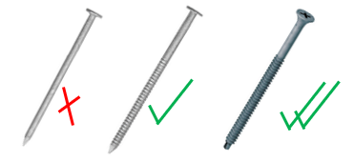  Exterior Screws  Ring Nails  Straight Shank Smooth Nails
2 | For metal sheet roofs make sure you install the metal clips, snap locks, and fixings as per the instructions. Especially important at eaves, gables and ridge. Securing the ridge cap is also very important. | 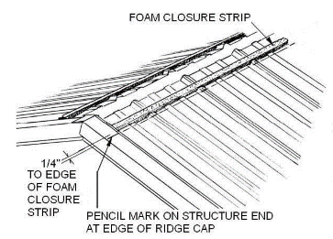
3 | Install bracing on roof structure: : install long members (2” x 4”) on the underside of the rafter or truss top chords starting at the peak of the roof and running diagonally 45º downwards to the eaves and repeat every 4th rafter or truss for the length of the roof. Brace the bottom chord with an overlapping long member running perpendicular to the bottom chord. Make the rafters or trusses work together. | 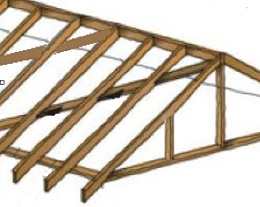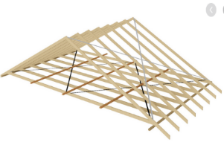
4 & 5 | Every Rafter must have straps over each rafter and down onto wall plate (both members on a double top plate) and stud or metal hurricane clips on both sides of rafter. At ridge beam, strapping over the ridge connecting both rafters must be installed. Alternatively collar tie or gusset plate can be installed. Do not overcut bird-mouth which leads to weak point in rafter.  Each hole in the hurricane strap or clip should be filled with a nail, unless the instructions specify less is allowable. Use the specified size of nail requested in the instructions. Take care not to split timber when nailing. | 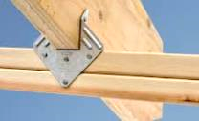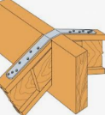  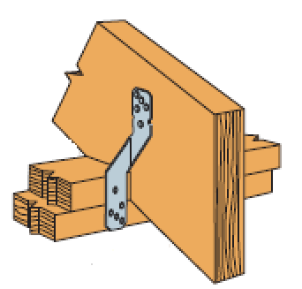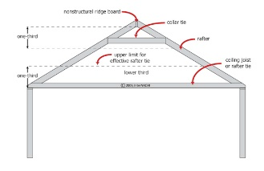
6 | Wooden gable end trusses must be well connected to the truss system and anchored to the super-structure. Recommended that anchorage is at 2’ spacing, and plywood sheathing and strapping extends down onto the studs of the wall below. | 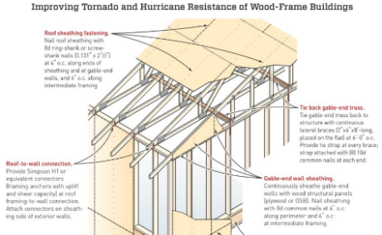
7 | Masonry gables must be reinforced and should be well connected to roof truss system. Reinforcement should take the form of longitudinal reinforcement and reinforced concrete members on the diagonals confining the masonry. | 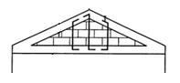
8 | Asphalt shingle to be as high quality as you can afford and each shingle secured at all 4 corners. Ice and Water Shield performed better than felt underlay in Hurricane Dorian.
9 | Barrel or Flat Tiles to be fixed through fixing hole not solely with mortar bedding | 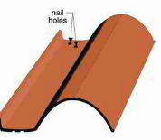
10 | Wall Plate should be 3”x6” (can be double 2”x6” top plate if the two members are adequately connected such as through nailing and gluing or straps – consider uplift in hurricanes) | 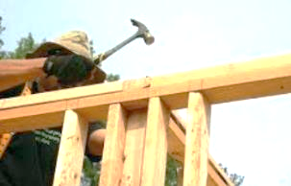
11 | Timber Wall Plate when on top of a concrete ring beam to be anchored to beam with 5/8” anchor bolts at max. 3’ centres. Bolts must have minimum 1/8” thick 1-¼” diameter washers and nuts with minimum two threads visible above each nut. Drilled holes should be sufficiently small to maximize bearing area for washers. | 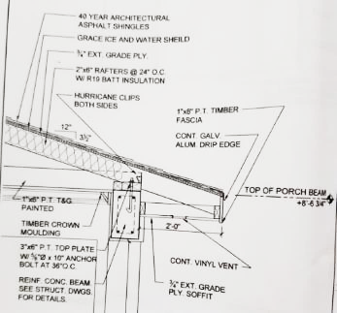
12 | Roof Overhang – promote a maximum of 1’ eave on main roof. For extra long eaves which are useful to shade windows, attach sacrificial eave which if forced in hurricane winds can fail without damaging roof structure. | 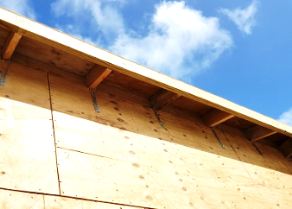
13 | Porches – promote separate (sacrificial) porches which may be lost in high winds without affecting main structure.
14 | Electrical connection masts where they pass through roof should be securely fixed to wall of house. In hurricane Dorian some houses were damaged when the main street electricity pole failed which pulled on the house mast damaging the roof. It is expected that if the house mast is secured better to the wall of the house the cable connection will fail first at the top of the mast. Use clamps secured appropriately to blockwork or multiple studs. The cable connection at the top of the mast should be installed to be sacrificial should the street poles fail in future hurricanes. | 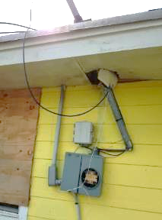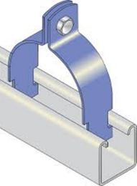
15 | Termites are a significant threat and all timber should be pressure treated lumber. Fixings must be correct for the type of pressure treatment, e.g. hot dipped galvanised or better. Any signs of termites should be treated with product designed specifically for this, and will need to be treated periodically. If member is too damaged replaced. Any signs of mold must be remediated before covering back up. | 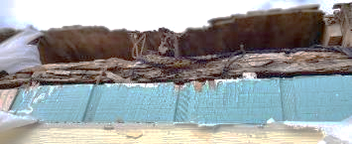
16 | Lumber should be a minimum 2”x6” for framing, for elements such as rafters, studs, blocking, bridging or bracing.
17 | Timber Frame - Wall connections – Where possible install additional 2”x6” posts at corners to bolt into adjacent wall panels at every return, corner ties between walls at ceiling joist level, metal angles and L plates can also be used. | 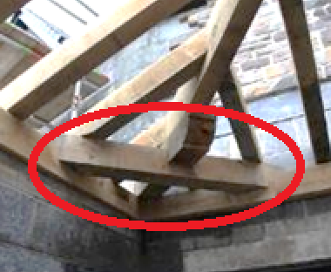
18 | Timber frame wall panels should have diagonal bracing – timber or metal. Both external and internal walls connected to external walls to be shear walls. | 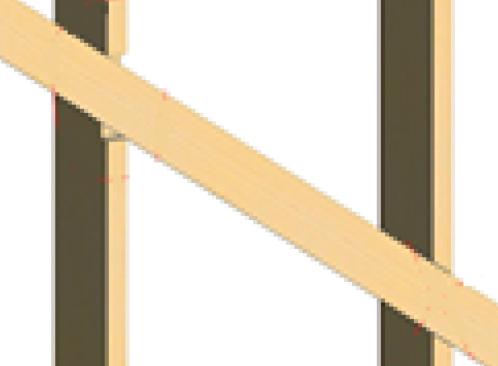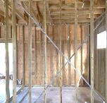
19 | Drill holes if required for wiring and plumbing should be well laid out, with holes being placed in the centre of the member. Maximum drill hole is 2” in a 6” member. | 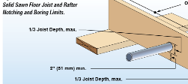
20 | Column vertical reinforcement should have starter bars provided in the footing and splices shall be lapped at least 24 times the diameter of the rebar used, so for No.5 bars a standard lap length would be 15”. In tidal-surge risk areas it is recommended that the footing splices should be lapped 48 times the diameter of the rebar used. | 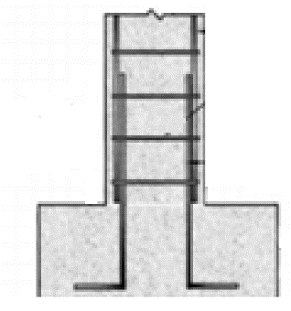
21 | Use Close-loop stirrups with 135º hook, rather than 90⁰ hook. |   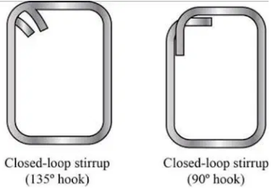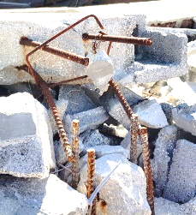
22 | Rebar spacers to be used must be specific for this purpose to ensure concrete cover is maintained during pouring and vibration. Do not use broken blocks. | 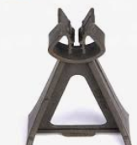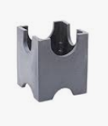
23 | Concrete must be a minimum 3000 psi, with maximum slump of 4 inches. 3 ½ Buckets (5- gallon buckets) of Cement (94 lbs bags) : 5 Buckets of Water (well water, not salt water): 6 ²/3 Buckets of Rock (freeport rock/pea rock) : 6 ½ Buckets of Sand (not beach sand – too saline). This mix will create 1 cubic yard of concrete = approx. 22no. 5-gallon Buckets. An additive in the form of a retarder can be used to stop it hardening too quickly if mixing by hand. Strictly control water – do not add too much. Source from a ready-mix producer wherever possible.
24 | Elevate the house wherever possible, at least 12” above known flood level or 18” above crown of adjacent road. In areas of tidal surge risk, this may include rebuilding on stilts or rebuilding with living accommodation above ground floor level and ground floor being sacrificial and easily openable to allow flood waters to pass beneath without damaging structure. Some households may consider jacking up existing timber frame structures but a engineer needs to be involved to ensure foundations and anchorage are appropriate. | 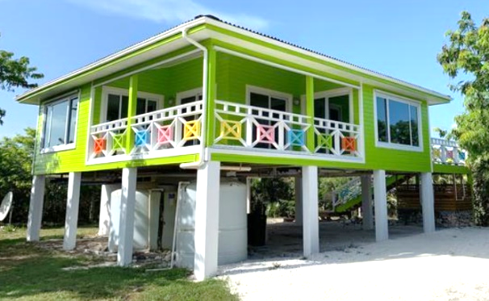
25 | If concrete block structure (CBS) walling is used in tidal areas, every other cell may have vertical reinforcement tied into footing and beam and horizontal mortar reinforcement. With tied reinforced concrete columns at 20’ maximum spacing and reinforced beams. It was found unreinforced blockwork fill used between tied columns did not perform as well as reinforced CBS in areas of tidal surge. | 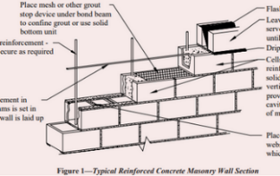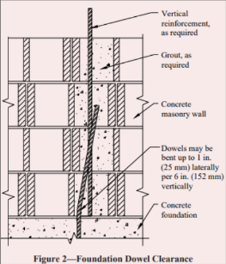
26 | Elevate important electrical-mechanical items and anchor them securely. Including Generators, AC Condenser Units, LPG tanks. Where possible elevate electricity meters to eye level to reduce future flood damage. Consider how flooding may impact conduits and piping and elevate and secure where possible.
27 | If attic will be used as refuge in future tidal surge ensure attic is easily accessible (with dropdown attic ladders for example), and attic includes small attic vent for ventilation and small window for emergency exit. | 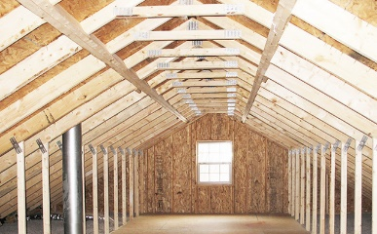
28 | Timber base plate – on top of concrete foundation to be anchored to with 5/8” anchor bolts at max. 3’ centres. Bolts must have minimum 1/8” thick 1-¼” diameter washers and nuts with minimum two threads visible above each nut. Drilled holes should be sufficiently small to maximize bearing area for washers. Alternatively, 1/8” x1” steel strap or better on each stud anchored past the base plate and into the concrete foundation. | 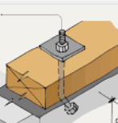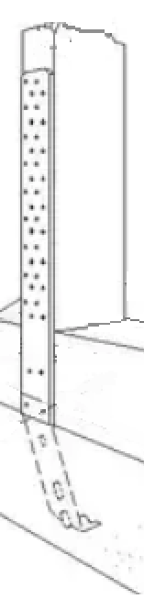
29 | Foundation Fill – compact in no more than 9” layers to avoid differential settlement in future. Treat for termites as necessary. | 
30 | Where outside of tidal surge area, consider rebuilding with internal hurricane/tornado safe room within house – seek a competent engineer to support with design, but this can take the form of constructing the bathroom with reinforced concrete block structure (CBS) and tied reinforced concrete ceiling slab, with small hurricane rated window and door. | 