Shelter Cluster Vanuatu – Meeting Notes
Meeting: | Shelter Cluster Vanuatu - Cluster Meeting
Date: | 26th October 2023 | Time: | 2pm-3pm
Meeting Facilitator: | Ken Mana | Location: | Climate change conference room

Agenda
Attendance:
Name | Organization | Role | Email Address | Contact
Ken Mana | NDMO | Shelter Cluster Lead | kmana@vanuatu.gov.vu | 7305387
Samandra Gete | VRCS | Shelter Cluster co-lead | coord1.vanuatu@sheltercluster.org | 5610805
Choutet Isabelle | CARE |  | Isabelle.choutete@care.int.org | 7756906
Alice kalontano | DFAT | N | Alice.kaltontano@dfat.gov.vu
Mark Voughan | DSOOAC |  | Kallista440@gmail.com | 5420762
Ryan smith | WVV |  | Ryan-smith@wvi.org | 5606014
Augustine Gare | VRCS |  | diastercoordinator@redcrossvanuatu.com | 7747847
Rico Aru | ADRA |  | RicoAru@adra.org.vu | 7730703
Chris Hartnett | NZ High Comm |  | Christopher.hartrett@mfat.gov.vu | 7664955
Janet jack | IOM |  | jsack@iom.int | 7611721
Dea Bickey | Save the children |  | Dea.bickey@savethechildren.org.au | 5437720
Lindah Peter | CARE |  | Lindah.peter@careint.org | 7684821

Topic
Agenda:
- NDMO estimated damage and needs
- Stock updates
- Proposed plan for immediate response
- Shelter response plan

The Shelter Lead shared the priority areas for the distribution of tarpaulins: Penama, Malampa, and Troba. The Logistics Representative informed partners that there are 13 Area councils in priority one with 10,000 households and a 50% immediate response rate. This means that a total of 5,000 tarpaulins will be distributed in these areas. Priority 2 areas will receive 25% of the tarpaulins, or 1250 tarpaulins.
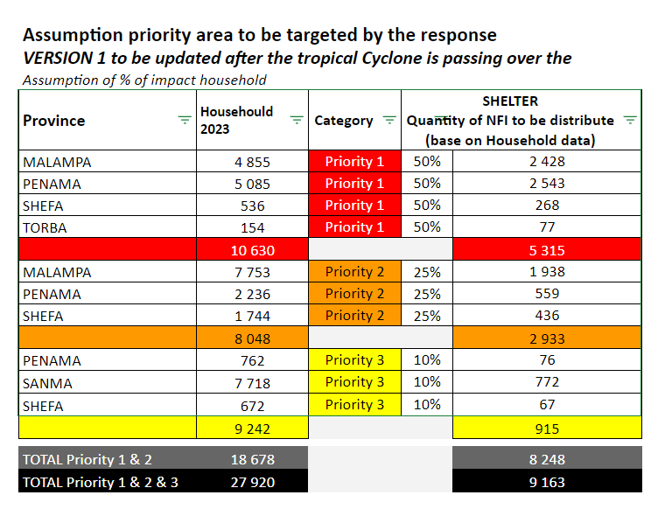
The Shelter Lead also shared the distribution sites for priority 1 with the partners. All partners agreed to the sites, but ADRA canceled its distribution in South East Ambrym due to less stock. ADRA will only be working in North Ambrym.
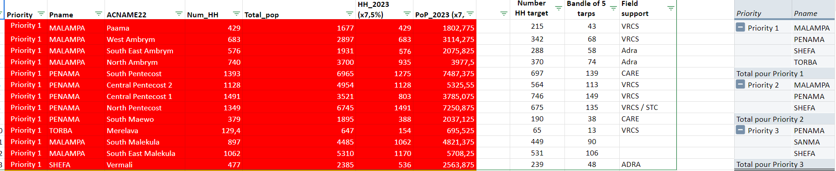
SHELTER STOCK IN COUNTRY AS OF 25 OCT 2023
PROVINCE | AGENCY | WAREHOUSE LOCATION | SUM de Tarpaulins | SUM de Shelter Tool Kit (IFRC) | SUM de Kitchen set | SUM de Blankets | SUM de Mat
 |  |  | 0 | 0 | 0 | 0 | 0
 | Total |  | 0 | 0 | 0 | 0 | 0
 | CARE VANUATU |  | 0 | 0 | 0 | 0 | 0
 | Total CARE VANUATU |  | 0 | 0 | 0 | 0 | 0
Total |  |  | 0 | 0 | 0 | 0 | 0
Malmapa | Vanuatu Red Cross Society | Malekula | 193 | 45 | 12 | 110 | 188
 | Total Vanuatu Red Cross Society |  | 193 | 45 | 12 | 110 | 188
Total Malmapa |  |  | 193 | 45 | 12 | 110 | 188
Sanma | Save the Children | Santo | 10 | 100 | 0 | 0 | 0
 | Total Save the Children |  | 10 | 100 | 0 | 0 | 0
 | Vanuatu Red Cross Society | Santo | 2000 | 300 | 360 | 1000 | 700
 | Total Vanuatu Red Cross Society |  | 2000 | 300 | 360 | 1000 | 700
 | World Vision Vanuatu | Luganville- Santo | 920 | 0 | 0 | 0 | 0
 | Total World Vision Vanuatu |  | 920 | 0 | 0 | 0 | 0
Total Sanma |  |  | 2930 | 400 | 360 | 1000 | 700
Shefa | Save the Children | Port Vila | 176 | 220 | 0 | 0 | 0
 | Total Save the Children |  | 176 | 220 | 0 | 0 | 0
 | Vanuatu Red Cross Society | Efate | 200 | 100 | 100 | 200 | 200
 |  | Port Vila | 3225 | 1239 | 500 | 5050 | 3525
 | Total Vanuatu Red Cross Society |  | 3425 | 1339 | 600 | 5250 | 3725
 | World Vision Vanuatu | Port Vila | 1030 | 168 | 0 | 0 | 0
 | Total World Vision Vanuatu |  | 1030 | 168 | 0 | 0 | 0
Total Shefa |  |  | 4631 | 1727 | 600 | 5250 | 3725
Tanna | World Vision Vanuatu | Lennakel | 1000 | 0 | 0 | 74 | 0
 | Total World Vision Vanuatu |  | 1000 | 0 | 0 | 74 | 0
Total Tanna |  |  | 1000 | 0 | 0 | 74 | 0
Torba | Vanuatu Red Cross Society | Vanua Lava | 110 | 82 | 105 | 16 | 50
 | Total Vanuatu Red Cross Society |  | 110 | 82 | 105 | 16 | 50
Total Torba |  |  | 110 | 82 | 105 | 16 | 50
Suma total |  |  | 8864 | 2254 | 1077 | 6450 | 4663

The Shelter criteria for immediate response:
2 tarpaulins to a destroyed household (sleeping house.)

Action Items
Action |  |  |  | Owner | Due Date
- Shelter cluster to inform NDMO to request assistance to world Vision to be able to distribute the tarpaulins |  |  |  | SCV
- Coordinate with the partners to distribute the tarpaulins to the priority areas. |  |  |  | SCV &Logistics
- Shared the draft distribution plan with all partners. |  |  |  | SCV

Next Meeting
Date: | TBC | Time: | TBC | Location: | TBC
Comment: | -

