Inclusion of existing or proposed agency projects
as Global Shelter Cluster activities
ACTIVITY PROPOSAL
9 September 2024

Activity title
Working Group on Addressing Extreme Heat Risks in Shelters and Settlements

Proposing/Lead agencies
The proposed lead GSC Partners are Oxford Brooks and WWF/US. CRS is a supporting GSC SAG partner.

In line with GSC Guidance, once the Working Group has been approved, a call will go out to all GSC partners to join the working group.

Background

Heat Events as Challenge for Shelter Assistance
High ambient heat together with high humidity (measured as the heat index) are a significant threat to health. While extreme heat can stress the human body, the addition of high humidity significantly reduces the ability of the body to cool. An inability to cool adequately can lead to hyperthermia and a worsening of a range of chronic health conditions, in the extreme leading to death. The UN-EHS Interconnected Disaster Risks 2023: Risk Tipping Points report together with “Tipping points” of risk pose new threats, UN report warns, provide additional details on the challenges from heat, humidity and climate change.

Humanitarian shelter is intended to protect users from the environment. This protective purpose extends beyond the four-wall-and-a-roof to include the ability of a settlement as a whole to provide a safe and secure living environment for those affected by a disaster or conflict. Further, shelter and settlements assistance needs to align with the Do no harm principle, where “shelter interventions” should not worsen risk or lead to more negative impacts.
Who is affected by Extreme Heat Events?
(Abridged from Global Heat Health Network)

- Pregnant women, due to the health consequences of heat stress.
- Newborns affected due to low birth weight therefore heat-stress-related morbidity and mortality.
- Children who lack experience dealing with heat stress and dependent on others for guidance and care.
- People experiencing chronic health problems, including kidney and circulatory problems.
- People with disabilities, leading to reduced abilities to recognize and take action to reduce heat stress.
- Those working outside and not able to take measures to reduce heat stress or working inside, where heat and humidity exceed the caution levels, e.g., women or girls cooking inside.

The challenge of extreme heat events for humanitarian shelter operations is demonstrated in coastal Yemen. In this area, IDPs experience temperatures and humidity levels exceeding the “caution” threshold of 26 Celsius and 40% humidity, and often the “danger” threshold of 31 Celsius and 40% humidity. The climate conditions make the negative consequences of extreme heat a constant threat.

Based on expected seasonal temperatures of at least 26 Celsius and humidity above 40%, humanitarian shelter operations caution level-heat events are a risk in the following IDP-hosting countries (in addition to Yemen): Haiti, Columbia, Venezuela, Mauritania, Morocco, Mali, Niger, Nigeria, Burkina Faso, Chad, Sudan, South Sudan, Somalia, Madagascar, Ethiopia, DRC, Mozambique, Zambia, Syria, Türkiye, Pakistan, Afghanistan, Bangladesh, Myanmar, Indonesia, Papua New Guinea, Viet Nam, and The Philippines.
Extreme heat has been considered in shelter design in some circumstances. Yet considering and designing for extreme heat is not currently part of the standard shelter approach using a range of problem-focused options. This contrasts with the threat posed by winter or cold weather conditions, where the Global Shelter Cluster can draw on over two decades of cold weather action plans and a range of technologies and approaches.

Humanitarian Section Engagement on Heat Events
The humanitarian-extreme heat event links have been significantly advanced by the IFRC Climate Center, including their collaborative report with OCHA. The report lays out actions to respond to heat event, include early warning, action plans and anticipatory actions based on warnings, and using social support mechanisms to ensure that those at risk can be identified and supported. Mention is given to the role of shelter design in mitigating the impact of heat events. There are specifics on dealing with heat events in camps but not directly other forms of settlements. Suggestions such as cooling centers or using green roofs, painting roofs white or designing thermically appropriate shelters are useful, but they don’t provide a comprehensive and operations-based shelter-and-settlement approach to dealing with heat events.

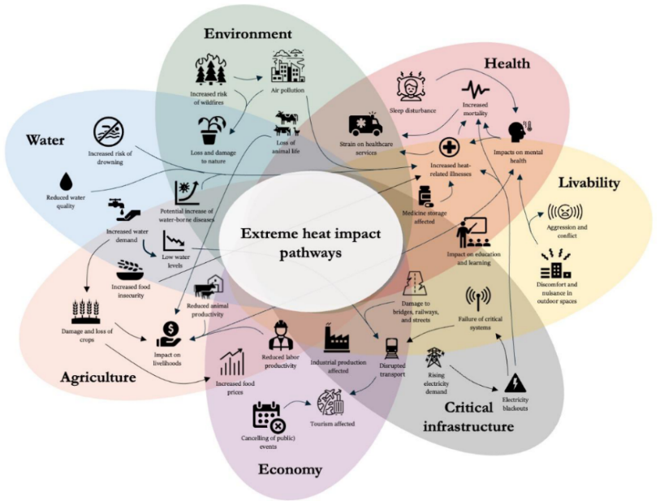
The Climate Change and the Escalation of Global Extreme Heat: Assessing and Addressing the Risks report discussed the impact pathways of extreme hear (see figure below). While aspects of shelter and settlements are mentioned, shelter and settlements are not specifically identified as part of the overall pathway to address challenges people suffer from when experiencing extreme heat. This gap is noteworthy given the core purpose of shelter to protect from weather extremes.

The Global Shelter Cluster’s Environment Community of Practice (ECoP) has raised the issue of extreme heat events as needing attention. And other Global Shelter Cluster partners have also started to work on and advocate for this topic. In other Clusters, extreme heat tends to come under climate change as a cause of heat waves, and not yet as a matter of how aid is delivered.

With an eye to raising the salience of extreme heat as a cross-cluster issue, the Global Shelter Cluster ECoP sponsored a 2024 Humanitarian Partnerships and Networks session on Heat, Humidity, Shelter and Settlements: Addressing a Critical Challenge for Humanitarian Assistance. Discussions indicated (1) a significant interest in the issue of extreme hear in the humanitarian context but also (2) no unified humanitarian approach to dealing with the issue.

As matters of principle and practice, addressing extreme heat events in the humanitarian context involves assuring climate-appropriate shelter is provided together with ancillary support (e.g., misters, fans) where appropriate; while construction material as well as natural ventilation should also play a role in shelter design considerations. The settlements approach calls for (1) a coordinated cross sectoral approach to providing support and services during extreme heat events (e.g., cooling centers together with health care and social support), and (2) settlement designs and facilities which reduce heat stress. The proposed Working Group on Addressing Extreme Heat Risks in Shelters and Settlements (hereafter Extreme Heat Working Group) provides a mechanism by which the GSC can incorporate extreme heat into shelter programming and engage with other Clusters on a common approach to minimizing the additional harm which these events can cause to disaster survivors.

Shelter-linked Operational Challenges from Extreme High Events

Extreme heat events pose four technical challenges for humanitarian shelter:

A. Rapid Onset: High heat index events can develop rapidly, too quickly to mobilize external support. As a result, dealing with high heat index events requires a significant preparedness component.

B. Shelter Designs: Emergency or transitional shelter can provide shade reducing air temperatures. However, emergency or transitional shelter are not usually designed to keep inside temperatures at or below 32 degrees Celsius on average, or designed to reduce humidity. Shelter design considerations include:
- The environment where shelter will be located and the environmental demands of specific shelter designs (including heat-protection characteristics).
- Shelter location and orientation: Selecting shelter locations and orienting shelters to minimize heat gain during the hottest parts of the day and allow (if the shelter is adequately designed) natural ventilation.
- Roofing: Reflective roofing materials (e.g., light colored coating) or using natural materials insulation.
- Shading: Installing shade structures over shelters, sharing outside shelters and shading in common-use spaces (e.g., markets, school yards, etc.).
- Thermal mass: Use of materials with high thermal mass such as earth and stones to reduce internal heating.
- Improving living environments/settlements: Planting trees and vegetation around the shelters to increase shade and local climate modification.
- Energy sources: Solar panels to power fans, humidifiers or dehumidifiers.

Further, occupants may close off ventilation for reasons of privacy or to reduce the impact of other weather conditions, leading to internal temperatures, particularly at night, above the WHO suggested level. For multi-unit housing residents, high temperatures and humidity can be difficult to address given the technical and energy requirements to cool across numerous individual housing units.

C. Limited Mechanical Means to Manage Heat and Humidity: Mechanical means, such as cooling systems (misters, fans, dehumidifiers, etc.) to reduce temperature or humidity are generally not part of emergency or transitional shelter and settlements assistance.

D. Limitations of traditional Humanitarian Approaches: According to the IFCR/OCHA report Extreme Heat: Preparing for the Heatwaves of the Future, “Few coordinated humanitarian needs assessments incorporate extreme-heat risks or anticipate the potential impact of heatwaves on people receiving humanitarian assistance.”

Settlements-level interventions, including cooling centers, green spaces, social outreach, “cash” supplements, cooling devices or other actions, cross traditional boundaries between shelter, site management, health, water, social services and other sectors. This can make a unified, coordinated response hard to fund and implement, particularly on a rapid, short-term basis.

In terms of a broader settlements approach the challenges involve how the design, layout, construction and service delivery of a grouping of shelters takes into account heat and humidity. This is where the cross-sectoral nature of heat impacts and corresponding interventions comes to the fore.

For instance, if planting of trees or shade nets would be useful, should this be coordinated via the Shelter Cluster (which is responsible for settlements planning) or via Camp Coordination and Camp Management (CCCM), and how would coordination take place without a CCCM Cluster? If misting centers are to be used, is their establishment and operation led by the Health, WASH, CCCM or another Cluster. Who would be responsible for distributing, supporting and educating about humidifiers, an energy efficient to cool in hot but dry climates.

Objectives, Activities, Milestones, Duration

Objectives

The initial objectives of the Extreme Heat Working Group are to:

Raise awareness of the significance of extreme heat as a factor affecting safe use and design of shelters and settlements, and,
- Provide resources to Shelter Cluster partners and others on how to reduce the impact of extreme heat on shelter users.

Given that the challenge of extreme hear is relatively new to the Global Shelter Cluster and to humanitarian partners, Extreme Heat Working Group may, while or after achieving these objectives, identify additional objectives or activities in support of a goal of reducing the impact of extreme heat on shelter users being assisted during humanitarian operations.

Activities and Milestones
Key activities and milestones include:
- A working group, including other sectors (e.g., CCCM, Health and WASH), formally established.
- Work plan approved, with input from other Clusters, as appropriate. The work plan will include capacity building for country clusters.
- Policy background note summarizing the humanitarian challenges posed by extreme heat events issued.
- Graphic message on the extreme heat threats to human health and the role which shelter and settlements can play in minimizing the threat issued.
- Catalogue and resource links for measures which can be used to reduce the threat from extreme heat events issued.

The actual dates by which these milestones will be achieved will depend on the timing of project-specific funding or, in the absence of, or in the case of limited, funding, the availability of voluntary labor to complete the mile-stone associated tasks.

Duration

The work of the Extreme Heat Working Group) is expected to take 24 months.

Contributory resource requirements
The following budget is indicative of the level of funding required to achieve the outputs listed above. The budget will be reviewed when the Working Group workplan is approved and formatted as needed for submission to donors for funding. Funding for the project is expected to come from donors via disaster preparedness or climate change adaptation funding mechanisms.

Indicative Budget
 |  | Units | Number | Rate (USD) | Total (USD) |  | Notes
Compensation | Project Manager | Days | 81 | 500 | 40,500 |  | 15% of work week over two years
Contracts | Information Sheet | Days | 15 | 600 | 9,000 |  | Developing content for information sheet, including research, drafting, reviews and revisions and final content review.
 | Catalogue of measures | Days | 30 | 600 | 18,000 |  | Research and consultations, drafting content reviews and revisions and final content review.
 | Policy background note | Days | 20 | 600 | 12,000 |  | Research and consultations, drafting content reviews and revisions and final content review.
 | Report design and formatting | Days | 15 | 600 | 9,000 |  | Development of publication-ready visual content for information sheet, catalogue and policy note, for both publication and web presentation.
 | Capacity development support | Days | 30 | 600 | 18,000 |  | On call technical support to Clusters on developing and implementing heat event management methods and technologies.
Travel | Air travel | Trips | 15 | 1200 | 18,000 |  | To present project activities and results, e.g., at HNPW or other meetings.
 | DSA | Days | 50 | 250 | 12,500
Subtotal |  |  |  |  | 137,000
Agency Indirect Rate |  | % subtotal | 137,000 | 0.1 | 13,700
Total |  |  |  |  |  | 150,700

Process
The increased attention to extreme heat events within attention to climate change is expected to provide a high level of interest in the project and working group activities. An initial discussion of the heat index issue for humanitarian operations took place at the 2024 Humanitarian Networks and Partnerships Weeks (HNPW), on 9 May 2024.

SAG approval and formation of the cross-sector working group will provide a base for input into the development of the graphic message, catalogue of measures and policy brief (see Section 7, below). The associated discussions and outreach are expected to identify additional parties interested in the project results, with an option of expanding the working group if needed.

The project will focus on producing the graphic message, catalogue and policy brief, including promoting these products and raising awareness on the heat index and shelter/settlement issues with the larger humanitarian community. This will include outreach (individually and via webinars) to Shelter Clusters where high heat index is likely to be an issue for shelter and settlements assistance. The project will not go into actual redesign of shelters, as this should be done locally to best consider options and opportunities. To the extent information is available, the project will provide technical advice where shelter redesign or similar work is undertaken by a Cluster.

The project will sponsor or participate in awareness raising events, for example at HNPWs, GSC meetings and via webinars for country Clusters. These types of engagement are expected to take place, on average, once every two months, under the direction of the project manager. The project manager will also develop outreach materials on the project (e.g., news items for circulation to Shelter Cluster partners) and as well as provide quarterly reporting to the SAG.

Under the overall management structure of the project grantee, a part time project manager will guide project activities. Based on a consensus of the working group members, an advisory group may be established, although the focus on project effort will be to produce the three products and enable dialogue and consultations rather than establishing complex administrative mechanisms.

The project is expected to close once the three outputs are delivered and reporting completed. This final reporting will identify further actions needed, if any, to advance the integration of high heat index information into shelter and settlement humanitarian operations.

Outputs
- Formation of an Extreme Heat Working Group, including other Clusters.
- Development of a Work Plan, including consideration of an expansion of Working Group objectives and activities to reflect cross-sectoral challenges in addressing extreme heat in a humanitarian context.
- A policy background note summarizing the humanitarian challenges posed by high heat index events, the evolution of these events in a changing climate and implications for humanitarian shelter assistance and donor support over the next five years.
- A simple graphic message on the high heat index threat to human health and the role which shelter and settlements can play in minimizing the threat. The graphic would be added to the Global Shelter Cluster web site, shared with Shelter and other Cluster partners and used by Country-level Clusters in discussion with local stakeholders within and outside the humanitarian assistance system on managing high heat index events.
- A catalogue of measures which can be used to reduce the threat from high heat index events. The catalogue would include shelter and settlement designs and mechanical means to address the impact of high heat and humidity, as well as standards or other means to measure the impact of the designs and mechanical means, with an emphasis upon the sustainability of each listing in the catalogue. Note that reducing the heat index can involve increasing humidity to cool air or removing humidity to improve body-level cooling. Both actions may be possible with machines which require relatively low levels of energy.
- Information events (webinars, meeting presentations, consultations with Clusters and cluster partners, informative graphics and short briefing notes) to share the materials developed and provide support as requested on technical issues.

For more on the heat index see https://www.noaa.gov/jetstream/synoptic/heat-index.
See https://www.weather.gov/ama/heatindex for heat index “caution” to “extreme danger” thresholds.
The upper temperature suggested by WHO for in-building temperature.
CCCM and the Red Cross/Red Crescent movement have developed graphic guidance on high heat events which can be adapted for high heat index events.

