Analysis Plan
NWSW Cameroon
Plan International
Contents
Methodology 3
Population Analysis 8
Age Gender Population Pyramids per Population Groups 9
Disability 12
Shelter and Settlement Type 13
Type of Location 13
IDP Settlement Scenario 16
Shelter Type 17
Occupancy Ratio of House to Determine overcrowding rates 20
Materials used in the Shelters of IDPs, Returnees and Non-Displaced and associated Damages 22
Apartment and House Structure 23
Shelter Damage 25
Accessibility and Shelter Type 32
Land and Tenure 33
Land Ownership Type 33
Land Ownership 34
Rent 35
Modalities of Payment 35
Source of Income for Rent 36
Average Payments 37
% of Population per size of shelter and average Price 41
Types of Shelter and Shelter Size and Average Rent per Population Group 43
Settlement Type and Location influence on Average Price of Rent 46
Eviction risk 47
WASH 48
Sanitation 48
Shelter and availability of Latrines: 50
Gender and access to sanitation facilities: 51
Missing Indicators for number of people per latrine 53
Handwashing Facilities 53
Energy, Lighting, and Cooking 54
Lighting 54
Main sources of lighting per population group: 55
Where do households cook: 56
Type of Stove 57
Type of Cooking Fuel 58
NFIs 59
Sufficiency of Items 59
Bedding type: 60
Kitchen Supplies: 62
Markets 63
Access 63
Availability of items in the markets 64
Income and Expenditure 65
Main Income 65
Average Income and Income in the Last 30 days: 67
Affected Population’s Perception of how income has changed 68
Main two expenditures 70
Needs and Humanitarian Assistance 71
Priority Needs in Terms of Shelter 71
Has your household received Shelter/NFI assistance in the past year? 72
Type of Assistance Provided 74
Intentions in the Next Year 75
Place of Origin: 75
IDP Intentions 76
Reasons for Staying IDPs 76
Reasons for Return Intentions 77
Levels of Integration 80
Annex 1 Sample Size per Division 81
Annex 2: Household Tool 83

Methodology
The original stated objective for the assessment was, “to increase the knowledge around the IDPs and Host Communities needs in Shelter and Basic Domestic Items in the North-West and South-West regions.” During the assessment design phase, the assumption was that the only available information on population dynamics was the International Organization for Migration’s (IOM) Multi Sectorial Needs Assessment (MSNA) which provides estimates on the number of internally displaced people and returnees according to key informants per village level. Given that the MSNA can only be taken as indicative of the situation rather than representative, the assessment sought to fill a critical quantitative gap on the shelter and NFI needs of IDPs through a household assessment and complementary qualitative focus group discussions. At the time of the assessment design, the focus was on internally displaced persons and hosts of internally displaced people, but during data collection, enumerators actually encountered 3 types of populations:
- Internally Displaced People (IDPs)
- Returnees – former internally displaced people returning to their villages
- Non-displaced people/host community: People unable to be displaced or people hosting IDPs in their village
While the original sample size was drawn from the number of internally displaced people reported in IOM’s MSNA from August 2021 at divisional level, the Shelter Cluster team had to recalculate the sample size based on the actual population type of the respondents after data collection was completed in order to conduct the analysis to the three aforementioned population types. In Annex 1, you can find a detailed breakdown of the sampling size per population group per division. Below you will see a summary of the sampling per population at regional level. While the sampling in the NW was covering significantly more subdivisions and aimed to achieve 99% confidence, the context of the NW and SW is extremely volatile with frequent pendular movements and access constraints, therefore the confidence level is best placed at 95% confidence level according to the following population types with the following confidence intervals. This means that in the context of the Northwest and Southwest, if we were to repeat the data collection 100 times, 95% of the time we would get identical results. In the NW region, between 41.01 to 46.99% of the population would be internally displaced people; between 8.61% to 19.39% returnees; and 38.89 to 45.11 % non-displaced. In the SW region, between 34.99% to 41.01% of the affected population would be IDPs; 12.16 to 17.84 % returnees; and 44.15% to 49.85% non-displaced. A further limitation to the assessment in the Southwest is that Fako Division was not included in the sampling due to lack of resources and the assumption that Fako was well covered due to significant humanitarian presence and previous assessments. Shelter Cluster partners felt that this omission was significant due to the fact that this division hosts the second largest number of IDPs behind Meme Division. Therefore, not all conclusions on the Southwest could be considered representative due to this methodological omission. Nevertheless, the Shelter Cluster team when calculating the estimated number of estimated non-displaced people did not remove Fako Division from the calculation. It is important to bear this in mind when reading the percentages and conclusions made from the collected data, with the weakest and less stable data being available on returnees in the Northwest Region.
Region | IDPs |  | Returnees |  | Non-Displaced
NW | 2.99 | 44% | 5.39 | 14% | 3.11 | 42%
SW | 3.01 | 38% | 2.84 | 15% | 2.85 | 47%

While the household tool was approved by the committee organising the assessment (see Annex 2), the Kobo tool was not given extensive enough view prior to it being deployed to the field. This created several data collection errors throughout the survey and required extensive data in order to analyse the minimum required data.
Given some methodological questions that arose during the analysis of the results of the Plan Household assessment, the Shelter Cluster was fortunate to have another source of data coming from the OCHA/IOM Multisectoral Needs Assessment. This assessment was conducted during a fairly similar time period as the Plan Household assessment and therefore provided a point of comparison despite the different methodologies used. The Plan assessment was conducted in December 2021-January 2022, while the OCHA MSNA was conducted during the months of February and March 2022. This assessment used several different methodologies including key informants, focus group discussions, and direct observation. In this methodology, IOM and partners visited the majority of villages assessed in their assessment:
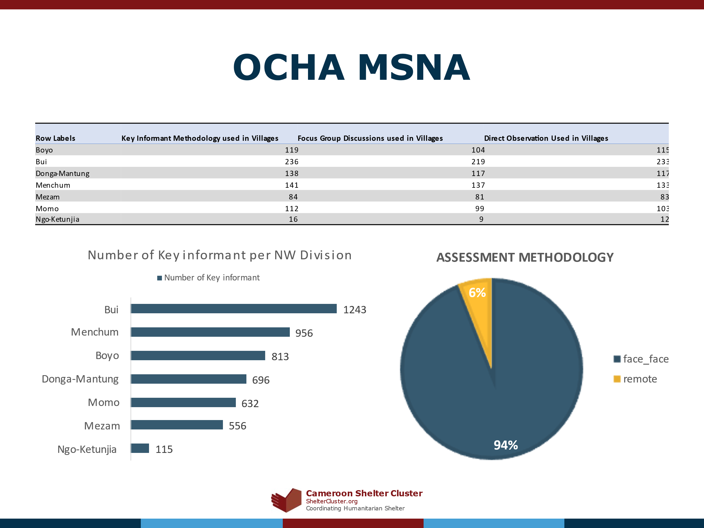
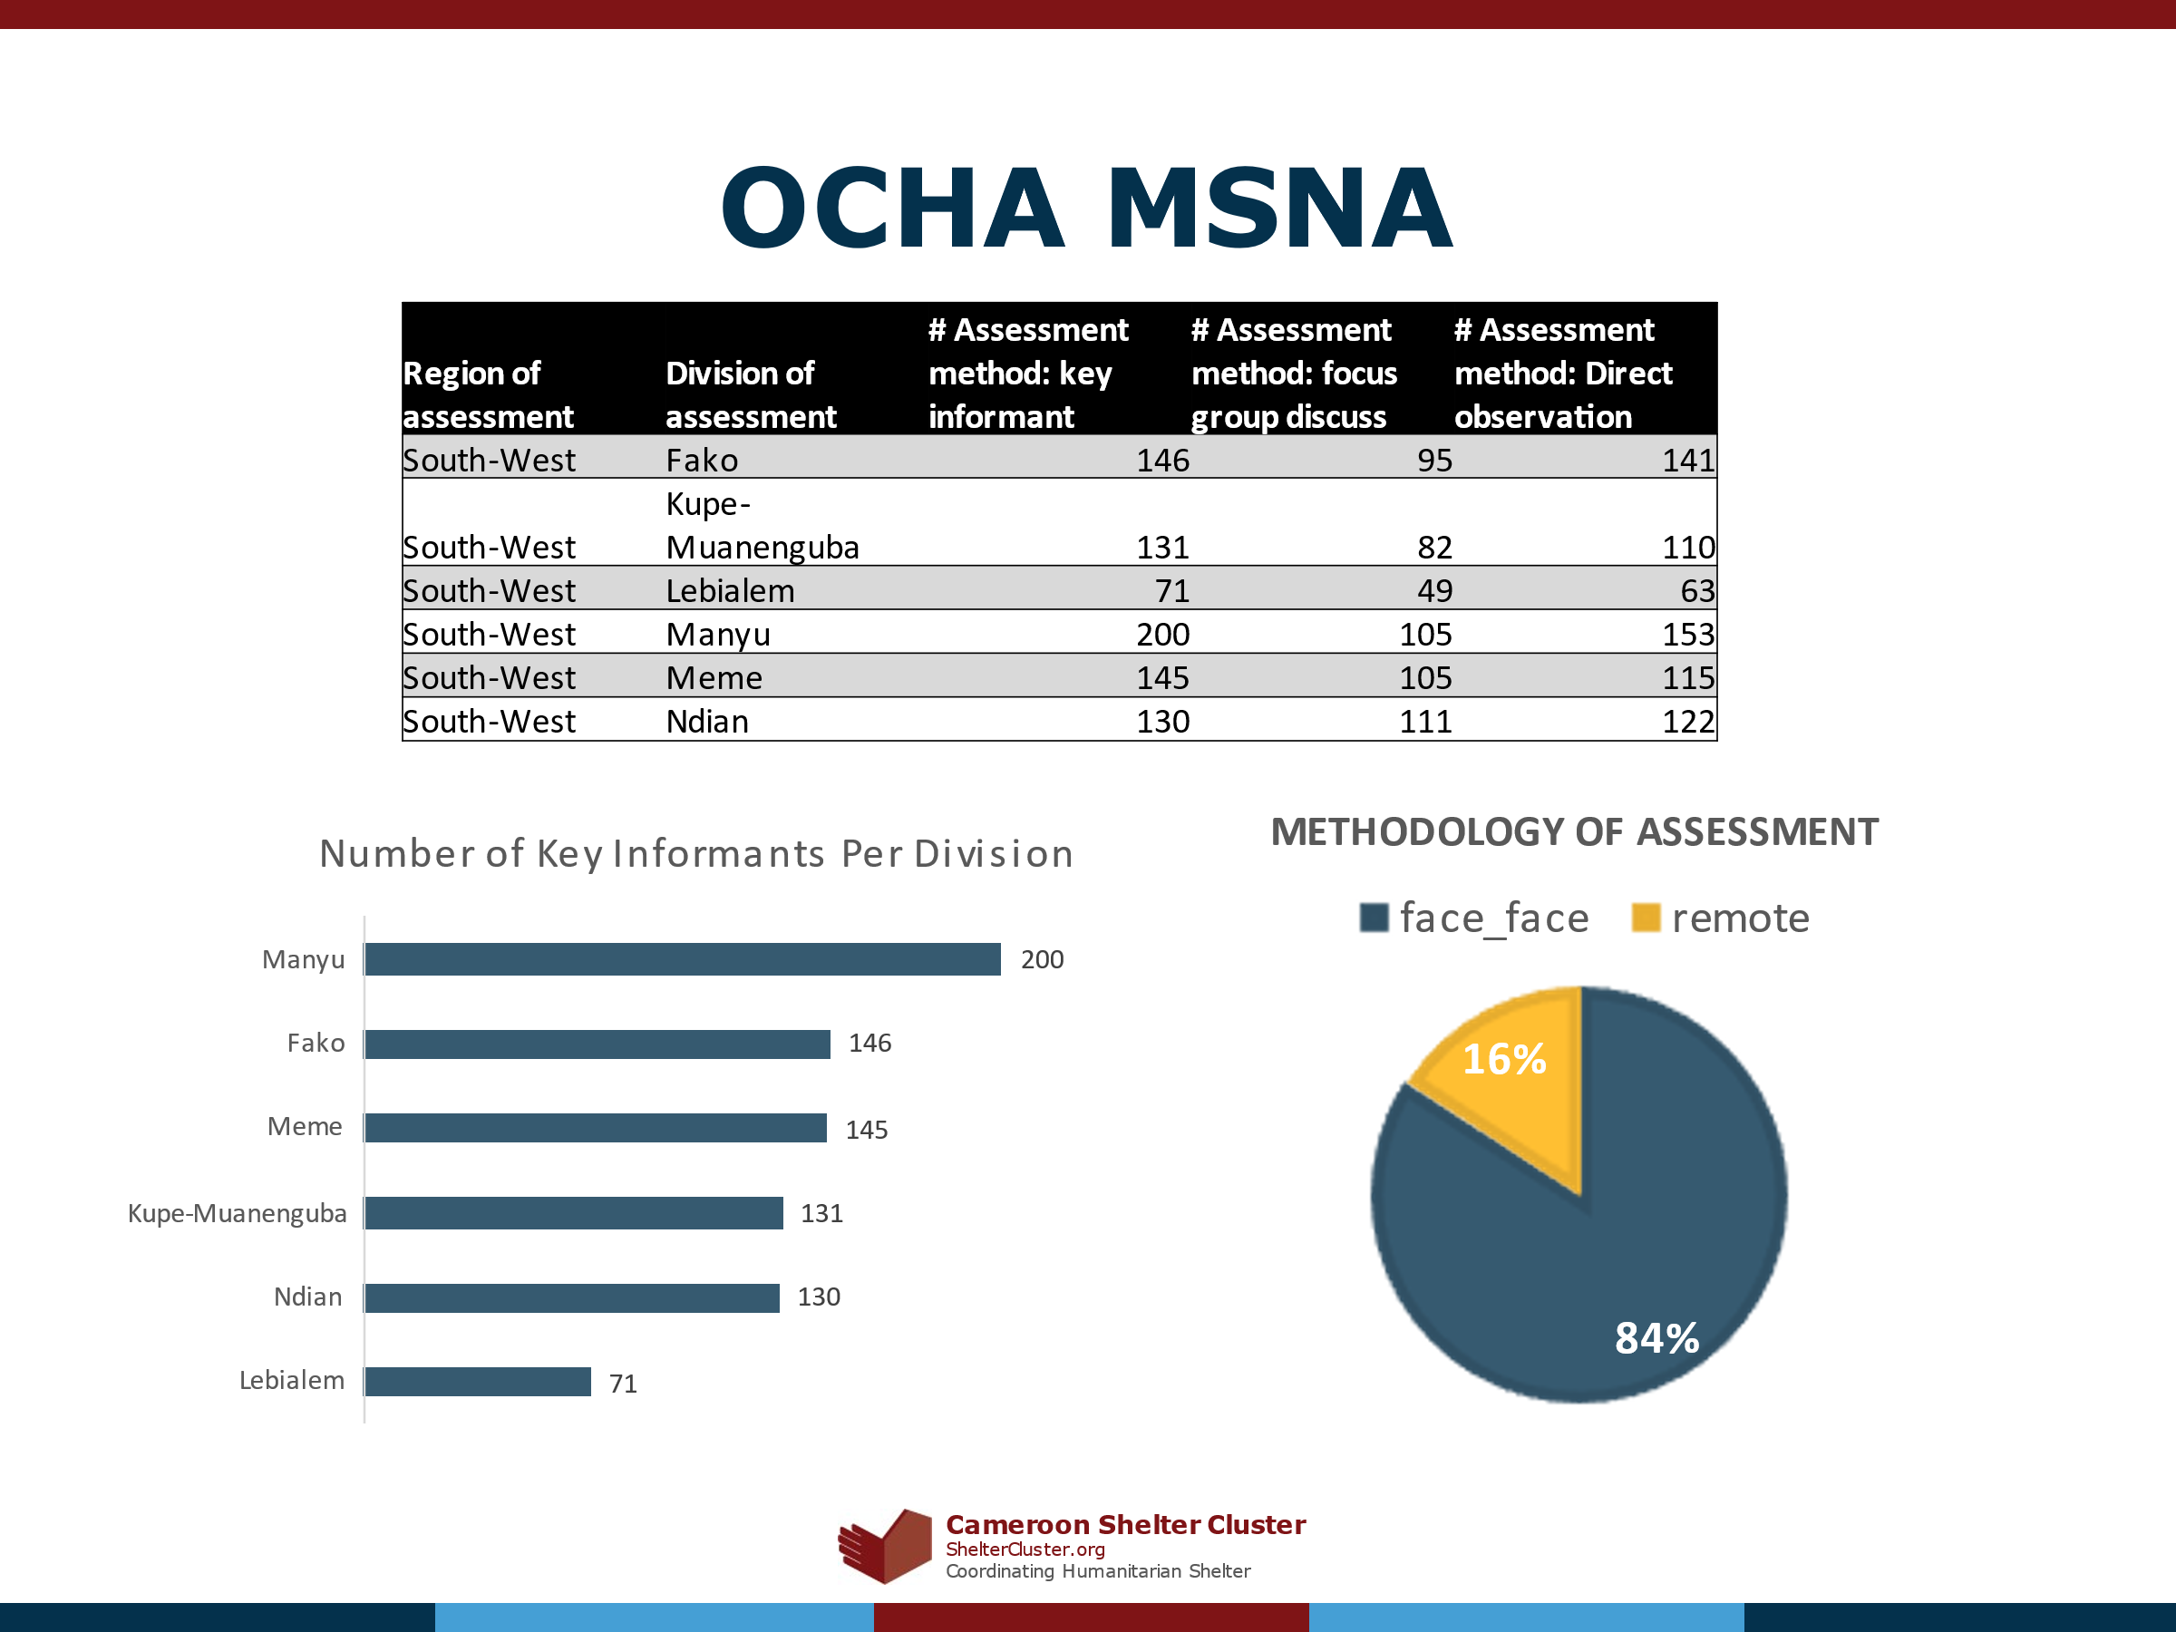

Role | Female | Male | Grand Total
Member PWD Focus Group | 121 | 151 | 272
NGO | 121 | 179 | 300
Local Administration | 145 | 595 | 740
Religious Leader | 219 | 539 | 758
IDP Representative | 385 | 472 | 857
Community Leader | 320 | 1,303 | 1,623
Member Focus Group | 787 | 976 | 1,763
Community Leader IDP | 1,117 | 1,509 | 2,626
Total |  |  | 8,939

Shelter Cluster Partners in the Northwest and Southwest Regions of Cameroon held two workshops to analyse the findings of the two assessments and to also validate and give their perspective on whether the data matched what they were seeing in the field.
- April 13-14 2022: Workshop in Bamenda: Presentation and Action Points
- April 27th-28th 2022: Workshop in Buea: Presentation and Action Points
Approximately 70% of the survey respondents in the NW were female and in all population groups, there were more women than men who were respondents to Plan International’s Household survey.

Out of all respondents in the NW region, the distribution between male and female and IDP, returnee, and non-displaced populations is the following:

In the divisions of the SW where the assessment was conducted, the distribution between male and female respondents was more even and across population groups, with more non-displaced/host males responding to the survey than females.

Below is a disaggregation of all respondents in the SW region according to population type and gender:

Data validation criteria was not used for the average age of the respondents, so 28 samples had to be dropped from the sample to calculate the average of respondents due to improper data entry. In the NW, the average age of female respondents was 49 years of age with, while the average of male respondents was 52. The minimum age of female respondents was 18 years for females and 20 years of age for males. The maximum age of female respondents in the NW was 84 years of age, while the maximum age of male respondents is 96 years of age. The breakdown by gender and status of population is the following:

In the SW, the average age of female respondents is 47 years old, while the average age of male respondents is 49 years old. In the SW, the minimum age for both male and female respondents is 18 years of age. The maximum age of respondents is 86 years old for females, and 93 years old for males. The average age of respondents in the SW per population status is depicted in the graph below:

Population Analysis
In terms of population breakdown, there was a data collection error: The data collection form did not seem to add any validation criteria to reflect that the number of people per age and gender in the household should equal the total number of people in the household. The question of number of people in the household perhaps did not have to be asked and could have been made a calculation question in Kobo. Based on the number of people in each age and gender category the total number of people in the household was recalculated and %s was applied to analyse the population pyramids of the affected population.

Age Gender Population Pyramids per Population Groups
Cameroon’s population is recognized for being relatively young as can be seen in these various population pyramids. According to the World Bank, Cameroon has on average 35 births per 1000 people, and a death rate of 9 people per 1000 people showing that the population will continue to grow at a rate of 2.7% each year. Accounting for the overall local population in Cameroon can be complicated as the country has only conducted two national censuses, with the last census conducted in 1987. According to population projections from the World Bank Indicators and Cameroon’s Institut National de la Statistique, the Northwest (NW) and the Southwest (SW) comprise 17.5 % of the population of Cameroon (10% of the population in the NW and 7.5% in the SW).
When one looks at the composition of the various population groups in the charts below, IDPs in both the NW (62% below the age of 18) and in the SW (61% below the age of 18) are the youngest population group, while non-displaced populations are the oldest with 56% of the population below the age of 18 in the NW, and 58% of the non-displaced population below the age of 18 years in the SW. This however is not a statistically significant difference, and therefore there is not a causal relationship in age differences and movement patterns of these two groups.

IDPs in the NW

Age | Female | Male
0-5 years | 12% | 10%
6-12 years | 13% | 12%
13-17 years | 8% | 7%
18-49 Years | 17% | 12%
Over 50 years | 6% | 4%

IDPs in the SW

Age | Female | Male
0-5 years | 12% | 10%
6-12 years | 11% | 11%
13-17 years | 10% | 7%
18-49 Years | 17% | 14%
Over 50 years | 4% | 5%

Returnees in the NW

Age | Female | Male
0-5 years | 11% | 10%
6-12 years | 12% | 11%
13-17 years | 8% | 8%
18-49 Years | 16% | 12%
Over 50 years | 7% | 5%

Returnees in the SW

Age | Female | Male
0-5 years | 10% | 9%
6-12 years | 12% | 10%
13-17 years | 9% | 7%
18-49 Years | 18% | 17%
Over 50 years | 4% | 5%

Host/Non-Displaced in the NW

Age | Female | Male
0-5 years | 10% | 8%
6-12 years | 12% | 10%
13-17 years | 10% | 8%
18-49 Years | 17% | 13%
Over 50 years | 7% | 6%

Host/Non-Displaced in the SW

Age | Female | Male
0-5 years | 12% | 9%
6-12 years | 11% | 9%
13-17 years | 8% | 7%
18-49 Years | 16% | 16%
Over 50 years | 5% | 6%

Disability

Disability in the NW-
Respondents were asked how many disabled people they had by type in their household. When taking the total number of people per household, 13% of non-displaced people in the NW have a disability as compared with 12% of returnees and 9% of internally displaced people. The difference between non-displaced disabled people and internally displaced disabled people is a statistically significant indicating that physical ability is a determiner in one’s displacement status. When one calculates the number of households with presence of disabilities in the NW, 37% of IDP households reported the presence of at least one disability; 47% of non-displaced households have at least one disability; and 50% of returnees reported at least one disability. The various types of disabilities per population group per the total number of people per household per respondent is depicted in the chart below:

Disability in the SW
In the SW, 12% of non-displaced people have a disability as compared to 8% of internally displaced people and 8% of returnees. This difference between non-displaced disabled people and internally displaced disabled people is also a statistically significant one indicating that physical ability is a determiner in one’s displacement status. Of respondents in the SW, 31% of IDP respondents reported at least one disability in their household; 40% of non-displaced respondents reported at least one disability; and 31% of returnees reported at least one disability in their household. The various types of disabilities per population group is depicted in the chart below:

Shelter and Settlement Type

Type of Location
  - NW– 72% of respondents in the NW region are living in rural areas.

SW- 85% of respondents are living in rural areas. The SW region has a greater degree of informal and formal settlement locations.

Given the dominant narrative of the crisis being largely urban in character, it was interesting that Plan’s assessment seemed to illustrate that the majority of the crisis affected population were living in rural areas. This is in contrary to the OCHA MSNA which labelled the number of villages to be of an urban character:

Shelter Cluster partners agreed IDPs were primarily sheltered in urban and semi-urban areas. This likely indicates that Plan’s assessment may have a selection bias in the sample.
In order to better determine the living situation of internally displaced people, IDP respondents reported on the settlement scenario in which they found themselves. The following is a breakdown of the various settlement scenarios as reported by IDP household respondents:

IDP Settlement Scenario

Amongst the survey respondents, in addition not the %s shown in the chart, .2% was reportedly residing in formal planned settlements (camps or collective centres) which is representing only 2 such buildings in the sample.
In the SW, IDPs reported a greater presence of formal settlements and also a greater degree of owning or renting their own house or apartment than in the NW. Host families were also reported by a greater percentage of IDPs in the NW than in the SW.

Shelter Cluster partners reported that likely for internally displaced people that the MSNA results were probably more accurate and that the majority of internally displaced people in the Northwest and Southwest were still living in hosted arrangements in homes. This also probably stems in part from the targeting and accessibility challenges for IDPs who are taking shelter in the bush. Given the contextual and security sensitivities of these locations, the Plan assessment likely under sampled makeshift shelter types and

Given this feedback, it is equally assumed that the high number of people in the Plan assessment reporting to be in self-settled arrangements (renting or owning), were likely renting. It was agreed that the terminology of “self-settled” was not very clear and was probably confusing for enumerators. This also highlights the need for the Shelter Cluster to provide better guidance to all humanitarian stakeholders on how to classify shelter and settlement typologies.

Shelter Type
89% of IDPs are living in houses according to respondents, followed by 10% in apartments with a few IDPs living in collective centre or tent-like accommodation:

The breakdown of settlement type and shelter types for IDPs is depicted in the graph below:
In the SW region, the predominant shelter types are the following:

It is notable that in the SW, IDPs are able to report a greater availability of emergency shelters than in the NW likely due to the restrictions on the distribution of certain items that would support in the construction of emergency shelter in the NW.
In the NW region, returnees and non-displaced people are in the majority living in apartments and houses as can be seen in the following graph:

Given that the Shelter Cluster in the Northwest and Southwest regions have not really used tents as part of the response, this shelter type was not clear. It is perhaps a confusion with makeshift shelters.
In the SW region, there are a greater variety of shelter types, while houses and apartments remain in the majority.

Occupancy Ratio of House to Determine overcrowding rates
To calculate the occupancy ratio for IDPs living in apartments and homes (99% of IDPs in the NW), the survey employed a proxy indicator of # of rooms per person. Data validation criteria was missing for the question of number of rooms in addition to the validation criteria missing for the # of people living in each household. A significant number of entries had to be dropped out of this question due to the data collection error. Unfortunately due to the limited sample for this question, the results do not depict the reality of overcrowding especially for IDPs who are hosted in their homes. It is suggested that for future shelter assessments that an estimate of the roof surface area in m2 be used. It is also suggested to add a question on the number of people sleeping per room with the gender breakdown. The results of the Plan assessment are shown below:
Northwest
Shelter Type | Internally Displaced | Non-displaced | Returnee
Apartment | 4 | 2 | 2
House | 3 | 2 | 3

Structure Type | Internally Displaced | Non-displaced | Returnee
Bamboo |  | 2 | 3
Concrete | 3 | 2 | 2
Mud bricks | 3 | 3 | 3
Timber |  | 2

Southwest
Type of Shelter | Internally Displaced | Non-displaced | Returnee
Apartment | 4 | 2 | 3
House | 4 | 2 | 2

Structure of House | Internally Displaced | Non-displaced | Returnee
Bamboo | 7 | 3 | 2
Concrete | 4 | 2 | 3
Mud bricks | 5 | 2 | 2
Plywood | 5 | 3 | 2
Timber | 4 | 2 | 2

Materials used in the Shelters of IDPs, Returnees and Non-Displaced and associated Damages
While there were no respondents who reported living in makeshift shelters in the NW of Cameroon, there was not a conditional formatting question in the kobo, so some respondents reported on the question of what kind of material their shelter was composed of. This happened in 27% of instances for IDP respondents, 12 % of instances for non-displaced respondents, and 3% of instances for returnees. The answers indicate that it is possible that IDPs and enumerators did not have clear guidance on shelter type. This highlights the need for the Cluster to better map out shelter typology and provide pictorial guidance on the types of Shelter found in the NW and SW. The indicative responses are illustrated in the graph below:

In the SW, 39% of respondents answered to the question on makeshift shelter material regardless of the shelter type. There were 55% of instances among IDP respondents, 40% of such instances among non-displaced respondents, and 25% of instances among returnee respondents. The indicative materials used in makeshift shelters for the SW are illustrated in the table below:

Many of the other response types indicated that there was a confusion with the composition of housing and apartments. The response rates should be taken as indicative rather than representative given the low sample answering this question.

Apartment and House Structure
A question was posed to all respondents living in houses and apartments which better indicates the type of housing generally found in the NW and SW. Again, the kobo quality control on this was lacking (no restriction to those who answered that they are residing in apartments or houses), so all respondents could provide a response to this question regardless of their shelter type. In the case of internally displaced people who said they were living in tents or in public buildings, they could be referencing shelters in their place of origin or not be familiar with the shelter type and terminology found in the survey. Notwithstanding, the results provide a clear overview about what are the main housing types found in the NW and SW of Cameroon. As illustrated by the graph below, mud brick housing is the most prevalent type of housing, followed by concrete, and then bamboo:

There are a greater variety of housing and apartment types in the SW as illustrated in the graph below. Timber is the more predominant material than mud brick homes in the SW.

Given that the terminology of shelter, settlement, and setting types seemed to be using many different terminologies both in the Plan Household Assessment and the OCHA Multi-Sectoral Needs Assessment, Shelter Cluster partners in the Northwest and Southwest regions brainstormed the following classifications to clarify terminology within the humanitarian context of the Northwest and Southwest regions of Cameroon:
Northwest Cameroon:
Setting | Settlement Scenario | Shelter | Structure | Roofs
Urban | Renting, Owner, Hosting, Squatting Public/Private | House  Apartment  Collective Shelter (rare) | Concrete, Cement, Sundried/Mudbrick | CGI, Thatch
Semi-Urban | Renting, Owner, Hosting, Informal Settlements, Squatting Public/Private | House, Apartment, Makeshift Shelter  Collective Shelter | Concrete is less than urban, Sundried/Mudbrick | CGI, Thatch
Rural | Owner, Hosting, Informal Settlements, Squatting Public/Private | House, Makeshift Shelter, Farm/Agricultural house or infrastructure | Bamboo, Thatch, Wood | Zinc, Thatch

Southwest Cameroon:
Setting | Settlement Scenario | Shelter | Structure | Roofs
Urban | Renting, Owner, Hosting, Squatting Public/Private | House  Apartment  Collective Shelter (rare) | Concrete, Cement, Timber Wood | CGI * (Plywood ceilings)
Semi-Urban | Renting, Owner, Hosting, Informal Settlements, Squatting Public/Private | House, Apartment, Makeshift Shelter  Collective Shelter | Concrete is less than urban, Timber Wood, Mudbrick | CGI
Rural | Owner, Hosting, Informal Settlements, Squatting Public/Private, Planned Camps built by Cooperatives, Bush | House, Makeshift Shelter, Farm/Agricultural house, or infrastructure, Open-Ground Shelter | Bamboo, Thatch, Wood, Mudbrick | CGI, Thatch

Shelter Damage
When asked whether their shelters had recorded any damage or not, IDPs in the NW were the most common population group to report (60%) damage which is probably a main reason for why they were internally displaced, while returnees were the second largest population group to report damage (58%). Non-displaced population groups reported the least damage to their shelters (38%).

In the SW, IDPs reported the most damage to their shelter (47%) followed by returnees and non-displaced people (44% respectively).

The survey asked respondents who reported damage the level of damage to their homes. However, there were several methodological errors when this question was being posed, including that the conditional formatting was not restricted to only those who reported damage to their homes. This therefore led to some data entry errors, including people who said they had no damage reporting various levels of damage, and also to people who said they had damage to reporting that they had no levels of damage. This makes it difficult to confirm the answers of the respondents. It is also important to remember that the respondents are providing their assessment of damages they witnessed, and the enumerators themselves were not technical. No photos were taken of the shelters, so it is also difficult to confirm the respondents’ opinion of their status. Also in humanitarian situations, respondents may be stressed by the damaged conditions of their shelters and could lack the technical terms to define the level of damage to their shelters. While language of structurally sound was used, this survey is in no position to make such judgements. In order to try to improve the quality of the data collected, a filter of reporting yes to damage was applied to the following breakdown of results.

Houses were the most prevalent type to report damages as reported by 88% of all respondent types in the NW, followed by apartments with the following breakdown per shelter type for all respondents:

In the SW, houses were also the most commonly type of shelter damaged as reported by 92% of all respondent types:

It is important also to look at housing type for the levels of damage. This can help practitioners to determine and advocate for better building materials for housing and also in informing strategies to repair homes in the aftermath of damage or destruction to shelters. Mud brick houses sustained the most damages of all housing types regardless of population breakdown. The following is a chart for those who report living in a house (excluding apartments) and the associated levels of damage reported:

Given the greater prevalence of timber houses reported in SW Cameroon, this shelter sustained more damage than mud bricks in the NW region.
Households were asked if they had damages what were the main challenges to repairing their houses. The question was supposed to be asked only to those households who had damages, but there was improper conditional formatting used in the form, and this question was posed optionally to all respondents. The following responses were filtered to only those who responded that they had damages:

Accessibility and Shelter Type
Disability mainstreaming in shelter interventions is critical in order to ensure that interventions are able to respond to the needs of the most vulnerable. Disabled people in the NW and SW are predominantly living in homes, per the following shelter types:

The breakdown of households with at least one disability and reported damage to their shelter is illustrated in the graph below:

Land and Tenure

Land Ownership Type

The Plan Household Assessment sought to understand the various tenure types of households in both the Northwest and Southwest. The majority of IDPs state that they are renting with a formal agreement (31%) followed by being hosted by a family free of charge (26%). Most (45%) non-displaced people and returnees (48%) were appropriate the owner of the entire dwelling:
The

The situation in the Southwest region was similar with the majority of IDPs (43%) renting with a formal agreement or renting with an informal agreement (20%). In the Southwest region, however, the majority of returnees (21%) were renting with an informal agreement, while a majority of non-displaced households (20%) didn’t respond to the question.

Land Ownership

Rent
Rent: As can be seen in the graphs above, the most common form of tenure arrangement for IDPs is renting mostly with a formal agreement.

Modalities of Payment
A follow up question was posed to respondents who said they were renting or hosted and paying for their dwelling to examine the form of transaction that went on between landlords/hosts and the respondents. Unfortunately, in the Kobo design of the tool, there was no conditionality applied to only respondents that answered to these two criteria. This may indicate that respondents and enumerators did not fully understand all the land tenure types or that there are more complex transactions going on for all tenure types and that tenure in the context of the NW and SW may be need to more fully mapped. Shelter Cluster partners remarked that cash was the most prevalent way to pay for rent, due to the fears that formal mechanisms of payment would increase the risk of taxation on the transaction between tenants and landlords. Partners also remarked that culturally in hosting arrangements, it was likely that internally displaced persons provided in-kind support to the host family but that payment in itself would be unlikely culturally.
Below you will find charts representing the main types of payments. Cash is the predominant form of payment for all population groups in the NW. Recall that this is a reduced sample and represents only 47% of IDPs, 9% of non-displaced, and 38% of returnees and therefore a wider margin of error is implied:

In the SW, cash is the most prevalent form of payment. Remember that this only represents 71% of IDP respondents, 21% of non-displaced respondents, and 38% of returnees.

Source of Income for Rent
The primary sources of income for paying rent was filtered to only those paying rent or paying hosts a fee. Those results are illustrated below:

Other sources of income including farming, unskilled labour, and other odd jobs.

Average Payments
In terms of the average payments that affected populations are paying, there were also some conditional issues in the design of the assessment form, so respondents sometimes responded to this question even if they said they were not renting or hosted. Pending a verification of these entries or perhaps also misunderstanding the tenure type, the following graphs illustrate the number of responses by tenure type. Some samples were removed because respondents did not respond to their shelter type.

In order to show the number of population groups per type that are paying a certain price, the lack of constraints and conditional formatting on the survey prevented a more detailed look at which population groups were paying what. The Jenks Scale range by prices is illustrated in the table below for each of the population groups.
Range of Average Payment NW | IDPs | Non-Displaced | Returnees | All Populations
6 XOF-3500 XOF | 3% | 1% | 0% | 4%
4000-7500 XOF | 5% | 1% | 1% | 6%
8000-14,0000 XOF | 5% | 1% | 0% | 6%
15,000 - 25,000 XOF | 4% | 1% | 0% | 5%
30,000-60,000 XOF | 1% | 0% | 0% | 1%
No Answer | 22% | 37% | 12% | 71%
0 XOF | 3% | 2% | 1% | 6%

Range of Average Payment SW | IDPs | Non-Displaced | Returnees | All Populations
2-48 XOF | 0% | 0% | 1% | 1%
500-5500 XOF | 11% | 2% | 4% | 17%
6000-13,000 XOF | 10% | 3% | 5% | 18%
14,000-30,000 XOF | 3% | 2% | 3% | 9%
35,000- 977,054 XOF | 0% | 0% | 0% | 1%
No Answer | 5% | 23% | 20% | 48%
0 XOF | 1% | 4% | 1% | 6%

For the category of internally displaced people, the OCHA MSNA provides a secondary source of information on the prices. Shelter Cluster partners felt that these prices were more realistic of what they had observed. This is likely because key informants at the village level would be more aware of the average rental prices in their communities.
Price of Rent | Number of IDP HHs in NW | %
200-1500 FCFA | 279 | 5%
2000-3500 FCFA | 1404 | 26%
4000-5600 FCFA | 947 | 17%
6000-8000 FCFA | 573 | 11%
8500- 15,000 FCFA | 2152 | 40%
0 FCFA | 72 | 1%

Price Range | # of Households in the SW | % of IDPs Renting
0 FCFA | 91 | 1%
1 - 1000 FCFA | 71 | 1%
1500- 4000 FCFA | 3178 | 44%
4500- 7500 FCFA | 1069 | 15%
8000 - 15,000 FCFA | 2363 | 33%
20,000 - 45, 000 FCFA | 433 | 6%

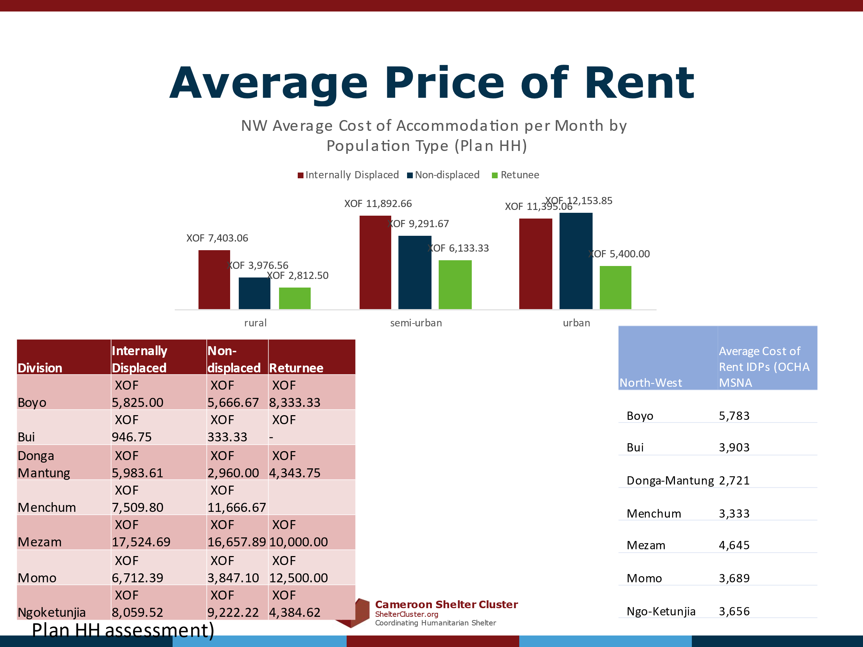

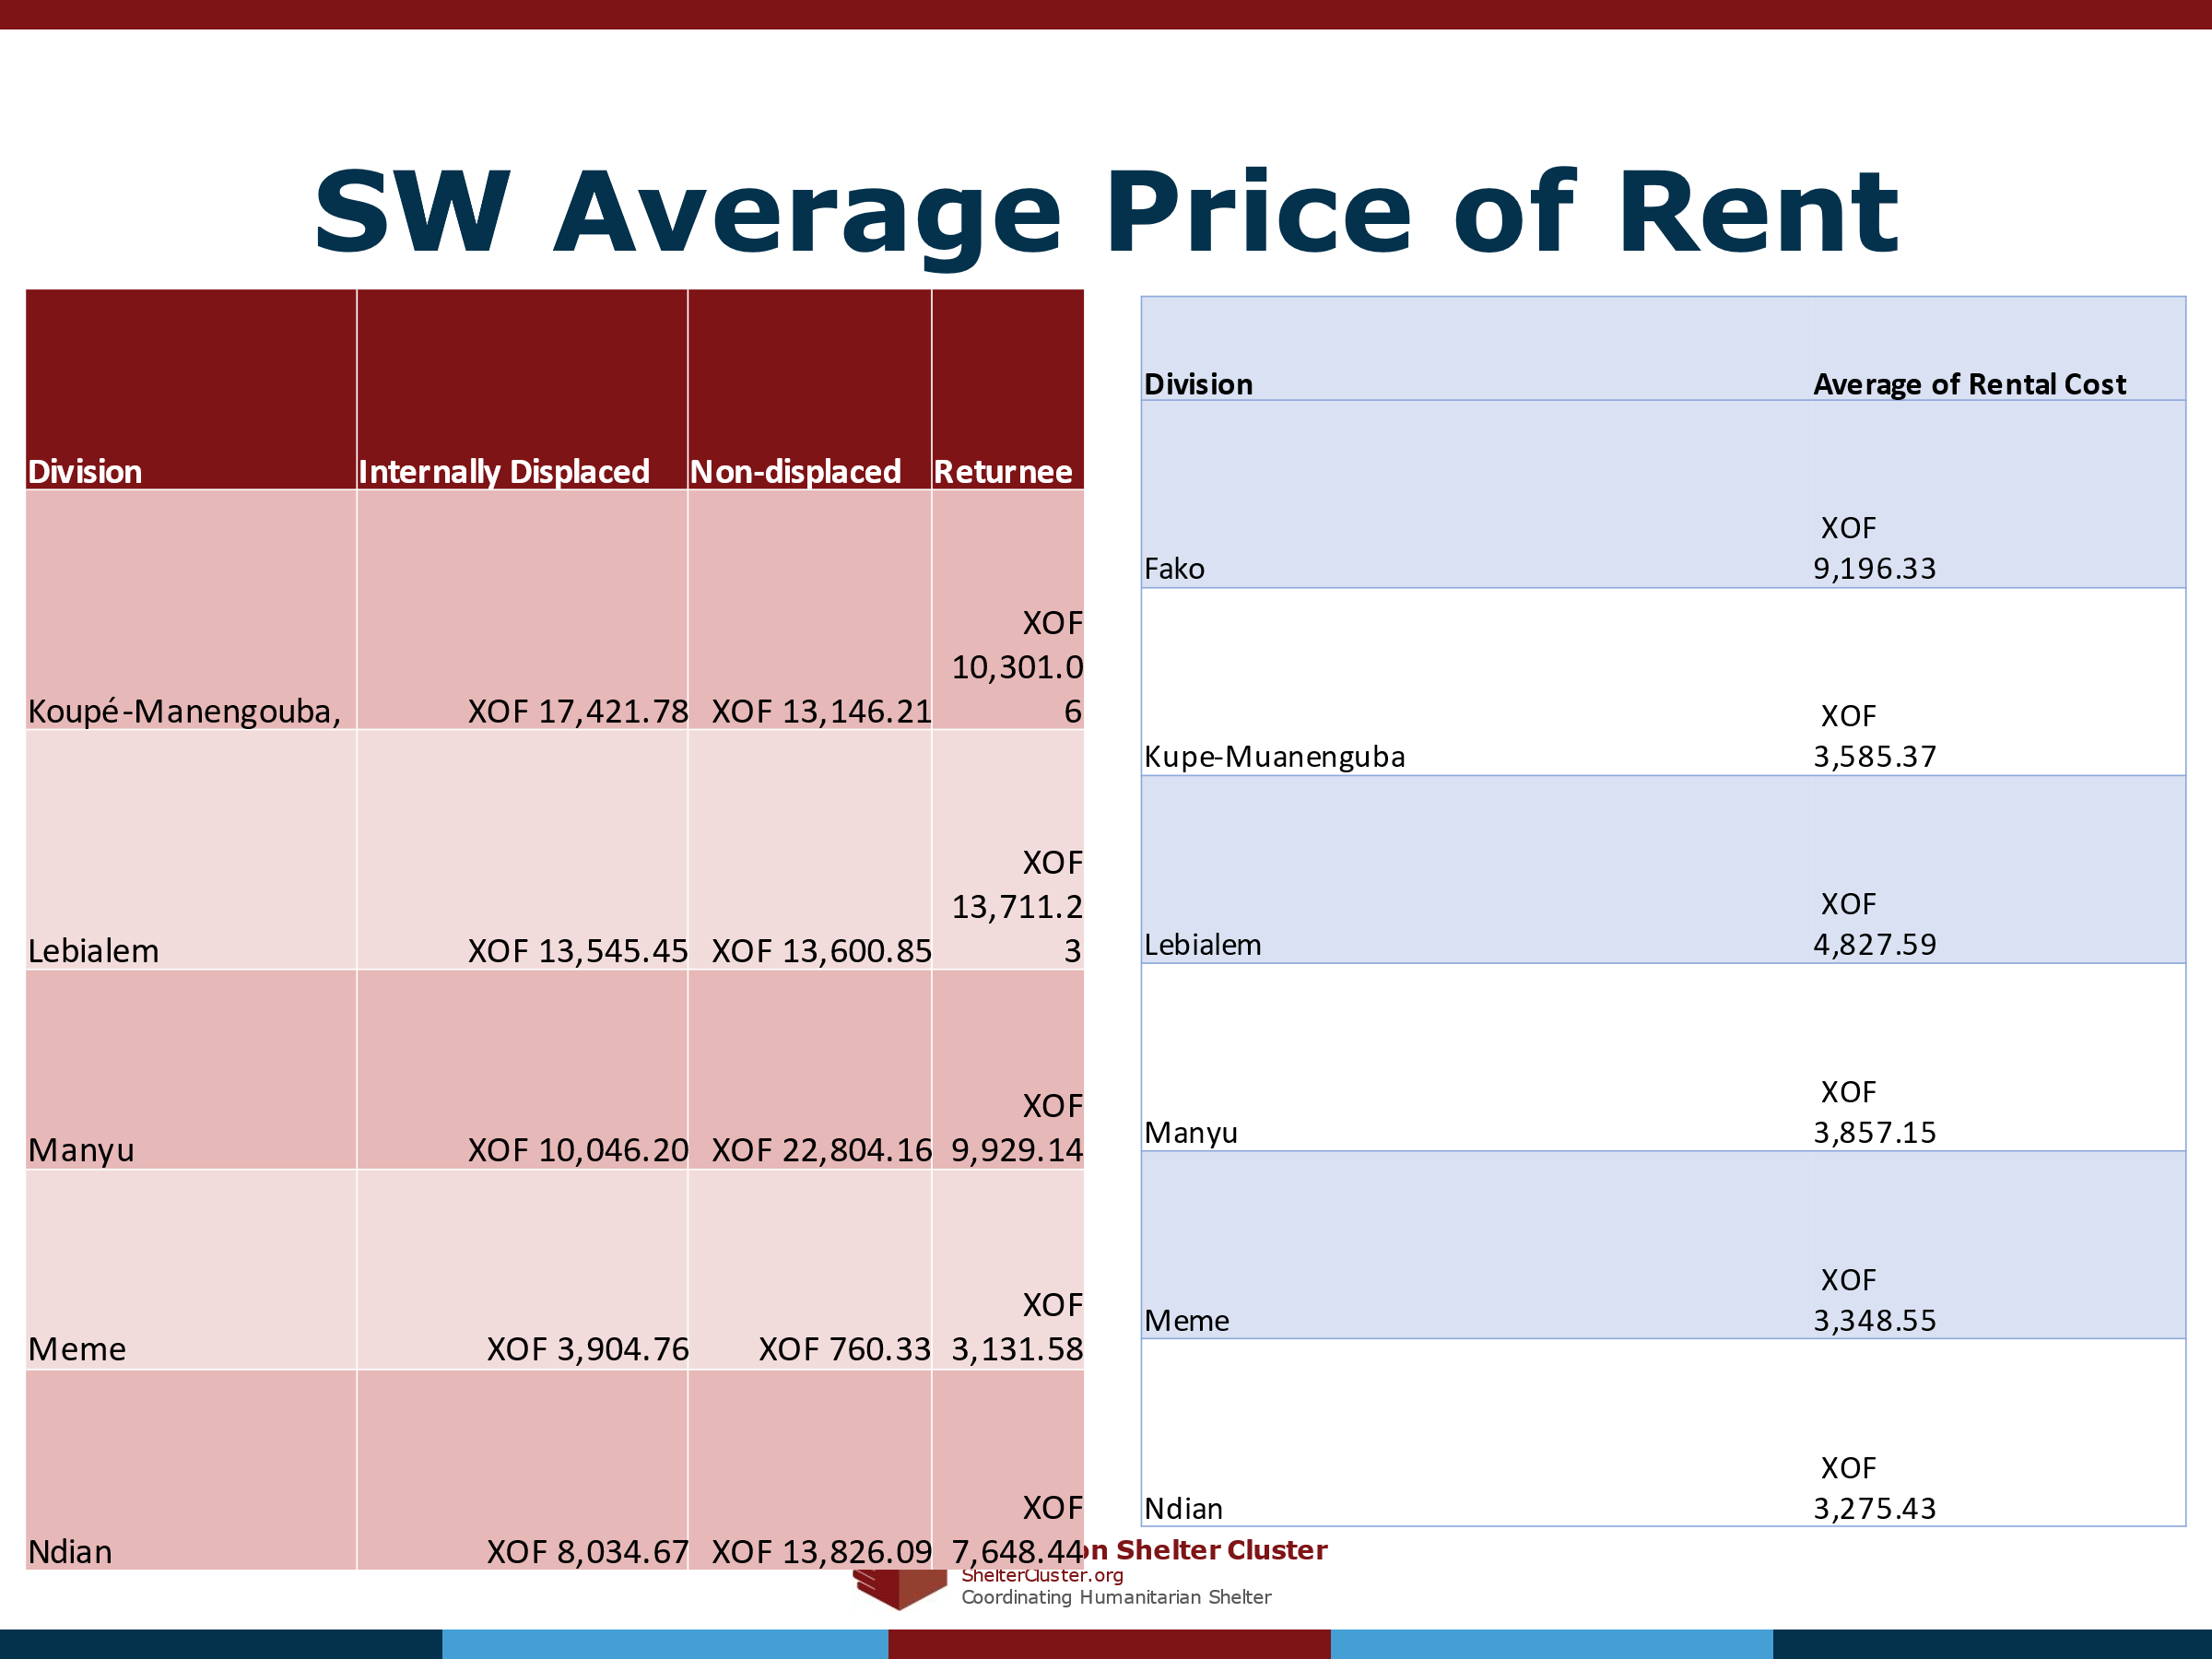

% of Population per size of shelter and average Price
To understand rental dynamics and prices, the type of house and the size of the house are critical indicators to understand how much rent is being paid. As can be seen from the graphs above, there is greatly reduced sampling for those who answered about how much they pay per month for their shelter. There were also errors identified in the proxy indicator for shelter size (# of rooms), as described earlier in this document. The lack of constraints and conditional formatting further does not enhance the analysis, but below are some charts that describe the size of the shelters and the percentage of each population groups paying that average cost per month. The %s were taken as a % of the whole sample of population. Some extreme values were discarded.
Number of Rooms in Shelter | Average XOF per Month | % of IDPs in the NW
1 | 5300 | 17%
2 | 9741 | 38%
3 | 11168 | 24%
4 | 14500 | 11%
5 | 11857 | 5%
6 | 5000 | 2%

Number of Rooms in Shelter | Average XOF per Month | % of Non-Displaced in the NW
1 | 7300 | 6%
2 | 7705 | 25%
3 | 3889 | 27%
4 | 5739 | 21%
5 | 9500 | 11%
6 | 3500 | 4%

Number of Rooms in Shelter | Average XOF per Month | % of Returnees in the NW
1 | 5000 | 7%
2 | 3972 | 23%
3 | 6154 | 29%
4 | 3000 | 17%
5 | 1000 | 11%
6 | 5000 | 6%

Number of Rooms in Shelter | Average XOF per Month | % of IDPs in the SW
0 | 0 | 0%
1 | 4685 | 41%
2 | 9756 | 37%
3 | 12086 | 12%
4 | 7840 | 4%
5 | 22667 | 2%
6 | 9714 | 2%
7 | 18333 | 1%

Number of Rooms | Average Cost of XOF per Month | % of Non-Displaced People in the SW
1 | 4823 | 6%
2 | 18910 | 21%
3 | 11514 | 24%
4 | 8904 | 13%
5 | 7984 | 13%
6 | 4938 | 9%
7 | 6462 | 5%
8 | 22001 | 3%
9 | 12500 | 1%
10 | 13333 | 1%

Number of Rooms | Average Cost of XOF per Month | % of Returnees in the SW
1 | 5188 | 11%
2 | 8892 | 24%
3 | 13086 | 23%
4 | 12696 | 16%
5 | 14536 | 10%
6 | 23070 | 7%
7 | 16667 | 2%
8 | 11250 | 2%

Types of Shelter and Shelter Size and Average Rent per Population Group
A more detailed rental market assessment is recommended for shelter agencies interested in delivering rental market programs. What follows would be the breakdown for the structure of the shelters and average prices per room per population group. The statistical relevancy and sample size is greatly reduced though, so this information can only be taken as indicative:

IDPs in Concrete Shelters
Number of Rooms | Average Cost Per Month | 9% IDPs in the NW living in Concrete Structures
1 | 10571 | 19%
2 | 14844 | 37%
3 | 26500 | 24%
4 | 12400 | 11%
5 | 11000 | 4%

Number of Rooms | Average Cost per Month | 26% of IDPs in the SW living in Concrete Shelters
1 | 6169 | 33%
2 | 13896 | 47%
3 | 14105 | 9%
4 | 8889 | 5%
5 | 14667 | 2%
6 | 10500 | 2%

IDPs in Mud Brick Houses
Number of Rooms in the Shelter | Average Cost Per month | 88% of IDPs in the NW living in Mud brick Structures
1 | 4571 | 18%
2 | 8955 | 39%
3 | 9790 | 24%
4 | 14680 | 11%
5 | 10300 | 6%
6 | 5000 | 2%

Number of Rooms | Average Cost per Month | 11% of IDPs in the SW in Mud Brick Shelters
1 | 6053 | 45%
2 | 13654 | 32%
3 | 8731 | 14%
4 | 20000 | 3%
5 | 21000 | 3%
6 | 30000 | 1%

IDPs in Shelters made of Timber
Number of Rooms | Average Cost per Month | 59% of IDPs in the SW in Shelters Made of Timber
1 | 4061 | 43%
2 | 7133 | 34%
3 | 12163 | 14%
4 | 5269 | 3%
5 | 26615 | 3%
6 | 7727 | 2%
7 | 17000 | 1%

Non-Displaced in Concrete
Number of Rooms | Average Cost Per Month | 7 % of Non-Displaced in the NW in Concrete Shelters
2 | 13750 | 10%
3 | 4500 | 35%
4 | 15000 | 26%
5 | 0 | 14%
6 | 3500 | 4%

Number of Rooms | Average Cost per Month | 35 % of Non-Displaced in Concrete Shelters in the SW
1 | 7200 | 8%
2 | 43076 | 26%
3 | 14342 | 25%
4 | 0 | 11%
5 | 6250 | 9%

Non-Displaced in Mud Brick Shelters
Number of Rooms | Average Cost Per Month | 89% of Non-Displaced in the NW living in Mud Brick Shelters
1 | 7300 | 7%
2 | 7132.352941 | 26%
3 | 3766.933333 | 26%
4 | 4473.684211 | 21%
5 | 4250 | 10%

Number of Rooms | Average Cost per Month | 37% of Non-Displaced in the SW in Mud Brick Shelters
1 | 3300 | 4%
2 | 6096 | 22%
3 | 12919 | 29%
4 | 15310 | 11%
5 | 14554 | 13%
6 | 12000 | 6%
7 | 28000 | 3%
8 | 30004 | 3%

Non-Displaced in Timber Shelter Structures
Timber | Average Cost Per Month | 26% of Non-Displaced in the SW in Timber Shelters
1 | 2111 | 5%
2 | 4711 | 12%
3 | 3308 | 15%
4 | 4850 | 17%
5 | 1180 | 19%
6 | 1900 | 17%
7 | 1833 | 8%
8 | 26667 | 5%

Returnees in Concrete Shelters
Number of Rooms | Average cost per month | 5 % of Returnees in the NW Living in Concrete Shelters
2 | 7500 | 24%
3 | 10000 | 41%

Number of Rooms | Average Cost Per Month | 17% of Returnees in the SW Living in Concrete Shelters
1 | 6571 | 19%
2 | 11607 | 26%
3 | 13750 | 20%
4 | 16000 | 15%
5 | 0 | 5%
6 | 145000 | 5%

Returnees in Mud Brick Shelters
Number of Rooms | Average Cost of Rent | 92% of Returnees in the NW Mud Brick Shelters
1 | 5000 | 7%
2 | 3531 | 23%
3 | 5455 | 28%
4 | 3000 | 18%
5 | 1000 | 12%
6 | 5000 | 6%

Number of Rooms | Average Cost Per Month | 28% of IDPs in the SW Living in Mud Brick Shelters
1 | 4501 | 8%
2 | 9040 | 19%
3 | 14404 | 25%
4 | 15375 | 16%
5 | 15629 | 15%
6 | 16250 | 9%
7 | 25000 | 2%
8 | 22500 | 3%

Returnees in Plywood Shelters
Plywood | Average Cost Per Month | 7% of Returnees in the SW Living in Plywood Structures
1 | 5125 | 6%
2 | 7714 | 16%
3 | 12600 | 12%

Returnees living in Timber Shelters
Number of Rooms | Average Cost Per Month | 38% of Returnees Living in Timber Shelters
1 | 4500 | 9%
2 | 7747 | 27%
3 | 9974 | 28%
4 | 7000 | 17%
5 | 10583 | 8%
6 | 11250 | 6%

Settlement Type and Location influence on Average Price of Rent
Lastly, the location of the shelter by settlement location is a key determiner in knowing rental dynamics, the indicators of geography and settlement type are therefore important to know the rental dynamics of the market. Below are some maps and graphs showing by settlement type, and then also by location and population type.

In the SW, urban non-displaced was dropped out due to a significantly higher average (outlier).

Eviction risk

The Plan assessment sought to understand the risk of eviction. Shelter Cluster partners shared from their experiences that the risk of eviction was particularly high in urban areas. The Shelter Cluster is attempting to receive additional information from the Housing, Land, and Property Area of Responsibility in order to have a secondary source of information on the rate of eviction. In the Northwest region, Shelter Cluster partners mentioned a high rate of eviction and affordability issues for internally displaced people in Bamenda. In the Southwest this noted both as being a challenge throughout Fako division and larger cities such as Buea and Kumbo.

WASH
WASH indicators need to be analysed alongside shelter ones in order to understand the adequacy of services within the shelter.

Sanitation
Access to functioning sanitation facility/latrine: NB: no proxies for functioning were used in this assessment.

Shelter and availability of Latrines:

Gender and access to sanitation facilities:

Missing Indicators for number of people per latrine
Common WASH indicators such as number of people per latrine were not possible to analyse in this assessment due to the fact that there was no question posed on the number of latrines per shelter. Equally it was not possible to examine WASH indicators on how many latrines were available for men and women within the shelters.

Handwashing Facilities
- Access to functioning handwashing facilities- NB: no proxies for handwashing facilities were used in this assessment:

Energy, Lighting, and Cooking

Lighting
Respondents were asked whether they had sufficient lighting at night. It should be noted that no proxies for sufficient were included in the survey:

Main sources of lighting per population group:

In terms of other sources of fuel mentioned in the NW, many respondents answered that they used bush lamps which uses kerosene as its source of fuel. Other respondents mentioned that they used torches which indicates a confusion between the more American reference flashlight which was a survey choice and the Anglican reference. Some other rare mentions included phone light and the light of a motorbike.

Of the other types of lighting sources, bush lamps were also the most frequent type of lighting used.

Where do households cook:

The other sources seemed to be missing from the data set.

As can be seen internally displaced people tend to be the population more likely to have to cook outside in shared spaces, while in the SW this is the dominant form of cooking for all population groups.

Type of Stove

Type of Cooking Fuel

NFIs
Respondents’ perception of the sufficiency of certain household items- This was based on the perception of respondents. No proxies for sufficiency were used in the assessment: In the NW, diapers and pads were the most lacking items, while internally displaced people also seemed to be lacking cooking items.

Sufficiency of Items

Bedding type:

Sleeping on the ground: A follow up question was posed to households that mentioned that they had people sleeping on the floor. Unfortunately, there was no conditional format question type applied to this question, so other responders with other bedding types responded. This could indicate that the household does not have enough bedding or that the respondents and enumerators did not understand the question type. Given the lack of clarity in this question, the filter of no bedding sleeping on the ground was reapplied as the % of people reported per household (given the methodological calculation recalculation mentioned earlier in this document) for the following breakdown:

Kitchen Supplies:

Markets

Access
Respondents access to markets by proximity to functional markets- Note that there were no proxies for functional used to measure the level of functionality of markets

Availability of items in the markets

Income and Expenditure

Main Income
Two Main Sources of Income: There was no choice of no income, but there was the reply of respondents who indicated that they earned 0 XOF in the last 30 days:

Average Income and Income in the Last 30 days:

Affected Population’s Perception of how income has changed
Affected Population’s Perception of how their income has changed since displacement/start of crisis: Again, there was a methodological issue in this question that seemingly all population groups were replying to this question, when it should have only been applied to displaced and returnees. The results are presented according to how they were answered, as non-displaced may have also been secondarily impacted the dynamics of the crisis.

Main two expenditures

Shelter Cluster respondents analysed this expenditure question alongside the priority of needs that key informants were asked during the OCHA MSNA:
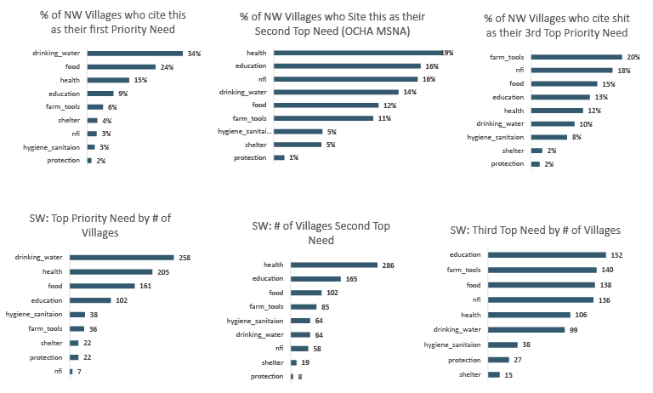
Shelter was still mentioned as the top needs of some of the village key informants interviewed, but not as high as drinking water, food, health, and education. Shelter Cluster partners reflected that this was likely that following the achievement of having a roof over their heads, the other details of a shelter would follow after these other significant expenses were covered.

Needs and Humanitarian Assistance

Priority Needs in Terms of Shelter

Has your household received Shelter/NFI assistance in the past year?

Shelter Cluster partners compared these responses with data collected in the MSNA on Shelter coverage and also on where villages reported past issues with distributions conducted.

Type of Assistance Provided
The cascading on this question was also not well applied, so that some people to whom this question did not apply replied to it. Given the analysis with the information collected from Key informants, the analysis of the Shelter Cluster 5W, and also this assessment, the %s are reflective of low coverage of shelter needs in the response.

Other forms of assistance included for the most part food assistance, while some answers indicated that enumerators or respondents did not fully understand the definition of non-food item.

Intentions in the Next Year

Place of Origin:
This questionnaire unfortunately did not use geographical cascading in Kobo, so it has required a lot of data cleaning to just track the interdivisional movement of patterns of IDPs from their place of origin to their place of displacement. More data cleaning could yield some interesting results on where the primary source of displacement to primary place of safety was. The following are the interdivisional patterns of movement from area of origin to division of displacement:
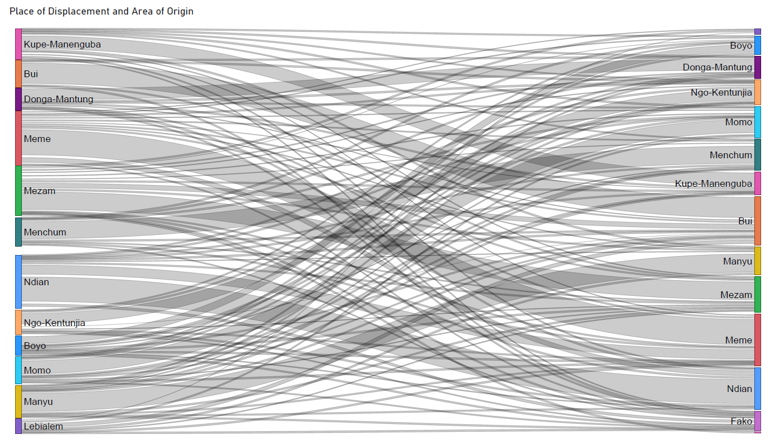

IDP Intentions
As can be seen in the charts below, the majority of IDPs in the NW would like to stay in their area of displacement as compared to the SW, where the majority are ready to return within the next year. Though it is also notable that in the SW there are an almost equal proportion of IDPs who are yet undecided about their intentions in the next year.

Reasons for Staying IDPs
This question was also posed to all respondents regardless of their intentions. So in order to properly assess the question, a filter was applied to only those that replied that they had the intention of staying in their area of displacement:

Reasons for Return Intentions
Again this question was to only be applied to those who stated an intention to return, so a filter was reapplied to only those who stated that they had the intention of returning. In the response, IDPs could select up to 3 motivations for being willing to return.

The other reasons were not found in the dataset.
In the assessment data validation workshop, Shelter Custer partners remarked on how housing was a primary factor in the decision-making and considerations of IDPs about their return movements. While this is a reduced proportion of the sample, as humanitarian actors move to adopt policies over the longer-term on intentions for return and support, it will be necessary to also conduct more in-depth studies on intentions. Housing and Shelter should be a key element of that research given that it is a key element of durable solutions.

Levels of Integration
Likely this should have only been asked to IDPs but seemed to be applied to more than one type of population. This question was mostly answered positively by IDPs showing that they are mostly welcome by the host communities in their area of displacement. Those not feeling integrated would perhaps be motivated to return at a later date.

Annex 1 Sample Size per Division
Below is a list of the data collected for each population and the confidence levels that could be applied on the divisional level per region
IDPs in the NW
Division | Internally Displaced Sample HH Assessment | MSNA August | Confidence Intervals for 95% Confidence Level | Confidence Intervals for 99% Confidence Level
Boyo | 86 | 7218 | 95% +/- 10.51 | 99% +/- 13.83
Bui | 209 | 9730 | 95% +/- 6.71 | 99% +/- 8.83
Donga Mantung | 93 | 5897 | 95% +/- 10.03 | 99% +/- 13.27
Menchum | 139 | 4816 | 95% +/- 8.19 | 99% +/- 10.78
Mezam | 246 | 9063 | 95% +/- 6.16 | 99% +/- 8.11
Momo | 153 | 3100 | 95% +/- 7.73 | 99% +/- 10.17
Ngoketunjia | 125 | 2679 | 95% +/-8.56 | 99% +/- 11.27
Total | 1051 | 42503 | 95% +/- 2.99 | 99% +/-3.93

Returnees in the NW
Division | # of Retunee HHs samples | Sum of Number of Estimated Returnee_Households | Confidence Intervals for 95% Confidence Level | Confidence Intervals for 99% Confidence Level
Boyo | 107 | 5428 | 95% +/-9.38 | 99% +/-12.35
Bui | 23 | 7845 | 95% +/- 20.41 | 99% +/- 26.86
Donga Mantung | 49 | 15287 | 95% +/-13.98 | 99% +/- 18.4
Menchum | 8 | 5878 | 95% +/- 34.63 | 99% +/-45.58
Mezam | 5 | 9078 | 95% +/- 43.82 | 99% +/- 57.68
Momo | 18 | 2811 | 95% +/-23.03 | 99% +/- 30.01
Ngoketunjia | 118 | 2311 | 95% +/- 8.79 | 99% +/- 11.57
Total | 328 | 48638 | 95% +/- 5.39 | 99% +/-7.1

Non-Displaced Population
Row Labels |  | Non-Displaced Local population Sample | Estimates based on 2005 Population Estimates and WB Population Growth Rate |  |  | Confidence Intervals for 95% Confidence Level |  | Confidence Intervals for 99% Confidence Level
Boyo |  | 221 | 55991 |  |  | 95% +/- 6.58 |  | 99% +/- 8.66
Bui |  | 63 | 144349 |  |  | 95% +/- 12.34 |  | 99% +/- 16.25
Donga Mantung |  | 149 | 121019 |  |  | 95% +/- 8.02 |  | 99% +/-10.56
Menchum |  | 11 | 72629 |  |  | 95% +/- 29.55 |  | 99% +/- 38.89
Mezam |  | 217 | 234984 |  |  | 95% +/- 6.65 |  | 99% +/- 8.75
Momo |  | 230 | 62181 |  |  | 95% +/- 6.45 |  | 99% +/- 8.49
Ngoketunjia |  | 100 | 83994 |  |  | 95% +/- 9.79 |  | 99% +/- 12.89
Total |  | 991 | 775147 |  |  | 95% +/- 3.11 |  | 99% +/- 4.1
IDPs in the SW
Division | Internally Displaced HH Sample |  |  | # of IDP HHs MSNA | Confidence Intervals at 95% Confidence Level |  | Confidence Intervals at 99% Confidence Level
Koupé-Manengouba | 143 |  |  | 1795 | 95% +/- 7.86 |  | 99% +/- 10.35
Lebialem | 74 |  |  | 880 | 95% +/- 10.91 |  | 99% +/- 14.36
Manyu | 165 |  |  | 2514 | 95% +/- 7.38 |  | 99% +/- 9.71
Meme | 305 |  |  | 7774 | 95% +/- 5.5 |  | 99% +/- 7.24
Ndian | 325 |  |  | 3014 | 95% +/- 5.14 |  | 99% +/- 6.76
Total | 1012 |  |  | 21241 | 95% +/- 3.01 |  | 99% +/- 3.96

Returnees in the SW
Division | Retunee HH Sample | Returnee HH MSNA | Confidence Intervals at 95% Confidence Level | Confidence Intervals at 99% Confidence Level
Koupé-Manengouba | 607 | 3293 | 95% +/- 3.59 | 99% +/- 4.73
Lebialem | 293 | 989 | 95% +/- 4.81 | 99% +/- 6.33
Manyu | 63 | 4889 | 95% +/- 12.27 | 99% +/- 16.15
Meme | 23 | 5817 | 95% +/-20.4 | 99% +/- 26.85
Ndian | 150 | 2355 | 95% +/- 7.74 | 99% +/- 10.19
Total | 1136 | 23815 | 95% +/- 2.84 | 99% +/- 3.74

Non Displaced Population SW
Division | Non-Displaced Sample | Estimates based on 2005 Population Estimates and WB Population Growth Rate | Confidence Intervals at 95% Confidence level | Confidence Intervals at 99% Confidence Level
Koupé-Manengouba, | 170 | 47335 | 95% +/- 7.5 | 99% +/- 9.88
Lebialem | 258 | 50992 | 95% +/- 6.09 | 99% +/- 8.01
Manyu | 491 | 81166 | 95% +/- 4.41 | 99% +/- 5.8
Meme | 129 | 146486 | 95% +/- 8.62 | 99% +/- 11.35
Ndian | 96 | 54956 | 95% +/- 9.99 | 99% +/- 13.15
Total | 1144 | 380934 | 95% +/- 2.85 | 99% +/- 3.81

Annex 2: Household Tool
NEEDS ASSESSMENT SURVEY: HOUSEHOLD QUESTIONNAIRE
SECTION 0. INFORMATION ABOUT THE INVESTIGATOR
Date of the survey
Investigator's name (or code number)
Organisation
Introduction
"Hello, my name is {_Name of interviewer_}, I work for {_Organisation_}. Do you have a few minutes to tell me about your experience of the overall situation in your shelter/NFI and your community? This Emergency Needs Assessment questionnaire informs humanitarian actors of the current situation in terms of availability and the condition of shelters/NFIs. The main aim is to provide sufficient information to identify immediate priority activities, anticipate potential future shelter problems, including projections and contingency planning. The information from this survey will only be used for sharing, informing the audience of shelter and NFI needs assessment activities. All personal information will be kept confidential and secure. The questionnaire is not a guarantee of assistance. Are you willing to share information about your shelter/NFI needs with us?

Thank you for your cooperation!

SECTION I. GENERAL PRESENTATION
1.1 | Status of the respondent | 1) Internally displaced person  2) Host  3) Returnee |  |  | | |
 | Are you the head of household? | - Yes  - No
1.2 | Name of respondent
1.3 | Age of respondent (Age >=18 ans) | ----------------------------------------------- |  |  | | || |
1.4 | Gender of respondent | 1) Male 2) Female |  |  | | |
1.5 | How many people live in the shelter/household? | ----------------------------------------------- |  |  | | || |
1.6 | How many people from each of the following groups are present in your household (including the head of household) | a. Girls aged 0-5 years how many?  b. Boys 0-5 years how many?  c. Girls 6 - 12 years how many?  d. Boys 6 - 12 years how many?  e. Girls 13 - 18 years) how many?  f. Boys 13 - 18 years) how many?  g. Men (18 - 49) how many?  h. Women (18-49) how many?  i. Men (50+) how many?  j. Women (50+) how many? |  |  | | || |  | || |  | || |  | || |  | || |  | || |  | || |  | || |  | || |  | || |  | || |
1.7 | How many individuals in your household (above 5 years of age) have difficulty in the following? | a. See, even with glasses?  b. To hear?  c. To walk or climb stairs?  d. Understand or be understood, when using their usual language?  e. Remember or concentrate?  f. Take care of himself/herself (e.g., wash or dress)? |  |  | | |  | |  | |  | |  | |  | |
1.8 | Since when have you been living in your current shelter? | -------------------------------------------------- |  |  | | || |/| || || |  Months/ years
SECTION II. INFORMATION ON THE PLACE OF RESIDENCE
2.1. | Region
2.2 | Division |  |  |  | | |
2.3. | Sub-division |  |  |  | | || |
2.4 | Village
2.5 | Geographical coordinates of the household | Latitude : Longitude:
SECTION III. SHELTER
3.1 | Location of settlement: | - urban  - semi-urban  - rural  - formal  - informal |  | | |
3.2 | Displacement situation : | - self-settled (renting or owner)  - self-settled (in an informal settlement)  - formal settlement (planned camp or collective center)  - Host family |  | | |
3.3 | Type of shelter: | - Makeshift / emergency shelter  - Tent  - House  - Apartment  - Public building (school, municipality, etc.)  - Collective Center  - No shelter / Open air
3.4 | If makeshift, type of material employed: | - Bamboo  - Other type of Wood  - Tarpaulin  - CGI sheets  - Straw  - Other specify
3.5 | (If house or apartment) How many rooms does your shelter have? | - How many rooms does your shelter have? :…………………………..
3.6 | (If house or apartment) what is the level of damage to your home? (Enumerator to verify, confirm through observation) | - No damage  - Minor damages (only finishings damaged such as painting, floor tiles)  - Significant damage but habitable (some partition walls, doors, windows but main structure sound)  - Severely damaged and inhabitable (structurally no sound so roof and main structure compromised
3.7 | What are the main challenges you face to conduct repairs on your shelter? | - Lack of money for repairs /reconstruction  - Inability to access markets to procure material for repairs / reconstruction:  - Because too far  - Because dangerous  - Unavailability of material for repairs / reconstruction  - No one in my household or community that can provide support for repairs / reconstruction  - NA, no issues with repairs / reconstruction |  | | |  | |  | |  | |
3.8 | (If house or apartment) what is the main structure made of? | - Timber  - Concrete  - Mud bricks  - Bamboo  - Plywood |  | | |  | |  | |  | |
3.9 | Do members of the HHs have access to a functioning sanitation facility (latrine/toilet)? | - Yes, inside the shelter  - Yes, outside the shelter (communal or shared latrines)  b. No, open air |  | | |
3.10 | Do members of the HHs have access to a functioning washing facility? | a. Yes  b. No |  | | |
3.11 | What would be your priority needs in terms of Shelter? | - energy (light or cooking)  - materials  - money  - additional space  - construction tools |  | | |  | |  | |  | |
3.12 | Has your household received humanitarian Shelter/NFI assistance over the past year? | a. Yes  b. No |  | | |
3.13 | If yes, how many times? | Specify
3.14 | If yes, what type of assistance? | - Non-food items  - Repair / construction material  - Plastic sheets / toolkits  - Other (specify)………………………………….
SECTION IV. NFIs
4.1 | Does your household own a sufficient number of these items (select all that apply. If possible, enumerator to confirm through observation): | - Bedding  - Cooking  - Water containers  - Mosquito-nets  - Soap  - Pads  - Diapers |  | | |  | |  | |  | |  | |  | |  | |
4.2 | Which type of bedding do individuals of your household use (select all that apply)? (if possible, enumerators to confirm through observation) | - Matrasses  - Bed  - Sleeping mat  - No bedding, sleeps on the ground |  | | |  | |  | |  | |
4.3 | If selected, “no bedding,” how many members of the household have to sleep on the floor? | - Provide number
4.4 | How many members of the household have to sleep outside? | - Provide number (even if 0)
4.5 | Does your shelter have sufficient lighting at night? | - Yes, always  - Occasionally  - Rarely  - Never
4.6 | What is your main source of lighting? | - Lights from electrical source (network)  - Lights from electrical source (generator)  - Candles  - Fireplace  - Solar lamps  - Flashlights  - Other (specify)
4.7 | Where does your household prepare your food? | - Inside our home  - Outside in shared spaces / in the street  - At neighbors’ / relatives / friends  - Other (please specify) |  | | |  | |  | |
4.8 | Does your household own a sufficient number of these items (select all that are applicable, If possible, enumerator to confirm through observation) | - Pots  - bowls  - plates  - spoons  - forks  - buckets  - knives |  | | |  | |  | |  | |  | |  | |  | |  | |
4.9 | Which cooking solution do you primarily use? | - Gas  - Wood  - Charcoal  - Eco-gas  - Fuel  - None  - If Other specify………… |  | | |  | |  | |  | |  | |  | |
4.10 | What type of stove do you primarily use? | - kerosene stoves  - Three stones fireplace  - Gas stove  - Sawdust stove  - Oven |  | | |  | |  | |  | |  | |  | |
4.11 | Does your HH have access to a functional market? | - Yes, at less than 30 minutes’ distance  - Yes, at more than 30 minutes’ distance  - Yes, at more than 1-hour distance  d. No |  | | |
4.12 | Which items are usually available on the market? (Select all that apply) | - bedding  - clothes  - footwear  - cooking utensils  - jerrycans  - mosquito nets  - soap  - pads  - diapers  - wood/fuel/gas  - CGI sheets  - timber  - plywood  - cement  - gravel  - plastic sheets / tarpaulins  - construction tools |  | | |  | |  | |  | |  | |  | |  | |  | |  | |  | |  | |  | |  | |  | |  | |  | |  | |
SECTION V. HLP
5.1 | What is the land situation of the household? | - Without any type of agreement (occupation)  - Hosting (specifically in the home of a host family) free of charge  - Hosting (specifically in a host family's home) for a fee  - Renting with formal agreement  - Renting with informal agreement  - Owner Of the shelter on the plot (or in the yard) that belongs to a third party with formal agreement  - Owner of the shelter on the plot (or in the yard) that belongs to a third party with informal agreement  - Owner of the entire dwelling, including the plot with formal agreement  - Owner of the whole dwelling, including the plot with an informal agreement |  | | |
5.2 | If you pay rent or are hosted in a paying capacity, how do you pay for it? | - Cash (specify amount)  - Household work  - Professional work  - Mobile money  - Other (please specify) |  | | |  | |  | |
5.3 | If you pay rent or are hosted on a paying basis, how much do you pay per month? | Indicate the amount
5.4 | What is the main source of income that enables you to pay your rent? | Employment/Employee  Support from relatives / friends / community  Humanitarian aid  Government aid  Savings  Other (please specify)
5.5 | Who owns the land/plot on which you are located? | - To me  - To a family member  - To a private individual,  - To the community,  - To the state,  - I don't know  - Other.  - Prefer not to say |  | | |
5.6 | Is the household at risk of eviction? | - Yes  - No  - I don’t know  - Prefer not to say |  | | |
5.7 | If yes, how soon? | - Less than a week  - 1 week  - Less than one month  - 1 month  - I don’t know  - Prefer not to say |  | | |
SECTION VI. RESILIENCE MECHANISM
6.1 | What are the two primary sources of income of your household NOW? | Work – Agriculture  From commerce  Regular salaried work  Casual work / daily wage – Skilled  Casual work / daily wage - Unskilled  Savings  Support from relatives/friends/community  Humanitarian aid  Government aid  Other (please specify)  No income
6.2 | If casual work / daily wage – Skilled, what type? | Construction  Medical  Education  Other (please specify)  Prefer not to say
6.3 | Primary source of income at place of origin | Work – Agriculture  From commerce  Regular salaried work  Casual work / daily wage – Skilled  Casual work / daily wage - Unskilled  Savings  Support from relatives/friends/community  Humanitarian aid  Government aid  Other (please specify)  No income  Prefer not to say
6.4 | Primary source of income during displacement | Work – Agriculture  From commerce  Regular salaried work  Casual work / daily wage – Skilled  Casual work / daily wage - Unskilled  Savings  Support from relatives/friends/community  Humanitarian aid  Government aid  Other (please specify)  No income  Prefer not to say
6.5 | What was your overall income in the past 30 days? | Specify  Prefer not to say
6.6 | How has your income evolved since your displacement? | Decreased  Increased  Remained the same  Prefer not to say
6.7 | In the last 30 days, what were your main expenditures (select 2) | Food  Education  Shelter repairs  NFI – hygiene products  NFI – non-hygiene products  Health  Other (please specify)
6.8 | Does your household have any productive assets? | Yes  No
6.9 | If yes, what type? | Animals  Machines  Housing property  Other (please specify)
SECTION VII. INTENTION TO RETURN/INTEGRATE
7.1 | What division where you living in prior to your displacement?
7.2 | What sub-division where you living in prior to your displacement?
7.3 | What village where you living in prior to your displacement?
7.4 | What are your movement intentions in the next year? | - Return to Area of Origin  - Stay in Area of Displacement  - Move to a different area of the country or abroad  - Do not know  - Prefer not to answer
Return intention

7.5 | If you are intending to return, why? (max 3) | - Shelter conditions perceived as better in Area of Origin (including facing eviction in area of displacement)  - Livelihood conditions perceived as better in Area of Origin  - Education conditions perceived as better in Area of Origin  - Security conditions perceived as better in Area of Origin  - Basic services perceived as better in Area of Origin  - Emotional desire to return / Follow friends, relatives, members of community  - I need to return to secure Housing, Land or Property  - Do not feel integrated in Area of Displacement  - Other (please specify)  - Do not know  - Prefer not to say
7.6 | How soon would you return? | - Immediately (less than a month)  - 1 to 3 months  - 6 months  - In a year or more
7.7 | What are the main obstacles to return, if you are intending to return? | Financial, no money to return  Transportation  Concern over security conditions  Concern over livelihood conditions  Concern over shelter conditions  No obstacles  Do not know  Prefer not to say
Intégration Intention

7.8 | If you are intending to stay in your area of displacement, why (max 3)? | - Shelter conditions perceived as better in Area of displacement (including facing eviction in area of displacement)  - Livelihood conditions perceived as better in Area of displacement  - Education conditions perceived as better in Area of displacement  - Security conditions perceived as better in Area of displacement / fear of returning to area of origin  - Basic services perceived as better in Area of Displacement  - Emotional desire to stay in area of displacement / Desire to integrate / Relatives, friends, community is in area of displacement  - Would like to return but no financial means to do so  - Other (please specify)  - Do not know  - Prefer not to say
7.9 | If you are intending to stay in your area of displacement, are you intending to integrate in the long term? | - Yes  - No  - Do not know  - Prefer not to answer
7.10 | If you are intending to move to a different part of the country or abroad, why (max 3)? | - Shelter conditions perceived as better elsewhere  - Livelihood conditions perceived as better elsewhere  - Education conditions perceived as better elsewhere  - Security conditions perceived as better elsewhere  - Basic services perceived as better elsewhere  - Emotional desire to move to a different part of the country or abroad / Relatives, friends, community is in other parts of the country or abroad  - Do not know  - Prefer not to say  - Other (please specify)
7.11 | Do you feel integrated here? | - Yes  - No |  | | |
7.12 | If yes, why? | - I am able to associate freely and participate in community affairs without discrimination  - I am able to vote in local community elections  - I am able to get a job without discrimination  - My children are able to go to school without discrimination |  | | |  | |  | |  | |  | |
7.13 | If no, why? | - I face discrimination and I am not allowed to associate freely or participate in community affairs  - I face discrimination in getting a job  - My children are discriminated and stigmatized in school  - I am not allowed to vote in local elections |  | | |  | |  | |  | |  | |
Sustainable integration in another part of the country or abroad (re-settlement)
7.14 | If you are intending to move to a different part of the country or abroad, why (max 3) ? | - Shelter conditions perceived as better in Area of displacement (including facing eviction in area of displacement)  - Livelihood conditions perceived as better in Area of displacement  - Education conditions perceived as better in Area of displacement  - Security conditions perceived as better in Area of displacement / fear of returning to area of origin  - Basic services perceived as better in Area of Displacement  - Emotional desire to stay in area of displacement / Desire to integrate / Relatives, friends, community is in area of displacement  - Would like to return but no financial means to do so  - Other (please specify)  - Do not know  - Prefer not to say
7.15 | If you are intending to move to a different part of the country or abroad, where? | Region: …………………………………  Department:…………………….  Town: …………………………………..  Country: ………….

https://data.worldbank.org/country/CM
http://slmp-550-104.slc.westdc.net/~stat54/nada/index.php/catalog/58/related_materials
ibid
recall that Returnees in the NW already had the lowest sampling level
These maps are the following: Villages reporting shelter support, NFI distribution villages where distribution point too far, NFI distribution villages were there was no information on the distribution calendar

