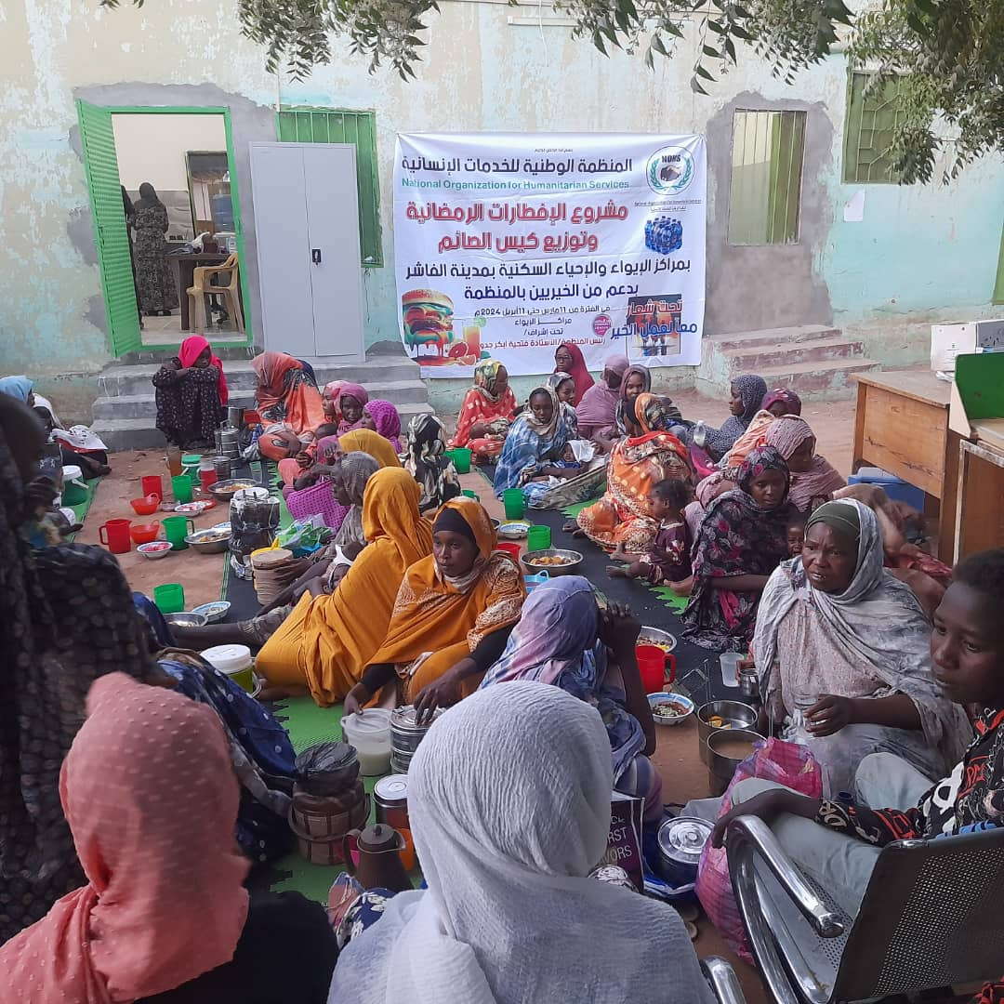
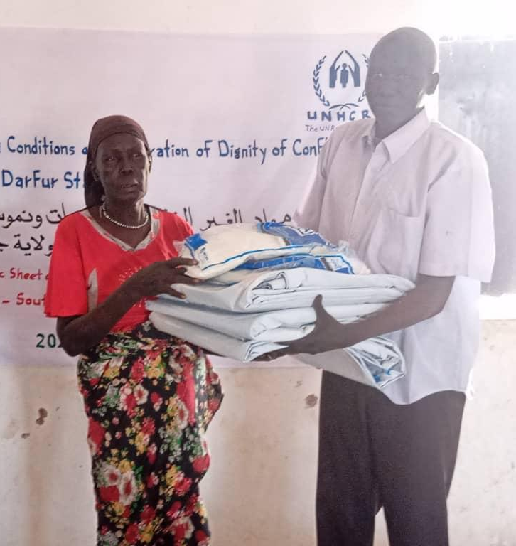
NFI kits are meticulously designed to address the multifaceted challenges faced by IDPs, ranging from protection against the elements to promoting health and hygiene in temporary living conditions.
This guiding document aims to outline the principles and considerations essential for the effective composition of NFI kits tailored specifically for IDPs. By understanding the purpose and significance of NFI kits and adhering to guiding principles, humanitarian actors can ensure that the assistance provided meets the diverse and evolving needs of displaced populations with sensitivity, inclusivity, and effectiveness. Through collaborative efforts and a commitment to humanitarian principles, we can strive to alleviate the hardships faced by IDPs and support their journey towards recovery and resilience.
- Introduction
Non-Food Item (NFI) kits play a crucial role in addressing the immediate needs and enhancing the resilience of Internally Displaced Persons (IDPs) in humanitarian crises. In times of crisis, when individuals and families are forcibly displaced from their homes due to conflict, natural disasters, or other emergencies, ensuring their immediate needs are met becomes paramount. In response to these needs, humanitarian organizations deploy Non-Food Item (NFI) kits to provide essential support to Internally Displaced Persons (IDPs).
The significance of NFI kits in humanitarian response cannot be overstated. These kits serve as a lifeline for displaced populations, offering not only material assistance but also restoring a sense of dignity and resilience during their time of upheaval.

- Meeting Basic Needs
NFI kits are designed to address the immediate needs of IDPs who have been forced to flee their homes due to conflict, natural disasters, or other emergencies. These kits typically include essential items such as shelter materials, hygiene products and household supplies. By providing these basic necessities, NFI kits ensure that IDPs have access to vital resources for survival and well-being during their displacement.
- Restoring Dignity
Displacement often strips individuals and families of their dignity and sense of agency. NFI kits play a crucial role in restoring dignity by providing displaced populations with essential items that contribute to their personal hygiene, comfort, and overall well-being. Items such as clean clothing, hygiene products, and shelter materials help IDPs maintain a sense of self-respect and dignity even in challenging circumstances.
- The Need for NFI kits in Humanitarian Contexts
- Enhancing Protection
NFI kits often include items that contribute to the safety and protection of IDPs, such as shelter materials that provide shelter from the elements and household items that improve security and comfort. By providing essential protection against environmental hazards and risks, NFI kits help mitigate the vulnerabilities faced by displaced populations, particularly women, children, and other vulnerable groups.
- Restoring Dignity
Displacement disrupts the lives of individuals and communities, requiring them to adapt to new environments and circumstances. NFI kits support IDPs in this process of adaptation by providing them with the tools and resources they need to cope with their displacement and rebuild their lives. By promoting resilience and self-reliance, NFI kits empower displaced populations to overcome adversity and work towards a better future.

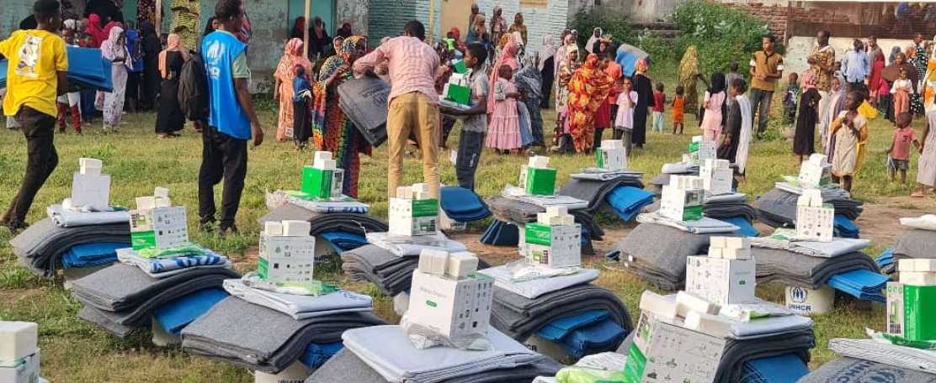
The effective composition of NFI kits is guided by a set of principles aimed at ensuring that the assistance provided meets the diverse and evolving needs of displaced populations with sensitivity, inclusivity, and effectiveness. These guiding principles serve as the foundation for the design, procurement, and distribution of NFI kits, informing decisions about the selection of items, packaging, and distribution mechanisms. By adhering to these principles, humanitarian actors can maximize the impact of NFI assistance and better support the resilience and recovery of IDPs during times of crisis.
- Guiding Principles for NFI Kit Composition

Transparency and Accountability: The procurement and distribution of NFI kits should be carried out in a transparent and accountable manner. Recipients should be informed about the contents of the kits and provided with opportunities to provide feedback on their usefulness and appropriateness.
Needs Based Approach: To ensure that the kit contents are tailored to address the specific needs and priorities of IDPs, the composition of NFI kits should be informed by a thorough needs assessment conducted among the displaced population.
Needs Based Approach
Quality and Durability
Transparency & Accountability
Age and Gender Sensitivity
Cultural Sensitivity
Inclusivity & Accessibility

Gender and Age Sensitivity: NFI kits should be designed to meet the diverse needs of different demographic groups, including women, children, the elderly, and people with disabilities. This requires careful consideration of gender-specific items.
Inclusivity & Accessibility: NFI kits should be accessible to all members of the displaced population, including those with disabilities or other special needs. Efforts should be made to ensure that the contents of the kits are inclusive and meet the diverse needs of all recipients.
Cultural Sensitivity: The composition of NFI kits should respect the cultural preferences, practices, and traditions of the displaced population. Efforts should be made to include items that are culturally appropriate and familiar to the recipients, while also avoiding any items that may be culturally insensitive or offensive.
Quality and Durability: Items included in NFI kits should be of high quality and durability to ensure they meet the needs of IDPs over an extended period. This includes sourcing items that are suitable for the local climate and conditions, and that they withstand the rigors of displacement and use in temporary living situations.
Each principle reflects a commitment to humanitarian values and aims to ensure that NFI assistance is needs-based, gender-sensitive, culturally appropriate, of high quality and durability, accessible to all, and delivered transparently and accountably. By understanding and applying these guiding principles, humanitarian organizations can contribute to the effectiveness and sustainability of their NFI interventions, ultimately enhancing the well-being and dignity of displaced populations in their time of need.
Non-Food Item (NFI) kits are instrumental in providing essential support to Internally Displaced Persons (IDPs) during humanitarian emergencies. These kits contain a range of key components carefully selected to address the immediate needs of displaced populations and promote their well-being and dignity. The table below shows key components of a full NFI kit, highlighting their significance in meeting the diverse needs of IDPs during times of crisis.
- Key Composition of NFI Kits

 | SIGNIFICANCE | ITEM | QUANTITY
Shelter and Bedding | - Shelter and bedding are paramount for the safety and well-being of displaced populations. NFI kits should include tarpaulins, sleeping mats, and blankets to provide temporary shelter and protection from the elements.  - These components offer a sense of security and privacy to IDPs, allowing them to rest and recuperate in a safe environment. | Plastic Sheet | 2
Shelter and Bedding |  | Sleeping mats | 3
Shelter and Bedding |  | Blankets | 3
Household Items | - Basic household items included in NFI kits facilitate daily living activities and promote self-sufficiency among displaced populations.  - Cooking utensils, water containers, lighting sources, and multipurpose tools enable IDPs to prepare meals, store water, illuminate their surroundings, and perform various household tasks.  - These items contribute to the resilience and autonomy of IDPs, empowering them to meet their basic needs in challenging circumstances. | Jerry Cans | 2
Household Items |  | Kitchen Set | 1
Household Items |  | Solar Lamp | 1
Health and Safety | - Access to essential health and safety supplies is crucial for addressing medical needs and ensuring the safety of displaced populations. NFI kits should contain mosquito nets for protection against mosquitos.  - Other supplies may also be added including first aid kits, common medications, baby care items, and protection tools such as and signaling devices.  - These components help IDPs address minor injuries, manage health conditions, and protect against health risks prevalent in displacement settings. | Mosquito nets | 2

Minimum Quantity | 2
Dimensions | 4m x 5m
Material | HDPE
Expected Life Span | 1 year
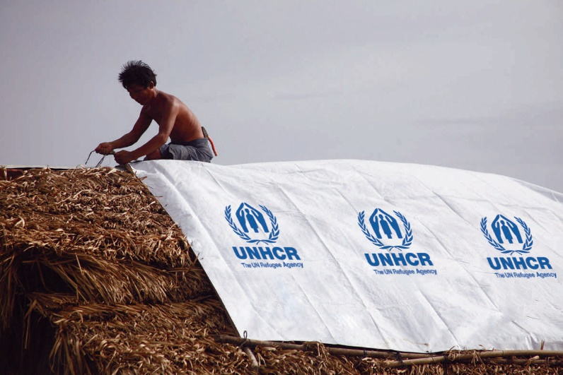
- Plastic Sheets

Reinforced plastic tarpaulin in sheets of 4 x 5 meters was developed and designed for long outdoor use in all climates. Plastic Tarpaulins are to be used in support to humanitarian operations, for temporary shelter and are recommended for individual (family) shelter protection.
Made of woven high-density black polyethylene (HDPE) fibers, warp x weft, laminated on both sides with low density polyethylene (LDPE) coating, with reinforced rims by heat sealing on all sides, (or 2 sides heat sealing and 2 sides double stitching), and a 3 to 5 millimeters diameter PE or PP (flexible materials) rope on the edge, inside the hem. 1000 denier minimum.

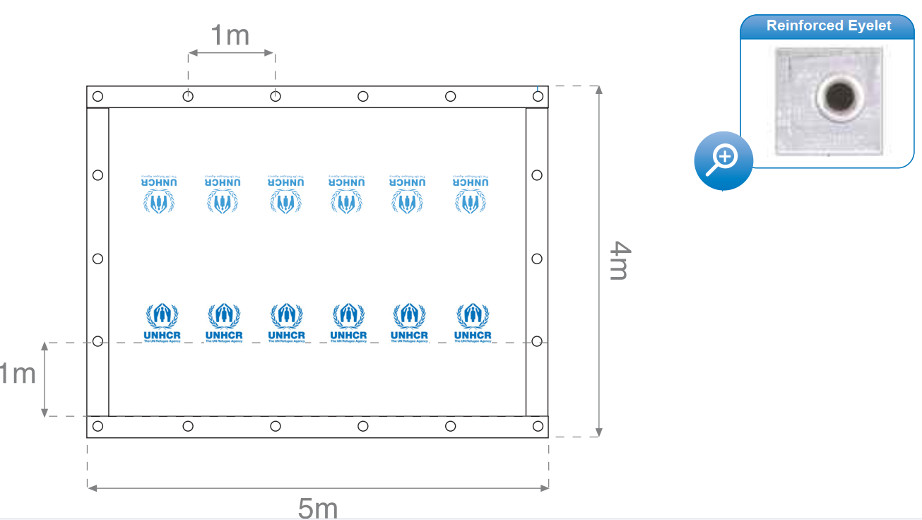
Material net weight: minimum 190 g/m2 ±20 g/m2.
Tensile strength: minimum 600 N both directions of warp and weft (BS 2576, 50 mm grab test, or equivalent).
Tensile strength of the eyelets: minimum 700N inside the eyelets as per ISO 1421-1, pulling lengthwise with a hook of 8mm wire diameter. To test in 2 eyelets in each side.
UV resistance: stabilized against ultraviolet rays and excess heat for
long outdoor exposure.
Minimum Quantity | 3
Dimensions | 180cm x 90cm
Sleeping Mat Area | 1.62 m2
Material | 100% synthetic yarns
Expected Life Span | 1 year
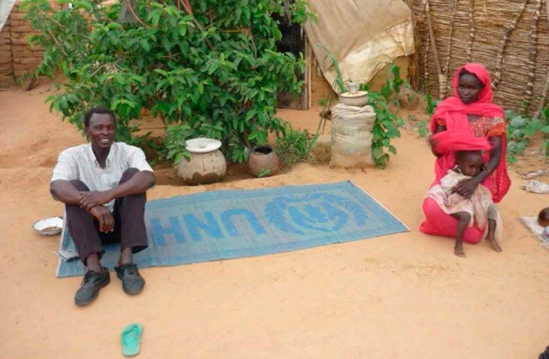
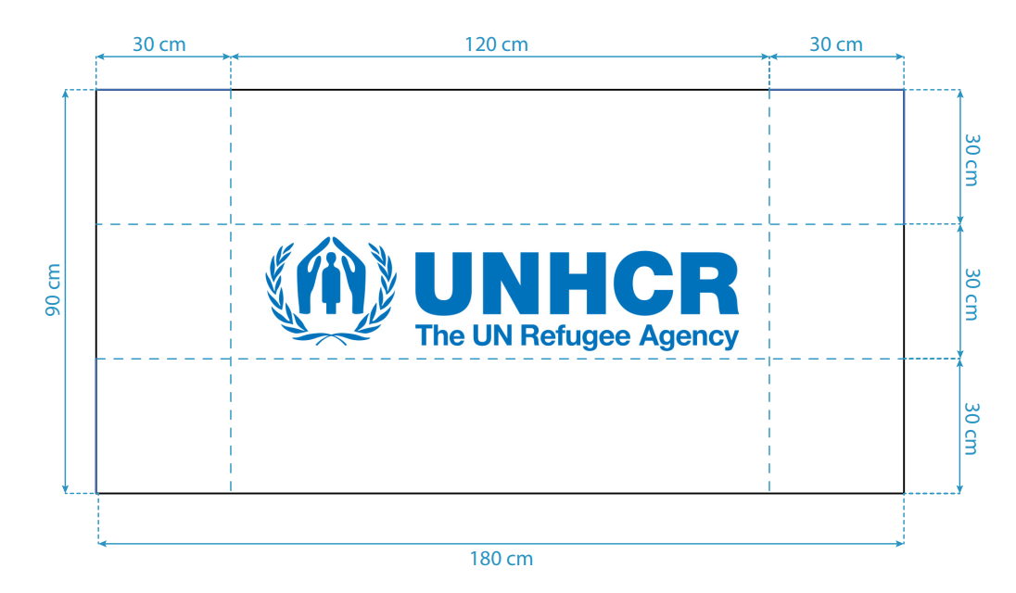
Synthetic sleeping mats are used to sleep on and must be waterproof, tear proof and material trim finished. The mats should be made from 100% synthetic yarns from virgin raw materials. Synthetic sleeping mats must not contain fillers, like calcium carbonate or any other type. The use of recycled materials is not allowed.
The synthetic yarns in a tightly woven 2/2 twill structure, using a monofilament or multifilament warp (PP tubes without fillers minimum 1000 tubes per meter length) and thick tape PP or polyester yarn in weft. The two short sides to be secured with a first stitch folded hem of the mat, plus one bias 40mm binding tape of minimum 10g/m with stitches through the fabric of the mat, OR with a double folded stitched hem. Four sides trim finished.
Weight: 0.500 kg/m2 minimum ±5%.
Color: Plain color, white or blue.Bursting Strength: ISO13938: 700 kPa minimum.
Tear Strength: The edges of the mat should not be tearable when strongly pulled outside by hand or other similar force.
Bursting Strength: ISO13938: 700 kPa minimum.
Expected Life Span: It is expected that sleeping mats will last for 12 months of use under hard tropical conditions. It has a shelf life of 4 years.
- Sleeping Mats

- Blankets

