2024 PiN and Severity Calculation Methodology
Severity Calculation Methodology
In Sudan, the Shelter and NFI Cluster has adopted the internationally recognized Shelter Severity Classification (SSC) methodology developed by the Global Shelter Cluster (GSC). This framework was introduced in 2023 as an integral component of the JIAF 2.0. The adoption of SSC aims to enhance and standardize the quantification and assessment of shelter needs across diverse operational contexts and global shelter response initiatives.
Within the framework of the SSC, the calculation of severity hinges on indicators distributed across three fundamental pillars that encapsulate various aspects of "shelter needs and conditions”:
- Pillar 1: The Physical Shelter — This pillar focuses on the physical condition and adequacy of the shelter, such as level of damage, privacy, shelter issues such as overcrowding, thermal comfort, etc.
- Pillar 2: Domestic Living/ NFIs — This pillar covers a range of elements essential to the quality of life within the shelter. Specifically, it encompasses household items, commonly referred to as NFIs, along with access to essential utilities such as fuel and electricity. It seeks to evaluate the extent to which residents are capable of performing essential domestic activities such as cooking, storing food and water, sleeping, etc.
- Pillar 3: The Settlement — This pillar provides a comprehensive evaluation of the broader community setting, emphasizing access to essential services and vital infrastructure. This includes, but is not limited to, accessibility to clean water and sanitation facilities, educational institutions, healthcare services, and other social amenities.

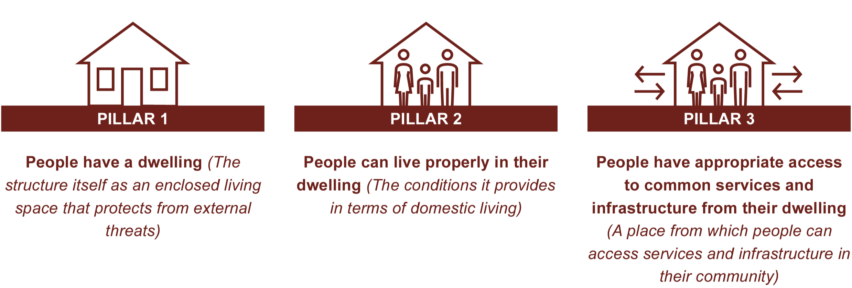

GSC’s SSC provides a standardized set of indicators, sub-indicators, and accompanying criteria. These elements are mandated for use across all countries implementing the SSC framework, thereby ensuring a unified conceptual approach in the calculation and understanding of the shelter severity of needs. Importantly, while the criteria provide a universal foundation, they are engineered for maximal adaptability to accommodate context-specific variables. Below outlines the adapted SSC framework employed by the Shelter and NFI Cluster in Sudan for the purpose of severity calculations:
SSC Pillar | Indicator | Sub-Indicator | Severity Scale | Levels/Criteria | Additional Information
Pillar 1:  Shelter | Ind 1: % of households living in safe and dignified dwellings (structure that protects them against external threats, health problems, weather and natural hazards) | Ind 1.1: Shelter Overcrowding | 1 – Minimal | Less than 2 people per room | 2 indicators from MSNA - # of HH members divided by # of rooms
Pillar 1:  Shelter |  | Ind 1.1: Shelter Overcrowding | 2 – Stress | 2-3 people per room
Pillar 1:  Shelter |  | Ind 1.1: Shelter Overcrowding | 3 – Severe | 3-4 people per room
Pillar 1:  Shelter |  | Ind 1.1: Shelter Overcrowding | 4 – Extreme | 4-5 people per room
Pillar 1:  Shelter |  | Ind 1.1: Shelter Overcrowding | 5 – Catastrophic | More than 5 people per room
Pillar 1:  Shelter |  | Ind 1.2: Shelter Type | 1 – Minimal | Less than 5% of HH live in substandard shelter typologies | Shelter Typologies include substandard (none, unfinished, makeshift); emergency; semi-permanent; and permanent.
Pillar 1:  Shelter |  | Ind 1.2: Shelter Type | 2 – Stress | 5% - 10% of HH live in substandard shelter typologies
Pillar 1:  Shelter |  | Ind 1.2: Shelter Type | 3 – Severe | 10% - 20% of HH live in substandard shelter typologies
Pillar 1:  Shelter |  | Ind 1.2: Shelter Type | 4 – Extreme | 20% - 40% of HH live in substandard shelter typologies
Pillar 1:  Shelter |  | Ind 1.2: Shelter Type | 5 – Catastrophic | More than 40% live in substandard shelter typologies
Pillar 1:  Shelter |  | Ind 1.3: Shelter Damage | 1 – Minimal | No damage | Minor damage includes maintenance needs, damage to windows/ doors; mild damage includes cracks in roofs/walls and damaged floors; moderate damage includes partial collapse of roofs/walls and missing windows/ doors; severe damage entails structural unsafety/total collapse.
Pillar 1:  Shelter |  | Ind 1.3: Shelter Damage | 2 – Stress | More than 40% of HH experience minor damage
Pillar 1:  Shelter |  | Ind 1.3: Shelter Damage | 3 – Severe | More than 20% of HH experience mild damage
Pillar 1:  Shelter |  | Ind 1.3: Shelter Damage | 4 – Extreme | More than 30% of HH experience moderate damage
Pillar 1:  Shelter |  | Ind 1.3: Shelter Damage | 5 – Catastrophic | More than 20% of HH experience severe damage
Pillar 1:  Shelter |  | Ind 1.4: Shelter Issues | 1 – Minimal | No issues or less than 40% of HH have 1 shelter issue | Shelter Issues assessed include leaking roofs; issues with locks; flooding; issues with privacy; Issues with heat or cold and lack of space.
Pillar 1:  Shelter |  | Ind 1.4: Shelter Issues | 2 – Stress | More than 40% of HH have 1 shelter issue
Pillar 1:  Shelter |  | Ind 1.4: Shelter Issues | 3 – Severe | More than 20% of HH have 2 to 3 shelter issues
Pillar 1:  Shelter |  | Ind 1.4: Shelter Issues | 4 – Extreme | More than 10% of HH have 4 to 5 shelter issues
Pillar 1:  Shelter |  | Ind 1.4: Shelter Issues | 5 – Catastrophic | More than 10% of HH have 6 to 7 shelter issues
Pillar 2:  NFIs | Ind 2: % of households with access to basic  household items | Ind 2.1: Access to NFIs | 1 – Minimal | HH has all 7 basic HH items | The 7 basic HH items include plastic sheets; blankets; sleeping mats; solar lamps; jerry cans; kitchen sets and mosquito nets. They enable water storage, food preparation, basic sleeping conditions, protection against vector-borne diseases, and access to lighting.
Pillar 2:  NFIs | Ind 2: % of households with access to basic  household items | Ind 2.1: Access to NFIs | 2 – Stress | HH has 6 basic HH items
Pillar 2:  NFIs | Ind 2: % of households with access to basic  household items | Ind 2.1: Access to NFIs | 3 – Severe | HH has 5-4 basic HH items
Pillar 2:  NFIs | Ind 2: % of households with access to basic  household items | Ind 2.1: Access to NFIs | 4 – Extreme | HH has 3 basic HH items
Pillar 2:  NFIs | Ind 2: % of households with access to basic  household items | Ind 2.1: Access to NFIs | 5 – Catastrophic | HH has 2-1 basic HH items or none
Pillar 3:  Settlement | Ind 3: % of households with tenure security and access to adequate  settlement situation with basic  infrastructure and essential services | Ind 3.1: HLP and Occupancy | 1 – Minimal | Over 80% of HH have tenure security and less than 20% of HH are facing HLP issues and risks | HLP issues include disputed ownership/rent; property looting/ occupation; eviction; issues with inheritance/  HLP documents or lack of understanding of HLP processes and rules.  Occupancy arrangements range from informal/formal ownership; informal/ formal rented accommodation; communal settings – collective centres such as public buildings; as well as hosting by family and friends.
Pillar 3:  Settlement |  | Ind 3.1: HLP and Occupancy | 2 – Stress | 40%-80% of HH have tenure security and less than 30% of HH are facing HLP issues and risks
Pillar 3:  Settlement |  | Ind 3.1: HLP and Occupancy | 3 – Severe | Over 0%-40% of HH have tenure security and less than 20% of HH are facing HLP issues and risks
Pillar 3:  Settlement |  | Ind 3.1: HLP and Occupancy | 4 – Extreme | HH have no tenure security and less than 70% are facing HLP issues and risks
Pillar 3:  Settlement |  | Ind 3.1: HLP and Occupancy | 5 – Catastrophic | HH have no tenure security and over than 70% are facing HLP issues and risks
Pillar 3:  Settlement |  | Ind 3.2: Settlement Situation | 1 – Minimal | Less than 10% of HH live in substandard settlements with impaired access to essential services and basic infrastructure | Settlement types range from residential neighbourhoods, informal/spontaneous settlements, and formal camps, and can be urban, peri-urban or rural.  Access to basic services and infrastructure is assessed on the basis of 8 indicators from MSNA across different sectors (WASH, Health, Education, etc.) assessing distance to services, settlement safety, accessibility, etc.
Pillar 3:  Settlement |  | Ind 3.2: Settlement Situation | 2 – Stress | 10% - 50% of HH live in substandard settlements with impaired access to essential services and basic infrastructure
Pillar 3:  Settlement |  | Ind 3.2: Settlement Situation | 3 – Severe | 50% - 70% of HH live in substandard settlements with impaired access to essential services and basic infrastructure
Pillar 3:  Settlement |  | Ind 3.2: Settlement Situation | 4 – Extreme | 70% - 90% of HH live in substandard settlements with impaired access to essential services and basic infrastructure
Pillar 3:  Settlement |  | Ind 3.2: Settlement Situation | 5 – Catastrophic | More than 90% live in substandard settlements with impaired access to essential services and basic infrastructure

Due to the all-encompassing SAF-RSF conflict that erupted mid-April of this year, conducting a country-wide MSNA in 2023 proved unfeasible. War significantly impeded both the physical access and telecommunications, rendering a comprehensive survey impossible. Consequently, the SSC framework in Sudan has been grounded on the most robust dataset available – the MSNA conducted in the second quarter of 2022.
However, it is important to note significant demographic shifts that occurred since then, with IDPs now primarily residing in the northern and eastern regions of the country. The 2022 MSNA dataset naturally lacks information on IDPs in these newly affected areas, as they were not present there during the time of the survey. To mitigate this data gap, information concerning "Residents" from the 2022 MSNA will be employed to complement the severity calculations for IDPs in these areas, given that approximately 70% of the new IDPs are being hosted within these communities.
To address the limitations imposed by outdated 2022 MSNA data and the rapidly evolving context, two additional proxy indicators have been integrated to supplement the SSC:
- Hotspot Areas (Baseline Data) – Hotspot areas are mainly categorized as severity levels 4 and 5 for acute hotspots. A smaller proportion received a severity level of 3, typically representing chronic hotspots that existed prior to the SAF-RSF conflict.
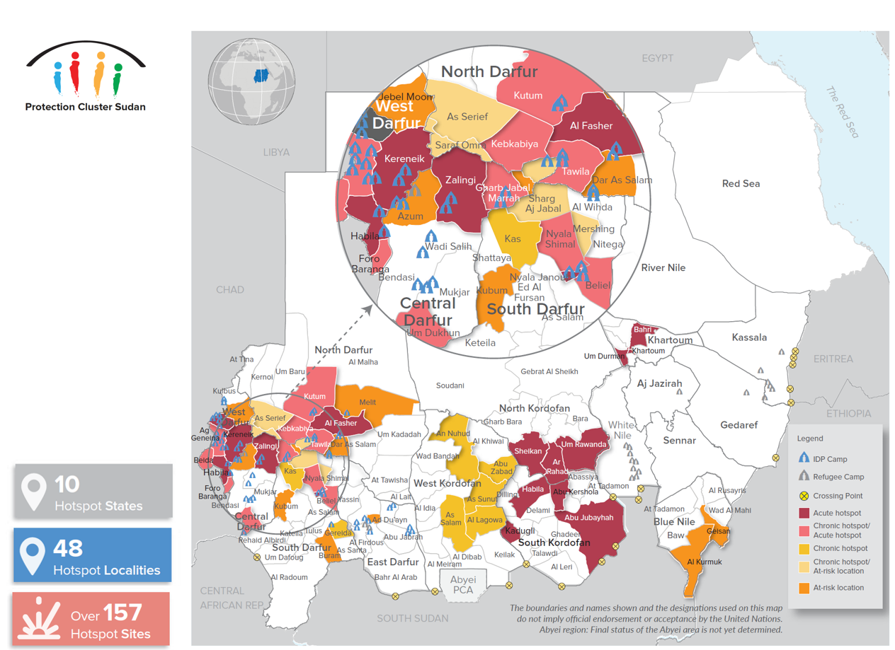

- Magnitude of Affected Population (Baseline Data) – The severity classification for different population groups based on their size is methodically determined to minimize variance within each of the five severity classes and maximize variance between them.

Population Group |  | Severity 1 | Severity 2 | Severity 3 | Severity 4 | Severity 5
IDPs  (AVG) | IDPs Baseline  (7.1M) | 0 | Less than 20,000 | Less than 50,000 | Less than 150,000 | Over 150,000
IDPs  (AVG) | New IDPs  (4.1M) | 0 | Less than 20,000 | Less than 50,000 | Less than 150,000 | Over 150,000
Host Community  (AVG) | HC Baseline  (6.5M) | 0 | Less than 50,000 | Less than  100,000 | Less than  150,000 | Over 150,000
Host Community  (AVG) | New HC  (2.7M) | 0 | Less than  10,000 | Less than  30,000 | Less than  85,000 | Over 85,000
Non-Displaced | ND Baseline  (14.4M) | 0 | Less than  100,000 | Less than  250,000 | Less than  300,000 | Over 300,000
Refugees  (MAX) | Refugees Baseline  (963K) | 0 | Less than  10,000 | Less than  20,000 | Less than  100,000 | Over 100,000
Refugees  (MAX) | Secondary Displaced  Refugees (186K) | 0 | Less than  2,000 | Less than  5,000 | Less than  25,000 | Over 25,000

The final severity level for each population group is derived from an aggregate of three key components:
- SSC Severity (MSNA 2022 Data);
- Hotspot Severity (Baseline Data);
- Population Magnitude Severity (Baseline Data).

People in Need (PiN) Calculation Methodology
After all localities are categorized into one of five severity levels, the People in Need (PiN) is generally calculated as the sum of the total population in localities marked with severity levels 3, 4, and 5.
To refine this approach, a weighting factor can be applied to each severity level and for each population group. This allows for a nuanced understanding of the urgency of needs. For example, in the Shelter and NFI cluster, displaced populations may be assigned a higher weighting factor to reflect their more immediate need for shelter compared to non-displaced groups.
For displaced populations (IDPs and Refugees), PiN is calculated as 80%, 60%, and 40% of the total population for severity levels 5, 4, and 3, respectively. This accounts for the fact that some were displaced before April 15 and may have had some needs met through aid or self-reliance.
For non-displaced groups (HC and NDP), PiN is calculated as 40%, 30%, and 20% of the total population for severity levels 5, 4, and 3, respectively, recognizing their lesser need for shelter and NFI assistance compared to displaced populations.
