Draft minutes of shelter cluster meeting for Hiraan region
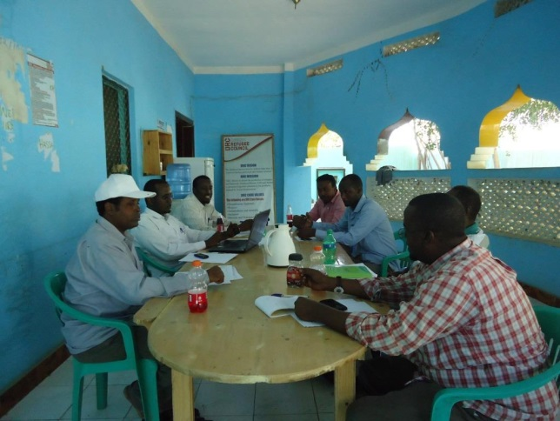
Date: 10th November, 2014
Venue: DRC Meeting Hall

Present
SN | Name of the participants | organization | Tel number | Email
1 | Abdikarim Hussein Abdi | DRC | 0615248448 | Abdikarim.h@drcsomalia.org
2 | Abdifatah Osman Aden | DRC | 0615859034 | Ao.adan@drcsomalia.org
3 | Mahamed Abdullahi Nor | Agrocare | 0618082290 | agrocaresom@yahoo.com
4 | Abdifatah AbdikadirAdow | SYPD | 0615573493 | sypdmog@yahoo.com
5 | Osman Abdi Yusuf | WARDI | 0615584737 | Wardi.hiran@hotmail.com
6 | Osman Mohammed Hassan | Techno plan | 0616776366 | Technoplanngo@gmail.com
8 | Mohammed Hassan Elmi | CCO | 0615537835 | cco114@hotmail.com
Agenda
- Welcoming and opening remarks
- Response activities from partners / clusters to the emergencies of the flood.
- Updates of completed, ongoing and planned shelter activities from cluster members
- 4w matrix
- AOB

The minutes

Welcoming and opening remarks:
DRC M&E coordinator/shelter cluster chair Mr. Abdikarim Hussein has been chaired the meeting and opened with welcoming statements and appreciation to the members on their attendance on punctual. The meeting started at 7:300pm and the participants introduced themselves by name and organizations they represent. The agendas and inter agency meeting minutes were circulated to the participants and participants were read, accepted without change.

Response activities from partners / clusters to the emergencies of the flood
In the meeting there were limited response activities to the displaced people by the floods as there are many needs and gaps regarding shelter. The following organization has provided response to the emergencies

DRC: distributed 900 NFI kits (1 plastic sheet, 3 single sleeping mat, 2 collapsible jerry-cans, 3 blankets, 2 mosquito nets, kitchen set and 3 bar soap) to 900 HHs at El-jaalle in partnership with UNHCR and also mentioned to be distributed in the course of the week 300 NFI kits to the displaced people at Bananey and shircaneco.

HAPO CHILD: Distributed 250 NFI kits (Composition) to the displaced people at Shirkaneco in partnership with UNICEF. This was mentioned in the inter agency meeting.

On the other hand there are organizations that have in plan to distribute NFI kits to the displaced people as response of the emergencies. Below are the organizations

WARDI: Mentioned in the meeting that they have 4000 NFI kits in their warehouse in Beletweyne waiting go ahead approval.

SCI: Mentioned in the inter agency meeting that have in plan to distribute 800 NFI kits to the displaced people by the floods but no update so far in the shelter cluster meeting on 10th of November, 2014.

SYPD: tried to get NFIs from NRC but due logistical problems the idea seems to impossible as the stock is in Mogadishu defusing the hope to respond the current emergency in Beletweyne district in Hiran Region.

Updates of completed, ongoing and planned shelter activities from cluster members
Besides the current emergencies, partners have shared information on their completed, ongoing and planned shelter activities. Following are the organization that have mentioned in the meeting the completed, ongoing and planned shelter activities
DRC: Mentioned in the meeting that they have completed construction of 90 CGI in Abudwak IDPs (Balligaras, Balligiish and Dayacan) out of 110 planned CGI. Hopefully the remaining 20 CGI will be completed in the course of the week. Furthermore 110 NFI kits to be distributed to the same beneficiaries are in the final stage of procurement.
DRC: mentioned in the meeting that they have in plan to construct 263 CGIs approved by CHF in Abudwak
SYPD: has secured some funds from the recent Strategic Reserve Allocation for Shelter cluster through which SYPD will construct 283 transitional shelters directly encompassing the use of corrugated galvanized iron (CGI) (141 ) shelters in Marka and (142) Belet Weyne. The transitional shelter construction will entail the integration of 100 communal disludgeable latrines to ensure the target beneficiaries have access to sustainable sanitation facilities. Each household will be provided with land tenure agreements for at least five years with possibility of ownership once further negotiations with local authorities are finalized.

SYPD will provide vouchers to 600 people (180 men, 210 women, 120 girls, 90 boys), (100 households) for owner-driven-shelter construction in marka (50) and Belet Weyne (50). SYPD will promote owner driven transitional shelter construction by providing vouchers for the purchase of construction materials and labour to allow the IDPs manage the construction of their own houses. SYPD will provide initial training to local artisans and engineers on settlement planning and management and CGI shelter construction. To ensure technical and cluster guidelines are adhered to, SYPD will provide technical backstopping during the construction process.

4w matrix
As usual each cluster has 4W matrix for coordination and as part of the agenda the partners have agreed to share the 4W matrix and then fill in their offices then send back to the shelter cluster focal point on 11th of November, 2014.

A.O.B
Lastly the partners have agreed to coordinate and share daily updates on the response activities of the emergency situation to have on same page and also to avoid overlapping.

