General Information: To support joint monitoring and evidence-based decision-making, the SNFI Cluster encourages partners to participate in the joint PDM data collection. The main goal is not only to gather data but also to analyze the results and draw meaningful conclusions about the effectiveness and impact of winter-related activities. The findings will help improve future planning, ensure better targeting, and strengthen accountability to affected populations.
Joint Data Collection Participation:
There are three ways to participate in data collection related to winterization activities:
- Through the UNHCR KoBo form – the survey already includes all activities outlined in the Winterization SOP, with a structured format and logical constraints with no possible changes. All collected data will be stored in the UNHCR KoBo account and analyzed by the SNFI Cluster.
UNHCR KoBo account: pdm_snfi_cluster
Password:pdm_2025
Name of the survey: PDM_Winter_25_26_Shelter_Cluster_Ukraine
- Through organization-specific questionnaires developed based on SNFI Cluster recommendations and aligned with the Data Analysis Plan (DAP). These forms must include all mandatory questions and follow the coding structure requested by the Cluster.
- Through independently developed questionnaires, designed in the organizations` own format. In this case, partners are expected to share a summary report of key findings with the SNFI Cluster.
Supporting documents:
- DAP. It includes all survey questions with explanations, answer options, and corresponding indicators. The DAP helps ensure consistent data interpretation and comparable results among all partners participating in joint monitoring.
- To help enumerators during data collection and support them in understanding the context before conducting interviews, please refer to the short description of activities below or consult the published Winterization SOP available via the provided link.
- KoBo XLSForm – for uploading the SNFI Cluster questionnaire to your organization’s own KoBo account.
Timeframe: According to MEAL standards for conducting PDMs, some organizations may plan to carry monitoring out 4–6 weeks after beneficiaries receive assistance. The SNFI Cluster does not require postponing these activities. The survey questions are designed to allow respondents to answer based on their current winter experience (if the season has just started) or their general experience of coping with cold weather.
However, please consider the importance of monitoring activities later in the season to obtain more accurate data on whether the assistance was sufficient to cover the entire winter — for example, whether it helped households cope with low temperatures and lasted from mid-October until the end of March.
Data Sharing: All collected data should be shared with the SNFI Cluster focal point. Please ensure that only SNFI Cluster–related questions and other essential additional data are included. Any extra information collected by the organization but not requested by the Cluster should not be shared.
It is up to each organization to decide when to share the data sets, from immediately after collection up until the final data submission deadline, which will be announced later as an additional request.
How to Prepare the Survey for Sharing with the SNFI Cluster:
- Following the DAP, organizations should include all mandatory questions exactly as written, including the question codes at the beginning of each sentence (Example of question code: “H.8. What amount of pellets did you receive?” — H.8 is the code.), to allow data consolidation.
- Questions on winter clothes, winter NFIs, heating appliances, and insulation of substandard house are optional for those organizations who work on their own KoBo form and can be taken as an example, adapted or supplemented. If organizations use the SNFI Cluster–proposed questions, please retain the original question codes. Refer to the example above for guidance.
- Question order may be changed or clarifying questions added if needed.
- In terms of data cleaning, no actions are required except for removing any sensitive data collected by the organization and deleting questions not requested by the SNFI Cluster, as these will not be used in the data analysis.
- Regardless of the language in which the PDM is conducted, please ensure that the English version of the questionnaire is maintained. Also, please submit the dataset in English only.
How Data Will Be Used:
- Only statistical information will be used for quantitative analysis of outcomes.
- All indicators for which data is collected are presented in the Data Analysis Plan.
- Cleaned and analyzed data will be displayed in the Winterization Dashboard and made available to all humanitarian organizations, stakeholders, and relevant partners.
- The results will be used to inform lessons learned and support the TWIG planning for Winter 2026–2027.
If you have any questions regarding KoBo usage, encoding, uploading data, or the questionnaire itself, please contact: panina@unhcr.org.
If you need assistance with technical aspects or explanations of technical terms/definitions, please contact fadieiev@unhcr.org
Context:
Monitored Period of Time - during the interview with the beneficiary, please ensure that the assistance received relates to Winterization 2025–2026, meaning it was provided between May 2025 and April 2026. No historical data from previous seasons should be collected even if the household was not monitored during that time.
Activities:
Winter clothes: This assistance can be provided in three modalities — in-kind, voucher, or cash. Please note that there are no separate questions for voucher and cash modalities, so please use the winter_clothes_cash (group name from the DAP) questions for both cases.
Under this assistance, it is expected that beneficiaries received/bought items from the SNFI winter clothing kit per person.
Please find the list of items below.
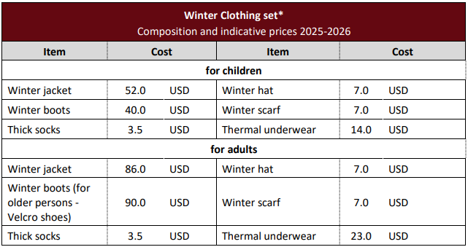
It is possible that the organization conducting the interview may have included additional items in the set, or that beneficiaries prioritized different clothing items after receiving cash assistance. However, during the interview, please focus on collecting information about the items included in the SNFI Cluster recommendations.
NFI for winter includes non-food items related to winter preparedness. There can be three modalities for distribution — in-kind, cash, or voucher. If the assistance was provided through vouchers for winter NFI, please use the winter_NFI_cash (group name from the DAP) questions.
Under this assistance, it is expected that beneficiaries received/bought items from the SNFI winter NFI set per person.
Please find the list of items below. 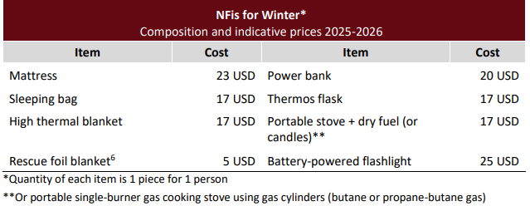
It is possible that the organization conducting the interview may have included additional items in the kit, or that beneficiaries prioritized different NFIs after receiving cash assistance. However, during the interview, please focus on collecting information about items included in the SNFI Cluster recommendations.

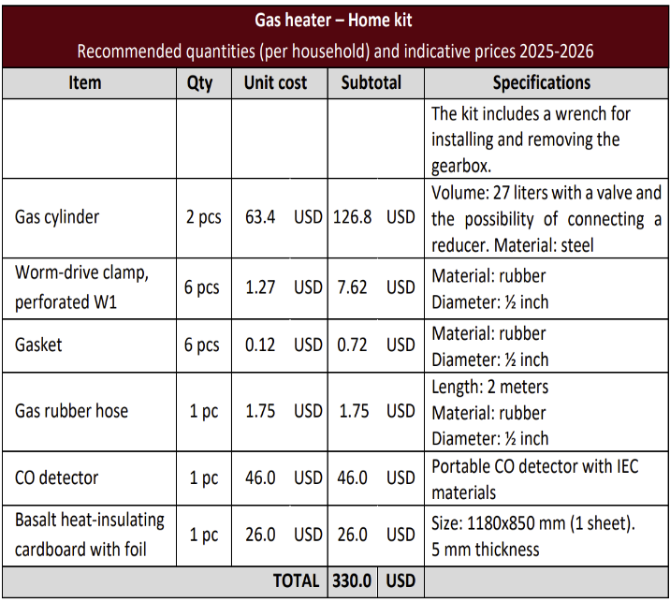
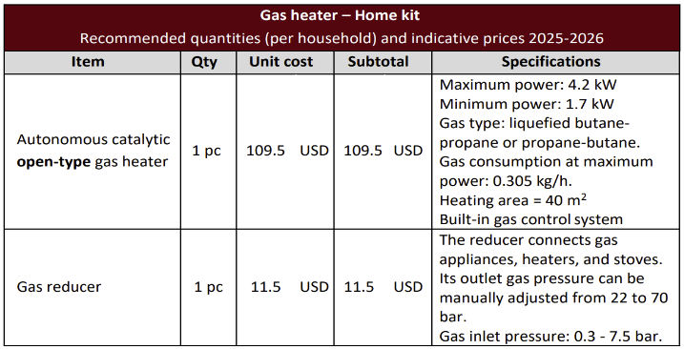
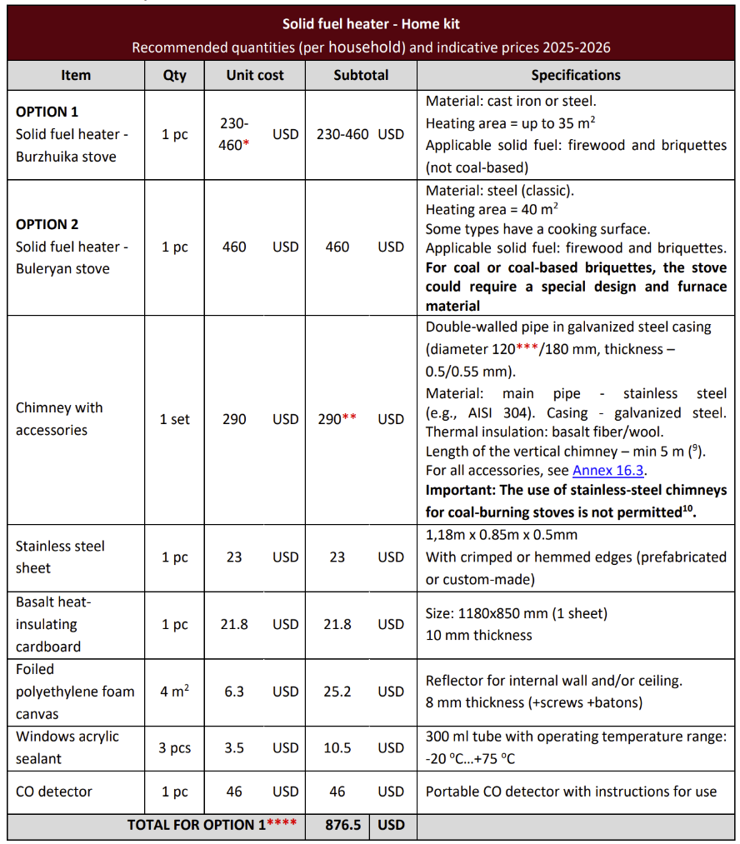
Winter heating appliances include solid fuel, electric, and gas heaters provided by humanitarian organizations. This type of assistance is delivered only in-kind, usually as a complete full kit with all necessary accessories and installation services.
The composition of the kits is listed below:
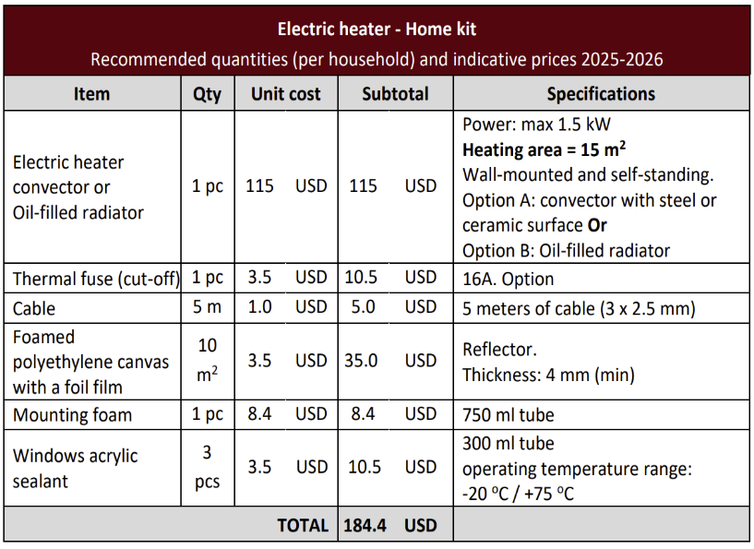
It is possible that the organization conducting the interview may have included additional items in the kit. However, during the interview, please focus on collecting information about items included in the SNFI Cluster recommendations.
Insulation of Substandard House consists of works that are not considered “regular” emergency repairs but rather energy-efficiency upgrades. These may include attic floor insulation and the replacement of old windows and entrance doors with energy-efficient alternatives. The goal is to improve thermal performance and reduce heat loss.
These interventions should be monitored as “insulation” only when implemented in non-war-damaged houses.
Definition of Substandard House:
- Not damaged by war,
- Has a functioning heating system, and
- Exhibits poor thermal performance due to inadequate design, low-quality construction, or poor maintenance.
If light or medium repairs include thermal insulation together with repairs for war-related damage, the entire intervention (including insulation) must be reported under Humanitarian Repairs and monitored through the Humanitarian Repairs PDM.
Cash for Utilities – financial assistance provided only in cash/voucher modalities, without any in-kind component, to help cover heating utility needs.
Please use the cash_for_utilities (group name from the DAP) questions for cash and voucher.
Solid Fuel – assistance that can be provided in cash, voucher, or in-kind modalities, depending on beneficiaries’ preferences and partners’ implementation capacity.
Types of solid fuel that can be distributed or purchased by beneficiaries:
- Firewood
- Coal
- Briquettes
- Pellets
Important distinctions:
Pellets: small, cylinder-shaped (6–8 mm diameter), made from compressed sawdust.
Briquettes: larger, block- or log-shaped, made from compressed materials.
Sometimes pellets and briquettes are confused or grouped together as “pellets”; enumerators should clarify the difference.
Firewood may be distributed as stacked m³ or loose m³.
Stacked m3 means the firewood is neatly arranged and packed — the pieces are stacked closely together, leaving only small air gaps.
Loos m3 means the firewood is just thrown loosely (not arranged). There are many air gaps between the pieces.
Before filling the survey, enumerators should ensure beneficiaries understand these differences to provide accurate answers.
Questionnaire:
The KoBo form and DAP provide comprehensive hints for all questions that could cause discrepancies or misunderstandings. Additionally, all constraint messages are included to explain why certain options cannot be selected together or why the form does not allow submission of particular answers.
However, there are a few points that should be taken into account before working with beneficiaries.
A.1. Organization`s name - If your organization intends to use the unified KoBo form but is not listed in the drop-down menu, please contact panina@unhcr.org to have the organization added to the list. This will help ensure consistent use and avoid frequent selection of the “Other” option.
A.2. Enumerator`s code, A.3. Beneficiary`s code - The SNFI Cluster does not collect any personal information through this PDM questionnaire. However, beneficiary and enumerator codes will help with data management and allow for follow-up with enumerators in case of any gaps, errors, or unclear information.
Please assign code names to all participants involved in data collection before starting, to ensure smooth processing and analysis of the collected information.
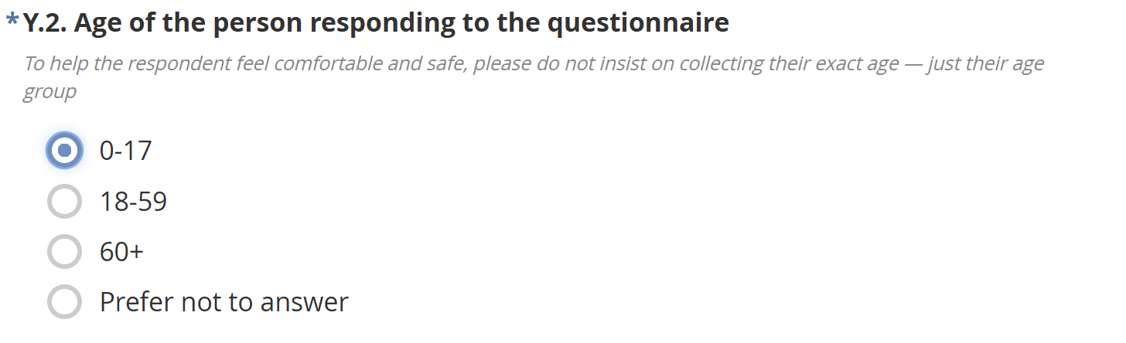
If a person is under 18 years old, please do not continue the interview with them.
If the organization needs to collect the exact age of beneficiaries, the question type can be changed from select_one to integer.
During the Shelter Cluster analysis, all ages will be grouped into predefined age categories.
Y.8. Which of the following issues best describe the current condition of your housing?
Please note that Y.8 options should be used only if the house was not damaged by the war.
If similar issues exist but were caused by shelling, strikes, or other war-related incidents, please select “I don’t have any problems above that are not related to the war.”
All war-related cases must be monitored under Humanitarian Repairs PDM interviews.

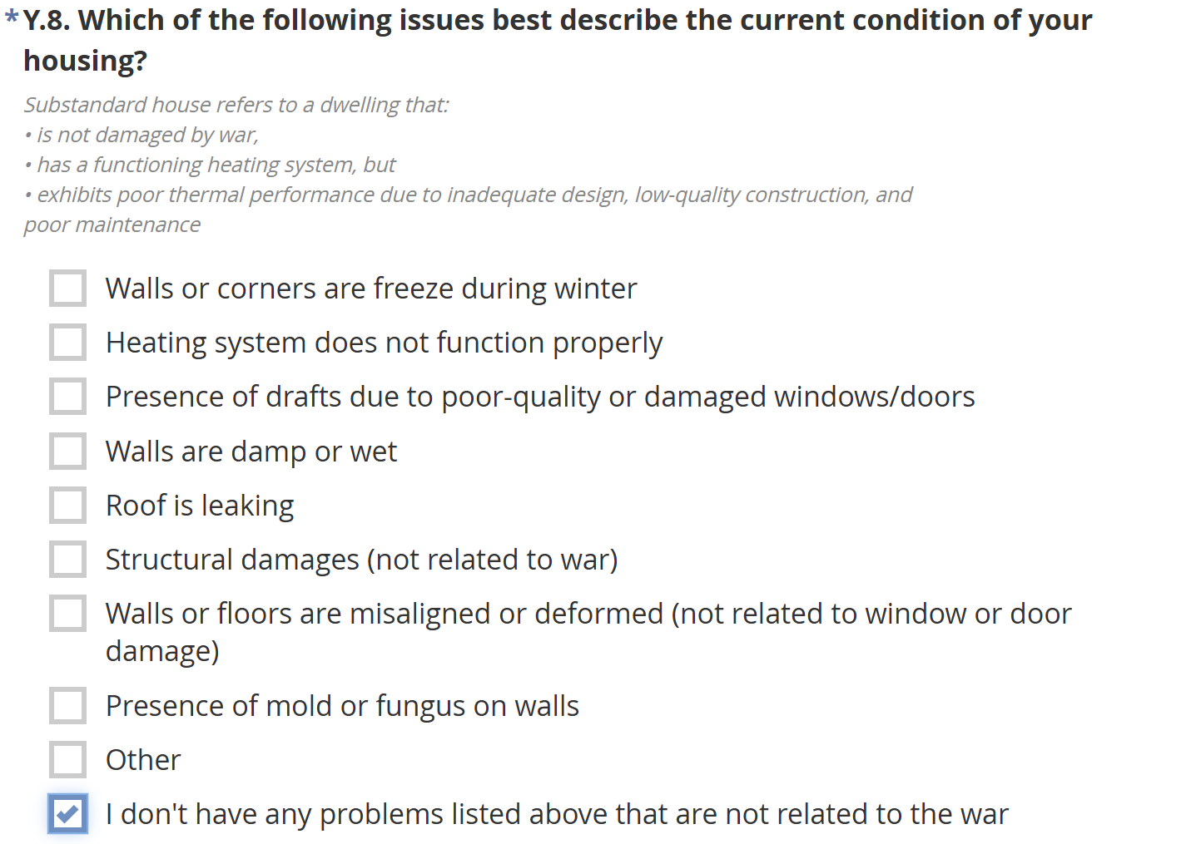
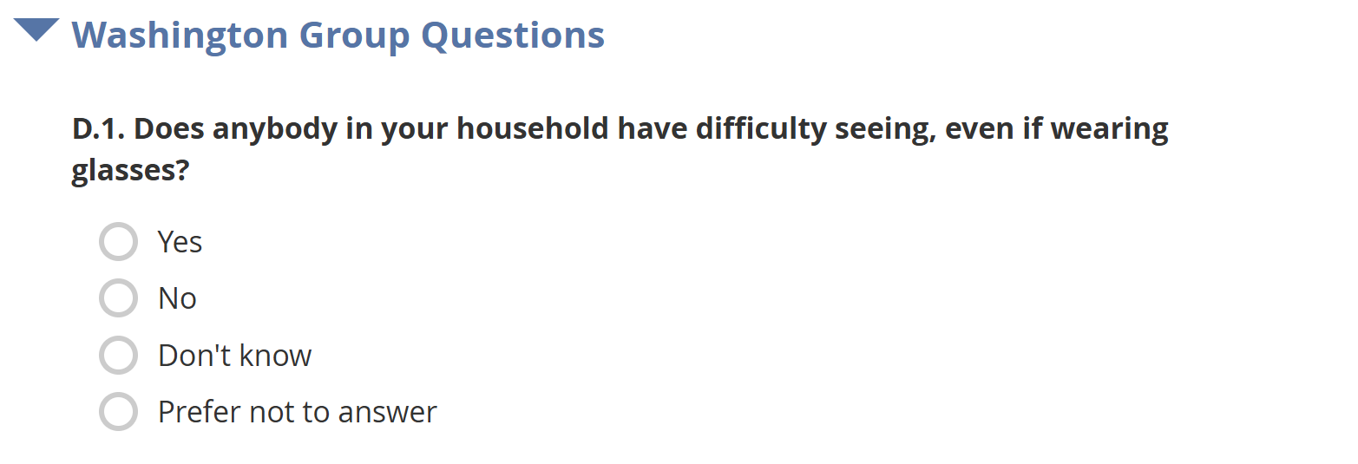
Washington Group Questions are not mandatory for partners conducting interviews through the UNHCR account or using their own form, but WGQs are still recommended by the SNFI Cluster.
Please include these questions whenever possible, but do not insist if they cause any communication difficulties with beneficiaries.
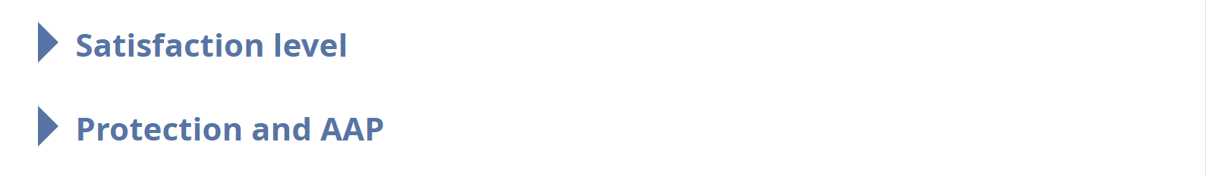
Questions related to the satisfaction level of all winter-related interventions, protection mainstreaming, and AAP remain crucial. The SNFI Cluster strongly recommends including them in your organization’s form. However, due to variations in donor requirements, these questions can be slightly adjusted if needed—keeping the original question codes as proposed—or significantly modified, though in the latter case, the responses may not be included in the collective SNFI Cluster dataset.
Please use the option that best fits your organization’s needs to meet donor requirements while still contributing to the collective PDM data collection.

