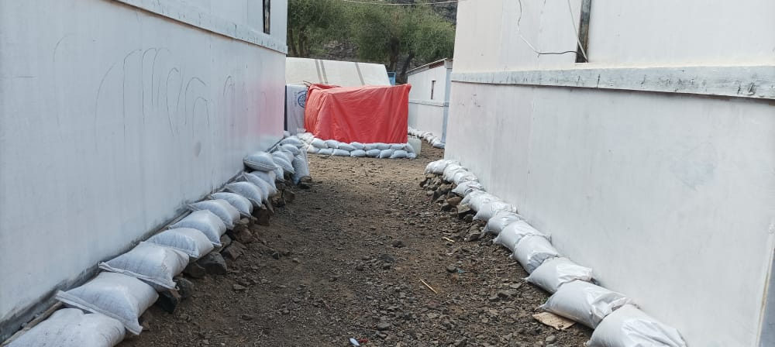
Republic of Yemen
KEY DATES
Establishment of Sector - August 2009
Activation of Cluster – March 2010
Latest insurgency - March 2015
No IDP camp policy adopted - June 2015
Alternative to Camps Policy – Sep 2018
CCCM Activated as a standalone – Jul 2019
Tents distribution policy revised – Mar 2020
January - March 2023
Shelter
NFI
People Assisted
Gaps vs Target
SITUATION & UPDATES
- Rainy season has started in Yemen resulting to flooding, which has so far impacted 8,000 IDP and host families mainly in IDP sites. Flooding caused displacements, damage to properties and public infrastructure, as well as the loss of crops and livestocks.
- The Cluster was allocated $1.35 million through the Yemen Humanitarain Fund (YHF) to support its Flood Preparedness and Response against its $26 Million requirements.
- A joint CCCM and Shelter Cluster Coordination Team visited Al Durahimi, in Al Hudaydah Governorate, a return area. Approxmaitely 500 IDP families returned and are in urgent need of rehabilitation/reconstruction and livelihood support.
ACHIEVEMENTS
- The Cluster received 11% ($28 million) of its 2023 funding requirements ($250 million) and has so far reached 164,000 IDPs, returnees, and vulnerable host with various shelter assistance including community-driven flood mitigation, Non-Food Items (NFIs), emergency shelter, transitional shelter and support for shelter maintenance, which improved the living conditions and mitigated protection risks.
- The Cluster developed its Flood Preparedness and Response plan to respond to the most vulnerable IDPs inside and outside sites prioritized in high risk flood hazards areas. The Cluster requires approximately US 26 million to reach its targets of 56,000 households/392,000 individuals.
- The Cluster Coordination Performance Monitoring (CCPM) exercise is concluded. The final action plan will be published on the cluster webpage and will be regularly monitored throughout the year.
- The Cluster conducted two information management refresher sessions for more than thirty cluster partners in Aden and Marib governvorate to improve the overall information management as well as reporting using the Activity Info Tool.
GAPS / CHALLENGES:
- Lack of funding to support longer-term shelter solutions for protracted situation and returnees.
- Eviction threats are rising in IDP hosting sites while some vulnerable families in rental accommodation are returning to IDPs due to unaffordable rent .
KEY FIGURES (Individuals) HNO & HRP 2023
7.5 Million 5.3 Million
People in Need People Acute in Need
3.3 Million 164 Thousand
Target 2023 Assisted as of Mar 2023

FUNDING (USD) (Source: FTS and SC FTS as of 31 Mar 2023)

CLUSTER COORDINATION TEAM
Martha Kow Donkor (UNHCR)
Cluster Coordinator
coord.yemen@sheltercluster.org
(+967) 712225325

Monir AlSobari (UNHCR)
Deputy Cluster Coordinator
depcoord.yemen@sheltercluster.org
(+967) 712225045

Ali Al-Eryani (UNHCR)
Information Manager
im.yemen@sheltercluster.org
(+967) 712225122

Aiman Al-Zoraiky (UNHCR)
Technical Specialist
tech.yemen@sheltercluster.org
(+967) 712225106

Shelter Cluster Coordination Structure

KEY DOCUMENTS
- 2023 HNO & 2023 HRP
- 2022-2024 Shelter Cluster Strategy
- 2022 Activity Matrix
- 2022-2024 SC Capacity Development Strategy
- 2023 Flood Preparedness and Response Strategy
KEY LINKS
- ShelterCluster.Org
- ReliefWeb

- Flood mititgation measures to 250 ESK and TS by NRC in Al Ma’afer district, Taizz gvoernorate. © Shelter Cluster/ Saleem Al Azazi

