

Shelter Needs Overview [YEAR]

[Country]

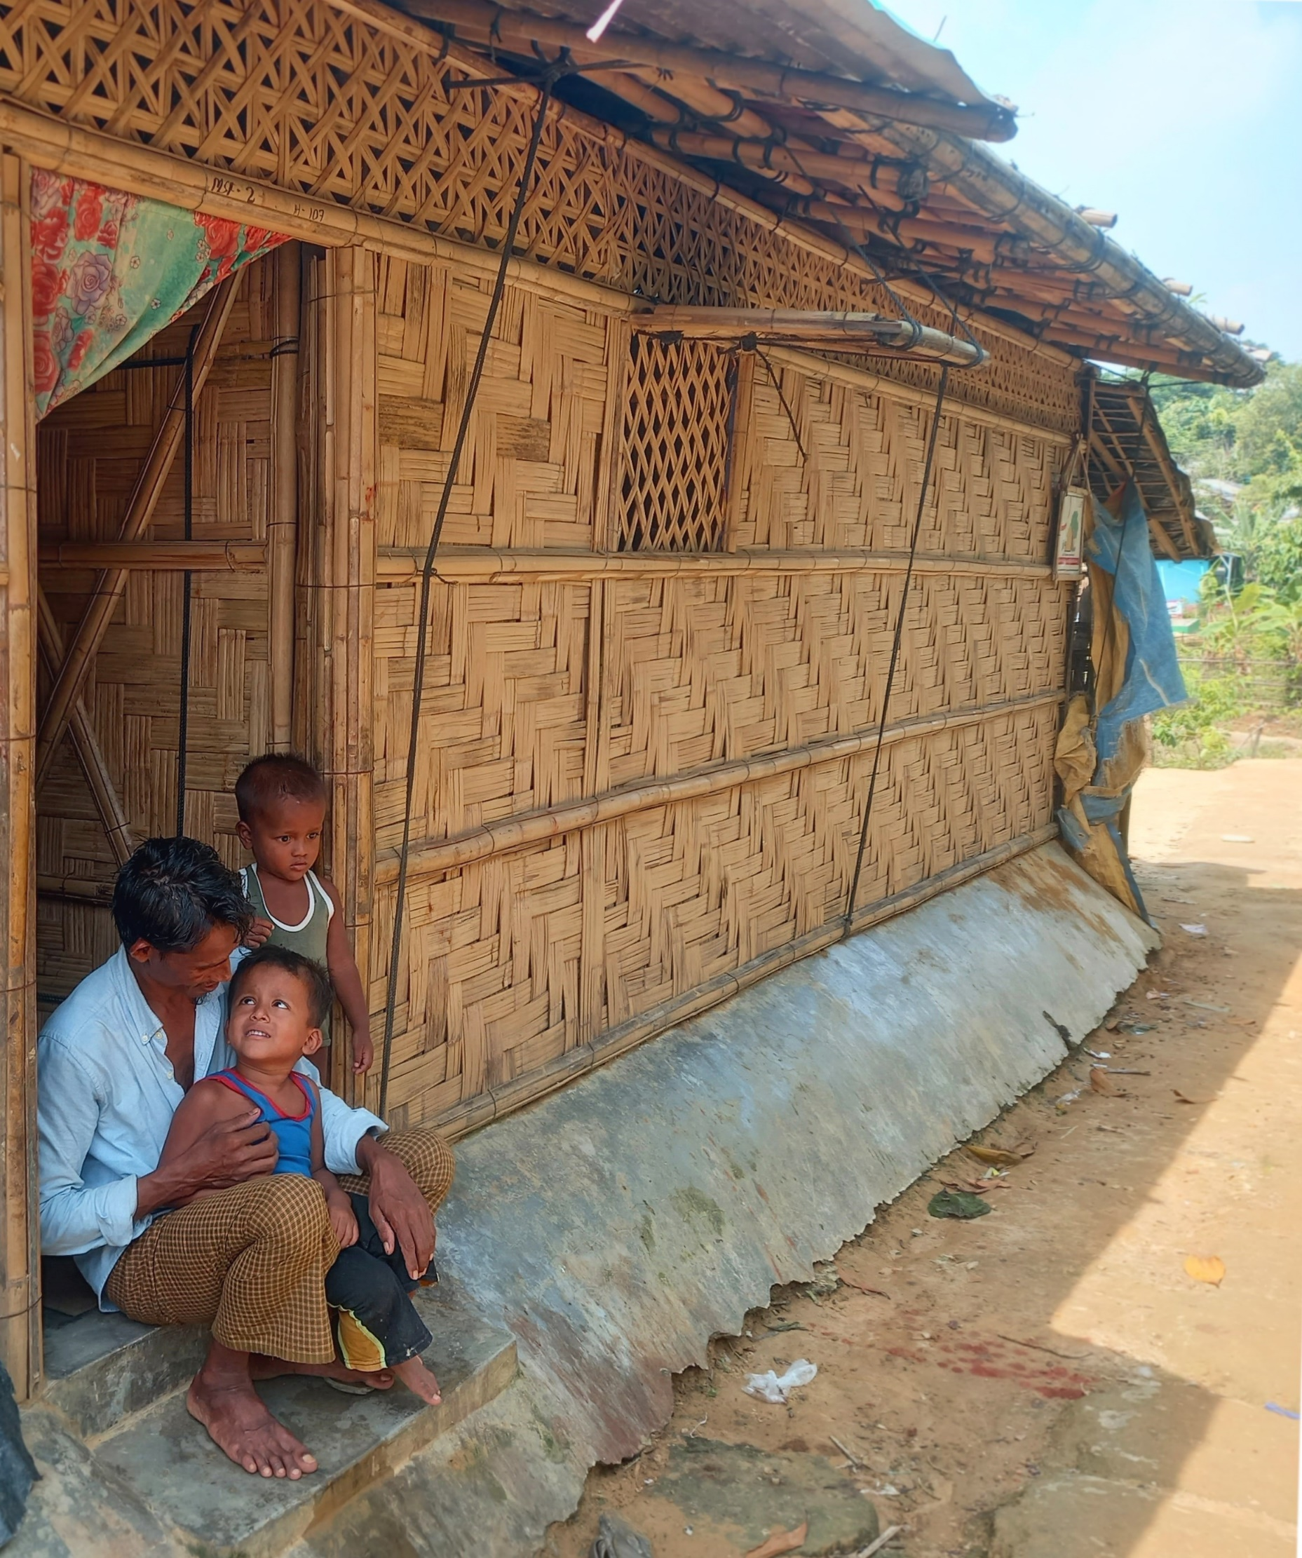
This cover page is meant to be an example, it does not reflect any specific obligation to use this picture or this layout. Insert the cover page of your choice and add your cluster logo. Make sure you are using the new cluster branding guidelines. The logo in the headers also needs to be updated with your cluster logo.
Throughout this document, text in italic is meant to describe the content of each section. It should be removed once the SNO is finished. The SNO should contain similar information to the HNO but should provide more details on the shelter sector.

TABLE OF CONTENTS
TABLE OF CONTENTS 2
Summary of Humanitarian Shelter Needs and Key Findings 3
Key Messages 3
Part 1. Impact of the Crisis and Humanitarian Shelter Conditions 4
1.1. Context of the crisis 4
1.2. Shocks and Impact of the Crisis 4
1.3. Scope of Analysis 4
1.4. Humanitarian Shelter Needs Conditions and Severity of Shelter Needs 4
1.5. Number of Shelter People in Need 4
Part 2. Risk Analysis 5
2.1. Risk analysis 5
Part 3. Situation Analysis and Monitoring of Needs 6
3.1. Situation Analysis 6
3.2. Monitoring of Needs 6
Annexes 7

Once your report is finished, you can update the table of content with a right click and select “Update Field” on the table of content.

Summary of Humanitarian Shelter Needs and Key Findings
This section should highlight the key findings and key shelter needs identified.
It should be short and easily readable so that readers in a hurry can have the main take aways of the SNO without reading the full report.

Key Messages
Key messages are aimed at other humanitarian actors and donors. It should highlight the view of the cluster on the needs, linking them with the cluster strategy and appeals. These key messages can also be your key advocacy messages.

Part 1. Impact of the Crisis and Humanitarian Shelter Conditions

1.1. Context of the crisis
This sub-section describes the context of the crisis. You can use the contextual information available on the JIAF platform. The context should nevertheless be looked at from a shelter angle to introduce the rest of the document.
Tips for Environment, Climate Change and DDRR Mainstreaming into Context Analysis:
- Incorporate Environmental and Disaster Risk Information: When analyzing background information, ensure the inclusion of data on existing natural hazards, pre-existing environmental issues, vulnerabilities, and risks that could impact the humanitarian shelter outcomes in light of the shock and unfolding crisis. Utilize country and local hazard and risk profiles, such as the World Bank Climate Risk Country Profiles and the Global Shelter Cluster’s Environmental Country Profiles (where available), to inform your analysis.
- Identify and Assess Key Underlying Environmental Drivers of the Crisis: Recognize and assess the critical environmental factors contributing to the crisis, including deforestation, land degradation, degradation of coastlines and wetland ecosystems, and pollution of water, air, and land—often resulting from improper waste management, emissions of pollutants, intensive agricultural practices, and soil salinization. For pre-crisis environmental data specific to the country or region, consult the Environmental Performance Index (EPI) at https://epi.yale.edu/.
- Identify critical environmental and climate change-linked problems linked to humanitarian consequences. E.g. Exposure to climatic and environmental hazards (e.g. people living with additional shelter needs due to hazard exposure); Negative impact of the crisis on natural resources (e.g. conflict over/competition for; depletion of); Impact of climate change on weather patterns and hazards (e.g. more severe flooding;) and displacement; Protection/environment links (e.g. from scarcity of natural resources)
- Identify potential climate and environmental risks to shelter projects informed by local shelter partners and existing documents, for example, by the World Bank’s Country Climate Risk Profiles and the Global Shelter Cluster’s Country-level Environmental Profiles.

1.2. Shocks and Impact of the Crisis
In addition to the context section, this sub-section should describe the shocks and their initial impacts. For this section again, information can be found on the JIAF platform. Again, the impact of the crisis should be looked at with a shelter angle.

1.3. Scope of Analysis
The scope of analysis refers to what was agreed with OCHA for the JIAF. It should detail the geographical coverage, the level of analysis and the population groups. It is also important to mention here the methodology that was used to calculate the PiN and severity (the SSC). In case the framework used is not what is advised at global level, a short justification paragraph should be added to explain the diversion from globally accepted standards.

1.4. Humanitarian Shelter Needs Conditions and Severity of Shelter Needs
This section provides details (graphs, analysis) of shelter needs observed in this country/context as per the Shelter Severity Classification indicators. Visuals are encouraged here.

1.5. Number of Shelter People in Need
This section should provide PiN numbers and relevant information linked to PiN numbers.

Part 2. Risk Analysis

2.1. Risk analysis
This sub-section contains a brief description of the risks by category of risks: operational, contextual, etc. It also describes their potential impacts on shelter needs and interventions if these risks materialize. Building on this analysis of potential impact, mitigation measures to be taken should be described.
Tips for Environment, Climate Change and DDRR Mainstreaming into Risk Analysis:
- Identify Vulnerabilities and Disaster Risks: Assess existing and potential hazards in the landscape, including natural hazards (e.g., floods, landslides) and vulnerabilities (e.g., poverty, conditions of women, children, and differently-abled persons). Identify potential disaster risks posed by shelter responses to both affected and host communities. Use national disaster management data or global tools such as the World Bank’s ThinkHazard and guidelines like UNDRR’s Words into Action Guide on National Disaster Risk Assessment, and Strengthening Risk Analysis in Humanitarian Planning.
- Examine Environmental and Social Implications: Identify major disaster risks and pre-crisis environmental issues impacting shelter, considering gender and inclusion implications, geographical effects on ecosystems or protected areas, and availability and access to natural resources.
- Include Environmental Risks in Assessments: Integrate environmental and climate risks when analyzing disaster risks and vulnerabilities. Consider risks stemming from the environment (e.g., natural hazards) and risks to the environment (e.g., impacts of humanitarian response activities). For guidance, refer to the Tip Sheet for Mainstreaming Environment, Climate Change and DRR into Needs Overviews.
- Assess Hazard/Vulnerability Links: Investigate whether the location of affected populations is subject to immediate hazards (e.g., flooding, municipal waste dumps, industrial storage). Determine who is affected, where, and how, and assess the impact on shelter and settlement siting.
- Engage Local Experts: Where possible, engage local DRR, climate, and environment experts in the risk analysis process to enhance the relevance and effectiveness of assessments.
- Coordinate Across Sectors: Coordinate with other sectors, including WASH, Food Security and CCCM, to jointly identify risks, reduce costs, and enable synergies in disaster risk management.

Part 3. Situation Analysis and Monitoring of Needs

3.1. Situation Analysis
This sub-section describes the current activities of the response. This should be put in perspective with the severity and needs observed. This sub-section will inform existing gaps in the response.

Green Team inputs:
Based on the critical problems identified, highlight issues that should be integrated into the response planning and why they are needed, for example:
- Climate change adaptation (e.g. to stop the cycle of displacement)
- DRR (e.g. linked to recurring hazards like flooding being exacerbated by climate change)
- Consider existing natural hazards and the risk of creating new hazards during shelter site selection (e.g. stability of slopes when locating collective emergency shelters)
- Shelter improvements for better protection from weather conditions (e.g. shelters at risk of flooding in rainy season; the need for cold/hot insulation/winterisation)
- Environmentally sustainable (durable) shelter solutions (e.g. with sustainably sourced materials)
- Natural resource management (e.g. replenishing natural resources for shelter construction)
- Links between HLP and environment (e.g. over contested land use and natural resource management that can be drivers of conflict)

3.2. Monitoring of Needs
This sub-section describes the monitoring plan for the coming year and any potential updates that are planned for this document.

Annexes
Annexes can be added if relevant in the specific context.
Environment, Climate Change and DRR resources:
- Tip Sheet for Mainstreaming Environment, Climate Change and DRR into Needs Overviews: This Tip Sheet is developed by the Global Shelter Cluster for Shelter Cluster Coordinators to guide them on environmental, climate change and DRR mainstreaming in preparation of the Shelter chapter of both HNOs or Shelter Needs Overviews.
- Technical support from the Environmental Support Team of the Global Shelter Cluster: environmentoperations@sheltercluster.org
- Response Planning Tip Sheet for Environment, Climate Change and DRR: This Tip Sheet is developed by the Global Shelter Cluster for use by country-level Shelter Cluster Coordinators to guide them on the minimum requirements for environmental, climate change and Disaster Risk Reduction (DRR) mainstreaming in preparation of the Shelter Chapter of HRPs or HNRPs. This guidance can also be used for the development of shelter cluster/sector strategies or for response planning that does not follow the Humanitarian Programme Cycle (HPC).
- Entry Points for DRR Mainstreaming in Shelter and Settlement Interventions: An overview of entry points to include DRR in shelter and settlement assistance, including ecosystem-based DRR.

