Terms of Reference
Strategic Advisory Group
Shelter & NFI Cluster Sudan

- Background
Shelter & NFI Cluster in Sudan, faces a multitude of challenges as it strives to provide critical assistance to vulnerable populations, affected by both conflict and natural disasters.
Key Information:
Shelter & NFI Cluster in Sudan was activated in 2012, and is led by UNHCR, mirroring the global arrangement for conflict-related situations as designated by the IASC Principals.
Recently, a transparent election process was held to select the cluster Co-Chair organization, with 27 cluster members casting their votes, including 18 INGOs, 8 NNGOs, and 1 Donor. Following this process, ADRA was selected to serve as the Co-Chair for the two-year term, starting from January 26, 2023. This was formalized with the signing of an MoU between ADRA and UNHCR on that date.
For years, countless emergencies have simultaneously persisted in nearly every corner of the country, causing extensive damage to homes, personal assets, and infrastructure. Despite these challenges, donor interest has remained limited due to ongoing political instability in Sudan and global financial constraints. Relief efforts were further limited by the vastness of the affected territory and access barriers stemming from insecurity, crumbling infrastructure, and seasonal road conditions. As a result, many areas remained underserved, compelling communities to depend on their own scarce resources for rebuilding. This perpetuated existing vulnerabilities and left them susceptible to repeated hazards. The intensifying socioeconomic crisis further contributed to the weakening of self-reliance mechanisms, placing people's safety and well-being at severe risk.
The already devastating situation culminated with the breakout of armed conflict between SAF and RSF on April 15, 2023, resulting in catastrophic consequences to civilian life and infrastructure, mobility, and access to public services/utilities. The fallout of the crisis includes soaring inflation, scarcity of essential commodities, diminishing cash liquidity and purchasing power, and shortages of energy and fuel for transportation, telecommunications, life-saving medical equipment and cold chain storage, among others. Finding solutions amidst this incredibly constrained environment, becomes increasingly challenging.
In the face of these multifaceted challenges, the Strategic Advisory Group (SAG) within the Shelter and NFI Cluster in Sudan is committed to ensuring that difficult prioritization decisions are made collaboratively, with representation from diverse stakeholder groups. By fostering shared responsibility and ownership of these critical choices, the SAG aims to strengthen the strategic direction and overall effectiveness of the Shelter and NFI Cluster in Sudan, ultimately enhancing the support provided to vulnerable populations amid an increasingly complex humanitarian landscape.

- Purpose
The Strategic Advisory Group (SAG) serves as a compact and efficient advisory board within the Shelter and NFI Cluster, steering its strategic direction and extending guidance to cluster members on various aspects of the shelter and NFI response. To maintain agility, the SAG carefully balances the need for swift decision-making with the importance of participation and effective management. Although the number of participants is limited, the composition of the SAG is thoughtfully designed to include representation from all key stakeholder groups present in the cluster's overall membership. By providing a forum for regular, collective, and agile decision-making, the SAG ensures that the cluster's governance remains participatory, inclusive, transparent, and accountable.
- Guiding Principles
The work of the SAG is anchored in Humanitarian Principles, Principles of Partnership and the Transformative Agenda. Additionally, SAG members pledge to consistently contribute to the group's efforts and champion specific SAG activities based on their knowledge, experience, and interest.

- Eligibility and Membership
According to the Cluster Coordination Reference Module, the SAG should be composed of 15 or fewer individuals who represent the broader cluster membership. Ideally, SAG members should be more senior representatives of their respective organizations, empowered to make decisions and represent their stakeholder group accordingly.
Eligibility to participate in the more strategic management work of a cluster is based on the following criteria:
- Operational relevance and sector-specific technical capacity.
- Proven track record with the cluster, including participation in the Humanitarian Response Plan (HRP), regular attendance and engagement in meetings at both the national and sub-national level as well as consistent 5W reporting in ActivityInfo.
- Demonstrated capacity to contribute strategically and to provide practical support.
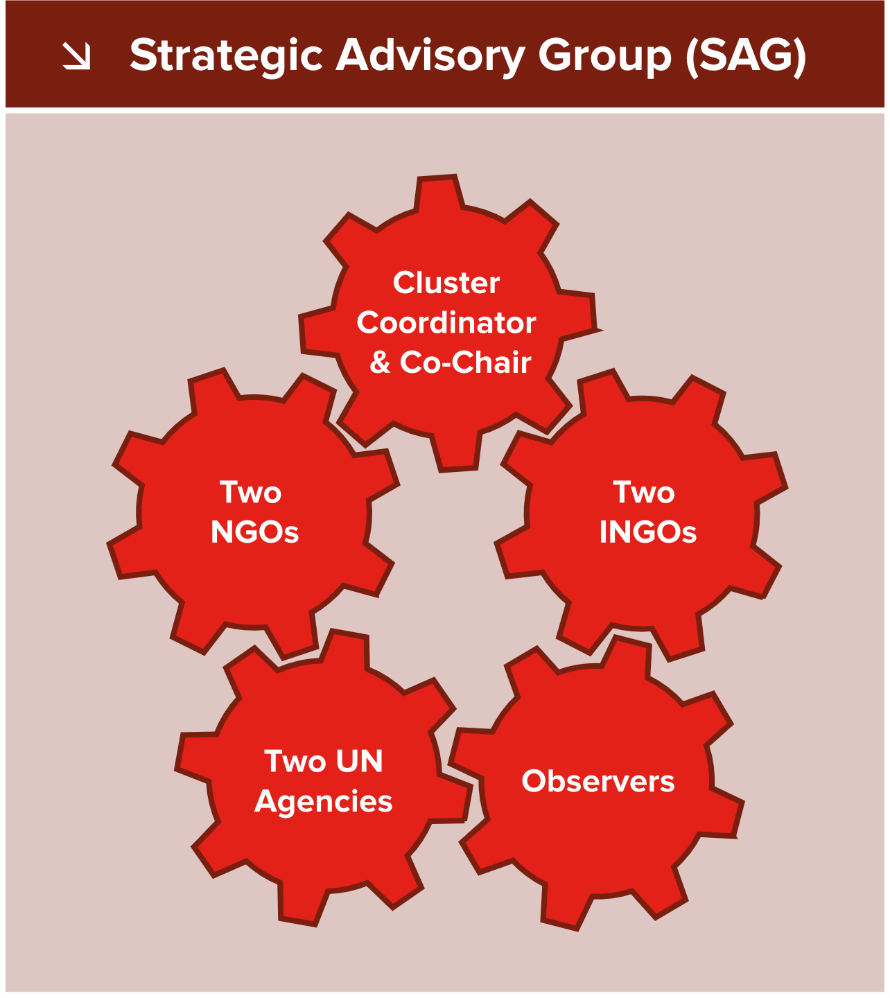
The SAG is led by the Cluster Coordinator and Co-Chair by default, while the below key actors, representative of cluster’s wider membership, are elected through a transparent process:
- 2 UN Agencies
- 2 International NGOs
- 2 National NGOs

Additionally, below members can participate in the SAG as observers:
- OCHA
- INGO Forum
- NNGO Forum
- Donors
- Red Cross/ Red Crescent

Potential invitees to SAG meetings, as appropriate, may include sub-national cluster focal points, subject matter experts or consultants, other Cluster Coordinators, and so on.
- Roles and Responsibilities
  Strategic Direction & Guidance | - Develop, monitor, and adapt the Shelter & NFI Cluster Strategy, including planning and facilitation of Strategic Planning workshops.  - Develop Cluster’s Preparedness/Contingency Plans.  - Develop/update Terms of Reference (ToRs) for various coordination arrangements, e.g., overall Cluster ToR, Co-Chair ToR, SAG ToR, TWIG ToRs, etc.  - Activate TWIGs as necessary and ensure proper representation within such groups. Monitor TWIG progress, ensure timey output and close them as appropriate.  - Assist the cluster in identifying and addressing policy and practice gaps and trends that impact service delivery.  - Develop policy and guidance documents on different aspects of the Shelter and NFI response.  - Support capacity-building initiatives, including training and technical assistance for cluster partners.
  HPC Support | - Agree on sector-specific indicators for the MSNA/ HNO.  - Agree on the cluster’s PiN and Severity calculation methodology.  - Develop the cluster’s Results Framework.  - Develop the clusters HRP funding requirement, including activity-based costing and prioritization per locality and population group.  - Assist with drafting HNO and HRP sector-specific chapters.  - Support HRP proposal review.  - Encourage timely 5W reporting in ActivityInfo against HRP commitments.
  Advocacy & Resource Mobilisation | - Develop cluster’s Advocacy Strategy and promote coherence of public messaging.  - Facilitate comprehensive Gap Analysis to inform resource mobilization efforts.  - Develop position papers and key messages for specific issues, emergency types or population groups.  - Formulate issues to be raised at the ISCG and HCT level.  - Prepare other advocacy material, e.g., infographics, advocacy notes, donor briefing material, etc.  - Develop guidelines to assist partner proposal preparation and increase the chances of S/NFI partners accessing pooled funding opportunities.
  Resource Allocation | - Review and provide input on the allocation strategies and parameters for pooled funding opportunities.  - Act as the Strategic Review Committee (SRC) and facilitate review of partner project proposals for various pooled funding opportunities.  - Promote an equitable and inclusive strategy for fundraising initiatives and partner selection processes within the cluster.
  Coordination & Collaboration | - Ensure active engagement in cluster meetings and working groups as well as timely information sharing, in order to lead by example and promote cooperation and collaboration.  - Represent interests and perspectives of respective constituencies, ensuring all partner voices are considered in decision-making processes.  - Advocate for settlement/area-based approaches and holistic responses with other clusters, including integration of cross-cutting issues in the Shelter and NFI response.  - Promote the the inclusion of shelter and NFI issues in relevant development/ nexus forums.
  Monitoring & Evaluation | - Facilitate the CCPM exercise and provide feedback on Cluster’s performance and achievements.  - Develop the cluster’s Action Plan and agree on performance benchmarks.  - Support the design of monitoring and evaluation tools for the Shelter NFI Cluster.  - Assist with preparation of different evaluation reports as well as good practice and lessons learned publications.  - Ensure the Cluster remains accountable to affected population, donors, and other stakeholders, by promoting transparency, learning, and continuous improvement.
Other | - Perform any other tasks agreed upon and self-imposed by SAG members in line with their strategic mandate.

- Modalities of Work
- The SAG will convene at least quarterly, with meetings initiated and organized by the Cluster Coordinator and/or the Co-Chair. Additional meetings may be scheduled as needed or upon the request from coordinators or any SAG member as appropriate (especially during large scale crisis).
- Meetings will take place via remote conferencing platforms as necessary, until in-person presence is possible again, when a hybrid approach can be applied.
- An agenda will be circulated in advance, allowing SAG members to contribute to discussion points.
- Cluster members or sub-national coordinators may bring issues to the attention of the SAG and, upon SAG approval, attend specific meetings where the issue raised will be addressed.
- Meeting minutes will be shared with SAG members and the broader Cluster membership as well as posted on the Sudan Page of the Global Shelter Cluster website.
- Decision-making, feedback, document development or any other SAG outputs, may occur virtually and outside of meetings, through online collaboration tools, WhatsApp group or email correspondence among SAG members, when convenient, more efficient and effective, or simply when other constraints necessitate such action.

- Decision-making and Validation
The SAG facilitates decision-making and validation through consensus-management, leveraging collaboration, open communication, and consideration of diverse perspectives to reach a decision that everyone can support. This approach addresses the concerns and needs of all stakeholders, nurturing a sense of shared ownership and responsibility for the outcomes. As a result, decisions tend to be more inclusive, balanced, and sustainable, fostering trust, mutual understanding, and long-term commitment among SAG members.
In instances where consensus cannot be reached on a particularly contentious issue, the matter will be escalated to the plenary session of the national cluster meeting for discussion and resolution through a majority vote.
The SAG is committed to maintaining a two-way flow of information with its wider cluster membership. This ensures that all SAG decisions recommendations, and outputs are also shared with all cluster partners for endorsement.

- Disqualification and/or Replacement of Members:
SAG members may be disqualified for any of the following reasons:
- Failure to attend three consecutive SAG meetings without prior notification and a valid reason.
- Failure to actively participate and contribute to SAG activities, discussions, and decision-making processes.
- Breach of the SAG's Terms of Reference.
If any of the above grounds for disqualification are observed, the Cluster Coordinator and/or Co-Chair may initiate a disqualification process, which includes:
- Providing written notice to the concerned SAG member, detailing the grounds for disqualification, and offering an opportunity to respond within a specified timeframe.
- Reviewing the response (if any) and discussing it with other SAG members to determine the appropriate course of action.
- If deemed necessary, holding a majority vote among the remaining SAG members to decide on the disqualification.
- Notifying the concerned organization of the final decision and the reasons for disqualification.
Cluster members may voluntarily forfeit their membership if they choose to withdraw from the cluster for any reason. In such cases, the member organization should:
- Submit a written request to the SAG, stating the reasons for the decision to forfeit membership.
- Fulfil any outstanding commitments or responsibilities related to the cluster, as agreed upon with the SAG.
- If applicable, facilitate the transition of any ongoing projects or activities to another suitable cluster partner, ensuring minimal disruption to the affected population and other stakeholders.

In the event of disqualification, or in the event cluster members decide to forfeit their SAG membership for any reason, the following steps will be taken to ensure the timely replacement of the SAG member:
- If possible, the SAG will recommend a new member from the list of partners who previously expressed interest in the SAG membership and share this decision with all cluster partners for endorsement.
- If this is not feasible, the Cluster Coordinator and/or the Co-Chair will notify all cluster partners of the vacancy and invite expressions of interest to fill the vacant seat.
- Interested organizations will follow the same application process as outlined in the Election Process section.
- If necessary, a majority vote will be held among the cluster partners to select the replacement SAG member.
- The newly elected member will serve for the remainder of the departing member's term.

- Election Process
- A streamlined election process for the interim-SAG will be announced through email and on the Cluster Meeting.
- Each interested organization must designate one SAG focal point and one alternate.
- If more organizations express interest than seats available, the decision will be made through a majority vote, whereby each cluster partner will be granted one vote. Cluster partners will be asked to designate a representative from their organization who will partake in the final selection process.
- The Cluster Coordination Team will not be participating in the vote.
- In the event of a tie, the Cluster Coordinator will cast the deciding vote, and that decision will be final.
- Interim SAG members are elected for a three-month term, after which, depending on how the situation develops, the term may be extended to a two-year period through a more formal process.
- The SAG ToR will be reviewed and adapted more frequently to ensure continued relevance and responsiveness to the evolving situation and requirements.

