
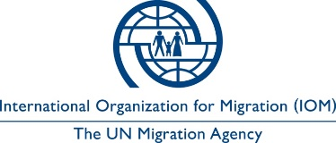

Users as Designers – South Sudan

Key Project Data Table
Country: | South Sudan
Crisis:  [Name of the specific disaster/conflict/complex crisis] | Conflict related displacement

Total number of people affected:

Project location(s): | Wau city, Western Bahr el Ghazal region
Project start and end dates: | 2018 - 2019

Number of people supported by the project:

[Please provide disaggregated data if available]
Project Highlights (successes and challenges):  [priority points in relation to disability inclusion] | - Engaging persons with disabilities in a participatory and collaborative design, prototyping, installation, and review process helps to ensure that infrastructure is suited to their needs.
Keywords: | Disability inclusion, users as designers, community participation
Project cost per shelter/household:  [Including organisational overheads, transport costs, etc.] | N/A – project focused on infrastructure upgrading

Users as Designers – South Sudan

July 2019

Overview of the Context
Standing at an ethnic and linguistic crossroads in the Western Bahr el Ghazal region of South Sudan, Wau city has been the site of large conﬂict-related displacements since September 2016. The largest of numerous displacement sites in the city, the Wau Protection of Civilians “Area Adjacent” to the Wau UNMISS base (PoCAA), currently hosts 17,435 (as per June 2019 Headcount) Internally Displaced Persons (IDPs). This self-settled camp stands as a refuge for civilians who have fled armed conﬂict in the neighbourhoods of Wau as well as towns and villages throughout the region.
Due to restrictions on land availability, Wau PoCAA remains one of the most congested IDP sites in South Sudan, with the average resident living in only 10.83m2 of land, a fraction of the Sphere humanitarian standard of 45 m2. This population density has led to site layout and design features that intend to balance the paramount need to accommodate displaced persons seeking physical protection with upholding accessibility, hygienic living conditions, security, and dignity.
Wau PoCAA‘s current design and infrastructure dates from a large-scale site rehabilitation completed in early 2018 in response to a massive, conflict-driven influx in mid-2017. In April 2017, renewed ﬁghting in close proximity to Wau town forced over 17,000 people from numerous communities to ﬂee to the Wau PoC AA site for protection, bringing the site population to over 39,000 people at the time. As IDPs streamed into the site, new arrivals were forced to crowd into existing family dwellings or built makeshift shelters along drainage ditches, near latrines and sanitation facilities, and on access roads. Given the already severe congestion in the site and following the failure of negotiations for additional land for site expansion, this arrival posed serious safety, health, security, and dignity risks to the site population.
In consultation with the community and cooperation with Shelter, WASH, Protection, and Health partners, Camp Management agency IOM mobilized site planning and engineering teams, heavy machinery, and community outreach workers to undertake a major decongestion and site rehabilitation operation. Concluded in mid-2018, this large-scale site reorganization and infrastructure installation sought to equitably distribute limited shelter space, create camp infrastructure and common services, reduce ﬁre and ﬂooding hazards, and improve health, safety, and sanitary conditions. Concurrently, it also sought to improve physical accessibility through a regular road grid and drainages. However, the site remained with limited space for pedestrian corridors, densely-inhabited shelters, and centrally located service points.
Since this site rehabilitation, IOM has worked addressing accessibility and protection risks stemming from inherent site design features necessitated by population density.

Project Summary
Each camp and camp-like setting imposes its own constraints on site planners and care and maintenance teams wishing to ensure site designs and humanitarian infrastructure responds to the needs of persons with disabilities in terms of physical access, safety, and protection risk mitigation. While guidelines on humanitarian inclusion exist and provide best practices and approaches to promoting accessibility, technical designs must be carried out on-site as context-adapted interventions. Site congestion, material availability, available funding, and cultural practices all affect the feasibility and effectiveness of interventions.
This case study, “Users as Designers,” provides an example of a successful approach to design of accessible infrastructure, carried out in Wau, South Sudan. This approach, in which site planners, construction workers, and persons with disabilities go through a consultation, design and prototyping, installation, and review phase collaboratively, ensured that infrastructure conformed to the end-user’s needs.

Approach: “Users as Designers Approach”
Following a disability access survey conducted at Bentiu POC site in collaboration with Humanity and Inclusion, Wau PoCAA Camp Management realized that many of the same issues cited in that similar site, such as a lack of two-way communication with humanitarian actors and barriers in accessing latrines, were also relevant for the Wau PoCAA. Together with the community, site planners and engineers undertook a “Users as Designers” approach to identifying physical access challenges and remedy them through targeted infrastructure installation and upgrading.
Steps in the Design Process:
- Community consultation to identify priority areas
- Organization of committee of persons with disabilities, including of people with different types of disabilities
- Interactive design sessions with the persons with disabilities committee
- Site visits, consultations, and interviews in “problem areas”
- Co-development of infrastructure prototypes
  - Construction of infrastructure prototypes
  - Trial installation period with testing by the persons with disabilities committee
  - Design changes and development of final design
- Community selection of installation locations
- Installation and handover to community
- Follow-up and ongoing consultation
Wheelchair Access
Wheelchair access was integrated as standard to all sanitation facilities and offices constructed in each block, and bamboo bridges were built to improve access for persons with disabilities over drainage network. Issues with maintenance and accessibility became apparent, so IOM engineering team under Camp Management and protection staff had a meeting with persons with disabilities to better understand their concerns and needs. The teams cognizant of the global recommended standards for inclusive facilities were able to guide conversations with persons with disabilities on what is desired and the standards needed. A new design was proposed for footbridges, made out of timber which was more durable and better for mobility devices, and with a handrail to provide added safety and support.

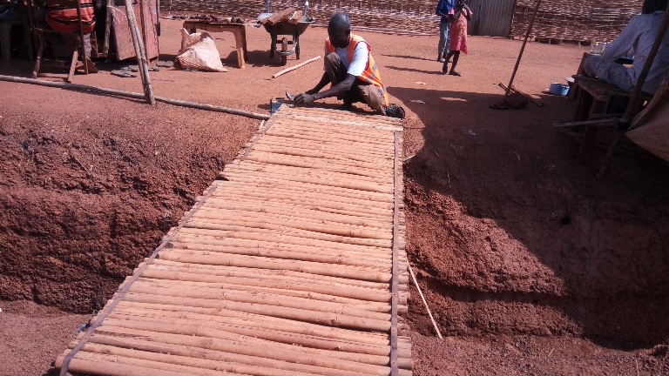  Old bamboo footbridge design without handrails and with rough bamboo surface | 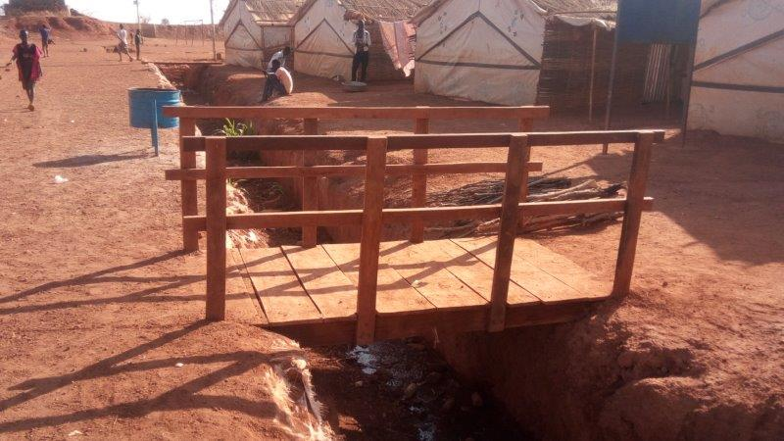  New timber footbridge design with handrails & smooth timber surface

Accessible Latrines
Following this approach of engaging the “users as designers”, staff then focused on latrines, gathering ideas from persons with disabilities and then designing a prototype for their testing and feedback. Latrines not only included a ramp and raised seat made out of local materials, but also a rail to guide persons with vision impairments to the latrine and then around the internal structure.
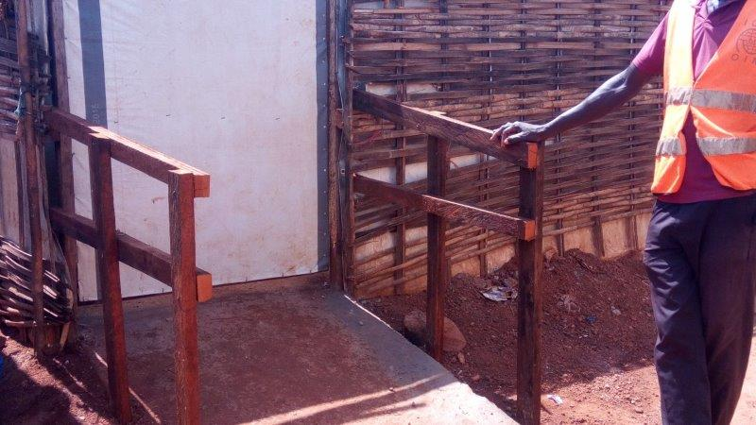  Accessible latrines entrance ramp designed with handrails in two level for both small and growth up persons | 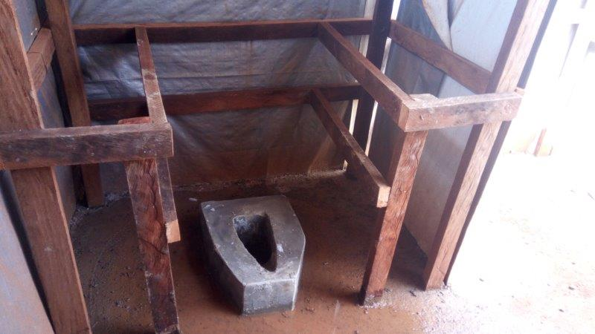  Accessible latrine seat design with two level handrails for both young and older persons

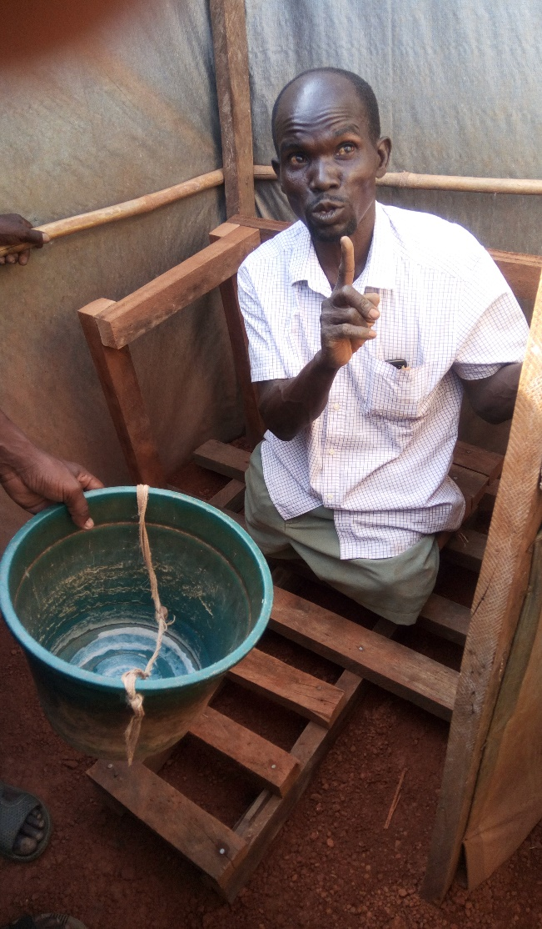 | 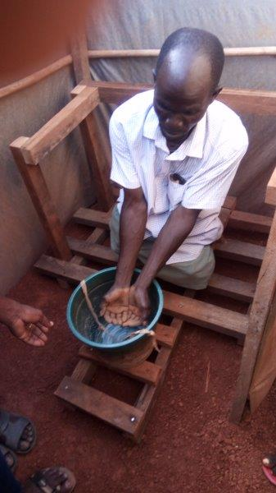
Photo: Testing the prototype for accessible shower and bathing designs.

Project Successes/ outcomes
There are now 55 timber footbridges in place, and over 60 latrines have been upgraded to the new design, meeting the needs of some 166 persons with disabilities registered in the POC AA. Engaging persons with disabilities from the beginning in design and testing processes has fostered a sense of ownership over the products. As such several persons with disabilities have taken their role in shelter and site planning further, becoming a part of the Care & Maintenance Groups in the camp. However, challenges remain in maintenance of these facilities with reports of other community member sitting on and damaging handrails.
“One thing that impressed me and I have learned, I have realized how important it is to get the beneficiaries involved right from design to implementation. There was nothing difficult – it was just engineering – playing with the design and coming up with something that works for them within the standards.” – Friday Charles Elly, CCCM- Assistant Site Planner/ Engineer, International Organization for Migration”

Next steps
IOM staff and the Care & Maintenance Groups are now educating the community through Town Hall Meetings, and engaging community leaders to raise awareness about the adaptations to bridges and latrines and how these support persons with disabilities to be independent in the community.

For more information, please contact:
Priscila Scalco
Programme Manager, IOM South Sudan
Email: pscalco@iom.int

Disability inclusion focal points – Global Shelter Cluster
Email: disability.inclusion@sheltercluster.org

https://www.cbm.org/fileadmin/user_upload/Publications/Humanitarian_inclusion_standards_for_older_people_and_people_with_disabi....pdf
HI & IOM (2018) Access to Humanitarian Services for People with Disabilities: Situational Analysis in Bentiu Protection of Civilians Site, South Sudan.

