Emergency Shelter
$xx
Funding requirement

Contact Information: Bernd Schell (bernd.schell@ifrc.org; +63-2-309-8622)

At the moment over 53,000 houses are reported as severely damaged or destroyed. Families live in the open, under cramped, hastily built makeshift structures from thin used tarps and other salvaged materials that provide inadequate shelter. Shelter materials are scarce as businesses remain closed due to damage.
The shelter cluster deployed the REACH assessment team in support of the government to determine the specific shelter needs of men and women of different ages and with different vulnerabilities . The cluster will focus on immediate life- saving shelter interventions. 35,000 families will be provided with plastic sheeting or tents, some tools and fixings and basic NFI’s. This should provide adequate shelter through the imminent rainy season so at least 3 months. Longer term solutions will also be required. To complement the government’s contribution of 5000PHP for a damaged and 10,000 PHP for a destroyed house, the cluster also targets 5000 vulnerable families for transitional shelter. Damage assessment for housing safety, technical assistance and training to women and men will be provided in implementing safer earthquake resistant building practices.

- Please provide agency information of your cluster members, particularly those who are submitting projects or are implementing partners. For agencies that participate in multiple clusters, please submit agency information only once, and mention all the participating clusters under the row on “Clusters / Sectors”.
Annex IV: Agency Overviews

Name | United Nations Office for the Coordination of Humanitarian Affairs (OCHA)
Headquarters | New York (USA), Geneva (Switzerland) | 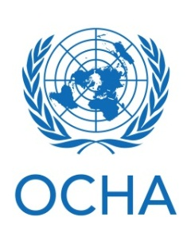
Website | www.unocha.org
HQ Contact | Özgül Özcan, Desk Officer, ozcan@un.org  Example
Philippines Contact | David Carden, Head of Office, carden@un.org
Clusters / Sectors | Coordination
Objective | OCHA mobilizes humanitarian assistance for all in need. OCHA delivers its mandate through coordination, policy development, advocacy, information management and humanitarian financing.
Presence, staff | Country Office in Manila, field offices / hubs in Cotabato City, Zamboanga City (7 international and 17 national staff members, of which 3 national staff are in Zamboanga City)
Name
Headquarters |  | Logo
Website |  | Logo
HQ Contact |  | Logo
Philippines Contact |  | Logo
Clusters / Sectors |  | Logo
Objective |  | Logo
Presence, staff |  | Logo

