A Perspective from Kalutara District Disaster Affected Areas

This note is based on the consultations and discussions held with affected communities, CBO and NGO leaders, religious leaders, plantation workers, plantation managers, officials of the agriculture department, security forces, and relevant government stakeholders of Bulathsinhala and Palindanuwara / Baduraliya - the most affected DS divisions in Kalutura district. In order to obtain this firsthand information from the affected population, and the first responders, primarily local NGOs and CBOs, ZOA placed two of its staff in the Bulathsinhala area in a local guest house from 5th – 9th June, 2017.

- Damage and Destruction
The District of Kalutara comprising of 14 Divisional Secretariat Divisions (DSDs) was one of the worst affected districts.
District Secretariat Division | # of families affected | # of individuals affected | Deaths | Injured | Missing | # of houses damaged
 |  |  |  |  |  | Fully damaged | Partially damaged
Bulathsinhala | 15,098 | 55,609 | 38 | 11 | 40 | 197 | 627
Palindanuwara | 6,345 | 25,548 | 23 | 1 | 7 | 130 | 436

Bulathsinhala and Baduraliya – Palindanuwara are two DSDs that were severely affected in Kaluthara district with several landslides and much flooding. Two major earth slips occurred in Thibbotuwawa and Pahiyangala mountains which caused the death of 22 persons in Thibbotuwawa. During 2005, 2008 and 2014 these areas were affected by floods. Yet, the damage and destruction in 2017 is much higher compared to the previous years, both in terms of landslides and the scale of flooding. The reason for this sudden escalation in the water levels in the river bank and overfilling into the villages was due to the Kukuleganga reservoir that supports the power station. It had to be opened up immediately to release large quantities of water in to the Kukuleganga River. This message did not reach the communities downstream, and hence massive flooding occurred in their houses at night within minutes. Adequate timely warning was not provided to the communities, despite having a system in place.

- Discussions with Community Based Local Agencies
It was gathered that the first responders, the local community including those affected had done an excellent job in “saving lives”, and risking their lives to “leave no one behind”. The intervention of several local actors is not known widely and the valiant efforts of the community based first responders are under reported and undocumented. And the security forces had played a pivotal role in searching for and rescuing people and providing food and water. Perhaps the humanitarian community can also learn from their experiences for future disaster responses.

The affected communities or the government officials on the ground don’t seem to have any information, whether any of the donations from international communities such as India, Pakistan and China will reach them, and what supplies have been provided to help them the victims.

The local communities appear to have good understanding of the damages, and more importantly the solutions to cope and recover. It is best if agencies already working or planning to work in these areas seek to support the solutions proposed by the local community to cope and recover, rather than delivering a one size fits all deliverables, which may lead to disempowerment and dependency of these communities and local organizations. The following organizations have engaged well in immediate relief efforts, and need further support to carry on their excellent work.

No. | Name of Organization | Coverage | Contact Person / Contact | Main Activities | Potential Collaboration
1 | Bulathsinhala Urban Development Foundation | Bulathsinhala town area and Mirishena estate | Mr. Nandana Jayasinghe – 0776460687 | Rural water supply for 2,000 families and government offices
2 | Sri Siddartha Community Development Foundation | Bulathsinhala DS Division | Rev. Ven. Nahalle Vajira - 0718053963  Mr. Nihal Jagath Shanthasri – 0779206822 | Community based eco friendly livelihood activities and emergency response | Shelter reconstruction, NFRI distribution, education support, DDR
3 | Cooperative Resource Centre, Partner of Stromme Foundation | Palindanuwara / Baduraliya area (5,000 families in 43 villages. Over 1,000 families of their target group has been directly affected.) | Mr. K. M. P. Wanigathunga – 0776024387 | Empowerment programs, Self help group activities, child development programs, livelihood support, emergency response and DRR | Emergency response, education, livelihood support NFRI distribution, water supply, shelter reconstruction and DRR

- Immediate Needs
It was observed and the preliminary discussions revealed that the local communities and CBOs have sufficient knowledge about the necessary solutions, as well as basic skills to engage in reconstruction efforts.
- Drinking Water
- The community based pipe borne water service (An Asian Development Bank intervention) had been restored within three days by its operator - the Bulathsinhala Urban Development Foundation. The Foundation as a first responder is supplying water from bowsers to the affected communities, and is reaching beyond their membership. Their services can be extended with very minimal financial support until wells are cleaned.
- Several open wells that were inundated will have to be cleaned. Until then a solution needs to be urgently found to those who were dependent on these wells. Communities are already struggling/working on well cleaning and hence rapid technical support is considered necessary.
- Small water storage points from water springs are damaged and need to be fixed immediately. This can be done promptly if resources are made available to local CBOs.
- Bottled water distribution is gradually decreasing and will cease soon.

- Food
- Cooked food has been distributed by the community, well-wishers, agencies and the military.
- Dry rations are also being distributed by these groups on an adhoc basis. Affected communities in remote areas are complaining that these supplies are not reaching them.
- There has been one distribution of food supplies by the Divisional Secretariat. Communities have not got any clear message whether these dry ration distributions will continue.

c) Non-Food Relief Items (NFRI)
- No cooking utensils and other household NFRIs have reached these communities. Some have received clothing, bed sheets, towels, toiletries.
- Some CBOs are compiling the items required for NFRI packs by engaging in discussions with the affected communities. A list of kitchen utensils required by the community based on the consultations and their suggestions is attached as annex 2.

- Shelter
- Since schools have re-opened most of the people have left the school premises. Hence, temporary shelters (TSs) are required immediately, as they are living with relatives.
- A total of 327 fully damaged houses and 1,603 partially damaged houses could be reconstructed or repaired easily by using debris (Eg-: Timber) and other local materials.

- Toilets
- Several toilets were fully damaged and detailed assessments and solutions need to be discussed with the affected communities.

- Basic education
- It is estimated that more than 50% of the students whose houses were flooded have lost their entire education items such as text books, exercise books, uniforms, shoes, etc.
- It is to be noted that targeting those who lost their education materials need to be carefully assessed in order to avoid blanket assistance and ensure effectiveness of humanitarian aid.

- Livelihoods
- Restoring livelihoods especially agriculture, tea and rubber must be addressed as a matter of priority.
- A large portion of the community members have lost their yearly paddy requirement stored from the last Maha harvest. Further, their Yala cultivation has been washed out due to the flooding. Hence, there will be a challenge for their food security until the next harvest in February 2018.
- Small scale/household tea and rubber estates have been severely affected and at it is estimated that at least 50% is fully damaged. This will result in a serious income shortfall not only to the owners, but also to plantation workers who do part-time work in these small holdings as they have increasingly depended on this for survival, given the low wages in plantation companies. Therefore, support to plantation workers cannot and must not be ignored.

- Psychosocial support
- The communities are extremely concerned about the following issues that impact their mental well being;
- People living downstream below the Kukuleganga dam are in constant fear now, as they have heard rumours that the dam is weak.
- Absence of communication from the government regarding plans for their immediate food security and support for recovery.
- Lack of information about professional psychosocial service providers for the families that have lost their loved ones or recovering/coping from the aftermath of the destruction.

- Suggestions for stakeholders involved in humanitarian action

- Engaging and empowering local community structures
- Ground level CBOs, local and religious organizations have been the first responders by actively connecting with communities, and possess clear detailed needs assessments on damages. They should be engaged and empowered further to implement the solutions they propose as appropriate. Having an on-going presence in the area will provide better insights to agencies about how best they could contribute to community solutions to support their recovery.
- Stronger coordination of all humanitarian actors on the ground is required, and supporting the District and Divisional Secretaries to undertake this task is a priority.
- Agencies and their donors should be encouraged to avoid a top down, one size fits all approach, and focus on linking relief, rehabilitation and development (LRRD).

- Drinking water
- Varieties of drinking water solutions that reach the communities need to be investigated. It can be based on the extensive knowledge on water resources of the local communities.
- Technical support is required to clean wells without causing damage to the well walls that may be affected due to the ground water pressure. Knowledge dissemination needs to be carried out urgently as communities are already cleaning their wells. Necessary tests have to be done prior to accessing the water for drinking. Hence, water testing services needs to be intensified. Local CBOs and communities active in water distribution can be empowered further to do these tasks with technical support.
- There appears to be potential to obtain water from mountain springs sans habitation upstream which can be maximized. Further, the nearby water bottling facility is an option to be explored as a CSR intervention to access quality water for distribution from bowsers.

- NFRI
- All the affected families do not need a standard NFRI kit, and it can be decided based on their loss. People need specific items, which the community can design for themselves. (Eg-: Attached list of kitchen utensils required.) This can be done very quickly and cost effectively with the support of CBOs/self-help groups.
- Local purchasing as much as possible will provide the communities with items that they are used to, as well as be a boon to the local industry. (Eg-: Blacksmith, ekel and coir brooms, doors, etc.)

- Shelter
- One size fits all temporary shelter interventions during tsunami and other flood responses may not be necessary and appropriate. There are ample local skills, resources such as sand, debris, timber, partially damaged timber, door/window frames to support TSs. This approach can be a boost to the local community and the traders.
- A community based, owner driven approach to TS, involving the community in the design and construction of their own houses would be the best way forward. The local community has made a remarkable attempt to find temporary shelter solutions utilizing the debris to the optimum. This model can be further developed to improve security by building half walls also with debris or cement blocks, and the remaining walls with cadjan and other materials. Agencies can provide technical and material support to improve this model.
- A distinction needs to be agreed between temporary and permanent shelter repairs, and ensure that permanent housing actors do not disqualify those who have received support for temporary repairs.
- Livelihoods
- Wherever feasible, ensuring seed paddy and other agricultural inputs for re-sowing during the Yala season and for the next Maha season is essential.
- The possibility of cultivating short term (2 - 2.5 months) paddy needs to be investigated along with the availability of seeds, as it can contribute to improve the food security challenge.
- Advocacy with the Sri Lanka Tea Board and Rubber Development Department to enhance and expedite the existing subsidy schemes for replanting needs to begin immediately, as rubber takes 5 years to provide returns, whilst tea takes 2 - 3 years. Further, to advocate for compensation for these long term crops that have been affected by a natural disaster.
- Plantation companies are also trying to support their workers through the provision of cash advances and avoiding monthly loan deductions from their salary. Further discussions with plantation companies will be required to identify potential areas of support.

- Resettlement
- Immediate efforts to resettle communities from high risk areas, with adequate incentives for relocation needs to be advocated with the government.
- A detailed study to be undertaken to examine the possibilities for reducing the damage and loss of lives, particularly with regards to the management of the Kukuleganga dam, and also the impact of decades of investment on disaster resilience and disaster preparedness. A critical revisit might help agencies in developing future DRR programs.

- Available Community Assessments
- Needs assessments compiled by local organizations – Please contact the organizations noted in annexure 1 below.
- NFRI requirements - Please contact Mr. K.M.P. Wanigathunge, Cooperative Society Resource Centre
- Shelter repair / reconstruction plan – Please contact Mr. Gamini Kumarasingha, Bulathsinhala
- Drinking water needs – Please contact Mr. Nandana Jayasinghe, Coordinator, Water Resource Centre

This information was gathered by Sarath Wijesiri and Lakshman Perera, and for further details please contact;
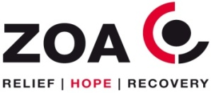
Raga Alphonsus
Advisor
Mobile : +94 773 100 470
Email: raga@zoasrilanka.org
K. G. Sarath Wijesiri
Consultant
Mobile : +94 775 368 619
Email: kgsarathw@gmail.com

ZOA, No. 6/1, Alexandra Road, Colombo 06, Sri Lanka.
Tel : +94 11 7529600 | Fax : +94 11 451 8827
Annexure 1 - Contact details of CBOs, key village leaders, and Government officers

No. |  | Name |  | Organization/Designation |  | Contact
Government officers
1 |  | Mr. Thrimanna |  | DS, Palindanuwara |  | 0714471116
2 |  | Mr. P.D. Upali |  | A/G/N, Palindanuwara, DS office |  | 0710440036
3 |  | Mr. S.K. Henadeera |  | DS, Bulathsinhala |  | 0763646486
4 |  | Mr. S.S. Wikramarachchi |  | A/G/N, Bulathsinhala, DS office |  | 0771282020
5 |  | Mr. Gamini Thilakarathna |  | Disaster Unit, Bulathsinhala DS office |  | 0718027521
6 |  | Mr. Kernel Jayasinha |  | Additional Director, Disaster unit, Kalutara |  | 0773957872
7 |  | Mr. Nandana |  | G/S, Mirishena division |  | 0728103496
8 |  | Mr. N.W.C. Prasad |  | G/S, Millakanda, Acting Yatagampitiya |  | 0771570880
9 |  | Ms. P.V. Thilini |  | G/S, Palindanuwera |  | 0713441475
Village leaders and CBO representatives
1 | Mr. Ariyapala Gamage |  | Coordinator, NGO National Action Front (NNAF) |  | 0718008370
2 | Rev. Nahalle Vajira Thero |  | President, Sri Siddartha Community Development Foundation (SSCDF) |  | 0718053963
3 | Mr. Nihal Jagath Chandrasiri |  | Coordinator, SSCDF |  | 0779206822
4 | Mrs. Kamani Chandra |  | Secretary, SSCDF |  | 0767490020
5 | Mr. Asoka Vajira Kumara |  | Treasurer, SSCDF |  | 0777414046
6 | Mr. Menaka Priyanth |  | Self Help Group Resource Centre – SHGRC (Partner of Stromme Foundation) |  | 0774434949
7 | Mr. K.R. Sathyapala |  | Village Leader (Mirishena watta) |  | 0770510933
8 | Mrs. Saraswathi |  | Village Leader (Mirishena estate) |  | 0724434212
9 | Mr. Wilegoda |  | Farmer organization leader, Bulathsinhala |  | 0718241387
10 | Rev. Warakagoda Sumana Thero |  | Purana Gallen Viharaya, Warakagoda |  | 0722319208
11 | Mr. Nandana Kottegoda |  | Media Centre Coordinator, Kukuleganga project |  | 0776460687
12 | Mr. Nandana Jayasinghe |  | Coordinator, Water Resource Centre |  | 0725424408
13 | Mr. Predeep Kumara |  | SAMAGI Youth Organization, Mirishena |  | 0768446150
14 | Mr. K. Gamini |  | Youth Organization Leader, Makeliella |  | 0772695053
15 | Mr. Asoka Harischandra |  | Kukuleganga Environmental Conservation Organization |  | 0768290024
16 | Mr. K.M.P. Wanigathunge |  | Cooperative Society Resource Centre |  | 0776024387
17 | Mr. Gamini Kumarasingha |  | Bulathsinhala |  | 0779013756

Annexure 2
Flood and Land Slide Disaster - May 2017
Palindanuwara Divisional Secretariat Division
Basic kitchen utensils required for a family of 6 members. (Discussed that this is adequate for every family.)
No. | Utensils | Quantity
1 | Steel manna knife and a knife for vegetable cutting | 1 | 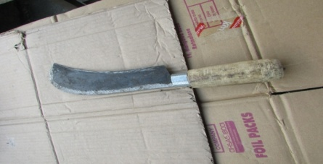
2 | Coconut scraper | 1 | 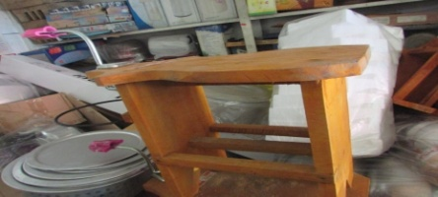
3 | Saucepans (Less than 2 kg) | 2 | 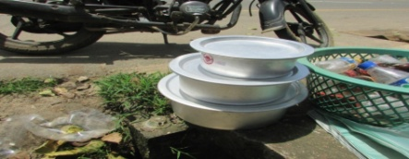
4 | Clay pots (To cook for 6 persons) | 2 | 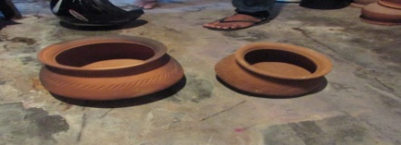
5 | Clay pans (To cook for 6 persons) | 2 | 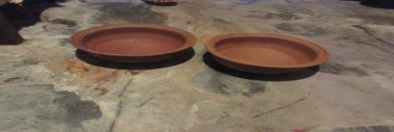
6 | Plates (Aluminium) | 6 | 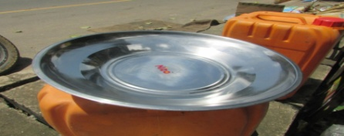
7 | Cups (Aluminium) | 4
8 | Kettle (Aluminium) | 1 | 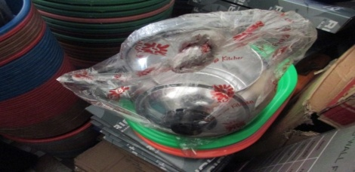
9 | Small bottles for spices | 6 | 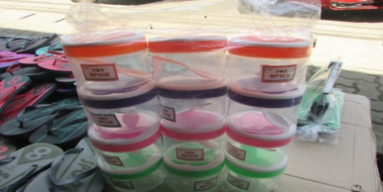
10 | Vegetable rack (Plastic) | 1 | 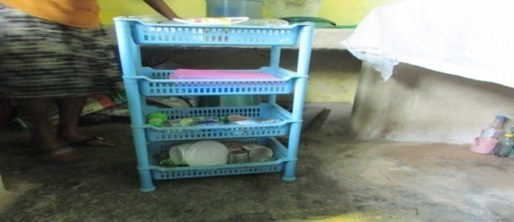
11 | Aluminium spoons | Large 3 Small 3 | 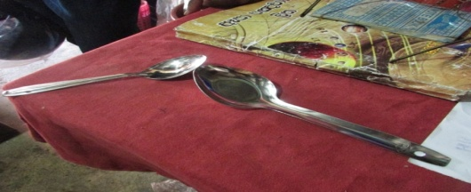
12 | Rice remover (Aluminium) | 1 | 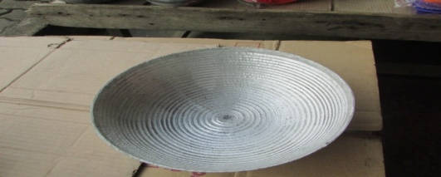
13 | Coconut milk strainer | 1 | 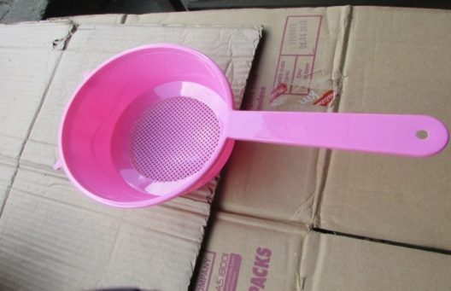
14 | Water pot (Aluminium) | 1
15 | Water filter | 1
16 | Tea jug (Aluminium) | 1 | 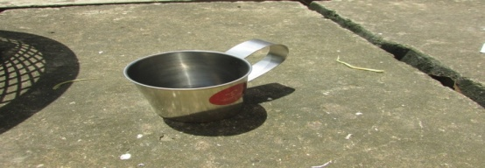
17 | Coconut shell spoons |  | 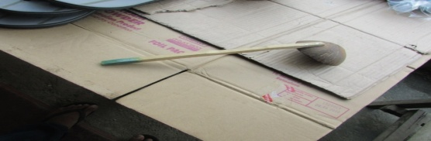
18 | Tea strainer | 1
19 | Clay pots | 2
20 | Chargeable torch | 1 | 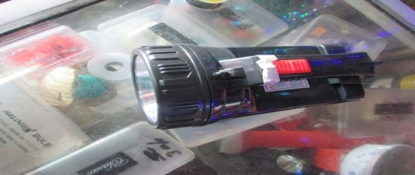
21 | Pail | 1
22 | Aluminium frying pan | 1
23 | Frying spoon | 1
24 | Basket (Plastic) | 2 | 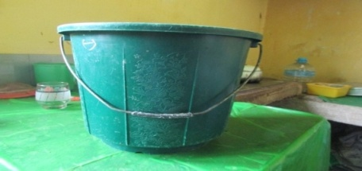
25 | Clay Burner | 1 | 