AYUUB Multi-sectoral Needs Assessment Report

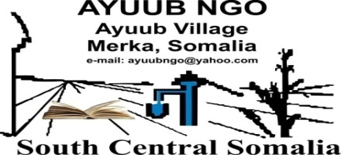
Lead Agency

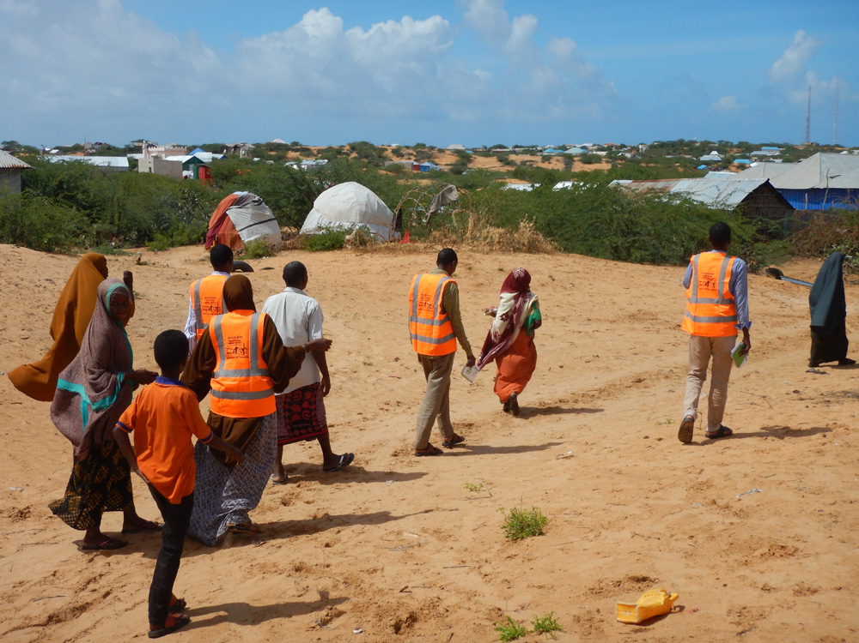
Co-coordinated by

Mogadishu Office

AYUUB Multi-Sectoral Assessment for Lower Shabelle June 2019
Coverage area: (Marka, Qoryooley, Kurtunwaarey, Awdhegle and Wanla Weyn)

Acknowledgement

First and foremost, we would like to thank and acknowledge the efforts put by AYUUB NGO’s departments of Livelihood, Health/WASH, Nutrition, Shelter, Protection, CCCM and Education for the tireless and sacrifice they performed during their exercise of Multi-Sectoral assessment undertaken in Marka, Qoryooley, Kurtunwaarey, Awdhegle and Wanla Weyn districts of Lower Shabelle region.

Sincere thanks bestowed to the Local Authority, and rest of participated in the assessment.
Secondly, we thank to all field level personnel, Local authority, Community members of community leaders, IMAMs, Women, Youth, teachers, and etc for the actively participation in the assessment and the great contribution and inputs to make this assessment fruitful, without their efforts and coordination, we would not have this product on hand.

Finally, and in the humblest way, special thanks go to AYUUB NGO head management for their logistically, communication, safety and security of personnel and coordination they bestowed to the assessment crew during the assessment mission.

Objectives of the assessment
- Identify gaps, challenges and opportunities in the humanitarian situation in Marka, Qoryooley, Kurtunwaarey, Awdhegle and Wanla Weyn.
- Assess the humanitarian situation of drought in Marka, Qoryooley, Kurtunwaarey, Awdhegle and Wanla Weyn.
- Recommend action points in pressing the needs, challenges and how to optimize on the opportunities in addressing the humanitarian situation.
- Use the assessment as a reference point for humanitarian actors.

Executive Summary;

Immediate Cluster Specific Priority Findings
Generally, Somalia has recently experienced two natural disasters during a protracted armed conflict. The drought which began in 2016 – the third major drought in as many decades – pushed more than half of the country’s population into food insecurity and displaced 1.6 million people, Lower Shabelle was among the most affected zone after beside Bay and Bakool region.
The heavy rains in April 2018 ended the drought but resulted in extensive flash flooding, flooding in riverine areas such Qoryooley and Marka which relatively produces a total IDPs of estimated 8000 households (52.000 indiv.) where children, women and elderly people are the most vulnerable members of them, after AS fighters intentionally diverted the Shabelle River Water to Six villages ( Gaaywarow, Buulo Sheikh, Haduumun, Jeerow, Farxaane and Maduulow) under Qoryooley district.

Marka hosted estimated of 3304hhs with almost 45% of children since the SNA forces took over the town from AS in August last years, and followed by reconciliation process led by President Farmajo in Oct 2018 and ended with tangible achievements, majority of the IDPs fled from the AS controlled areas hosting airstrike and ban of agriculture activities imposed by AS in a large farmland, the IDPs fled to the villages of Buulo Jaan, Tima Adde, Ayuub, Abeylow, Wakaaladda, Buulo Kuudka, Abosivo, Ceel Xaaji, Aw Yaalle, Nurta taliyo, Cusmaan Qulle and Bufow Bacaad and established IDPs points.

Some of the IDPs were responded with Health, Shelter and Education by AYUUB NGO in the support of SHF and UNICEF, but the people in need are more than reached numbers, claiming for more response, even with multi-sectoral response of Livelihood, Health/WASH, Nutrition, Shelter, Protection, CCCM and Education

The overarching result of recurrent natural disasters and continuous armed conflict has been the disruption of critical infrastructure and basic services, large population movements, insecurity and violence, and pervasive poverty. Simultaneously, rapid urbanization driven by displacement, morphing livelihoods, deeply eroded household resilience, and widespread protection concerns have influenced a shifting humanitarian and development landscape.
Considering the protracted crisis, integrated and harmonized information sources that support both the immediate and long-term response are ever more necessary.

After all these, giving ears to drought emergency state alerted by Somali Government in January 2019 due to forecasted rainfall shortage in the Gu rainy season for 2019 and similar alerts issued by UN and NGO Consortium in February 2019 and all called for preparedness of resources and capacity to respond to the matter timely, AYUUB NGO being a partner has a full presence in Lower Shabelle launched multi- sectoral needs assessment in the districts of Marka, Qoryooley, Kurtunwaarey, Awdhegle and Wanla Weyn.

The organization organized 14 qualified personnel from the various departments of Livelihood, Health, Nutrition, Education, Protection, Shelter and CCCM who undertook the assessment on the needs of these sectors by engaging with the local authorities, community leaders, different groups of socials in the selected areas, where they discussed the immediate needs in the ground through FGD session, KII, household interview, general observation, and site visits for the high profile locations, like learning spaces, health facilities, water points, IDPs points.

The assessment team visited Marka IDPs settlements of Aw yaalle with 307hhs, Nurta Taliyow with 518hhs, Buufow Bacaad with 420hhs, Aw beylow with 570hs, Tima Cadde with 475hhs, Ceel Xaaji with 414hhs, Abosivo with 231hhs, and Cusmaan Qulle with 369hhs.

Awdhegle/KM50 IDPs settlements: Fedi Kuus with 310hhs, Buulo Muudey with 287hhs, Garas Kulmiye with 312hhs, Yaaq Buulle with 428hhs, Buulo Qalaali with 295hhs, Bakina with 128hhs, Todoba derbi with 352hhs and Aala yaasir with 402hhs

Qoryooley IDPs settlements: Degaaye beere with 390hhs,,Halane with 287hhs, Hodan with 106hhs and Wadajir with 266hhs.

Wanla Weyn IDP settlements: Bakaal with 289hhs, Dau,d Bulle with 315hhs, Teendhada with 311hhs, Caga boorre with 193hhs and Hakabo with 211hhs.

Kurtunwaarey IDPs settlements; Xiin Faniin with 319hhs, Xaafad Jadiid with 297hhs, Daydoog with 386hhs, Hormuud with 125hhs.

Besides that, the team have also visited number primary schools like Tima Adde, Gay Warow, Bakaal, Buulo Mareer and KM50 primary schools under the five selected districts for the assessment where the team engaged with teachers, schools CECs, students and some of the parents, discussing with them the priority needs in the areas.

The assessment team evaluated the overall situation of the visited sites, but focusing on the sectors considered in the mission, the team noted that a total of 6343hhs IDPs are suffering for various needs of Livelihood, Education, Protection, Shelter, CCCM, health and Nutrition, in the districts of Marka with 3304hhs, Qoryooley with 1049hhs, Kurtunwarey with 1127hhs, Awdheegle with 2514hhs, and Wanla Weyn with 1319hhs, where majorty of the affected IDPs are children, women, elderly people and people with special needs.

Beside that nearly 3500hhs vulnerable community members were visited and all drew their needs and suffer and called for urgent support from the aid organizations and well-wishers to safe their lives from the drought and conflict entailed disaster.

whereby over 8900hhs of both IDPs and host community are facing hardship life for livelihood, affected with bad feeding for the children under 5 and PLWs due to no access proper livelihood and can signal a symptom of malnutrition if not responded timely.

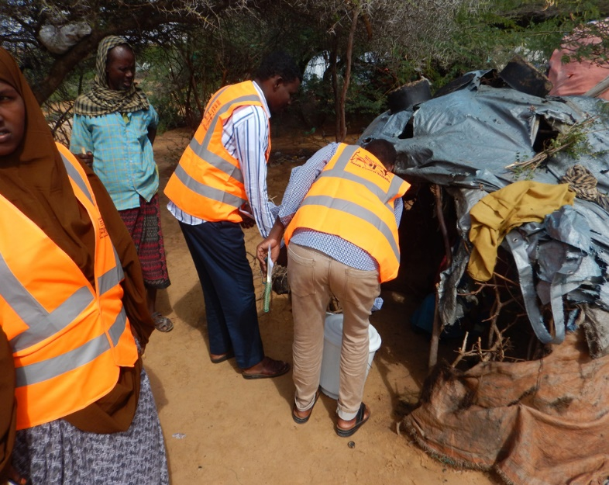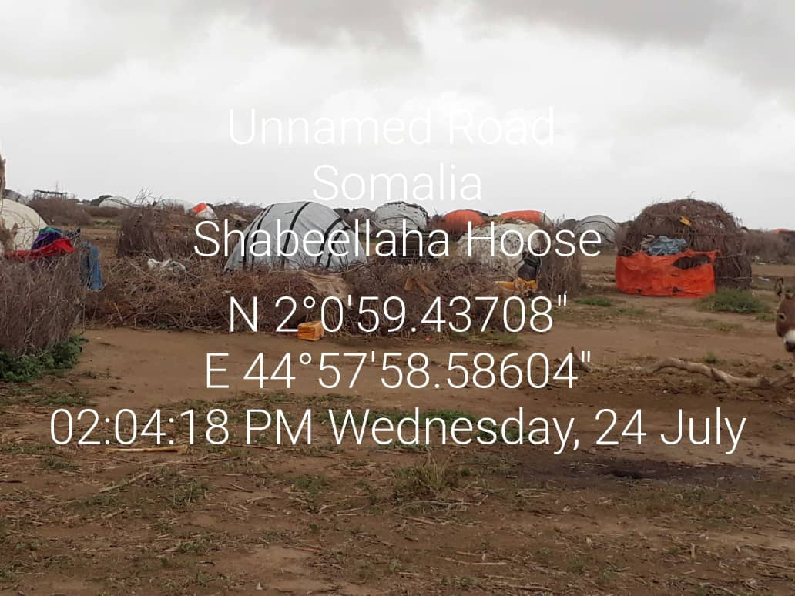

SECTORAL SITUATION ANALYSIS

Livelihoods:

The assessment team observed in the IDPs sites visited, that hundreds of children under five band Pregnant and Lactating Women (PLWs)with signs of poor feeding that can develop to MAM and SAM rates if not responded appropriately, and timely, the interviewees told to the team that their first priority is food as they don’t access food property, they were displaced by the draughts and conflicts including the airstrike increased in Lower Shabelle region, left their homes and NFIs back and were forces to be IDPs in Marka, Qoryooley, Kurtunwareey and Awdheegle and Wanla Weyn.

Education:

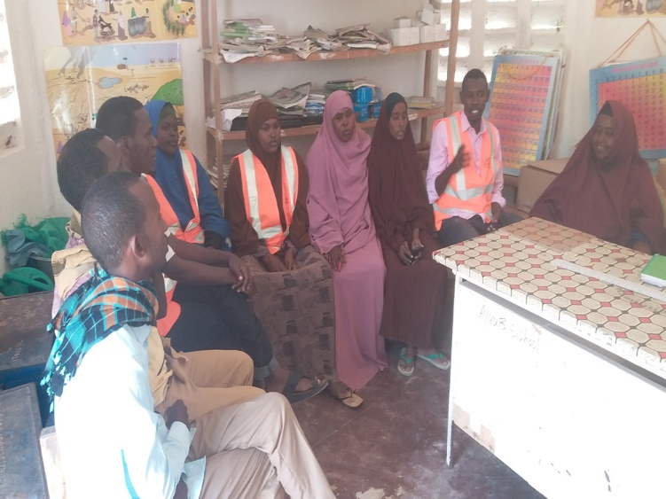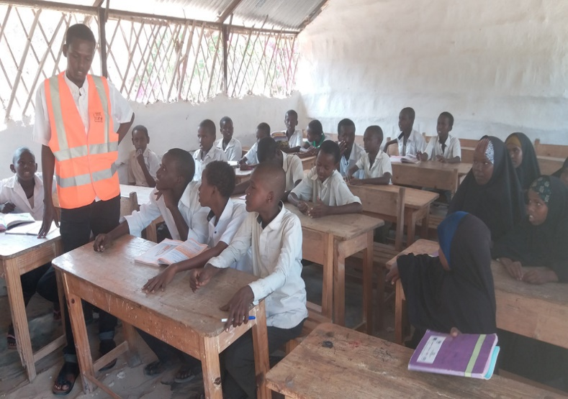Nearly 3700 children of school age are not attending at the education spaces, due to displacement caused by the repeated conflicts and drought and forced these children to face child labor, as to support their families in the livelihood.

The team noted that the schools are not sufficiently access learning materials, 90% of the schools’ teachers did not get teaching incentives for the last two years, teachers did not access training for the last three years, 95% of the schools are working under poor learning spaces due no rehabilitation was undertaken and some of them were affected in the conflicts, there was noted more of drop out schools due to poorness of the family livelihood, early marriage, child exploitation and frequent displacement for the causes of droughts and conflicts, for instance, Grade one enrolment usually starts with 600hs pupils pers school, in opposite at grade eight about 50-60 pupils graduate due to above stated factors.

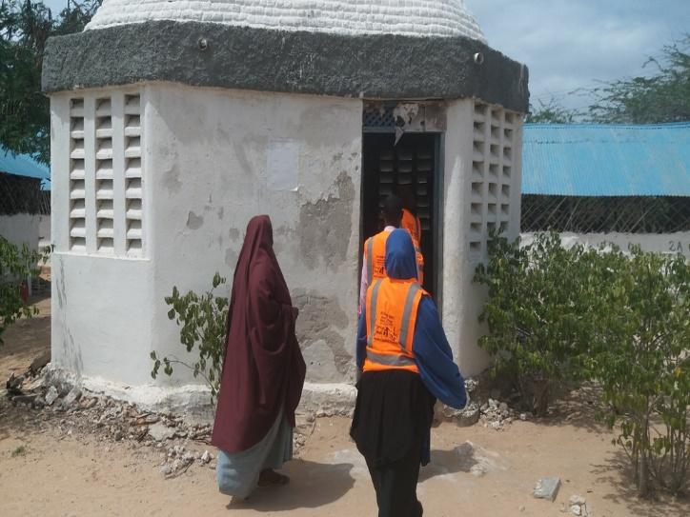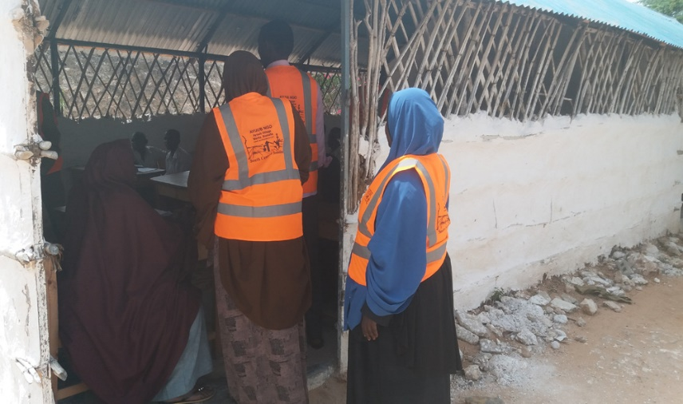

Health and WASH:

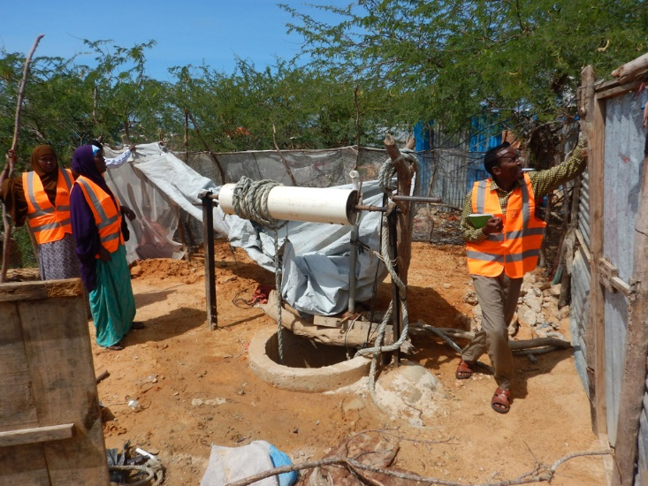T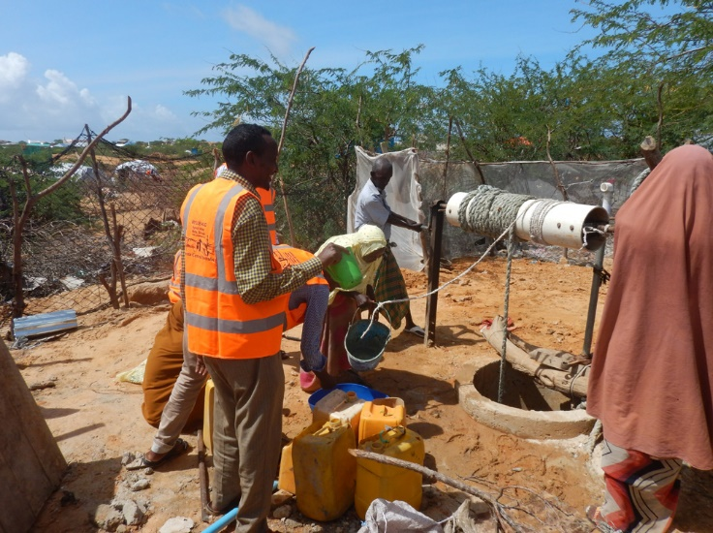he assessment team visited some selected health facilities in the above districts, observed the health services conditions, supplies adequacy and diversity to the increasing diseases concerns, number of beneficiaries accessing at the sites, beside that interviewed facility Incharges and some selected beneficiaries through FGD sessions on the various health related needs they have in their respective areas.

The interviewed members expressed their concern about the increasing diseases, mainly resulting from the draughts and bad feeding, which are harming their communities and the demographic growth in the areas and the inadequate supplies to respond these needs.

The members told to the assessment team that due to temporary services that awarded to the organization running health in the area, and the continuation increasing needs for health services are something not matching, meanwhile, majority of the projects awarded are 6 months to 9 months and the need for health response is growing and continues.

For WASH branch, the team visited five water points providing water services to the community in Abeylow IDPs Camp (Marka) KM50 IDPs Camp ( Awdhegle), Xiin Faniin IDPs Camp ( Kurtunwarey), Bakaal IDPs Camp ( Wanla Weyn) Degaaye Beerre IDPs Camp ( Qoryooley)

The observed a crowd and long line of IDPs, host communities and livestock of cow, goat an camel gathered therein, seeking water to drink, some of the water points can not provide water for 12hrs, as the water goes down after the sun hots, where some others need for rehabilitation and all are lacking or having poor water barracks to properly fetch the water.

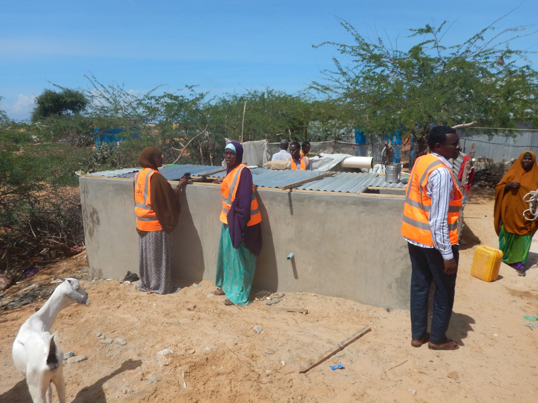Water shortage was highly noted all visited sites, which is affecting the life of the population, for WASH problem which became the source seasonal and skins disease suffered by the respondents.

Majority of the schools have not enough and proper latrines for the children, which is limiting the chances of female attendance to the schools.

Health and Nutrition:

According to the last Food Security and Nutrition Analysis Unit (FSNAU) -Post Deyr 2018, shows overall acute malnutrition in Somalia at 12.6%. thus, The FSNAU forecasts worsening food security and nutrition situation in the second quarter of 2019 in Bakool, Bay, Middle and Lower Shabelle. Poor nutrition may deteriorate further with delayed rain and the impending drought. The FSNAU projects the GAM in Afgooye/Awadegly district at 16.5% and SAM at 3.1%. The Nutrition Cluster estimates about 4,200 SAM cases in the Afgooye/Awadegly districts annually with an estimated population of about 290,000 (including 56,000 IDPs). AYUUB with the support of UNICE, SHF and WFP has been delivering Nutrition and Livelhood supports to the affected community in Marka, Qoryooley, Kurtunwarey, Awdheege and Wanla Weyn districts of Lower Shabelle, but the response still no enough due to the continuation of the conflict and drought and increase of the need.

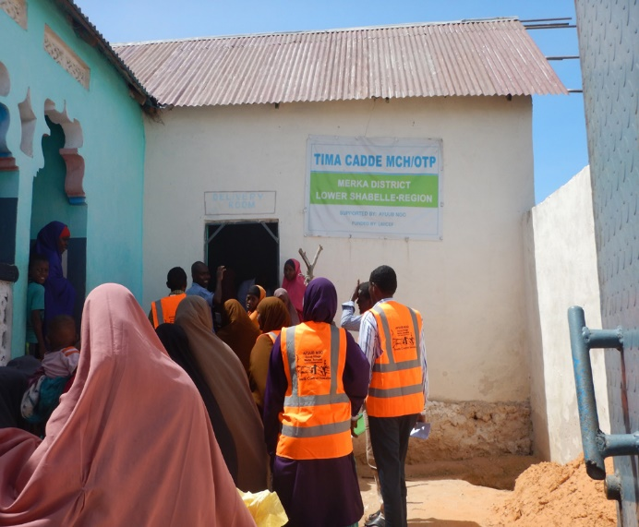
During the assessment the team interviewed the community, mainly the IDPs, conducted FGD sessions in the various IDPs points, and noted that the livelihood system is very poor in the area, where the households do not access food as per human need of three periods per days. The signs of malnutrition were seen on the faces of children under five, PLWs and elderly people, which needs for significant response for saving lives. 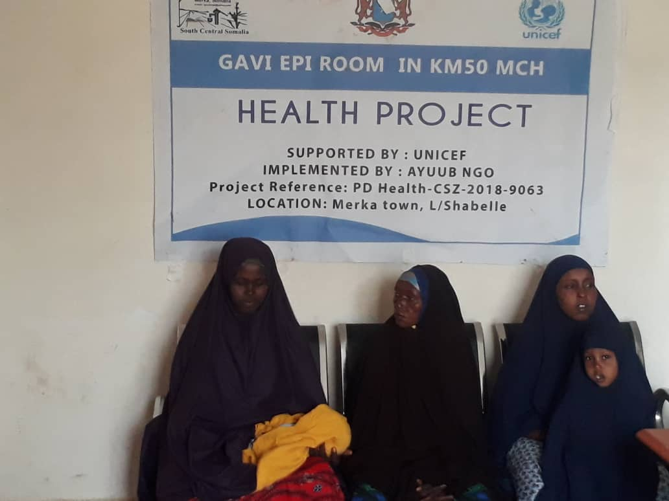
Summary of Nutrition Status: - Children 06-59 Months
MUAC (cm) | Nutritional status | N= 556 (100 % )
>13.4cm |  | 39
12.5cm to 13.4cm | At risk of Malnutrition | 27
11.5 cm to 12.4 cm | Moderate Malnutrition | 23
< 11.5 cm | Severe Malnutrition | 10
Oedema | Severe Malnutrition | 1
Total Screened |  | 556

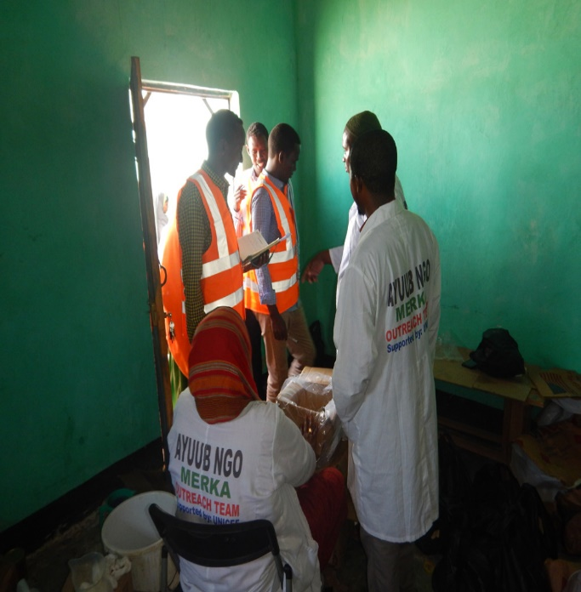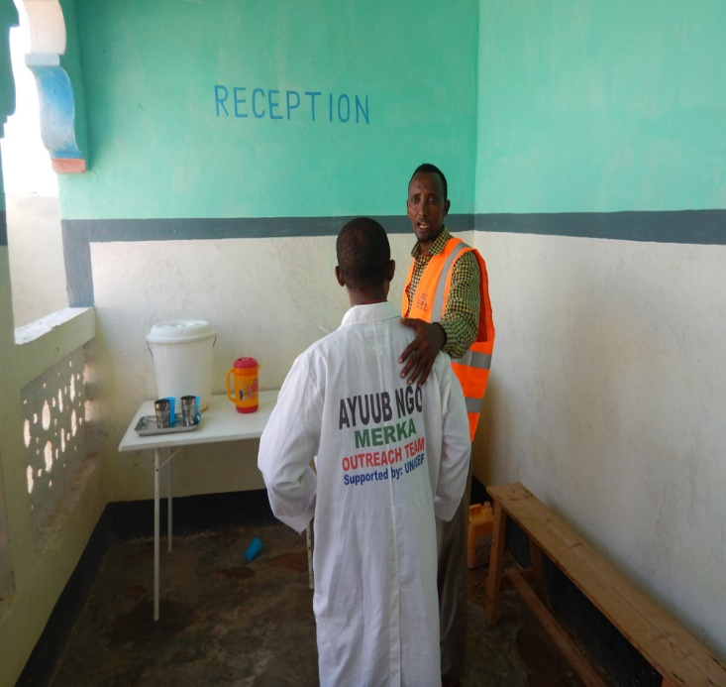

Shelter/CCCM:

The team visited the above IDPs Camps and observed the poor shelter condition the IDPs live under, they live under an old cloth made cottages, non-protective for sunlight, cool and even for protection, the FGD groups expressed their concerns about the poor shelter they live under, theft and other protection issues are always associated which is increasing the GBV risks.

The IDPs cottages were set up randomly and not organized, which require CCCM activities to arrange the settlement construction to leave enough space in the settlements, design for latrines and wastage pits, the current settlement structure the team seen is at risk for cooking fire breakouts, can destroy whole the settlement and harm the IDPs.

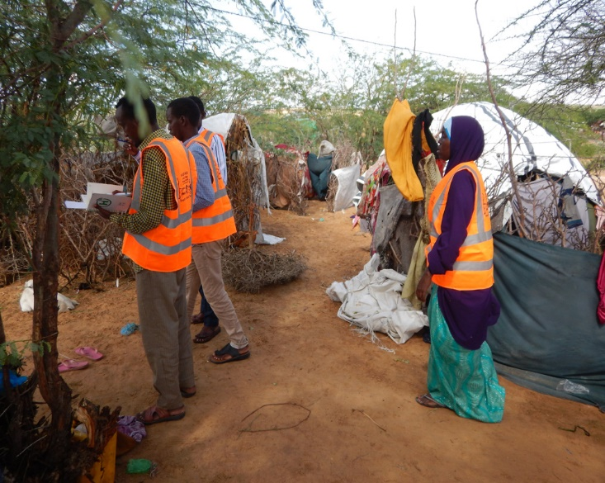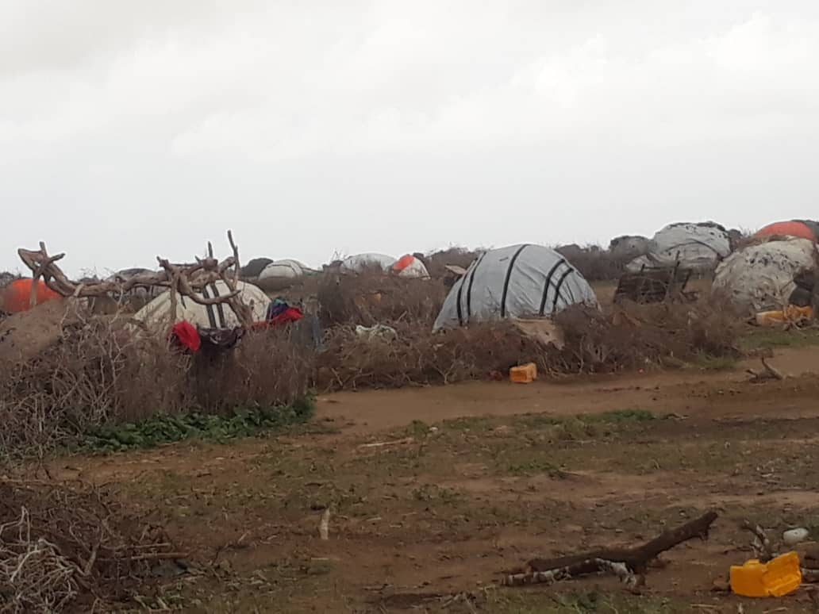

The IDPs settlement needs for coordination among them, by establishing camps committees, organizing meetings to discuss their needs and share information about their issues, to be more cohesive and coordinated community along with the host community in the areas, to mitigate security risks and GBV issues.

Protection:

The team found out that 33% of the IDP camps were inaccessible either by road, air or water. Security for women and girls was as low as 20% with most of them expressing concern during humanitarian aid distributions. The women and girls walk for about 30 minutes in search of water in the absence of response from aid partners. Latrines are located in high risk places, far from the reach and shared among men and women with most women abandoning usage for men. There were 119 cases of early pregnancies reported in the month preceding the assessment with most respondents having not received any birth spacing or family planning services in the last one year. There is only one referral district hospital which is some 150km to the furthest IDP camp. Majority of the respondents indicated that they are stressed and traumatized by the displacements.
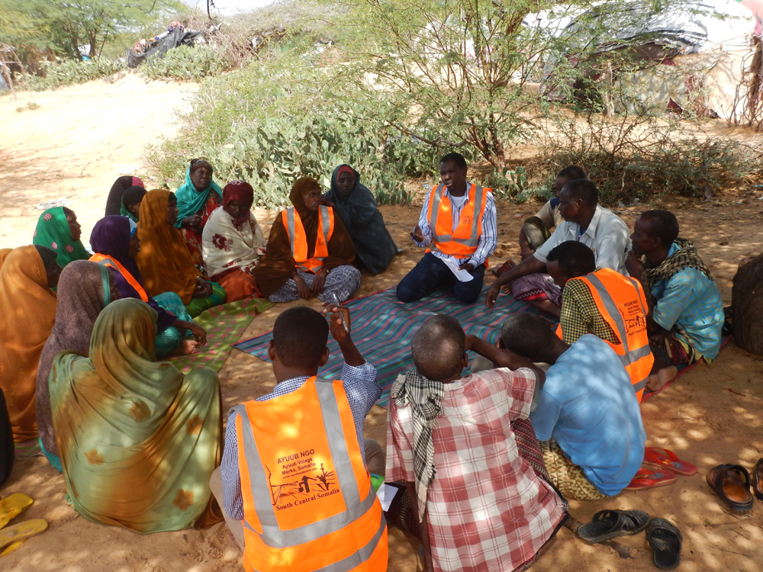
SUMMERIES OF RECOMMENDATIONS FOR IMMEDIATE AND SHORT-TERM NEEDS
(JULY- DECEMBER 2019)

SECTOR | RECOMMENDATIONS
FOOD, LIVELIHOODS ASSISTANCE,        CASH AND VOUCHER |  | Provision of veterinary services such as drugs, livestock vaccination, herbicides and pesticides for the agro-pastrolists, training community animal health workers and supporting them with vet kits to help them prevent disease outbreaks and further livestock losses.
 |  | Provision of donkey carts, hammer for stone breaking and other sophisticated machines for earning a sustainable living.
 |  | There is need for emergency unconditional cash transfer to the IDP’s and Poor Host Communities to enable them to have access to basic needs.
 |  | Creating small scale business, and cash for work program to generate the livelihoods of the vulnerable populations.
 |  | Creating community-based resilience programs that reflects the community priority to reduce their vulnerability and increase their resilience against shocks resulted by climate changes, environmental degradation and man-made disasters
 |  | Giving consideration to the poor host communities by creating small business and livelihood skills for better coping mechanism through a market driven skills and income generation activities.
 |  | IDP’s require reintegration program so that they build their own business here or return program to their areas of origin since the latter option is difficult due to security issues.
 |  | There is need for restocking and agricultural inputs such as drought resistant seeds, farming tools and environmentally friendly irrigation system (solar water pumping system) for the farmers to produce cash crops and cereals in order to boost their living condition and improve their income.

WATER, SANITATION AND HYGIENE    (WASH) |  | Hygiene promotion and sanitation materials distribution is recommended to ensure personal and environmental hygiene, with a specific focus on adolescent girls and women in the displacement settlements.
 |  | Construct/dislodge latrines to reduce open defecation in the IDPs.
 |  | Establish, increase and train Water Management Committees to manage community water points.
 |  | Distribute NFI/Sanitation hygiene kits, and enhance water storages and treatments.
 |  | Rehabilitation of existing water sources: shallow wells and boreholes and improve Water piping systems
 |  | Promoting water treatment at source and household level.
 |  | Improving water infrastructure and service management. This will involve capacity building of local water management institutions (water user associations).
 |  | Construction of household latrines at IDP camps and construction of institutional latrines.
 |  | Distribution of water storage containers for IDPs (WASH NFIs)
 |  | Carryout hygiene promotion campaigns in all camps and build the capacity of community hygiene volunteers.
  HEALTH |  | Provide health/medical supplies in existing health and nutrition facilities
 |  | Due to the recent rains received, there is a need of distribution of insecticide-treated nets in order to prevent possible malaria outbreaks.
NUTRITION |  | Integrations of WASH, Health and Nutrition with relief especially family ration to curb sharing of the nutrition products meant to treat acute malnutrition.
NUTRITION |  | There is need for nutrition screening in the IDPs to determine the current levels of malnutrition in the IDP community.
NUTRITION |  | To maintain the situation under control and reverse the trend in the current admissions, there is need for additional support and attention from humanitarians to avoid the situation slipping further.
NUTRITION |  | Operationalizing Humanitarian Intervention in major accessible villages surrounding them to reduce more displacements to Merka.
NUTRITION |  | Scale up nutrition services treating and preventing acute malnutrition among children and women.
  PROTECTION |  | Provision of adequate water at household level to reduce protection risks of women/girls to fetch water from a distant locations and provision of donkey carts to improve the livelihoods of the vulnerable IDPs.
 |  | Capacity building and law enforcement of governments institutions i.e. the legal system/judicial through the provision of communication gadgets, rehabilitation of government facilities and training (on SGBV case management and protection) to local administration, police officers and judicial officers.
 |  | Installation of Street Solar lights and provision of hand-held torches to provide security and enhance the protection of the IDPs especially Girls and women from GBV violations during night time.
 |  | Establishments/construction of Child Friendly spaces for the settlements where most unaccompanied and separated children are reported. This supports in identifying children with symptoms of stress and provide them informal education and holistic responses through the case management process.
 |  | Provision of NFI/Shelter Kits that are lockable to the IDPs to enhance their protection from the rains, direct sunlight and perpetrators of Gender Based Violence (GBV) especially at nights and during rainy seasons.
SHELTER   |  | Provision of emergency shelter support (ESK) for those who are living in the temporary makeshits without proper shelter now.
 |  | All shelter partners are in treasure to advocate more funding for Shelter interventions by speaking with different donors and partners to invest the massive gap in the sector, as most of the IDPs in Merka are living in temporary makeshifts.
 |  | Provision of other shelter packages apart from non-food items, e.g. construction of transitional or semi-permanent and permanent shelters for those have land with specific period of secure tenure or (permanent land) verified through HLP working group and District authority.
 |  | Distribution of non-food Items (NFIs) to the IDPs at the assessed sites and others who have not proper shelters.
 |  | Request all the partners who have NFIs in plan to speed up the distribution of NFIs/shelter packages to newly arrived IDPs with deep consideration of the most vulnerable communities through the leadership and coordination of shelter cluster and OCHA.
 |  | Distribution of mosquito-nets to protect pregnant women and children from malaria.
  EDUCATION |  | Increase community awareness in support of education for all children regardless of gender and socio-economic status. Build capacity of community education committees to manage own schools after projects phase out.
 |  | Improve educational infrastructure where schools exist through provision of water, teaching & learning materials, training of teachers, construction of more classrooms and latrines.
 |  | Introduce school feeding program for IDP schools to increase enrolment and retention and of learners.
 |  | Conduct feasibility study to know the number of children at risk with particular focus on UAC and those fleeing from areas controlled by the non-state armed actors who are either living in IDP camps or integrated in urban villages.
 |  | Introduce postural/mobile education program specifically targeting rural communities.
 |  | Introduce affirmative action in support of girl child education at primary and secondary level. Train more female teachers to bridge the gender gap in the teaching workforce.
CCCM |  | Establish camp committees for the various IDPs settlements stated above. Train the camp committee on camp management and camp coordination, safety of the camps, leaving enough spaces among the ESKs constructed. To enhance the internal communication for the IDPs and coordination with the Local authority in terms of safety and security of the population and law and order. Designing monthly meetings to discuss their needs, gaps and recommend the partners on the ground for advocacy and response.

Long Term Needs
- monitor movements in the camps using household specific serialized registration number.
- Resilient building mechanisms for people in crisis
- Government support to plan and provide services to emergency critically affected populations
- Increase partnerships with local businesses and innovators to find local solutions to localized problems facing youth and women.
- Enhanced security and access to newly liberated areas.

Sampling and Data Collection Methodologies

An average of 5% sample was picked for each of the 29 camps in the 5 villages targeted for the assessment. This gave us an average sample proportion of about 18. The selected IDP settlements were in newly accessible areas and most are new arrivals due to prolonged drought. The sample methodology involved focused group discussions, observation and key informants. Focus group discussions targeted the household level in the camps with mostly targeting heads of households with one discussion targeting women headed households and another for child headed households. Key informant included gate keepers, camp coordination camp management leads, government representatives for different sectors and representatives for persons with special needs among others.
Data collection was done through the use of questionnaires with a total of 525 sample questionnaires administered in the 29 camps from the 5 villages. Each questionnaire had 78 questions covering population demographics and sectors of food and livelihoods, water sanitation and hygiene, education, shelter, camp coordination and management, protection, health and Nutrition.
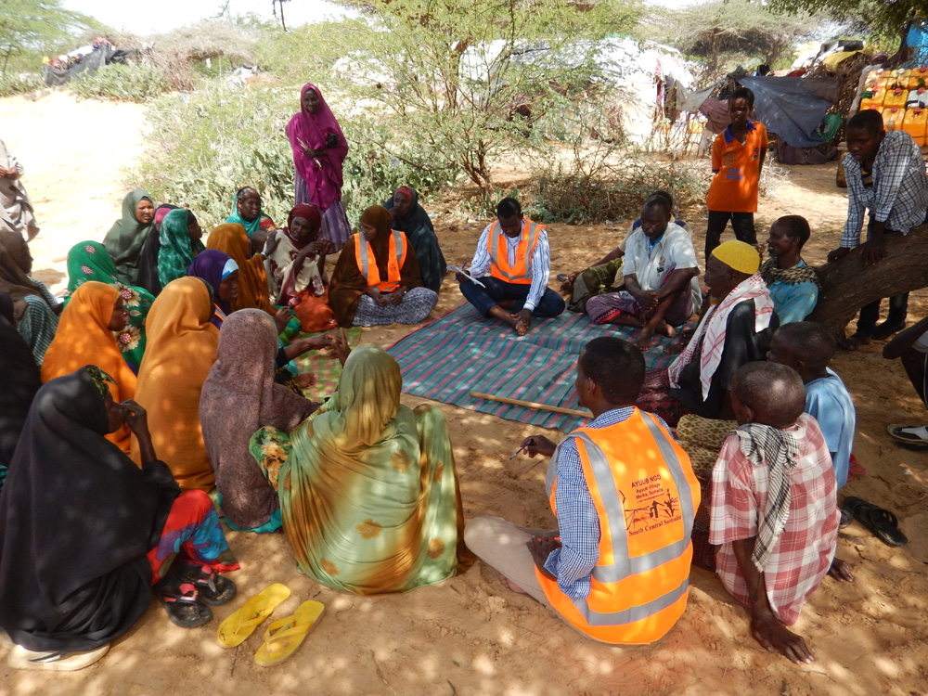
Table 1 Distribution of Submitted Data
Village | Number of Camps | Sample Proportion | #of HHs | % of the Sample | Number of FGD s
Marka IDP settlements | Aw yaalle | 15 | 307 | 4.89 | 3
Marka IDP settlements | Nurta Taliyow | 20 | 518 | 3.86 | 4
Marka IDP settlements | Buufow Bacaad | 20 | 420 | 4.76 | 4
Marka IDP settlements | Aw beylow | 20 | 570 | 3.51 | 4
Marka IDP settlements | Tima Cadde | 20 | 475 | 4.21 | 4
Marka IDP settlements | Ceel Xaaji | 20 | 414 | 4.83 | 4
Marka IDP settlements | Abosivo | 15 | 231 | 6.49 | 2
Marka IDP settlements | Cusmaan Qulle | 20 | 369 | 5.42 | 3
Awdhegle/KM50 IDPs settlements | Fedi Kuus | 20 | 310 | 6.45 | 3
Awdhegle/KM50 IDPs settlements | Buulo Muudey | 15 | 278 | 5.40 | 2
Awdhegle/KM50 IDPs settlements | Garas Kulmiye | 15 | 312 | 4.81 | 3
Awdhegle/KM50 IDPs settlements | Yaaq Buulle | 25 | 428 | 5.84 | 4
Awdhegle/KM50 IDPs settlements | Buulo Qalaali | 15 | 295 | 5.08 | 3
Awdhegle/KM50 IDPs settlements | Bakina | 15 | 128 | 11.72 | 2
Awdhegle/KM50 IDPs settlements | Todoba derbi | 15 | 352 | 4.26 | 3
Awdhegle/KM50 IDPs settlements | Aala yaasir | 15 | 402 | 3.73 | 4
Qoryooley IDPs settlements | Degaaye beere | 25 | 390 | 6.41 | 4
Qoryooley IDPs settlements | Halane | 25 | 287 | 8.71 | 3
Qoryooley IDPs settlements | Hodan | 15 | 106 | 14.15 | 3
Qoryooley IDPs settlements | Wadajir | 25 | 266 | 9.40 | 2
Wanla Weyn IDP settlements | Bakaal | 20 | 289 | 6.92 | 3
Wanla Weyn IDP settlements | Dau,d Bulle | 15 | 315 | 4.76 | 2
Wanla Weyn IDP settlements | Teendhada | 15 | 311 | 4.82 | 3
Wanla Weyn IDP settlements | Caga boorre | 15 | 193 | 7.77 | 3
Wanla Weyn IDP settlements | Hakabo | 20 | 211 | 9.48 | 2
Kurtunwaarey IDPs settlements | Xiin Faniin | 20 | 319 | 6.27 | 3
Kurtunwaarey IDPs settlements | Xaafad Jadiid | 15 | 297 | 5.05 | 2
Kurtunwaarey IDPs settlements | Daydoog | 20 | 386 | 5.18 | 3
Kurtunwaarey IDPs settlements | Hormuud | 10 | 125 | 8.00 | 1
TOTALS |  | 525 | 9304

Population Demographic

Category | Sex |  |  |  | Age Sum | % of Grand Total
Category | Female |  | Male |  | Age Sum | % of Grand Total
Category | Total Number | Category Percentage | Total Number | Category Percentage | Age Sum | % of Grand Total
<=59 Months | 752 | 36% | 1321 | 64% | 2073 | 11%
5 -11 yrs | 1705 | 48% | 1874 | 52% | 3579 | 18%
12-17 yrs | 1290 | 40% | 1979 | 60% | 3269 | 17%
18-59 yrs | 4056 | 63% | 2403 | 37% | 6459 | 32%
>60 yrs | 2704 | 61% | 1740 | 39% | 4444 | 22%
Category Totals | 10507 | 50% | 9317 | 50% | 19824 | 100%
Grand Category % | 53% | - | 47% | - | - | -

 | Pull Factor
HH Type | Humanitarian Aid | Safety | In Search of Work | Just Migrated | Grand Contribution
Conflict Affected | 0 | 90 | 50 | 34
Disease Outbreak | 0 | 50 | 0 | 7
Drought | 30 | 70 | 40 | 12
Returnee | 0 | 0 | 0 | 0

Dependency and Persons with Special Needs
The assessment identified 560 individuals with special needs. These were persons with physical disabilities, mental disabilities, psycho-social trauma and 1500 persons who totally depended on aid assistances either due to their disability of because of age limitations (under 18 or over 70 and living alone). Most of this group were female with (73%) while males stood at (27%)

Sectoral Analysis:
Education and Child Protection:
Institutions in Merka | % of HHs with Children in
Primary Schools | 42%
Secondary Schools | 12%
Tertiary Institutions | 3%
Sex |  | Number | % Population
Children | Male | 5174 | 26.10
Children | Female | 3747 | 18.90
Children | Total | 8921 | 45.00
Adults | Male | 4143 | 20.90
Adults | Female | 6760 | 34.10
Adults | Total | 10,903 | 55.00
Total |  | 19,824 | 100.00

Common Child Labor;
- Vending and Hawking.
- Farming
- House keeping
- Herding
- Shop keeping

Livelihood Sources;
- Agriculture and farming.
- Animal keeping
- Vending
- Small scale businesses
Household Regular Income Sources;
- Farming and farm products
- Small scale businesses
- Reliance from aid assistance
Access to Cash and Household Expenditure;
- Food and water
- Shelter and clothing
- Education
- Health services

ACCESS TO BASIC NEEDS:
Since the start of 2019, the communities have not received any medical assistance. The only food they receive is from well-wishers. They also have to walk between 3 to 10 kilometers to get water which in most circumstances is not safe for drinking. The cost of a barrel of water is currently at 4 dollars which is quiete expensive for the IDP population. The only health facility in the vicinity is the Marka Health Centre run by AYUUB but even this facility is located about 15 kilometers to the furthest IDP settlement. The IDPs are using locally available materials like sticks, plastics and old canvas/clothing to construct shelter. Most household items needed like jerry-cans, basins, cooking utensils and cooking aids are either not available or the old things they had carried with themselves during displacement. The IDPs have no access to latrines and there is evidence of open defecation within the camps. There are no schools in the camps that largely hosts children below 18 years (school going ages). The camps have not been lit at night and this posses grace protection concerns for women and girls as they move about in the evenings.
Main needs include support for women and children with psycho-social trauma, support for persons with special needs, health and nutrition screening and service delivery, provision of emergency food assistance and safe water, access to teaching and learning services, safe and hygienic sanitation services including hand washing facilities, referral pathways for health and protection concerns and proper coordination with all stakeholders to better manage the camps.
Priority Needs; (Top Three)
Based on the analysis below (see table), it is evident that the households would spend 100 Dollars Gift on Food 48%, shelter 18% and Hygiene facilities 12%.
Basic Need | Average Amount in (USD) Spent | % of Total (Gift)
Food commodities (Staple and non-staple, etc.) | 48.00 | 48%
Health Care Services commodities (drugs, etc.) | 0 | 0%
Potable water (including containers, treatment, etc.) | 10 | 10%
Shelter and Housing commodities (furniture, building material, etc.) | 18.00 | 18%
Household commodities (Utensils, pots, mats, blanket, mosquito net, cooking set, etc.) | 0 | 0%
Hygiene Facilities (establishing) and commodities (clothing, washing, soap, pads, etc.) | 12 | 12%
Energy commodities for heating, cooking, lightning and charging | 0 | 0%
Transport services (To work, health center, markets, etc.) | 0 | 0%
Education commodities (uniforms, shoes, stationaries, books, etc.) | 9 | 9%
Education services (transport, fees, teachers, etc.) | 0 | 0%
Communication commodities (Phone, credit, etc.) | 0 | 0%
Communication services (providers, towers, network, etc.) | 0 | 0%
Other (Legal support, special needs, seeds, tools, agricultural inputs, etc.) | 3 | 3%
Total | 100 USD | 100%

Household Perceived Priority Needs (Best Three)
Ranks | Most Frequent Needs | Reasons Why the Needs Can’t be Met | Form of Assistance Delivery Sought Cash, Service and In-Kind Ranks for Each Need)
1 | FOOD | Reason 1: lost livelihoods | Assistance Rank 1: cash  Assistance Rank 2: In kind  Assistance Rank 3:
1 | FOOD | Reason 2: Prolonged drought
1 | FOOD | Reason 3: Lack of aid assistance
2 | SHELTER | Reason 1: Displacement | Assistance Rank 1: In kind  Assistance Rank 2:  Assistance Rank 3:
2 | SHELTER | Reason 2: Lack of aid assistance
2 | SHELTER | Reason 3:
3 | WASH FACILITIES | Reason 1: Displacement | Assistance Rank 1: In kind  Assistance Rank 2: cash  Assistance Rank 3:
3 | WASH FACILITIES | Reason 2: Lack of aid assistance
3 | WASH FACILITIES | Reason 3: Loss of livelihoods

Humanitarian Assistance Provided in May 2019 to the IDP
S/N |  |  | IDP camps
 | Cash Transfer | None | Marka, Qoryooley, Kurtunwaarey, Awdhegle and Wanla Weyn
 | Food Voucher | None | Marka, Qoryooley, Kurtunwaarey, Awdhegle and Wanla Weyn
 | Drinking Water | None | Marka, Qoryooley, Kurtunwaarey, Awdhegle and Wanla Weyn
 | Water for Other Purposes | None | Marka, Qoryooley, Kurtunwaarey, Awdhegle and Wanla Weyn
 | NFIs (household items) | None | Marka, Qoryooley, Kurtunwaarey, Awdhegle and Wanla Weyn
 | Hygiene facility/Toilets | None | Marka, Qoryooley, Kurtunwaarey, Awdhegle and Wanla Weyn
 | Shelter Commodities | None | Marka, Qoryooley, Kurtunwaarey, Awdhegle and Wanla Weyn
 | Nutrition Feeding/Feeds | None | Marka, Qoryooley, Kurtunwaarey, Awdhegle and Wanla Weyn
 | Support In Education/Accessibility | None | Marka, Qoryooley, Kurtunwaarey, Awdhegle and Wanla Weyn
 | Health Service/Medical Care | None | Marka, Qoryooley, Kurtunwaarey, Awdhegle and Wanla Weyn
 | Community Awareness Campaign on Health and Hygiene | None | Marka, Qoryooley, Kurtunwaarey, Awdhegle and Wanla Weyn
 | Community Awareness Campaign on Child Feeding Practices | None | Marka, Qoryooley, Kurtunwaarey, Awdhegle and Wanla Weyn

Views of Focus Group Participants on Assistance Received.
The community expressed concern that with the experience of below normal rainfall this season, they would slide from drought crisis to full fledged famine. This is because there has been no humanitarian aid assistance to the families in these villages since March 2018 after the first response to the 2017 drought. The community now urges all concerned stakeholder including government, UN agencies, donors, national civil society organizations and the international community to come to the aid of the internally displaced population of the 5 districts assessed by AYUUB.

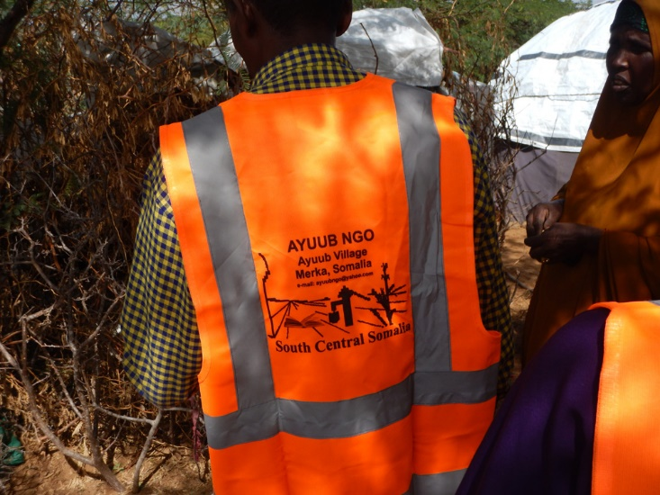

Assessment Agency Villages and their IDP Camp

The AYUUB multi-sectoral assessment has been fully supported by the departments of Livelihood, Health/WASH, Nutrition, Shelter, Protection, CCCM and Education in Marka, Qoryooley, Kurtunwaarey, Awdhegle and Wanla Weyn districts of Lower Shabelle region. The IDP camps assessed were 29; Aw yaalle
Nurta Taliyow, Buufow Bacaad, Aw beylow, Tima Cadde, Ceel Xaaji, Abosivo, Cusmaan Qulle, Fedi Kuus, Buulo Muudey, Garas Kulmiye, Yaaq Buulle, Buulo Qalaali, Bakina, Todoba derbi, Aala yaasir, Degaaye beere, Halane, Hodan, Wadajir, Bakaal, Dau,d Bulle, Teendhada, Caga boorre, Hakabo, Xiin Faniin, Xaafad Jadiid, Daydoog and Hormuud.

Acronyms
ACRONYMN | DESCRIPTION
AYUUB NGO | A national Non-Governmental Organization in Somalia.
CCCM | Camp Coordination Camp Management
WASH | Water, Sanitation and Hygiene
IDP | Internally Displaced Person(s)
UNICEF | United Nations Children’s Fund
UN | United Nations
PLWs | Pregnant and Lactating Women
ESK | Emergency Shelter Kits
NFIs | Non-Food Items
OCHA | Office for the Coordination of Humanitarian Affairs
GBV | Gender Based Violence
SGBV | Sexual and Gender Based Violence
FGD | Focused Group Discussions
KII | Key Informant Interview
SAM | Severe Acute Malnutrition
MAM | Moderate Acute Malnutrition
SNA | Somali National Army
AS | Al-Shabaab
SHF | Somali Humanitarian Fund
NGO | Non-Governmental Organization
CEC | Community Education Committee
MUAC | Mid-Upper Arm Circumference
HH | Households

FSNAU and FEWSNET, “Food Security Outlook: Above-average rainfall throughout 2018 expected to drive improvements in food security.” June 2018.
OCHA, “Somalia Humanitarian Bulletin 5 – 31 July.” July 2018

