Housing, Land and Property Mapping Project
Bangladesh

Background
The following fact sheet and research memo have been developed to provide quick and key information of the legal and procedural context relating to Housing, Land and Property (HLP) within the target country. They are intended to inform programming and emergency responses, especially those involving shelter interventions. A rapid understanding of the tenure landscape in each country context can assist in delivering stronger and more equitable responses, however these documents are not intended to be legal advice.
The HLP mapping project has been undertaken by Allens lawyers, using templates developed by the Australian Red Cross (ARC) and the International Federation of the Red Cross and Red Crescent Societies (IFRC). All of the research has gone through a verification process with in country lawyers and/or country experts.

Document Change Management
These documents are intended to be used and updated as necessary to ensure that they are always providing the most current and relevant information. We would appreciate ongoing feedback and updates from those working in country, in response or preparedness.
If you would like to make any changes to the document, please submit to the document manager Leeanne Marshall via the below table.

Title | Bangladesh HLP Profile
Description | Fact Sheet and Research Memo
Created By | Allens Lawyers, Australian Red Cross, IFRC
Date Created | May 2018
Maintained by | Leeanne Marshall lemarshall@redcross.org.au
Date | Submitted by  (name, organisation, email) | Suggested amendments  (please indicate section, paragraph, page as needed) | Status
Housing, Land and Property Laws in Bangladesh
1. Key laws and actors
Laws | The key pieces of legislation governing land and property include:  - the Transfer of Property Act 1882 which governs the transfer of private interests in land;  - the Registration Act 1908 which governs registration of private interests in land; and  - the Land Reforms Ordinance of 1984 which establishes a land ceiling, governs the distribution of Government land (khas) to the landless and regulates sharecropping agreements.
Key government actors | The main government department responsible for land administration is the Ministry of Lands, however the Ministry of Law, Justice and Parliamentary Affairs also plays a role in land administration.  The National Housing Authority is responsible for implementing the national Government's housing policies, while the Urban Development Directorate is responsible for administering national planning law and policy.  Several cities have their own planning agencies, which are generally referred to as Development Authorities (eg, the Capital Development Authority (Dhaka) and the Chittagong Development Authority).
2. Common types of tenure
Tenure type | Registration required | Description
Common law freehold | Yes | Exclusive ownership of land for an indefinite period.
'Permanent' lease / khas | Yes | The right to use a plot of government land (khas) ranging between one and three acres for a period of 99-years at no cost.
Leasehold | Only if greater than one year | The right to use land or housing owned by another for a fixed period in exchange for payment of rent. Leases of more than one year must be registered. Leases of one year or less do not need to be in writing.
Sharecropping agreement | No | An agreement whereby a sharecropper and landowner each receive one-third of the crop, and the remaining third is allocated based on their contribution to the costs of growing the crops. Sharecropper contracts must be for a minimum of five years and are heritable.
Customary ownership | No | In the Chittagong Hill Tracts region (CHT Region), which is home to the majority of Bangladesh' indigenous people, land use and ownership is governed by customary law.
Co-operative ownership | No | Using land and/or housing as a member of a registered co-cooperative society which owns the land.
Tied tenancy | No | Occupying housing as an employee of a government agency or private organisation, or as a labourer on agricultural land.
Bed or room rental | No | Renting a bed or room, usually on a short-term basis.
Informal tenure types | No | Tenure which does not comply with registration requirements, such as leasing for more than a year without a registered lease, or owning freehold land which has not been correctly registered.
Squatting | No | Illegally living on land which is not one's own, including either public or private land.
The most secure forms of tenure are common law freehold, registered leases and 99-year leases of Government land (khas). However, even persons with these types of tenure may face difficulty maintaining their land due to widespread landgrabbing.
The first three types of tenure in the table above are required to be registered. In practice, serious problems with Bangladesh's land registration process mean that informal conveyancing is extremely common and land record certificates (khatians) cannot be relied on as conclusive proof of land ownership or rights (see section 2.2 of the attached memo).

3. Security of tenure of vulnerable groups
Indigenous groups | Outside of the Chittagong Hill Tracts region, customary ownership of land is not legally recognised. Within the Chittagong Hill Tracts region, the migration of Bengali settlers onto customary land has created conflict with indigenous peoples, who often lack the resources to adequately defend their property rights.
Women | In practice, women in Bangladesh rarely have formal, legal property rights. This is largely due to Muslim and Hindu inheritance laws, which limit wives' and daughters' entitlements to inherit property. The religious and social norm of purdah, which restricts women's interactions with persons outside of her family, is also a barrier to women understanding, acquiring and enforcing property rights.
Minority groups | Until 2001, Bangladesh's Hindu, Buddhist and Christian populations were often targeted under the Vested Property Act, which permitted the Government to confiscate property from any individual it designated an 'enemy of the State'. Although this law has been repealed, its legacy is the dispossession of religious minorities of large amounts of property.
Informal settlements | In all major urban centres, a significant proportion of the total population lives in slums. However, tenure arrangements within slums are diverse and not all slum residents experience a high degree of tenure insecurity. Slum residents with the least secure tenure are those squatting on public land.
Landless people | The principle of adverse possession applies. A squatter will acquire rights to land if the rightful owner does not bring proceedings to evict them within 12 years of the date on which they began squatting on the land.
4. Eviction and expropriation
Eviction | The Government is entitled to evict persons squatting on its land, provided that it gives such persons 30 days' notice. This can be reduced to 7 days' notice in certain circumstances. It is unlawful for the Government to evict persons without providing alternative housing or resettlement plans.
Expropriation | The Government may acquire property that is needed, or likely to be needed, for any public purpose or the public interest. Compensation must be provided. However, given the high rates of unregistered landholdings, land is often seized without compensation.

Disaster Law Housing, Land and

Property Mapping Project

Bangladesh

Contents
1 Introduction 3
1.1 Overview 3
1.2 Background information on Bangladesh 3
2 Common Tenure Types 5
2.1 Tenure types 5
2.2 Documenting Tenure 8
2.3 Customary Ownership 9
2.4 Informal Settlements 10
3 Security of Tenure of Vulnerable Groups 11
3.1 Women 11
3.2 Indigenous Groups 12
3.3 Minority Groups 12
3.4 Landless People and Squatters 13
4 Eviction, Expropriation and Relocation 13
4.1 Eviction 13
4.2 Expropriation 14

Disclaimer
This report is the result of a desktop review of publicly available information. This report is not legal advice.

- Introduction
  - Overview
The Red Cross Red Crescent aims to respond to disasters as rapidly and effectively as possible, by mobilising its resources (people, money and other assets) and using its network in a coordinated manner so that the initial effects are countered and the needs of the affected communities are met.
The Australian Red Cross (ARC) is a key Partner National Society, supporting the International Federation of Red Cross and Red Crescent Societies' (IFRC) response to natural disasters in the Asia-Pacific.
The Red Cross Red Crescent has identified that better knowledge of local housing, land and property laws in the Asia-Pacific is vital to ensuring that emergency shelter is delivered efficiently and equitably in the aftermath of natural disasters.
Australian Red Cross, with technical support and initial research from IFRC, has provided the research template to which this memorandum responds. This memorandum comprises three main sections.
- The first section, entitled 'common tenure types', provides an overview of the different types of housing and land tenure in Bangladesh. It outlines the methods used to create and transfer tenure, and analyses the degree of security of tenure afforded by each form of tenure.
- The second section, entitled 'security of tenure of vulnerable groups', considers whether, and to what extent, certain groups face legal barriers to owning or accessing land and housing. This section focuses primarily on women, minority groups, indigenous groups and landless people, each of which face particular legal barriers.
- The third section, entitled 'eviction, expropriation and relocation', considers Bangladesh's statutory and case law which governs, or is applicable to, forced evictions and compulsory acquisition of land.
  - Background information on Bangladesh
Bangladesh is a low-lying country positioned around the Bengal river delta, sharing a border with India and Myanmar. Bangladesh's population of 161 million is overwhelmingly of the Bengali ethnic group and Muslim religion, however, the country also has significant Hindu, Buddhist and Christian minorities. Bangladesh has 27 indigenous groups with their own language and cultures, which comprise approximately 1.5 per cent of the population. These indigenous groups are concentrated in the Chittagong Hills Tract Region.
The vast majority (approximately 80 per cent) of Bangladesh's land mass is alluvial lowland centred around the Bengal delta, which comprises the Ganges, Brahmaputra and Meghna Rivers. Most of this land is below 10 metres above sea level and highly susceptible to flooding. The only mountainous regions are the Chittagong Hill Tracts in the southeast, the Low Hills of Sylhet in the northeast and the highlands in the north and northwest.
Bangladesh is severely overpopulated, with the population of 161 million located on just 144,000 square kilometres. Approximately 34 per cent of the total population is located in urban areas, with the major cities being:
- Dhaka with a population of 17.598 million;
- Chittagong with a population of 4.539 million;
- Khulna with a population of 1.022 million; and
- Rajshahi with a population of 844,000.
The remainder of the population is located in rural areas and is, generally, directly dependent on agriculture for its livelihood, which creates immense pressure on agricultural land.
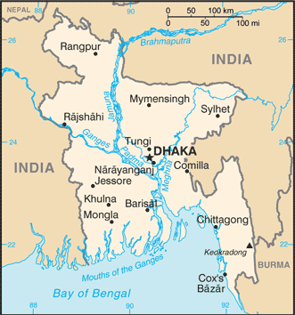
(Map reproduced from: Central Intelligence Agency, 'Bangladesh' The World Factbook <https://www.cia.gov/library/publications/the-world-factbook/geos/bg.html>)
Bangladesh has six tiers of government as shown in the diagram below.

- Common Tenure Types
  - Tenure types
    - What are the key pieces of legislation governing housing, land, building and planning? Please provide links to copies of the legislation.
The key pieces of legislation governing housing, land, building and planning include:
- the Transfer of Property Act 1882 which governs the transfer of private interests in land;
- the Registration Act 1908 which governs registration of private interests in land;
- the Land Reforms Ordinance of 1984 which establishes a land ceiling, governs the distribution of Government land (khas) to the landless and regulates sharecropping agreements; and
- the Khas Land Settlement Policy which also regulates the distribution of Government (khas) land to the landless.
    - What types of tenure exist?
The table below summarises the main forms of tenure in Bangladesh. It is important to understand that the types of tenure in the table below may co-exist so that there are several layers of tenure in relation to one parcel of land. For example, a person who has common law freehold may enter into a 2-year lease with a tenant, who may in turn lease a room to a sub-tenant.
Tenure type | Description
Common Law Freehold | Exclusive ownership of land for an indefinite period. Under Bangladeshi law, no private individual is entitled to own more than 20 acres of agricultural land.
Permanent lease / Khas lease | The right to use a plot of government land ranging between one and three acres for a period of 99-years at no cost. Rights to use khas are granted by the Ministry of Lands to landless persons (ie, persons without common law freehold). This type of tenure is often referred to as a 'permanent lease'.
Leasehold | The right to use land or housing owned by another for a fixed period in exchange for payment of rent, often referred to as a cash lease. Leases of more than one year must be registered. Leases of one year or less do not need to be in writing.
Sharecropping agreement | The sharecropper and landowner each receive one-third of the crop, and the remaining third is allocated based on their contribution to the costs of growing the crops. Sharecropper contracts must be for a minimum of five years and are heritable.
Customary ownership | In the Chittagong Hill Tracts official government institutions and customary institutions share authority over property law. In practice, however, customary law is practiced and government institutions rarely intervene.
Co-operative ownership | Where a person uses land and housing as a member of a registered co-cooperative society which owns the land.
Tied tenancy | Where a person occupies residential accommodation in their capacity as an employee of a government agency or private organisation, or as a labourer on agricultural land.
Bed or room rental | Where a person rooms a bed or room, usually on a short-term basis. Bed rental is often referred to as 'mess housing'.
Informal tenure types | There are many types of informal tenure, meaning tenure which does not comply with registration requirements. This includes the following.  - leasing without a registered lease — a person who has a verbal agreement to occupy land or housing in exchange for payment of rent for more than one year, or from year to year.  - owning land which has not been correctly registered — a person owns land in circumstances but the land is not properly registered. For example, the transfer of the land to the current owner was not registered, or the current owner owns part of a subdivided block and the subdivision has not been registered.
Squatting | Squatting refers to living on land which is not one's own, whether public or private, without any right or permissions to do so. There are at least two forms of squatting:  - squatting on land and living in self-constructed housing or shelter; or  - squatting on land by renting housing unlawfully constructed on the land by another person.
    - Which, if any, of these types of tenure provide a high degree of security of tenure?
The most secure forms of tenure are common law freehold, registered leases and 99-year leases of Government land (khas). However, even persons with these types of tenure may face difficulty maintaining and proving their tenure. As discussed in greater detail in section 2.2 below, landgrabbing is widespread in Bangladesh and poses a threat to persons with all types of tenure. Further, serious problems with Bangladesh's land registration process means that land record certificates (khatians) cannot be relied on as conclusive proof of ownership or rights.
    - How does tenure differ between urban and rural areas? If possible, please provide statistics about the prevalence of each type of tenure in urban and rural areas.
Detailed statistics about the prevalence of each type of tenure in urban and rural areas are not available. However, it is possible to generalise that rural residents are more likely to have the more secure types of tenure: common law freehold, permanent freehold (khas) or leasehold tenure.
The majority of urban residents access land through informal conveyancing or oral agreements. Slum settlements are highly prevalent in all urban areas and are characterised by less secure tenure arrangements created through informal conveyancing or oral agreements, such as room and bed rental, and squatting.
    - What are the main government and non-government bodies (eg, representative bodies) which administer or deal with housing, land and property?
The main government department responsible for land administration is the Ministry of Lands, which has the following divisions.
- The Directorate of Land Record & Survey is responsible for conducting surveys of land and producing individual land record certificates (khatian) and maps (mouza) for each plot of land.
- The Land Reform Board is responsible for administering Government land (ie, khas), setting and collecting the Land Development Tax, implementing land reform legislation, and preparing updated land record certificates (khatians) and maps (mouza) in between surveys. The Land Reform Board operates through upazila Land Offices and Union Council tehsil offices.
- The Land Appeal Board is responsible for determining appeals against the decisions of government officials in relation to land issues, namely land taxes, and the ownership and boundaries of land as recorded in land record certificates (khatians) and maps (mouza).
In addition to the above, the Department of Land Registration is responsible for registering changes to land ownership arising from sales or other transfers of land, reporting changes to the Ministry of Lands and collecting the Immovable Property Transfer Tax. The Department of Land Registration sits within the Ministry of Law, Justice and Parliamentary Affairs. It operates through District Registrars at district level, and Sub-Registrars at upazila (sub-district) level.
The following government departments or agencies are involved in housing and planning law and policy.
- The National Housing Authority is responsible for implementing the national Government's housing policies and is, therefore, involved in developing and providing public housing, and implementing slum resettlement projects.
- The Urban Development Directorate is the national agency responsible for administering planning law and policy, however several cities have their own planning agencies as follows:
  - Capital Development Authority (Rajdhani Unnayan Kartripakkha or RAJUK in Bengali) for the nation's capital Dhaka;
  - Chittagong Development Authority;
  - Khulna Development Authority; and
  - Rajshahi Town Development Authority.
Planning agencies may be also be involved in housing development and slum resettlement projects.
  - Documenting Tenure
    - What statutory instruments or legal documents (eg, title deed or leases) are used to create or transfer tenure?
    - What non-legal documents or actions (eg, verbal agreements or handshakes) are used to create or transfer tenure?
Under Bangladeshi law, the following types of transactions are required to be registered: leases for more than one year, or from year to year; transactions relating to common law freehold, such as transfers or subdivisions; and the grant of 99-year leases of Government land (khas). It is possible for the Government to exempt leases of 5-years or less from the requirement of registration by publishing an order in the official Gazette. However, we are not aware of any orders to this effect.
In practice, informal conveyancing is extremely common because there are major problems with Bangladesh's land registration process. We use the term 'informal conveyancing' to refer to transactions which do not adhere to registration requirements. The World Bank rates Bangladesh 186th of 190 countries in terms of the ease, efficiency and quality of its land registration processes. The deficiencies in Bangladesh' land registration process are as follows:
- Land registration is a complex, lengthy and expensive process. For example, in Dhaka registering a transfer of freehold land will take approximately 245 days, require a payment of 10% of the purchase price and involve 8 different procedures. These procedures are generally too difficult for lay people to follow without legal assistance, and too expensive for the urban poor. The cost of land registration is exacerbated by government corruption, which means it can be necessary to pay bribes in order to have transactions registered.
- The accuracy of land record certificates (khatian) and maps (mouza) is undermined by the fact that several government agencies are involved in the land registration process and there is poor coordination between them. Ownership rights are recorded in three different offices:
  - the Directorate of Land Record & Survey (DLRS) is responsible for conducting surveys of land, including preparing individual land record certificates (khatian) and maps (mouza);
  - the Department of Land Registration (DLR) is responsible for registering land transfers and reporting these to the Land Reform Board; and
  - the Land Reform Board (LRB) is responsible for manually preparing updated land record certificates (khatian) and maps (mouza).
Delays in communication between the DLR and LRB mean that records held by the LRB may not be up-to-date. Further, this system products duplicate and potentially inconsistent land record certificates (khatian) and maps (mouza). The khatians held by the DLRS, which are updated following transfers of land, may be different to the khatians held by the LRB, which are prepared following land surveys.
- Due to poor coordination between government agencies, a land record certificate (khatian) issued by either DLRS or the LRB cannot be relied on as conclusive proof of ownership. If a person wishes to conclusively prove ownership of common law freehold, they may require copies of both khatians (ie, from the DLRS and LRB) and the deeds or other documents used to transfer the land.
- The land registration system has been partially digitalised, however many records are still held in hard copy and updated manually. For example, updated khatians prepared by the Upazila office of the LRB are prepared manually. Hard copy khatians maintained by the LRB are often worn out and indecipherable due to damage from humidity and insects.
- There is a widespread phenomenon known as 'landgrabbing', whereby private individuals or entities 'grab' land from its rightful owner by forging land registration documents, often with the assistance of corrupt government officials who accept bribes. The prevalence of this type of fraud further undermines the value of khatians as proof of land ownership.
Due to the above problems, the land registration process has 'no meaning or relevance to the majority of the urban poor'. Instead, the majority of urban residents in Bangladesh access tenure via informal conveyancing or oral agreements. Oral lease agreements pose no legal issue, provided their duration is one year or less. However, documents which are required to be registered but are not registered are legally ineffective and, therefore, unenforceable.
  - Customary Ownership
Indigenous people comprise approximately 1.2% of Bangladesh's population and comprise two main geographical groups: plains dwellers and hills communities. The hills communities live predominantly in the Chittagong Hill Tracts Region (CHT Region), while the plains dwellers are predominantly located in the north, north-west and north-east of the country.
The CHT region has a separate legal and administrative regime which blends customary and formal law. Although Government institutions maintain concurrent jurisdiction, they rarely exercise this power. Therefore, land use and ownership is governed by customary law.
There are groups of plains dwellers who continue to follow customary principles of land use and ownership. However, outside the CHT Region, the formal law applies and customary law is not legally recognised.
  - Informal Settlements
    - What are the locations and boundaries of informal settlements?
    - What kinds of tenure arrangements are in place in informal settlements?
Research and mapping activities in Bangladesh generally focus on the broad category of 'slums' (bastees), which refers to a settlement which features most (but not necessarily all) of the following characteristics:
- predominantly very poor quality housing;
- very high population density and room crowding;
- poor environmental services, especially water and sanitation;
- low socio-economic status; and
- lack of security of tenure.
Slums are commonplace throughout Bangladesh, and are particularly prevalent in urban areas. In all major urban centres, a significant proportion of the total population lives in slums, as follows:
- 37 per cent in the Dhaka Metropolitan Area;
- 35 per cent in Chittagong;
- 19.5 per cent in Khulna;
- 32 per cent in Rajshahi;
- 27.4 per cent in Sylhet; and
- 30.1 per cent in Barisal.
In 2005, the Centre for Urban Studies, MEASURE Evaluation and the National Institute of Population Research and Training comprehensively mapped slums in the above six urban centres and produced a 'slum map' for each city. We refer to this as the 2005 Slum Mapping Study. These maps are reproduced in Schedules 1 to 6 to this memorandum. Unfortunately, more recent maps are not available.
There are many different forms of tenure present in slums, including the following:
- owning registered land;
- renting land and/or housing under a written contract;
- renting land and/or housing under a verbal agreement;
- renting a room or bed under a verbal agreement;
- owning subdivided but unregistered land;
- renting land and/or housing on subdivided but unregistered land;
- squatting on land and living in self-constructed housing;
- squatting on land by renting housing unlawfully constructed on the land by another person;
- street dwelling (ie, homelessness).
It is important to note that the above types of tenure vary in the degree of security which they provide. The first two types of tenure are reasonably secure, while most of the remaining types of tenure lack security. The degree of tenure security always depends on the specific circumstances involved, such as the nature of relationships with the landowner or landlord.
- Security of Tenure of Vulnerable Groups
  - Women
    - Can women legally own, rent or inherit land and housing?
    - In practice, do they? If not, why not?
The Constitution of Bangladesh (the Constitution) provides that all citizens are equal before the law and entitled to the equal protection of the law. In practice, however, women in Bangladesh rarely have formal, legal property rights. A major reason for this is the laws governing inheritance.
Matters of inheritance are governed by religious laws and, therefore, depend on whether the deceased is Muslim or Hindu. Under Hindu inheritance laws, women are only entitled to inherit in exceptional circumstances. Most Bangladeshi women are subject to Muslim laws of inheritance, which provide that:
- daughters of a deceased are entitled to receive half of what the brothers inherit; and
- a widow receives one-eighth of her husband’s property if they have children and one-fourth if they do not.
In practice, women's rights to inherit land under Muslim laws are undermined by cultural customs. For example, the norm that a 'good sister' should surrender her share of inheritance in favour of her brothers.
Women's rights to own and inherit land are also undermined by religious and social norms, including purdah, which is a Hindu and Muslim practice of restricting women's contact with persons outside of her family. Purdah is a barrier to women understanding, acquiring and enforcing property rights, and makes them vulnerable to exploitation by male family members. For example, a man may register land in his sister's name, while depriving her of any use or benefit of the land. This allows him to avoid the land ceiling of 20 acres, and is referred to as a benami transaction.
  - Indigenous Groups
    - Is indigenous customary ownership (or custodianship) of land legally recognised?
As indicated in section 2.3 above, with the exception of the CHT Region, customary ownership of land is not legally recognised.
    - Does customary ownership provide indigenous people with a high degree of security of tenure?
    - If not, what are the barriers to indigenous people owning and/or living on their land?
Customary ownership of land generally does not provide indigenous people with a high degree of security of tenure. There are significant barriers to indigenous people living on their customary land, even in the CHT Region where customary law is observed. The following are two examples from the CHT Region.
- The migration of Bengali settlers from the plains onto customary land has created significant conflict. Bengali settlers often fail to recognise customary ownership of land, and indigenous groups often lack the resources to defend their rights effectively.
- Major infrastructure and commercial projects have caused significant displacement indigenous people. For example, the construction of the Kaptai Dam as part of a hydro-electricity project has submerged 40 per cent of all cultivable land in the CHT Region and displaced over 85,000 people.
  - Minority Groups
    - Can minority groups (ie, ethnic minorities, immigrants, stateless people) legally own and/or rent land and housing?
    - If so, are they subject to special conditions or restrictions?
As stated in section 3.1 above, the Constitution provides that all citizens are equal before the law and entitled to the equal protection of the law. Notwithstanding this Constitutional protection, until 2001, Bangladesh's Hindu, Buddhist and Christian populations were often targeted under the Vested Property Act, which permitted the Government to confiscate property from any individual it designated an 'enemy of the State'. The Hindu minority was heavily targeted under the Vested Property Act, with approximately 45 per cent of the Hindu population affected and 2.6 million acres of property confiscated.
In 2001, the Vested Property Act was repealed and replaced with an act providing a process for affected persons to reclaim their land, the Vested Properties Return Act of 2001. The latter Act has, however, been strongly criticised for inadequately providing for minorities to reclaim confiscated property. The legacy of the Vested Property Act is that large numbers of Bangladeshi citizens belonging to religious minorities, particularly the Hindu minority, have been dispossessed of property.
  - Landless People and Squatters
    - Do landless people/squatters have rights to land and/or housing (eg, adverse possession)? If so, are those rights respected?
      - Adverse possession
The principle of adverse possession does exist under Bangladeshi law. A squatter will acquire rights to land if the rightful owner does not bring proceedings to evict them within 12 years of the date on which they began squatting on the land. In practice, however, squatters may not have sufficient resources to successfully invoke this legal principle.
      - Distribution of khas to the landless
Bangladeshi law provides for a land ceiling of 20 acres of agricultural land per person, and for the distribution of Government land (khas) to the landless. Government land includes land formerly held by private individuals which exceeded the land ceiling.
There are several barriers to the landless obtaining permanent leases of khas (ie, 99-year leases), including that the application process is lengthy and complex, and corruption within the Ministry of Lands means that bribes may be required for an application to be successful.
Notwithstanding the formal system for redistributing land, land distribution is extremely inequitable. Approximately 52 per cent of the rural population (which accounts for almost 75 per cent of the nation's population) is landless or nearly landless (ie, holding a negligible amount of land).
- Eviction, Expropriation and Relocation
  - Eviction
    - Are there laws or regulations prohibiting forced evictions?
    - In practice, are those laws adhered to?
Forced evictions of squatters occur throughout Bangladesh. The 2005 Slum Mapping Study found that, of the 9,048 slums surveyed, 6.5 per cent had experienced one or more evictions in their present location, or were currently under threat from eviction.
The Study found, however, that evictions are not very common in slums located on private land and run on a commercial basis (ie, where the residents pay rent to a private landowner for beds, rooms or housing). Evictions are a greater threat to slums located on public land.
The Government is entitled to evict persons squatting on its land, provided that it gives such persons 30 days' notice. This notice period may be reduced to 7 days if the Government is satisfied that the full 30-day notice period would not be in the public interest. There is anecdotal evidence that, in practice, this notice requirement is not always complied with.
The High Court of Bangladesh has delivered several important judgments in relation to the rights of slum dwellers in relation to forced eviction. These judgments establish that forced eviction without alternative housing or resettlement plans is unlawful. In practice, successive Governments have failed to adhere to the High Court's rulings by carrying out evictions without providing alternative housing to evictees, or by failing to properly implement resettlement plans.
  - Expropriation
    - Are there laws or regulations permitting the government to expropriate land?
Article 42 of the Constitution permits the Government to expropriate the land if permitted by a law and if due compensation is paid to the registered owner. Given the high rates of unregistered landholdings, land is often seized without compensation.
The main instrument for the compulsory acquisition of land for public purposes is the Land Acquisition and Requisition Act of Immovable Property Ordinance of 1982. The Government may acquire property that 'is needed or likely to be needed for any public purpose or the public interest'. Property used for religious or burial or cremation purposes may not be acquired.
The Ordinance sets out a process for publishing notices of land to be acquired, accepting objections to this acquisition over the following 15 days, considering objections to the acquisition, the making of reports, and a final decision on the acquisition by the Government or Deputy Commissioner. Where a decision is made by the Government or Deputy Commissioner in relation to the acquisition of land, that decision is conclusive evidence that the property is needed for a public purpose or in the public interest.
The Government is required to pay 'market value' compensation for acquired land and take a range of factors into consideration. However, compensation is only paid to persons listed as the owners in the land administration records. Further, while compensation is supposed to be at 'market value', the legal assessment processes are reported to almost always result in much lower prices and do not compensate for loss of income from land.
Finally, there are concerns that promised payments as a result of these seizures rarely eventuate. The Government's title in the property vests upon the payment, or deemed payment, of the relevant compensation. There is also no resettlement policy or law to assist people who are affected by land acquisition processes.
    - If so, are those laws or regulations applicable in the context of a disaster?
Given the notice provisions, decision making process and the number of objections that can be raised, the Land Acquisition and Requisition Act of Immovable Property Ordinance of 1982 appears unsuited to immediate use following a disaster.

Schedule 1
Source: Nazrul Islam et al, above n 7, 23
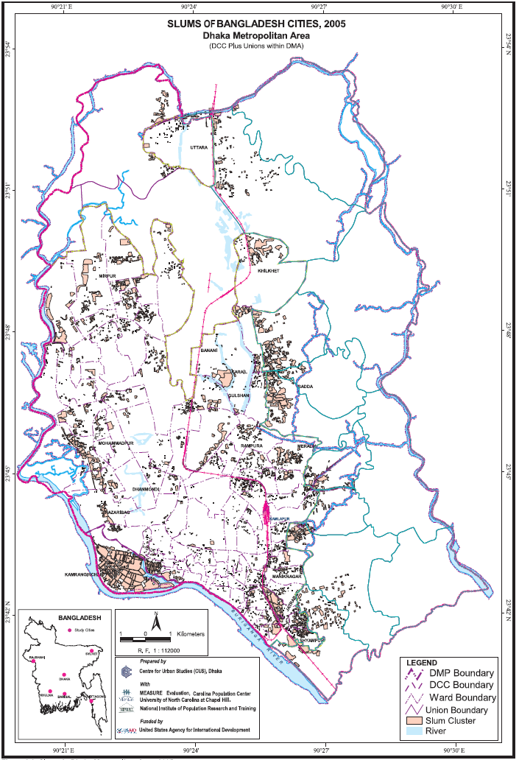
Source: Nazrul Islam et al, above n 7, 25
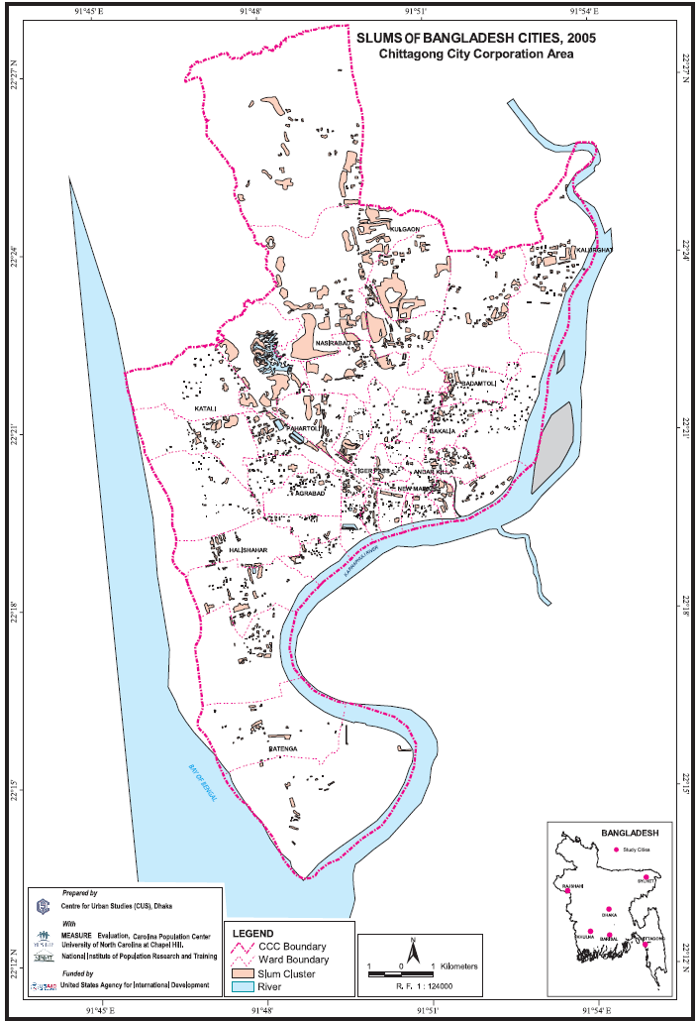

Source: Nazrul Islam et al, above n 7, 27
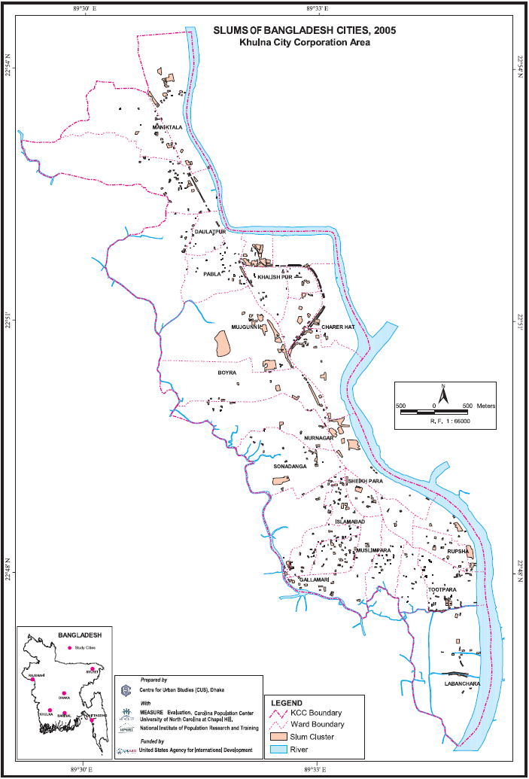

Source: Nazrul Islam et al, above n 7, 29
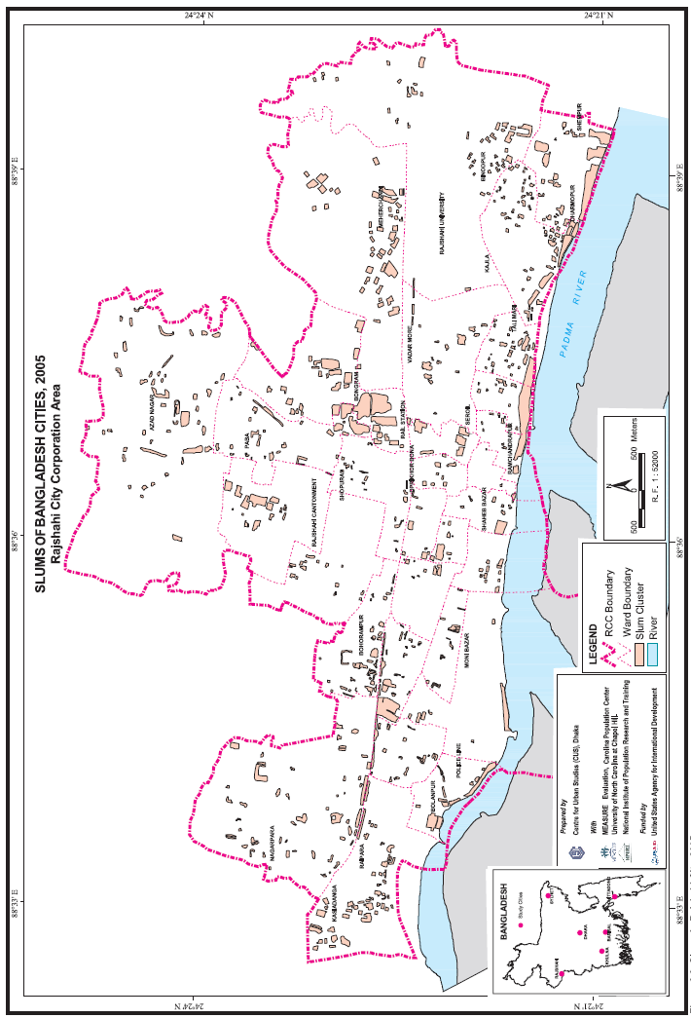

Source: Nazrul Islam et al, above n 7, 31
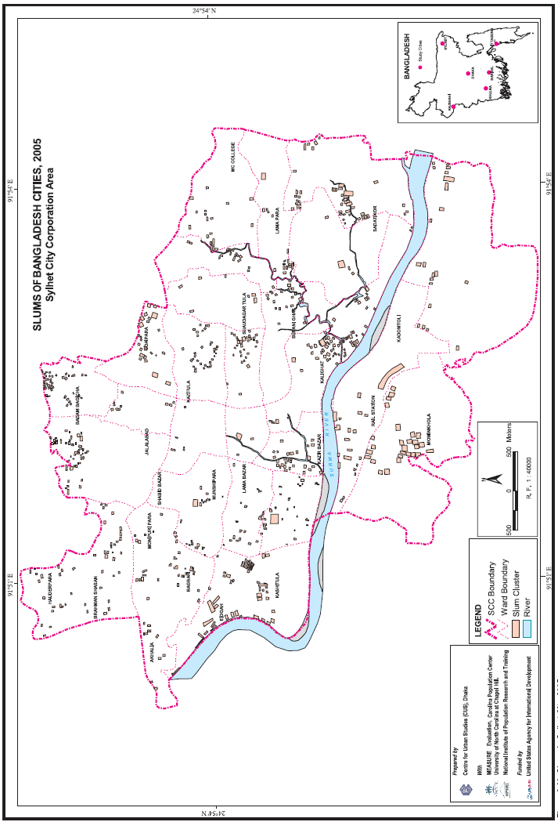

Source: Nazrul Islam et al, above n 7, 33
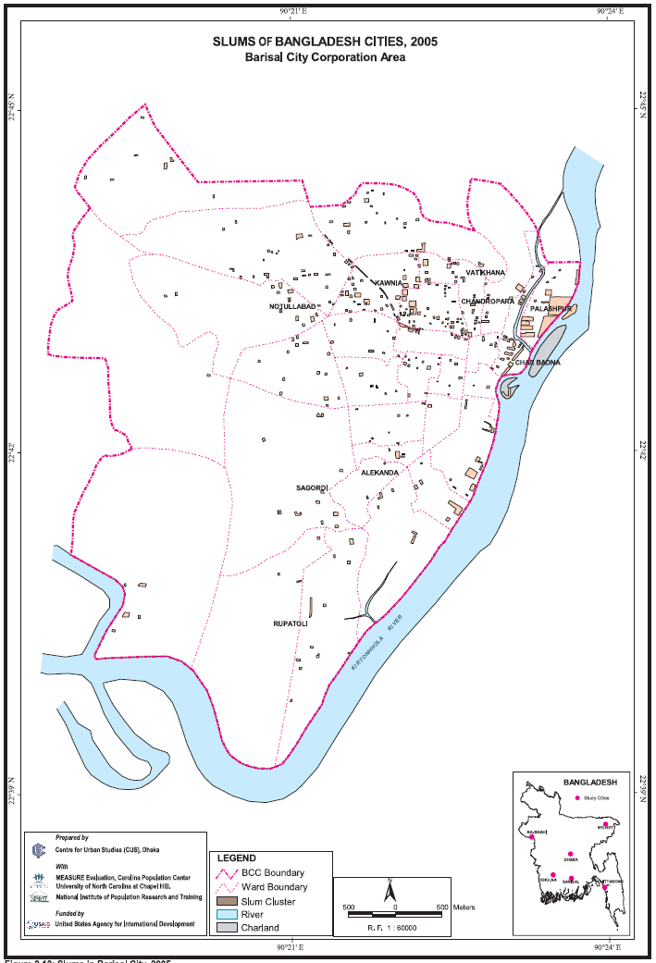

International Land Coalition, 'National Engagement Strategy: Promoting People Centred Land Governance – Bangladesh's(2012) <http://www.landcoalition.org/sites/default/files/documents/resources/nes_report_4_bangladesh_web_en.pdf> 12.
Central Intelligence Agency, 'Bangladesh' The World Factbook <https://www.cia.gov/library/publications/the-world-factbook/geos/bg.html>.
Ibid.
The information in this table originates from the following resources: Salma Shafi, Geoffrey Payne and Geoffrey Payne and Associates, Land Tenure Security and Land Administration in Bangladesh – Final Report (June 2007) <http://newgpa.org.uk/wp-content/uploads/2014/03/landtenuresec.pdf>; USAID, Property Rights and Resource Governance – Bangladesh <https://www.land-links.org/wp-content/uploads/2016/09/USAID_Land_Tenure_Bangladesh_Profile.pdf>; LANDac, Food Security and Land Governance Factsheet: Bangladesh (2016) Land Governance for Equitable and Sustainable Development <http://www.landgovernance.org/assets/2014/09/Bangladesh-Factsheet-20121.pdf>.
Land Reforms Ordinance of 1984, s 4.
USAID, above n 2, 6.
Nazrul Islam et al, 'Slums of Urban Bangladesh: Mapping and Census, 2005' (Centre for Urban Studies, MEASURE Evaluation and National Institute of Population Research and Training; May 2006) available from <https://www.measureevaluation.org/resources/publications/tr-06-35> 20; Salma Shafi et al, above n 4, vi.
Ibid.
LANDac, above n 4, 5-6; Salma Shafi et al, above n 4, 3-4. See also Kasphia Nahrin and M. Shafiq-Ur Rahman, 'Land Information System (LIS) for Land Administration and Management in Bangladesh' (2009) 2 Journal of Bangladesh Institute of Planners 116 <http://ndc.gov.bd/lib_mgmt/webroot/earticle/1906/Land_Administration_and_Management_in_Bangladesh.pdf>; Monzur Hossain, 'Improving Land Administration and Management in Bangladesh' (Report prepared for the General Economics Division of the Planning Commission, Bangladesh; 14 January 2015) <http://www.plancomm.gov.bd/wp-content/uploads/2015/02/4_Improving-Land-Administration-and-Mangement.pdf> 20.
Ibid.
International Land Coalition, above n 1.
KH MD Nahiduzzaman, 'Housing the Urban Poor: An Integrated Governance Perspective' — The Case of Dhaka, Bangladesh' (Doctoral Thesis, Royal Institute of Technology in Stockholm, 2012) 88-89.
Ibid.
Salma Shafi et al, above n 4, 4; Registration Act 1908 s 17(1)(d).
Registration Act 1908 s 17A.
Ibid s17.
The World Bank, Ease of doing business in Bangladesh (2016) <http://www.doingbusiness.org/data/exploreeconomies/bangladesh#registering-property>.
USAID, above n 4, 6.
Salma Shafi et al, above n 4, vii.
Nahrin and Shafiq-Ur Rahman, above n 9, 118.
Monzur Hossain, above n 9, 22-23.
Ibid.
LANDac, above n 4, 6; Monzur Hossain, above n 9, 22-23.
News from Bangladesh, 'Digitalizing Land Registration in Bangladesh' (4 November 2010) reproduced at <http://www.unpan.org/PublicAdministrationNews/tabid/115/mctl/ArticleView/ModuleID/1467/articleId/23326/Default.aspx>.
USAID, above n 4, 6; LANDac, above n 4, 6.
Salma Shafi et al, above n 4, 4.
Registration Act 1908 s 17(1)(d).
Osman Goni, 'Registration Law in Bangladesh' <https://osmangoni.com/registration-law-bangladesh/> citing Registration Act 1908 s 49 and Pabitra Ranjan Roy vs Proshanta Talukdar 14 MLR (2009) 69.
International Land Coalition, above n 1, 22.
USAID, above n 4.
Raja Devashi Roy, Traditional Customary Laws and Indigenous Peoples in Asia (2005) Minority Rights Group International <http://www.refworld.org/pdfid/469cbfb70.pdf>.
Nazrul Islam et al, above n 7, 14.
Ibid 20.
Ibid.
Salma Shafi, Geoffrey Payne and Geoffrey Payne and Associates, above n 3, vi-vii.
Ibid.
USAID, above n 4; Sultana Kamal, Law for Muslim Women in Bangladesh (September 1988) Women Living Under Muslim Laws <http://www.wluml.org/node/248 >; see also the Muslim Family Law Ordinance of 1961.
International Land Coalition, above n 1, 24; A M J Arens, Women, land and power in Bangladesh: Jhagrapur revisited (2011) University of Amsterdam < https://pure.uva.nl/ws/files/1321666/92159_14.pdf >.
Ibid.
Ibid.
Ibid.
USAID, above n 4, 8.
Ibid 5.
International Land Coalition, above n 1, 23.
Abul Barkat, Deprivation of Hindu Minority in Bangladesh: Living with Vested Property (Pathak Shamabesh, Dhaka, 2008) 2.
International Land Coalition, above n 1, 23.
See, eg, Upal Aditya Oikya, 'The Vested Property Repeal (Return) Act 2001, A Road to Solution or the Perpetuation of Deprivation of the Hindu Minorities in Bangladesh' South Asia Journal (8 February 2017) <http://southasiajournal.net/the-vested-property-repeal-return-act-2001-a-road-to-solution-or-the-perpetuation-of-deprivation-of-the-hindu-minorities-in-bangladesh/>.
Limitation Act 1908 s 28; Item 44 of the First Schedule to the Limitation Act 1908.
USAID, above n 4, 6.
Nazrul Islam et al, above n 7, 20.
The Government and Local Authority Land and Buildings (Recovery of Possession) Ordinance 1970 s 5(1).
Ibid.
Mohamed Abdul Mohit, 'Bastee Settlements of Dhaka City, Bangladesh: A Review of Policy Approaches and Challenges Ahead' Procedia – Social and Behavioural Sciences 26 (2012) 611, 615; Azm Anas, 'After a Painful Eviction, Bangladesh Slum Dwellers Start Over with a 990Year Lease' Citiscope (13 november 2015) <http://citiscope.org/story/2015/after-painful-eviction-bangladesh-slum-dwellers-start-over-99-year-lease>.
Iain Byrne and Sara Hossain, 'South Asia' in Malcolm Langford (ed) Social Rights Jurisproudence: Emerging Trends in International and Comparative Law (Cambridge University Press, 2008) 139-140 citing ASK v Government of Bangladesh 19 BLD (1999) 488 and Aleya Begum v Bangladesh & Others 53 DLR (2001) 63.
Ibid.
Mahbub Alam Talukder, Land Acquisition Policy in Bangladesh: A Case Study on the Land Acquisition Activities of Tangail District, LLM Thesis, BRAC University, 2006 <http://dspace.bracu.ac.bd/jspui/bitstream/10361/268/1/Land%20Acquisition%20Policy.PDF>.
Land Acquisition and Requisition Act of Immovable Property Ordinance, 1982, s 3.
Ibid.
Ibid, s 5(2).
Ibid, s 8.
USAID, above n 4, 8.
Dhaka Water and Sanitation Authority, Dhaka Water Supply and Sanitation Project: Resettlement Policy (2008) <http://documents.worldbank.org/curated/en/869151468003909535/pdf/RP69500VOL1010BOX0327393B.pdf>, 3.
LANDac, above n 4.
Land Acquisition and Requisition Act of Immovable Property Ordinance, 1982, s 11.
Ibid.

