IOM Cox’s Bazaar (CXB) Mission
ANNEX IV
AID IS FREE – Sign for Cash for Work Payments
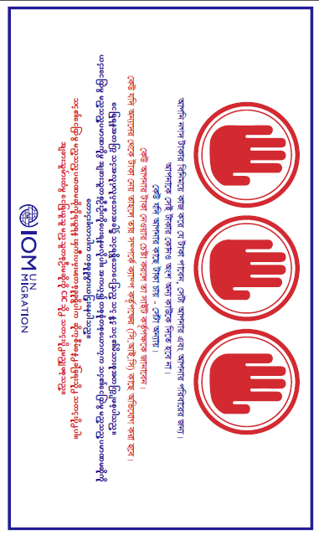
Sign for CFW payments in Burmese and in Bengali

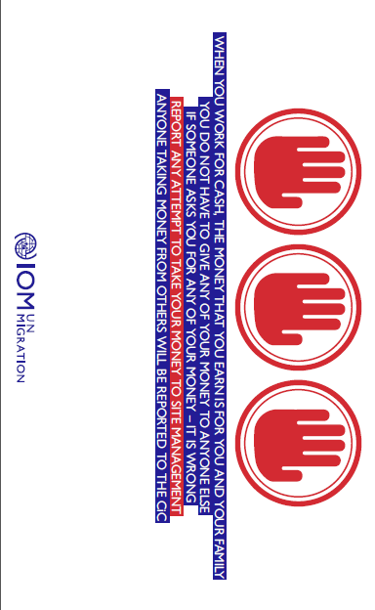
Sign for CFW in English version for reference

