Cabo Delgado Standard Operating Procedures on
Survival Kits
DRAFT

Introduction

A survival kit is a collection of essential, multi-sectoral life-saving items that improve people’s ability to survive in deep field locations where they are cut off from access to basic items. These populations are often on the move, hiding or unable to move due to insecurity, the rainy season or lack of resources to reach quicker a safer location. Typically, there is a small window of access to the population. Humanitarian partners must make a strong case for requesting survival kits, as it is a last resort. Additionally, there are times when the Inter-Cluster Coordination Group (ICCG) makes the collective decision to send survival kits to a given location.
The ICCG also decide on the items that comprise the survival kits, based on consultations with communities, assessments (rapid or detailed) or international humanitarian standards. A survival kits might include any combination of critical loose items from various clusters, primarily food security and livelihoods (FSL), health, shelter and non-food items (Shelter), nutrition, and water, sanitation and hygiene (WASH).
Survival kits will be previously assembled in a warehouse designated by the Logistics Working Group(LWG)(following an agreed packaging format), where all items from different cluster’s pipelines will be delivered. The LWG will ensure the transportation of the assembled kits to the targeted locations, in close coordination with distribution teams.
Regardless of the chosen kit items, the weight should not exceed 20kgs, and the recommended items to be included are:
Survival kit
Cluster/AoR | N | Item | Unit | Weight (kg) | Volume (m3) | Qty per HH size
 |  |  |  |  |  | 1-5 pers/HH | 5-10 pers/HH | 10-15 pers/HH
Shelter Cluster | 1 | Plastic sheet (4x6m) | unit | 5 | 0,015 | 1 | 2 | 3
Shelter Cluster | 2 | Solar lamp | unit | 0,24 | 0,00053 | 1 | 2 | 3
Shelter Cluster | 3 | Kitchen set (adapted) | unit | 3 | 0,012 | 1 | 2 | 3
Shelter Cluster | 4 | Bag | unit | 0,5 | 0,019 | 1 | 2 | 3
Shelter Cluster | 5 | IEC Shelter | kit |  |  | 1 | 1 | 1
Health Cluster | 6 | Mosquito nets | unit |  |  | 1 | 2 | 3
Health Cluster | 7 | Face masks | unit |  |  | 5 | 10 | 15
WASH Cluster | 8 | Bucket | unit |  |  | 1 | 2 | 3
WASH Cluster | 9 | Collapsible Jerrycan | unit |  |  | 1 | 2 | 3
WASH Cluster | 10 | Soap bar | piece |  |  | 4 | 8 | 12
WASH Cluster | 11 | Certeza | unit |  |  | 1 | 2 | 3
WASH Cluster | 12 | Capulanas | unit |  |  | 1 | 2 | 4
WASH Cluster | 13 | Sanitary pads (2x3 reusable/ 2x10 disposable) | set |  |  | 1 | 2 | 3
WASH Cluster | 14 | Underwear (cotton S-L) | piece |  |  | 2 | 4 | 6
PSEA AoR | 15 | IEC PSEA | kit |  |  | 1 | 1 | 1
FSL Cluster | 16 | High Energy Biscuits (pack 100gr) | kg |  |  | 4,5 | 9 | 13,5
Nutrition Cluster | 17

All kits need to be packed before transportation.
All items except the bucket should be included in the bag, so buckets would be stock-pilled during the transportation.
See below a sample for packing and transportation considerations:
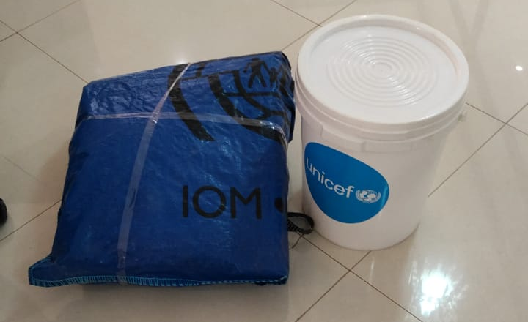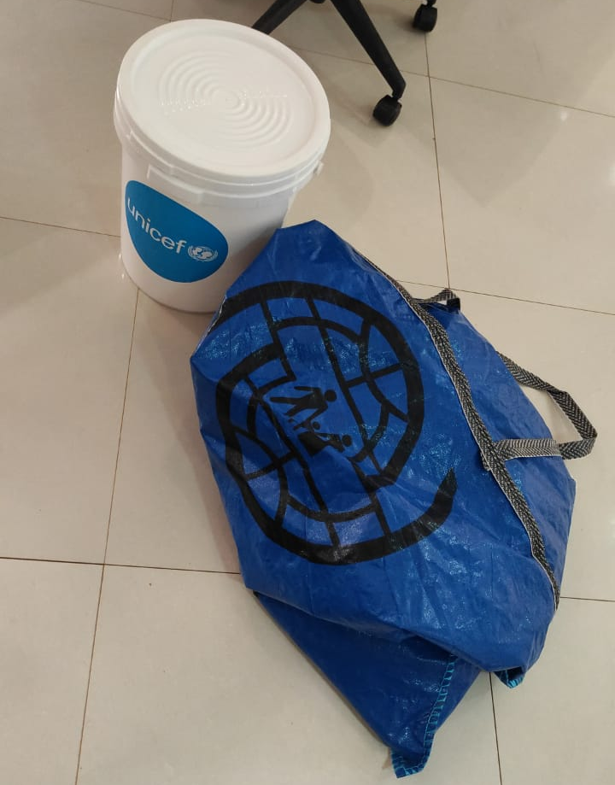
This kit was prepared with items currently available (1 plastic sheet, 1 mosquito net, 1 bucket, 1 jerry-can, 4 soap bars, 1 bottle of Certeza, 1 capulana, 1 set of sanitary pads, 2 pieces of underwear), with a total weight of 9,2 kg and volume of 70x50x30 cm.

Deciding on Survival kit

Survival kits modality is a LAST RESORT response. Under extreme circumstances, clusters will allow its partners to employ the survival kit modality. Cluster endorsement includes a combination of the majority of the following circumstances:
- In extremely volatile areas where access is limited to under one week, with very little chance of a second visit.
NOTE: If a population is accessible more than once, or longer than a week, the multi-sectoral team must do an assessment first. If a stakeholder requests a survival kits distribution, the ICCG will analyse the situation, and decide to support or not;
- When vulnerable people will not become targets or looted after a survival kits distribution;
- Ensure that distribution will not cause unrest in the community because the number of supplies does not cover the entire caseload; and
- When the ICCG collective resolution is to respond with the Survival kits modality.

How to Access Survival kits?

Survival kits operations are a coordinated effort amongst all concerned clusters ie. the Shelter, Health, FSL, WASH, and Protection clusters, including the Logistics working group, represented by the respective cluster lead agencies.
The Shelter Cluster acts as an overall focal point for this operational modality, facilitating coordination between all agencies. Partners that are interested in participating in survival kits operations submit their pipeline request items to the Shelter, WASH, Health, Nutrition and FSL Clusters through each cluster’s item request process.
The Logistics Working Group team coordinates the logistics of items with all clusters. Cargo is delivered from Pemba, which serve as the logistics hub for prepositioning and transport by the Logistics Working Group to the field locations.
The Shelter Cluster requires a distribution report within a maximum of two weeks of the distribution, that will be shared with all involved clusters.

Survival kits distribution planning
Once it is confirmed that:
- Movement of more than 500 persons (or 100 HHs) is reported by the Emergency Tracking Tool (ETT);
- Area cannot be accessed more than once; and
- Area is accessible but not longer than one week.

Thereafter, follow the planning steps listed below:
- Coordinate with the local authorities at district and locality (posto administrativo) level;
- Find trusted community leaders/elders who represent their community, or representatives within the group of IDPs on the move;
- Ask if the community wants to receive anything, knowing the risks;
- If they do want to receive, ask the trusted community leader:
  - Who needs prioritized assistance within the community?
  - Which are the pressing needs of the community (from the predetermined list described in the introduction)?
REMINDER: Even if the team can only visit this population once and must rely on the local authorities’ population figures, the clusters still cannot provide items for the full amount they say exist. Not only are the numbers typically inflated, but also the clusters should not do blanket (100%) distribution for the population. This is a difficult distribution to do as it causes tension, therefore the clusters rely on the humanitarian partners’ expertise to mitigate risk in any way possible. One suggestion is to use any Communication with Community mechanism available (Linha Verde) and existing connections with the community to prepare in advance for lowering expectations and helping building relationships with community members who can back up the team once tensions rise.
  - When is the best time to receive assistance with survival kits?
  - Where do they want to receive the survival kits? Where should the helicopter land or the boat arrive? Collect exact coordinates.
  - Is there anyone else we should notify in our planning?
5. Set up a contingency plan for the operation. Keep in mind the following risks:
- Unrest in a population of people who have been in need for a long time.
- The number of survival kits will be smaller than the amount of people in need.
- Analyse the insecurity situation in the area to know the likelihood of interruptions and relocation.
6. Adequate planning of the distribution, including the transportation of assembled kits and deployment of required people, need to be done in advance in coordination with local authorities.
7. When on the ground and during distribution set up, do not draw attention. Be quick and do not allow anticipation to build for distribution. Be discreet about activities.
8. Pipeline request to be submitted to each cluster for relevant items:
- In the comments section, thoroughly explain why survival kits modality is the only way to respond.
- If circumstances require, the items can be reduced (not all items are available or kits must be “lighter” due to transport/financial or other reasons), choose the highest priority needs.
- Follow the agreed quantity of items per households as much as possible. If any change is required, urgently communicate to ICCG.
- Request items from Shelter, FSL, Health and WASH Clusters simultaneously while keeping all Cluster Coordinators informed so that logistics teams in each sluster can arrange transport to Logistic Working Group designated warehouse efficiently, for further transportation to the targeted location.
8. Implementing partners to submit a distribution report within two weeks of the distribution to each cluster involved.

