BRIEF FOR RECONSTRUCTION AND SHELTER - INCLUSION OF PEOPLE WITH DISABILITIES

Disability Key Messages - Inclusion of people with disability in response to Cyclone Pam
- People with disability and older people may face significant barriers to accessing assistance in the wake of Cyclone Pam.
- In line with International Human Rights Law, the UNCRPD, SPHERE standards, and guidance from IASC clusters, they have the need and right to be included in emergency relief, recovery and longer term development activities, with their specific vulnerabilities and needs taken into account.
- Failure to consider these groups may result in potential exclusion of at least 20% of the affected population.
- Activities should seek to promote a ‘twin track’ approach which ensures that people with disability and older people:
1) access all ‘mainstream’ operations; and
2) are referred to ‘specialist’ services as available, to meet specific needs e.g. needed medical consultations and essential medications, wheelchairs, crutches, white canes, spectacles etc.)

CONTACTS
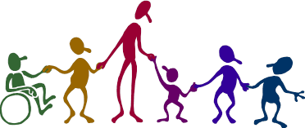
Disability Desk Officer (Sam Kaiapam) | skaiapam@vanuatu.gov.vu
Disability Promotion and Advocacy Association (Nelly Caleb) | dpasanto@vanuatu.com.vu
Vanuatu Society for Disabled People (Ellison Bovu) | vsdp@vanuatu.com.vu
CBM-Nossal Contact Person (Sally Baker) | sm.baker@unimelb.edu.au

LINKS – CBM – Inclusive post-disaster reconstruction : Building back safe and accessible for all
16 minimum requirements for reconstruction: http://www.cbm.org/article/downloads/54741/16-minimum-requirements-for-building-accessible-shelters.pdf
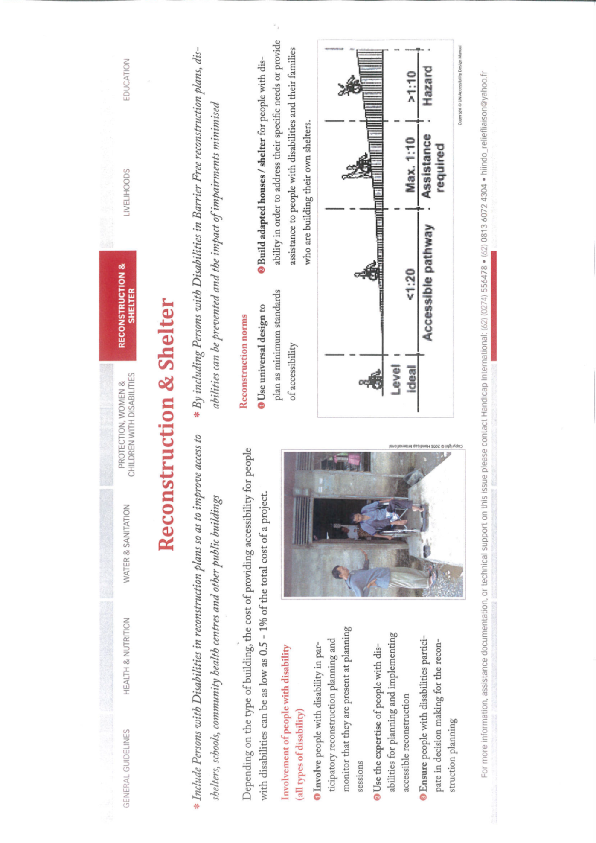
Extract from : Disability Checklist for Emergency Response (Handicap International)

UN Convention on the Rights of Persons with Disabilities, especially article 11. Available from: http://www.un.org/disabilities/

