Plastic sheeting
Make it last longer
Ensure no sharp points damage the plastic sheet.
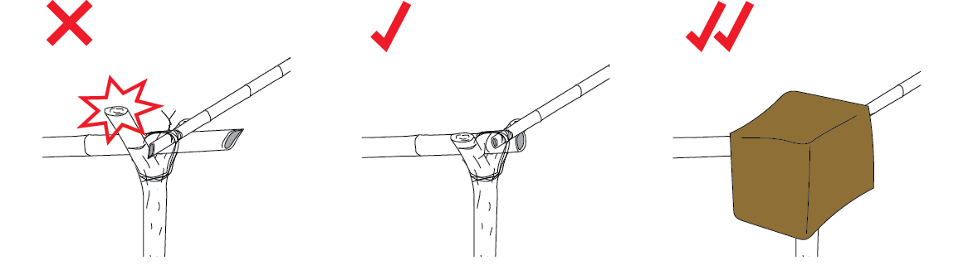
Good
Better
Bad
Use cardboard /other materials between sheet and frame
Protect tent from the sun,
use any materials available
Stop plastic sheet flapping in the wind – It will get damaged
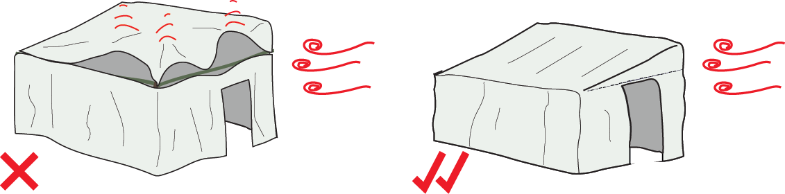
Ways of fixing by using rope
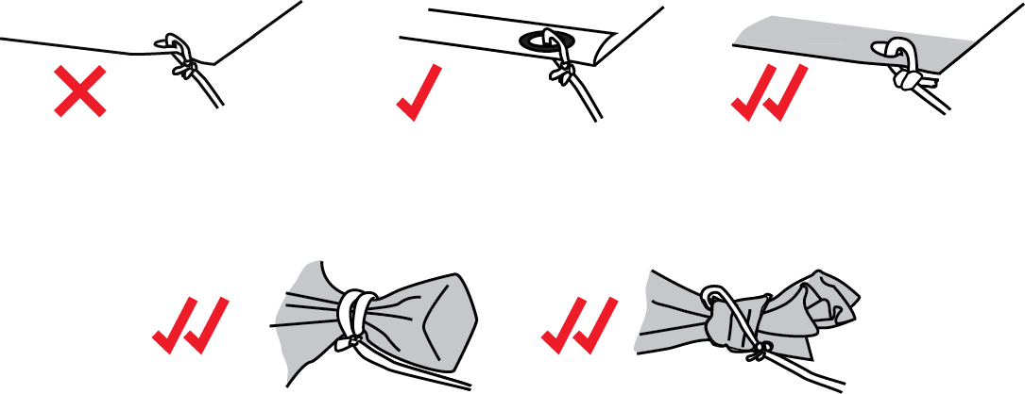
Make Knot with Rope Inside
No Reinforcement
Place Stone Inside
Rope through reinforcement band
Rope through Eyelet
South Sudan March 2013

