Monthly ES/NFI Cluster Meeting Minute
Date: 23rd January 2014
Time: 10:00AM
Attendees
IOM, OCHA, UNICEF, IRC, NRC, GOAL
Agenda
- Review of minute of the previous meeting
- Cluster members ES/NFI related activities update (by members) and IOM presents 3W matrix for December 2014
- Discussion on joint assessment report on Nogob zone of Somali region; findings, resource availability, needs priority
- Standardization working group report
- A.O.B

- Review of minute of the previous meeting

The effects of previous flooding in Leitchor on host communities was agreed to be raised during cluster lead meetings by IOM and OCHA. This need to be followed up on.
- Discussion on ES/NFI support and gap for the Afar flooding

IOM and OCHA initiated and conducted a joint verification assessment on outstanding needs of flood affected communities in Afar. As per the assessment findings 4143 households in zone 1 and 3 were reported to have outstanding NFI needs. After the assessment IOM distributed 1000 kits in Amibara woreda which leaves a gap of 3,143. Thus far following the flooding in September/October 2014, at least 70% of the ES/NFI needs of the region was addressed by various members of the cluster including government.
Action point: The cluster suggested that a further verification should be conducted at least by the agencies based in Afar whether the remaining households returned, recovered or still have the needs.

- Cluster members ES/NFI related activities update (by members) and IOM presents 3W matrix for December 2014
During the month of December ES/NFI distribution among cluster members was very minimal due to the end of year period where in most cases funding ended. A total of 513 kits were distributed by IRC (500) in Gambella and ERC (13) in North wollo.
- Discussion on joint assessment report on Nogob zone of Somali region; findings, resource availability, needs priority

Multi agency assessment that comprised of Somali regional government represented by DPPB, HB WB and EB, UN agencies, INGOs and LNGOs was conducted on 5th-17th of January in Salahad and Lagahida woredas of Nogob zone. The Major causal factor for the crisis situation in the zone as identified by the team was shortage of Gu and Deyr seasonal rain. This has resulted in critical WASH related problems, health risks, school dropout and unusual animal migration. A total 23,646 people (3,941HH) in nine kebeles were reported to have been in a critical situation requiring humanitarian attention. Of this figure 1,525 HH in Salahad and 980 HH in Lagahida were reported to be conflict induced protracted IDPs since 2003, 2009 and 2012.
The team recommended cross sectoral humanitarian assistance, among which was provision of ES/NFI. However. During this cluster meeting participants suggested that Access issues may be preventing full information from coming out – verification needed – as the disaster situation may not affect all in the same way in losing their household kits. Some may need some items but may not all ES/NFI kits are needed.
Action point: IOM to liaise with JigJiga sub office to contact the team and DPPB to find out what justification is for NFI request.
There are outstanding needs of NFI for flood affected remote communities in Gambella particularly in Akobo, Jor, Wanthoa and Jikawo. In this regard, UNICEF is planning to distribute 2000 partial kits in JiKawo and Jor. DPFSA is screening beneficiaries in both woredas. ZOA also identified that there are at least 1390 HH in Akobo and 1296 HH in Wanthoa with critical ES/NFI needs.
Action point: IOM to coordinate Gambella Region NFI cluster meeting ASAP.
- Standardization working group report

The standardization working group that comprise IOM, UNICEF, IRC and ICRC met and monitored IOM’s specification of standard kits.
Sample of kits presented for review by the standardization working group.
SN | List of kits | Specification | Price | Remarks made by the WG
1 | Hessian Bad | 100kg capacity | 8
2 | Mosquito net | Square, WHO standard, impregnated | 92
3 | Soap | washing, laundry, 250g | 6.11
4 | Ladle | Stainless steel, 125ml | 25
5 | Blanket | Wool, 1.60m x 2.20m, 2kg (+/- 5%) | 158.70
6 | Rope | 20m plastic strong | 30
7 | Tarpaulin/plastic sheet | 4x5m, 200g/m2, HDPE inner, LDPE exterior, blue color, UV coated | 290 | If there is a local supplier share the contact
8 | Sleeping mat | 2mx2.5m, plastic woven | 117.39
9 | Jerry can 20 lt | Non collapsible plastic | 120 | It should be non-recycled
10 | Jerry can 10lt | Non collapsible plastic | 29.90 | It should be non-recycled
11 | Cooking pot | 7lt with lid and handles | 189 | Handles should be attached lower from the edge
12 | Drinking cup | Stainless steel 300ml | 16.52 | Preferred locally made, stainless steel, trapezoid shaped without handle
13 | Plate | Round, stainless | 29
14 | Water jug | Stainless steel, 3lt | 119
15 | Washing basin | Aluminum, medium size, round 60cm | 170

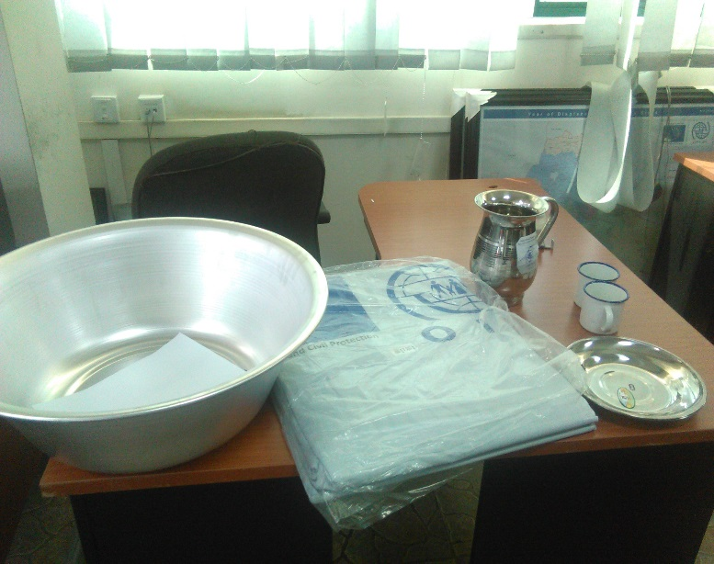
Figure 1 Sample kits

