

Secondary Data Review – 24/May/201
FREEDONIA -
SHELTER & CRISIS OVERVIEW

Current situation
Key figures
- 9 million total population (2005 census) with majority living in capital city of Lauperville (3 million)
Most affected areas due to storm Ralf in Central Mountain Region
- Central Mountain Region prevalence of food insecurity, SGBV, infrastructure (breached dykes), destruction of agriculture and loss of livelihoods
- Interventions needed to prevent additional deaths, avert disease outbreaks, and facilitate coping mechanisms for farmers severely affected by floods

- Complex displacement situation in Freedonia with a mix of IDPs and refugees
- Medium-scale, recent refugee crisis from neighboring Chemalia- initial estimates indicate that it could be as many as 40,000 in the last three months and is likely to increase at the rate of 10,000 every month.
- 15 known IDP camps and likely high numbers of IDPs moving from northern region towards capital city of Lauperville
- Government has strong presence in Lauperville but growing rebel activities in northern region and tribal leadership in central mountain region suggest increasing political challenges and challenges for accessing the populations
- Storms forecasted - areas vulnerable to landslides and flooding require contingency planning
- Possible flood-related displacement towards IDP camps in South East and South West (limited-access areas)

- Areas that could require parallel coordination mechanisms and potential challenges for accessing affected populations: Central Mountains and Northern Regions
  - Northern region is still considered extremely insecure. SPLA maintains
  - Government forces clashing with Sariot People’s Liberation Army (SPLA)
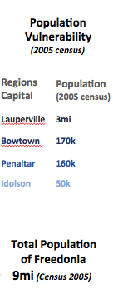
  - Unofficial structures sit side-by-side
  - Government has a comprehensive control of people accessing this area and consider them as hostile and do not negotiate with them
  - These groups exercise control of some areas as well, which hampers the humanitarian access
  - Limited access: Road network provide a limited access to this area – only a secondary road exists, which already limits the flux of people and vehicles access. In case a disaster blocks this access, evacuation/humanitarian aid would be severely compromise

REGIONS OF BEAUTIFUL FREEDONIA | (source: very creative JIPS)

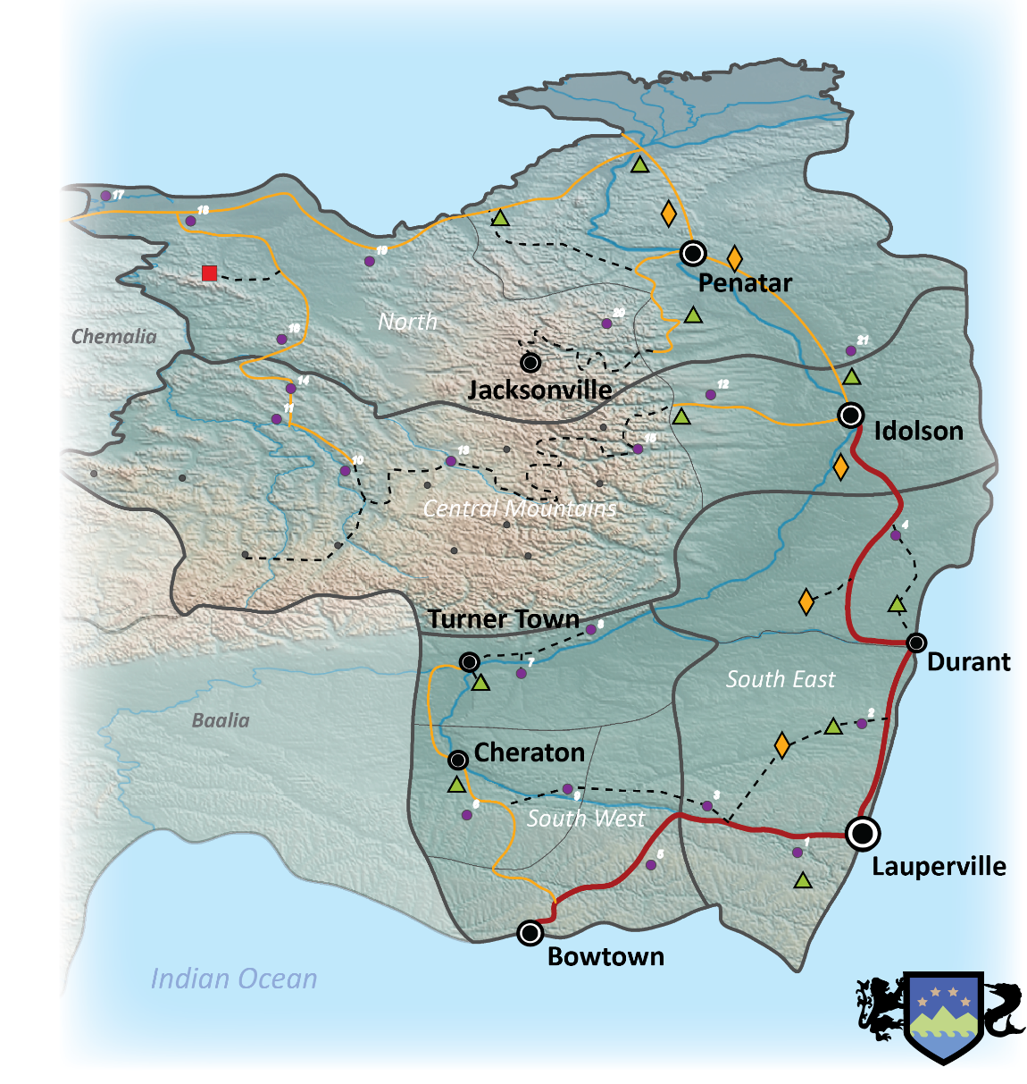

MAP OF AREAS VULNERABLE TO FLOODING AKA THE BEST MAP THAT MONEY CAN BUY | (source: very lazy GIS experts)

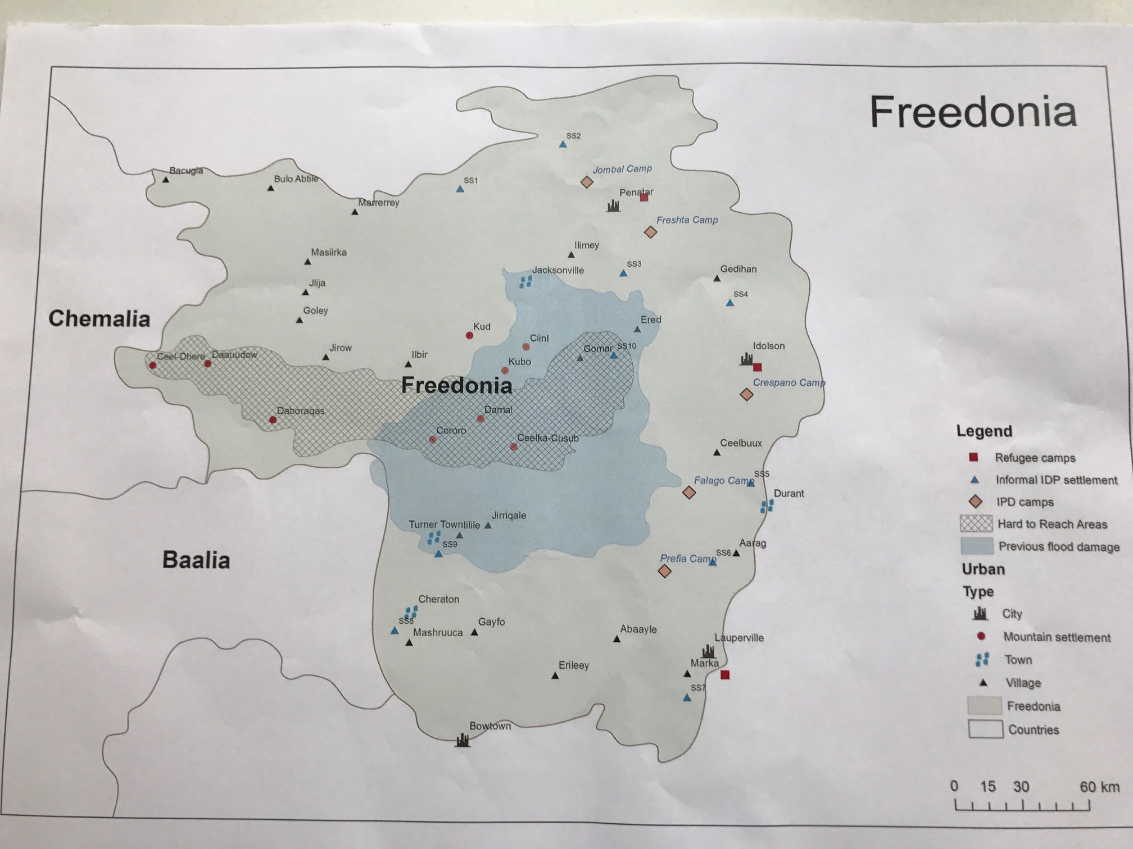

Shelter and NFI

Priority Shelter Concerns

Idolson County:
Hygiene and water kits for 1,890 households and hygiene promotional materials
Assistance for 890 totally and 1000 partially damaged houses
Shelter NFIs for 1,890 households

Turner County:
Shelter family kits for 4000 households

Penatar County:
Hygiene and water kits for 132 families needed
Shelter family kits for 132 families needed

Jacksonville County:
Hygiene and water kits for 1000 families needed
Shelter kits for 1000 families needed

Source: UNDAC-AMD Rapid Needs Assessment in Central Freedonia, date of publication to be confirmed

Information gaps for Shelter and NFI
- West Central County:
  - more information needed on WASH issues and shelter damage in remote mountain settlements
  - Mapping of informal IDP settlements needed
- Idolson County:
  - Effects of storm/flooding unknown in informal and formal IDP and refugee camps
- Turner County:
  - More detailed assessment needed for shelter, multi-sectoral preferable

Current Shelter and NFI stockpiles and gaps

