GSC Coord Workshop: Greening the Response
22nd September 2020
Key Takeaways from the Session
- The Global Shelter Cluster Coordinators’ Workshop and the Global Shelter Cluster Meeting will be held through a series of mini sessions this year due to the Pandemic of COVID19.
- Shelter Cluster Coordinators play a key role in greening the shelter response by thinking through the life cycle of the response and the shift in materials used from emergency to transitional shelter and through fostering collaboration between partners on how best to recycle materials.
- Many agencies in the Shelter Cluster have organisational policies that can support your work in encouraging a greener response. Use this as leverage for encouraging compliance with Shelter Cluster partners.
- The Global Shelter Cluster has a policy statement on reducing single use plastics but no statement on greening the response. Country-Cluster Coordinators and the GSC SAG to consider whether such a statement may be helpful or whether agencies should adapt their own individual greening the response policies.
- Consider mainstreaming of greening the response in your country-level Shelter Cluster Strategies. Some best practices have already begun in some countries and can serve as an example to other countries on how these tools may be adapted to your country.
- Environmental Community of Practice can be consulted early in the response and needs information from the field to better support you on greening your response. Get in contact with them through: havedisastercallkelly@gmail.com

Introductory and Welcoming Remarks: Global Shelter Cluster Coordinators
The Global Shelter Cluster Co-Coordinators welcomed the Shelter Cluster Coordinator Teams to the 2020 Coordination Workshop. This year’s event was held virtually due to the context of COVID-19. Due to the hope that an in-person meeting would materialise later in the year, the originally planned workshop scheduled for June was postponed until September and October, which falls in the middle of HRP planning season. Ela Serdaroglu, the Global Shelter Cluster Coordinator from IFRC, acknowledged the inconvenience and burden that this could pose to the Shelter Cluster teams in the field. She introduced the design of this coordination workshop which would be held as mini sessions over a certain number of days and invited coordinators to attend as many sessions as was possible given their current workloads with their regular Shelter Cluster duties and this busy planning session. She also recognized that this was the fifteenth year of the cluster approach which provided an opportunity to reflect back on what humanitarian response was without the cluster approach but also to look ahead at the emerging challenges and to think how the cluster approach could adapt to better address these challenges. She issued thanks to the coordination teams for staying and delivering during this time, but also acknowledged that COVID-19 had highlighted the importance of the need for a more localised response. The Global Shelter Cluster Team continues to be available to support the Cluster Teams virtually while field support missions have been reduced due to travel limitations during the Pandemic.
Brett Moore, the Global Shelter Cluster Coordinator from UNHCR, acknowledged that 2020 had been a strange year and had introduced new challenges that could not have been envisioned a year ago when all Cluster teams met last in Geneva. He highlighted and complimented the Shelter Cluster Teams on many of the innovative practices that they had created to enhance shelter coordination in the field. He encouraged cluster teams to share best practices with one another. He expressed his wish that the virtual format of this year’s meeting would enable a greater participation of stakeholders who may not have been able to travel to Geneva previously. Today’s session we will hear from Charles Kelly who has a lot of ideas of how we can make our responses more environmentally sustainable. He thanked everyone for their participation and wished them a profitable week.
The Shelter Cluster team has put the entire Coordination Workshop agenda online on a dedicated page and presentation, so you can follow the agenda and attend the session that your schedule enables. The presentations are posted there following the session for you to review: https://www.sheltercluster.org/response/global-shelter-coordination-workshop
Greening the Response
Charles Kelly, lead for the Global Shelter Cluster’s Environmental Community of Practice (ECoP), began the session by inquiring into whether attendees had ever greened their response. While there was much hesitation from the Cluster team participants, he reminded attendees that greening the response is not as hard as it sounds. Greening the response involves reducing the environmental impact of our shelter response while also taking steps to improve the environment. Greening is greening whether it is big or small activity. While as Shelter actors’ primary aim should be to save lives which may in effect harm the environment initially, we should through the Cluster be encouraged to go through an Environmental Review Process which will help us review how we are doing as a Shelter Cluster and where we can make improvements that would benefit the environment. As Shelter Cluster coordinators, there is an opportunity to encourage greener actions and to link various stakeholders. One primary challenge is funding. It is difficult to get Cluster members to do things when people don’t have funding to make the response greener. This requires Cluster teams to have guidance and advocacy in place which encourages donors and partners to green their response. There are many benefits of greening the response: and there are a lot of arguments that can be made to donors for funding shelter responses that are greener in nature:
- It improves the quality of the response. Improving the quality of where people are living will engage people in their own recovery process. Greening process over time can significantly increase the owner driven process. Some examples include:
  - Using debris as construction materials
  - Clearing debris correctly
  - Using shelter materials to maximise use; Coordination function to properly manage debris
  - Coordination strategy, practices and guidance: Thinking through life-cycle of assistance is a key coordination function for cluster teams in the field
  - Thinking through Life-cycle of assistance: Plastic Sheeting and Tents: Need to plan early in the response what you will do with plastic sheeting and tents throughout their entire life cycle.
  - Transitional Strategy and Handover: Need to think through implications of exit strategy from materials and what local actors will receive as materials in the longer-term response after the emergency phases finishes. This aligns with the Cluster’s planning and implementation of their strategy in shifting from emergency to transitional shelter.
  - As a Cluster coordinator or technical coordinator, fostering collaboration between agencies to work together on the issue of how to recycle materials used in the response can lead to better outcomes for greening the response.
Examples from Vanuatu in terms of flyers on Use, reuse, repair, and disposal of tarpaulins: 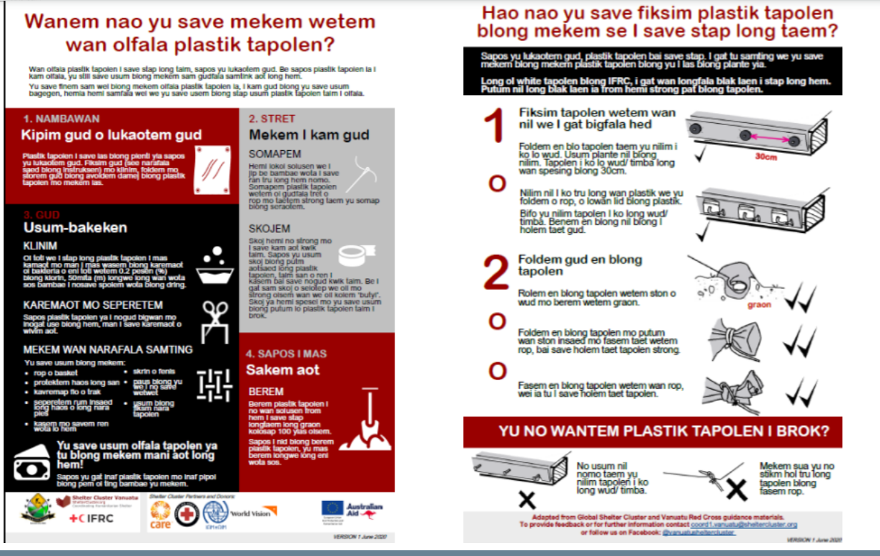

In terms of specific guidance on greening the response, there is not a lot of literature that is well developed for humanitarian responses specifically. One recommended guidance is Green Readiness, Response, and Recovery: A Collaborative Synthesis. In terms of applications to a shelter response, there are a few shortcomings in terms of the following topics, which may require contextualisation to the respective responses where Shelter Clusters are responding:
    - Land tenure is very sensitive
    - Asset ownership
    - Contested visions of recovery
    - Survivors may create a commemorative space after the disaster and needs to be considered in settlement planning and shelter activities in terms of space allocation
Q: What can Shelter Cluster Coordinators in the field ask of the Environment Community of Practice in terms of support, and what kind of resources as an Environment Community of Practice do you wish you had to better support the country clusters in the field?
A: ECOP has most of the answers for how to start greening, but one challenge is that it is difficult to get on the agenda when we are not in country. There were a few environmental advisors on the ground in Mozambique, but it was difficult to handle things remotely. Having early questions and communications can really support the environmental agenda – so more questions from the field would help the overall work of the ECOP and in connecting clusters with those in their network in the field.
Q: From your experience, had you seen a greener response in the context of COVID?
A: The answer is so far no.
Q: What battles should we pick? What do we prioritise in greening our shelter response?
A: Logistics Cluster has been working on these issues and some of what they have been doing is very practical and returning materials (return to sender approach), reducing the amount of stuff that is sent to the field. You need to link with other groups in the field to work on reducing the environmental footprint. The process and thinking about this in the context of Shelter Coordination is about reducing and about being more efficient with what is provided. Logistics Cluster is looking at this in terms of packaging. MSF is looking at vehicles and batteries and returning them to the US. In Vanuatu, after they rebuild houses, how would you use the plastic sheeting as it is not needed on the island? Sometimes it is necessary to refuse assistance. Wasting fuel by flying water to Pakistan when there is water in the country is one example of wasted and less efficient assistance. The Cluster Coordinator can’t refuse things, but you need to encourage organisations on how to make more efficient practices.
Moving through the stages of the shelter response as you move towards transitional shelter– One should start thinking through how one can mainstream green principles through the process of emergency shelter to transitional shelter. Some principles for consideration include:
- How does one procure items at less impact to the environment? How can distributions be organised in a more environmentally friendly manner?
- What materials are using in the construction process? Which ones would have a better impact on the response while also preserving structural integrity and other good shelter building principles?
- Packaging- reducing the amount of plastics used in packaging of materials.
- Transportation of both materials and people.
This is where the 6 Rs should become paramount considerations in Shelter Cluster Strategies:
- Reduce
- Return to Sender
- Recycle
- Reuse
- Repurpose
- Refuse!
Let’s examine what are some of the principle environmental policies of the agencies that are composing the Shelter Cluster in the field.
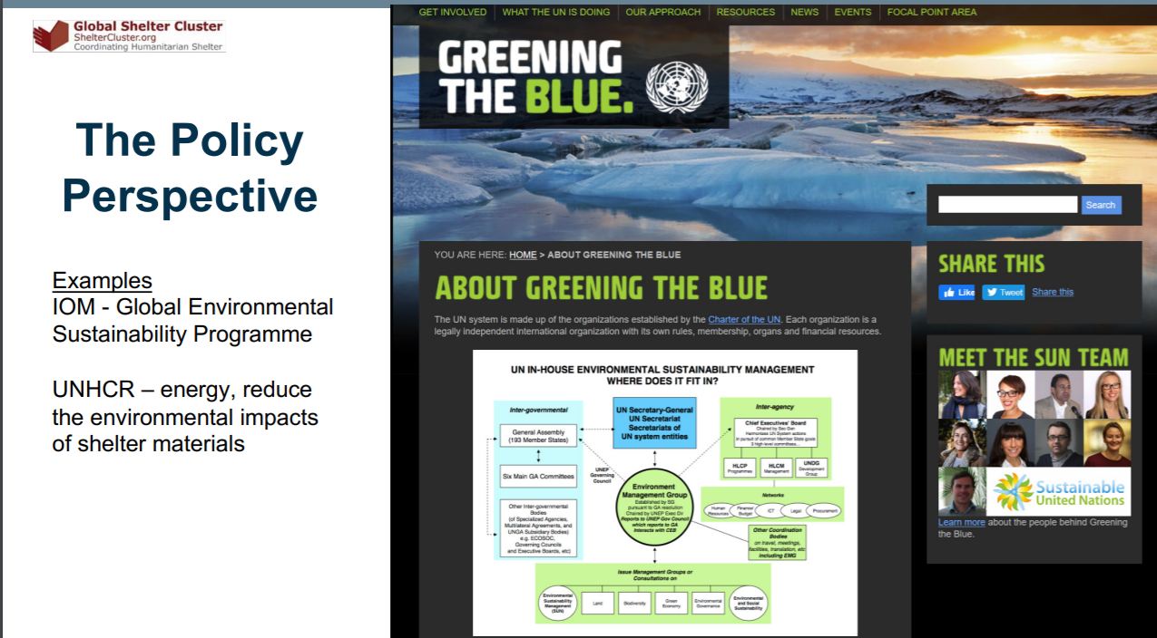
.
UN: https://www.greeningtheblue.org/about-greening-blue
As a Shelter Cluster Coordinator, you can look at some of the policies that agencies use to evaluate how agencies are doing in terms of greening their response. Compliance per agency varies by context. There is often a gap between the policy and application in the field. People in the field are trying to figure out how to do their projects in a green way. Bottom-up efforts are a good thing and can drive a lot of change.
The Global Shelter Cluster approved a statement on reducing single use plastic, but the GSC doesn’t yet have a statement on greening the response. This may be a recommendation for the Global Shelter Cluster to explore, but at the same time it may not be necessary if all agencies composing the cluster have a statement. Though if a statement were adopted, it could be a good starting point at field level when trying to lead discussions on the topic. The Environmental Community of Practice would be interested to know Cluster Coordinators Feedback on this. There are already some promising signs of initiatives coming from country-level Shelter Clusters:
- Vanuatu Piloting an Environmental Checklist
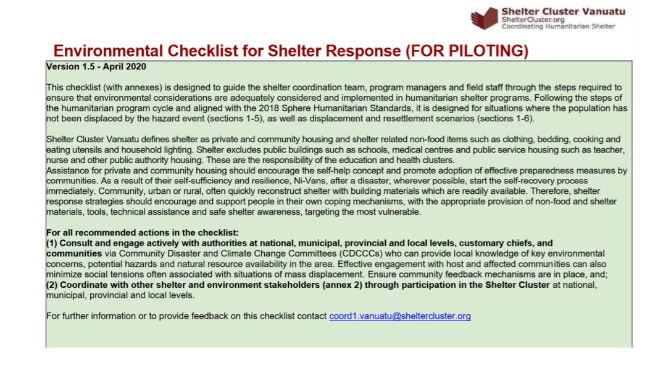
- Democratic Republic of Congo: Shelter Cluster Strategy – opening statement concerns environmental inequalities in terms of how people live and the types of shelters
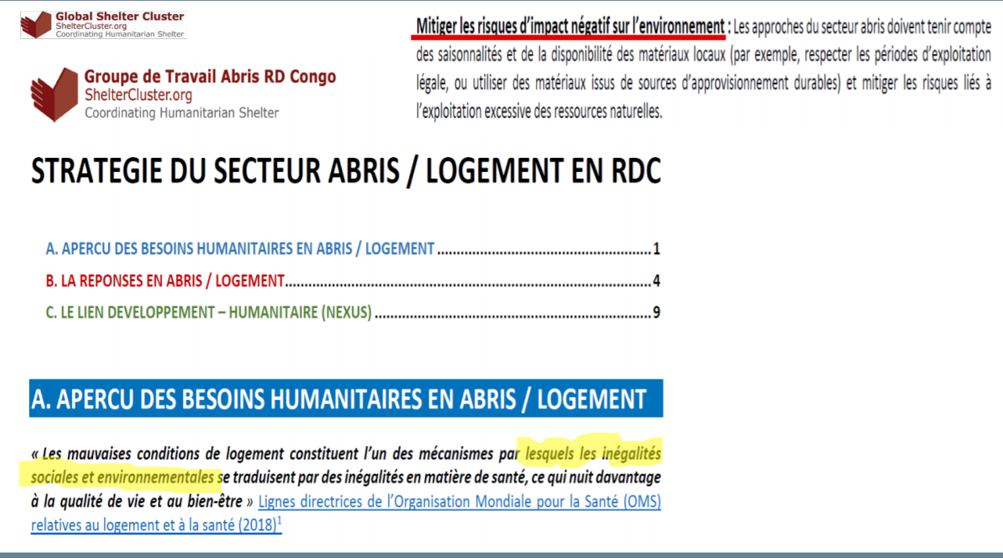
Remember
- Something is better than nothing.
- Don’t have to package it as environment, until you have everyone on board then you can start evaluating and reflecting on your policies have had an impact on the environment and hopefully in a positive way.
- Shelter Cluster can create this group which is the coalition of the willing- of agencies who are able to share externality costs on environmental implementation.
- Positive peer pressures is important and this is where Shelter Cluster can be of value added.
- Tap into organizational policy and bottom-up interests.
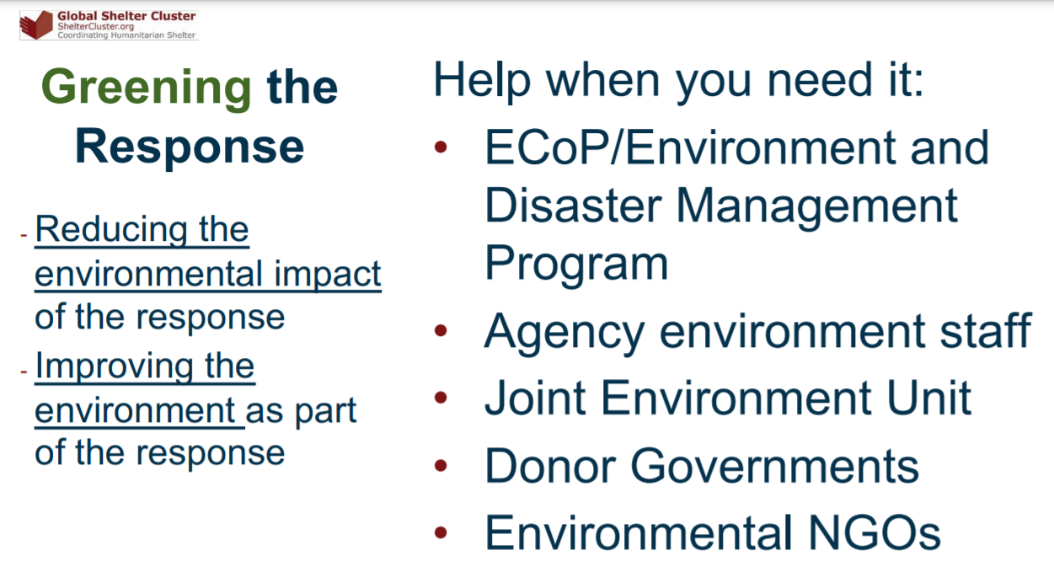Q: Where should we invest our attention and our resources? What are the most pressing challenges and where can we make the most differences?
A:
- Depends on the response
- Look at what you are going to do with the assistance once it arrives. What are you going to do with that plastic once it is no longer usable? Need to think forward, and this is what the environmental concerns about…
- Can we reduce our footprint as we move forward in the transition of the response? What can we do?
Q: If you are Cluster Coordinator, what would be your advice to the agencies to reuse in a flash flood situation when you know that all materials have been washed away due to flooding?
A: ECOP can provide guidance on how to sort through them. I have not mentioned anything about climate change and this may be a subject for future discussion. During the Global Shelter Cluster Meeting, there will be a side event session, where we will discuss Asbestos in more detail.
Q: Is there any research being done on recyclable material for tarps and tents?
UNHCR is working on reusing materials for core relief items and blankets. Luxembourg Shelter Research Centre is beginning to work on this. Iraq collected tents and sent them to companies for recycling. Many things are happening, and we are not maybe hearing about them, so need more information on those practices to facilitate exchange of best practices.
Q: In Syria due to sudden displacements at the end of 2019-early 2020, IDPs have been displaced in the middle of fields with limited materials. Syria had an experience using debris as construction materials which costs quite a lot. Many Shelter Cluster partners are using concrete block shelters as an alternative. Good experience with some of the partners – Cluster keeps advocating for a greener response. Though is it true that we can’t be 100% green in our response?
A: Today it is difficult to be 100% green in the response. It may be necessary to harm the environment temporarily to save lives, but be aware of this so that you can find the way to ameliorate the situation as soon as you can such as replanting trees and remediate the negative environmental impacts. Anticipate some approaches to remediation- operational context. With the current context in Syria, some donors particularly USAID will treat this kind of like a development process rather than a disaster response process and they can start environmental reviews.
Q: More a comment than a question: Nature is the only sustainable thing. Localisation and cash are two key components and are low hanging fruits and they are easy for us as Cluster Coordinators to remember greening solutions. Another idea is targeted rather than blanket response. Reduce, reuse, recycle: The number one step is recycling. Recycling is a bit of a myth. We need to find out how we make things last longer. How do we make things last longer? How do we avoid recycling as we remember that is last resort?
A: Thank you for these comments. Indeed there has been a bit of work and research on this topic, which was an engagement with the London School of Economics looking at cash and the environment: https://www.sheltercluster.org/sites/default/files/docs/cashenvironment_-_implications_and_opportunities.pdf
Q: What about the use of local knowledge and materials?
A: Use of local knowledge is quite important, but there is a trade-off between local and imported materials. The advantage of local materials is that they are available, but their extraction may not be sustainable. We have to start with the questions, can we use them or not? We should not always go for default local solutions- it may be necessary for logistics reasons, but that if that has a negative environmental impact, you need to address it through mitigation.
Q: Are local materials always greener regardless of the transportation aspect?
A: No not always, if it is a scarce resource, it may not be necessarily more green.

Those Registered and Attendees
First Name | Last Name | Email Address
Angel | Pascual | pascuala@unhcr.org
Mariam | Hyder | mhyder@iom.int
Abraham | Tesso | atesso@iom.int
Francisco | Monteiro | franciscovassalomonteiro@gmail.com
Adriana | Duran | durangam@unhcr.org
Dipti | Hingorani | dipti.hingorani@ifrc.org
Shirin | Narymbaeva | shirin.narymbaeva@ifrc.org
Cecilia | Schmoelzer | cecilia.schmoelzer@sheltercluster.org
Roster | Kufandiko | rkufandiko@redcross.mw
NAHAVITATSARA | Angelo | nahavitatsara@gmail.com
Lucio | Cocconi | lucio.cocconi@ifrc.org
C | KellY | havedisastercallkelly@gmail.com
Lilia | Blades | coord.americas@sheltercluster.org
Thuong | Nguyen | tnguyen@redcross.org.uk
Leeanne | Marshall | lemarshall@redcross.org.au
Deepika | Bhardwaj | bhardwad@unhcr.org
Sergey | Sahakyan | arcs-dm@redcross.am
Ela | Serdaroglu | ela.serdaroglu@ifrc.org
MARINA | MUCCIARELLA | mucciare@unhcr.org
Jacques | Habyarimana | jhabyarimana@samaritan.org
Yurii | Arnautov | arnautov@unhcr.org
Pankaj | Singh | singhpa@unhcr.org
Serge | AGANZE | aganze@unhcr.org
Siyat Ahmed | Mohamed | program@avord.org
Mohamoud | Hersi | hersimo@unhcr.org
Jonas | Cordova Gomez | jcordovagomez@iom.int
Mais | Al Suradi | alsuradi@unhcr.org
Andrim | Salangadi | andrim@unhcr.org
Pablo | Medina | pablo.medina@ifrc.org
Munguntuya | Sharavnyambuu | munguntuya.sh@redcross.mn
Brett | Moore | mooreb@unhcr.org
Joana | Correia | joanaalmeidacorreia@gmail.com
Padmore | Okal | okal@unhcr.org
Mohammed | Alamir | coord.turkey@sheltercluster.org
Renee | Wynveen | wynveen@unhcr.org
Miguel | Urquia | urquia@unhcr.org
Tom | Bamforth | tom.bamforth@sheltercluster.org
joseph | ASHMORE | jashmore@iom.int
Mark | Victorio | markmauro.victorio@gmail.com
Baria | Alkafre | alkafre@unhcr.org
Caroline | Dewast | coord.rdc@sheltercluster.org
Selam Wudu | Kassa | skassa@iom.int
Habtamu | Gulilat | hgulilat@iom.int
Elena | Velasco | elena@evr-arquitectura.com
Emigdio | Filardi | filardig@unhcr.org
Wilson | Perez | perezw@unhcr.org
Marta | Pena | marta.pena@ifrc.org
Wahyu | Widayanto | wahyu.widayanto@ifrc.org
Muchamad | Darisman | mandarisman@gmail.com
avianto | amri | avianto.amri@gmail.com
Hijaz | Jalil | hijaz.jalil@ifrc.org
idha | kurniasih | idhakurniasih@hotmail.com
Dave | HODGKIN | dave.hodgkin@gmail.com
Arwin | Soelaksono | arwinsoelaksono@gmail.com
Mamen | SANCHA | mamen.sancha@sheltercluster.org
Nurta | Adan | adan@unhcr.org
martin | de vries | mdevries@redcross.ca
Brice | DEGLA | degla@unhcr.org
Didik | Mulyono | dididea@gmail.com
Johanes | Juliasman | johanes.juliasman@crs.org
Aynur | Kadihasanoglu | aynur.kadihasanoglu@ifrc.org
FALY | Fabien | aritiana23@gmail.com
sviatoslav | savchuk | savchuk@unhcr.org
Neil | Bauman | neil.bauman@sheltercluster.org
Robert | Dodds | robert.dodds@ifrc.org
Mohammad Baqir | Haidari | haidari@unhcr.org

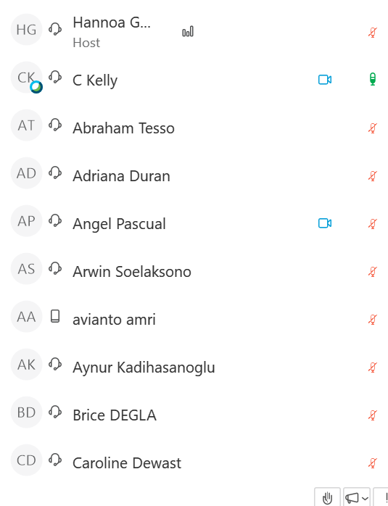
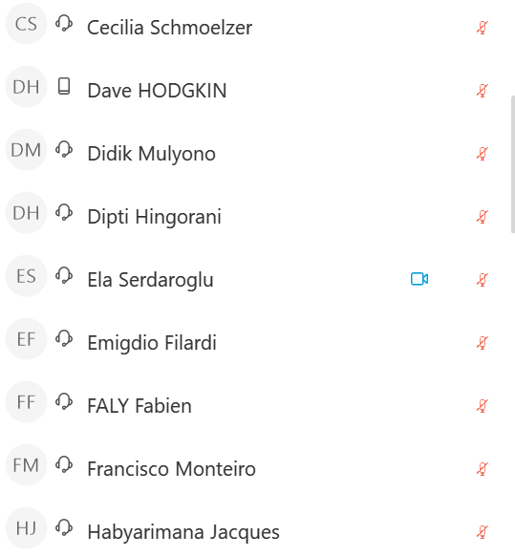
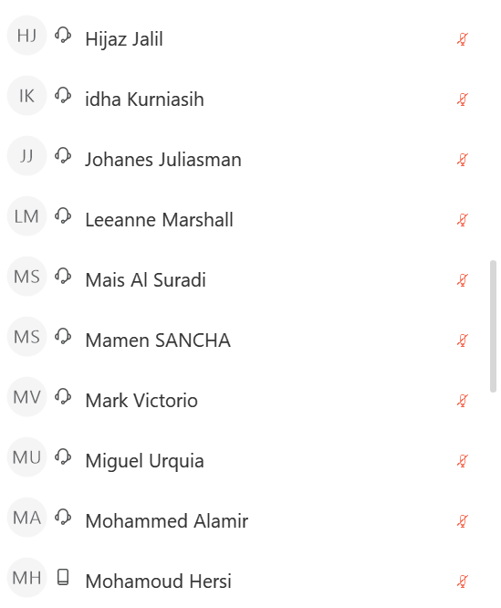
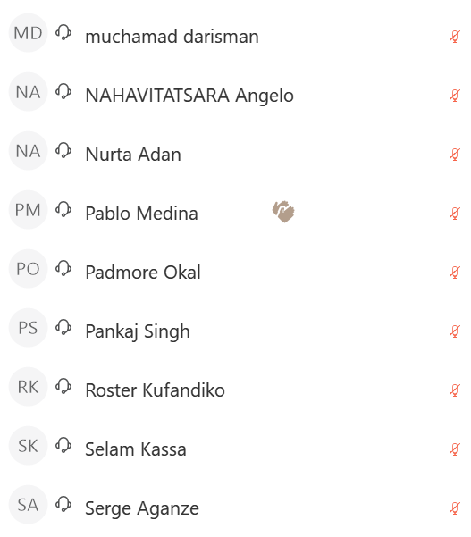
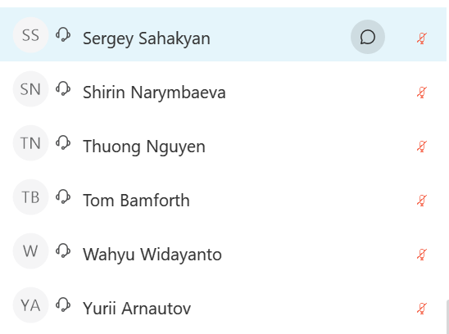
Slava Savchuk

