
August 2016

Country/Region

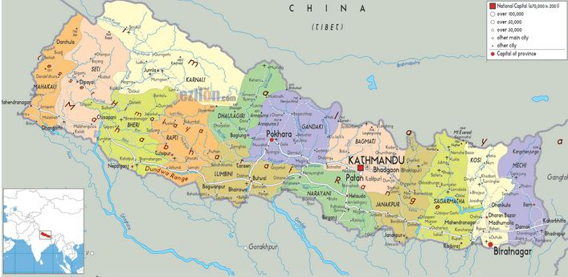

A political, or another relevant map of the country/region
OVERVIEW

Provide a short overview of:
- country’s risk profile (anticipated risks to country/ies, populations & operations ranked by impact and likelihood: low, medium, high) and identify the type of hazards: seasonal or static.
- country’s vulnerability profile (socio-economic and demographic).

NEED ANALYSIS

Provide a short overview of possible key needs in terms of shelter and NFI, this can, for instance, be based on contingency plans or risk assessments.

EMERGENCY RESPONSE PREPAREDNESS

Provide a short overview of emergency response preparedness, elaborating on:
- coordination structures reinforced, working relations with the national authorities and other international and local partners established.
- roles and responsibilities of members of the humanitarian community clarified: operational capacity & arrangements to deliver relief and protection, IM, assessm ents, response monitoring arrangements and etc.
- Contact lists of relevant agencies (agencies with permanent presence in the country, national authorities) maintained and regularly updated.

GAPS / CHALLENGES

Provide a short overview of the key gaps and/or challenges vis-à-vis APA or MPA checklists.

ASSESSMENT PREPAREDNESS

- Baseline data compiled and stored (census data disaggregated by existing vulnerabilities), key indicator sets populated.
- A list of trained staff (contacts) maintained.
- A common inter-agency assessment format agreed (at least within Shelter & NFIs sector)
- A price list for CGI & tarps maintained. Top 5 producers & suppliers identified.
- An overview of country’s housing typologies maintained.

KEY FACTS & FIGURES

The Latest Crises: November 2015
Activation of Cluster: 11 December 2015

Cluster management arrangements: for example working groups etc.

Frequency of cluster meetings:

XX Total cluster partners
XX IOs & INGOs with permanent presence in the country
XX Local NGOs

CLUSTER TEAM - Contacts

Cluster lead agency: IFRC
Co-lead: ACTED
Cluster coordinator:
Email:
Telephone:

Information Management Officer:
Email:
Telephone:

KEY DOCUMENTS (hyperlinks)

Shelter cluster contingency plan
Technical guidance
IM products
Contact lists of cluster partners, including national authorities

KEY LINKS

Country page on sheltercluster.org
XX visitors in August

Country page on humanitarianresponse.info
Country page on relief.web

INFORMATION ON STOCKS

- Amount and whereabouts
- Main warehouse locations
- Main supply chains

