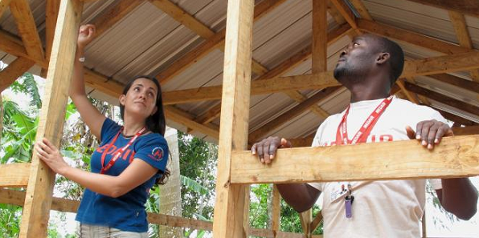
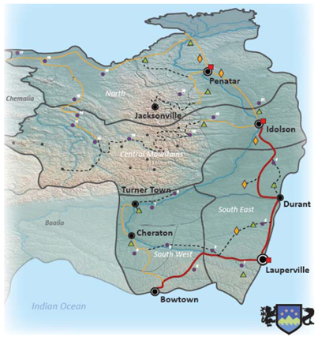
NEED ANALYSIS
- Shelter needs are highest in Central Mountain region due to damage caused by recent flooding and in the western and northern regions due to recent refugee influx from neighboring Baalia and Chemalia
- UNDAC Rapid Needs Assessment reports need for shelter kits for 5,000 households, shelter NFIs for 2,000 households, and assistance to 2,000 partially or totally damaged homes
- Additional need for shelter for refugee response as refugees reported by ACF Rapid Needs Assessment to be settling in makeshift camps and improvised shelters
- Multi-sectoral needs assessment led by OXFAM in Lauperville demonstrates

RESPONSE
- Planning Shelter distribution with 4550 emergency tents in the pipeline stock, and NFIs including 5164 mattresses, 197 blankets, 385 fuel barrels, 435 stoves, 136 sleeping mats, 500 sleeping bags
- Planning two main assessments: rapid needs assessment to better understand priority shelter needs of refugee populations in Northern and Southeast regions and in-depth joint needs assessment to clarify needs and living conditions in Idolson, Turner and West Central Counties of the Central Mountain region.
- Potential interventions in Lauperville to improve tenure security and shelter quality to be discussed in Assessment Working Group.

GAPS / CHALLENGES
- Access constraints to settlements in Central Mountain region have limited assistance distribution capacity
- Limited resources and response gap requires emphasis in OCHA Flash Appeal (FA)
- Risk of upcoming storm - coordination with UNDP necessary for contingency planning for response activities

COVERAGE AGAINST TARGETS (HH)

Expert Photographer / GSC 2017
CLUSTER TEAM
Ken Renkata
Freedonia Shelter Cluster Coordinator
coord.freedonia@sheltercluster.org / +1234567890

Information Management Officer, Refugee Focal Point
Patrick Mfufu
mfumu@sheltercluster.org / +1234567890

Information Management Officer, Assessment Focal Point
Llhanna Santos
lhannags@sheltercluster.org / +1234567890

Information Management Officer, Population Data Management Focal Point
Niroj Shrestha
shrestn@sheltercluster.org / +1234567890

Information Management Officer, Inter-cluster liaison
Melissa Weihmayer
Weihmayer@sheltercluster.org / +1234567890

KEY DATES
Key events that led to activation of cluster includes IDP crisis since 2010, compounded by Storm Ralf and refugee influx from Chemalia and Baalia,

KEY DOCUMENTS
- Shelter Cluster/IM Strategy
- 4W operational guidance
- Secondary Data Review
- Data Analysis Plan

KEY LINKS
Country page on ShelterCluster.org

KEY FIGURES
10 315,000
Cluster partners People in need

FUNDING (source: OCHA Financial Tracking Service)

