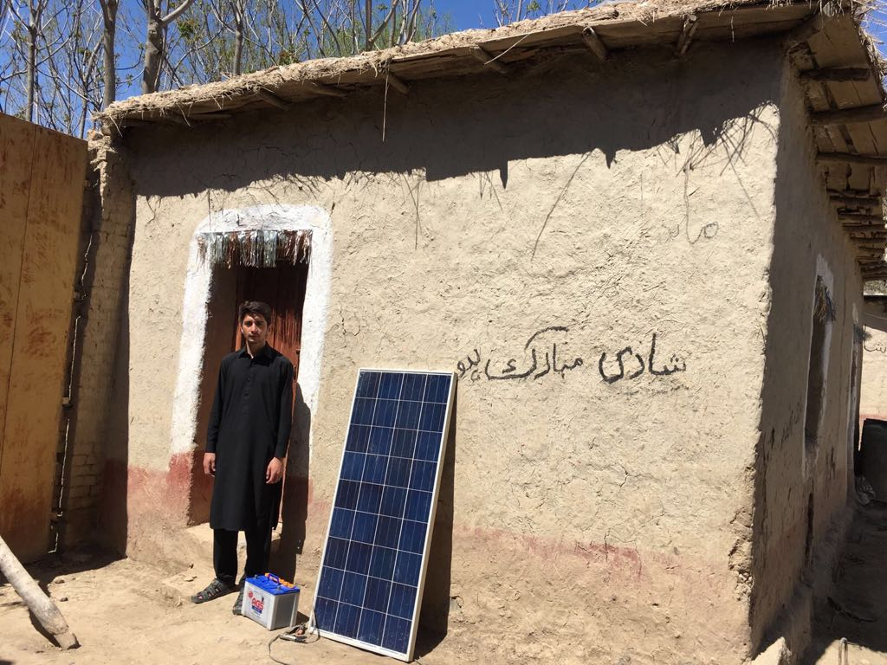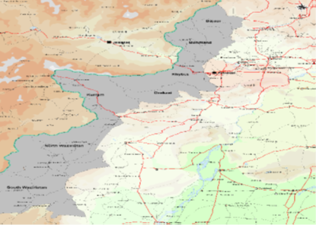
NEED ANALYSIS
- The Federally Administered Tribal Areas (FATA) of Pakistan with an estimated population of 8 million inhabitants. Since 2008, more than 5 million people had been displaced from the FATA and the Malakand Division of Khyber Pakhtunkhwa. Since 2010 some 2.6 million (94%) have been returned to their places, of which 1.4 million IDPs returned in 2015-16. From January to March 2018, 21 families returned while 0.17 registered IDPs are still in displaced areas.
- Shelter support interventions continue to be critical need in return areas. Under PHPF (UNOCHA) $ 1 m is allocated for shelter assistance to most vulnerable families.
RESPONSE
- The Shelter Cluster plans to assist recently returned population by providing assistance in shape of conditional cash grant or shelter kit or roofing kit materials for permanent shelters and CRIs on need bases. By this Shelter Cluster incorporating the early recovery and development response in their Humanitarian strategic plan. In 2018 shelter cluster planned to provide assistance to the 30% most vulnerable of the remaining IDP’s families including returnees from Khost-Afghanistan. Total 9,554 families will be assisted including unregistered families.
- Shelter Cluster is in process of transition alongside other clusters in the Country.
The targeted HH for shelter is 6,210 and NFI/CRI is 3,344.
GAPS / CHALLENGES
- Access to the return area is still a challenge both for monitoring of ongoing projects and implementation of new projects.
- The major projection by Shelter & NFI cluster in KP/FATA is around 6.6 M $ in 2018.

COVERAGE AGAINST TARGETS (HH)

CLUSTER TEAM
National Coordinator
Yaris Khan (UNHCR)
afridiy@unhcr.org / +923008593582

Technical Coordinator
Faraz Ahmad (UNHCR)
ahmadfa@unhcr.org / +923455116098

National Co-Chair
Noor-ul-Amin (FDMA)
amin@fdma.gov.pk / +923459669334

Information Management Officer
Shafqat Mehmood (UNHCR)
mehmood@unhcr.org / +923009802335

KEY DATES
Provide a short description of the key events and dates before and/or after cluster activation.

Activation of cluster: Month Year

KEY DOCUMENTS
- Shelter/NFI Cluster Strategy
- Technical guidance
- Maps

KEY LINKS
- Country page on ShelterCluster.org
XX page views in Month Year
- Country page on HumanitarianResponse.info
- Country page on ReliefWeb

KEY FIGURES
20 0.169 m / 64,289
Cluster partners People in need / targeted

FUNDING (source: OCHA Financial Tracking Service)

Photographer / Organisation, Year

